Pathway Entrances and Exits

Most pathway maps will contain genes that are not present in the genome you’re annotating. The important thing is to determine if the pathway is still functional, which you can do by looking at the pathway entrances and exits. The entrances and exits connect each individual pathway to larger gene functions, and determine if a certain pathway is functional.

Let’s look at the pathway for lysine biosynthesis as an example.

The pathway in RAST:

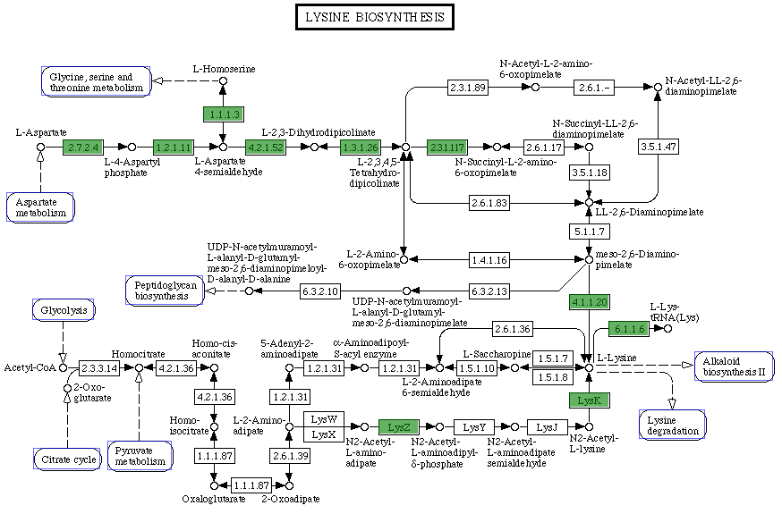

Genes highlighted in green have been found in the H. utahensis genome.

The pathway in KEGG:

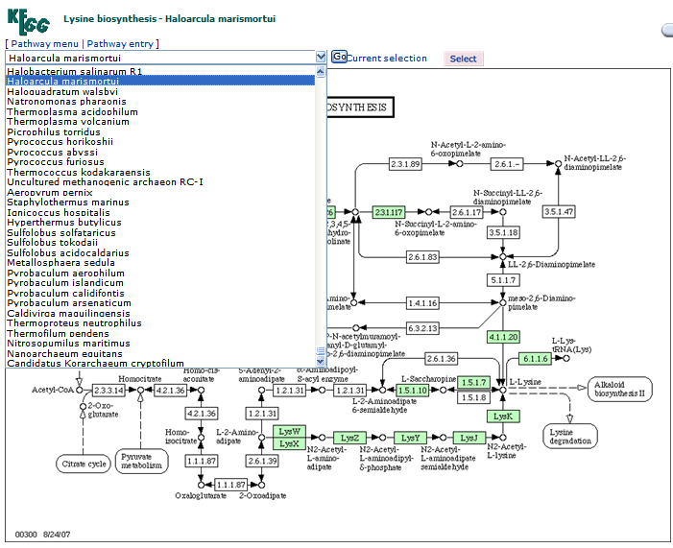

When viewing the pathway in KEGG, I selected to display the genes present in Haloarcula marismortui, which has a very similar genome to H. utahensis.

The KEGG pathway, with H. marismortui highlighted:

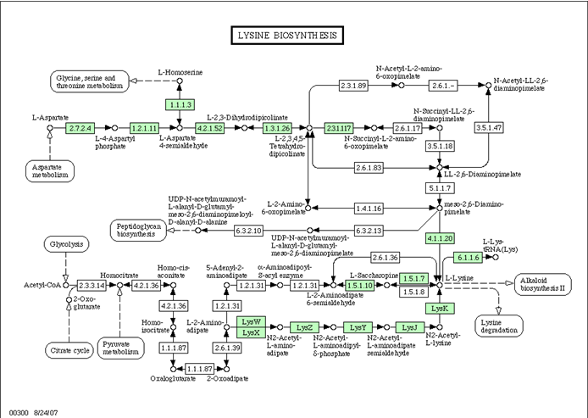

Comparing the H. utahensis and H. marismortui pathways lets us see which paths are more likely to be complete. If genes are absent in both pathway maps, we are much less likely to find them in the H. utahensis genome.

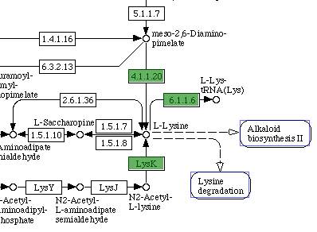The product of the pathway, L-lysine, is located here:

The entry points into this pathway from other pathways are marked with boxes, with arrows pointing into the pathway. For example, the glycolysis process and citrate cycle produce products that are then used in the lysine biosynthesis pathway.

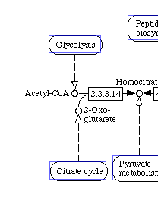The boxes indicate other pathways that lead into this pathway.

However, since most of the genes between these two entrances and the lysine end product are missing in both H. marismortui and H. utahensis, it’s unlikely that these entrances to the pathway are functional.

Another entrance to the pathway, via aspartate metabolism, is more complete, only missing a few genes in the H. utahensis pathway map. More to the point, there are multiple ways to get from the entrance to the endpoint, as you can see here:

(Path is highlighted in red.)

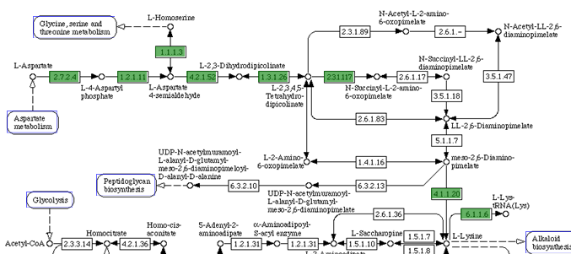
Before we check to see if this pathway is intact, however, we need to make sure that the entrance we’re using is valid. Click on the box for aspartate metabolism to be taken to that pathway map.

The aspartate metabolism pathway in RAST:
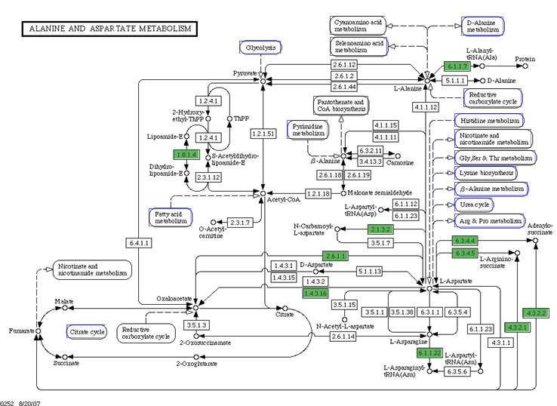

The exit to the lysine biosynthesis pathway is circled; two intact pathways from the exit to the nearest entrance, from the reductive caboxylate cycle, are highlighted in red.

The other entrances to the pathway have few genes connecting them to the lysine pathway, so it’s much more likely that the necessary proteins originated from the reductive carboxylase cycle. The carboxylase cycle, as well as the citrate cycle, feed into many other pathways, so we won’t check it for now. Let’s go back to the lysine pathway.

Since this is the most likely route from entrance to endpoint (or exit, to the lysine degradation), let’s examine this route in more detail.

There are four possible routes you could take between entrance and endpoint, completing the pathway. Two of those possible routes have three genes missing; one has only one. Beginning by checking the route that has the least missing genes can be helpful.

Begin by looking up the E.C. number in question on EXPASY; this will give you the name of the protein or enzyme the gene encodes for. The EXPASY search page is here: http://www.expasy.ch/enzyme/enzyme-search-ec.html

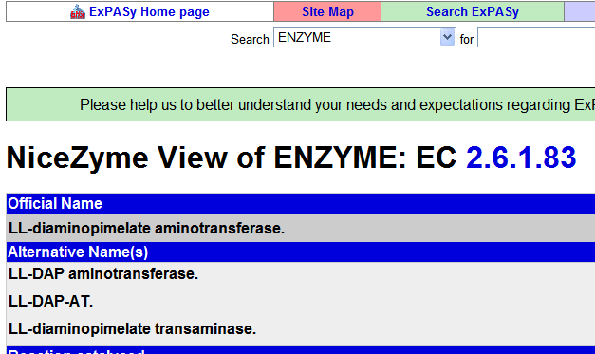

Now that you know the enzyme’s name, you can search for it in the annotation spreadsheets for the three genome databases. The spreadsheets are located here on the wiki: http://gcat.davidson.edu/GcatWiki/index.php/Halorhabdus_utahensis_Genome

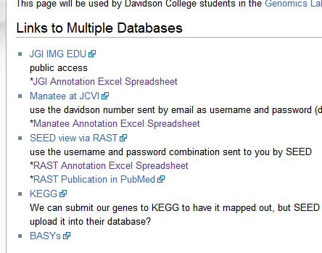

Once you’ve opened an annotation spreadsheet, use Find (Control+F, or Apple+F if using a Mac) and input the name of the enzyme you’re looking for.

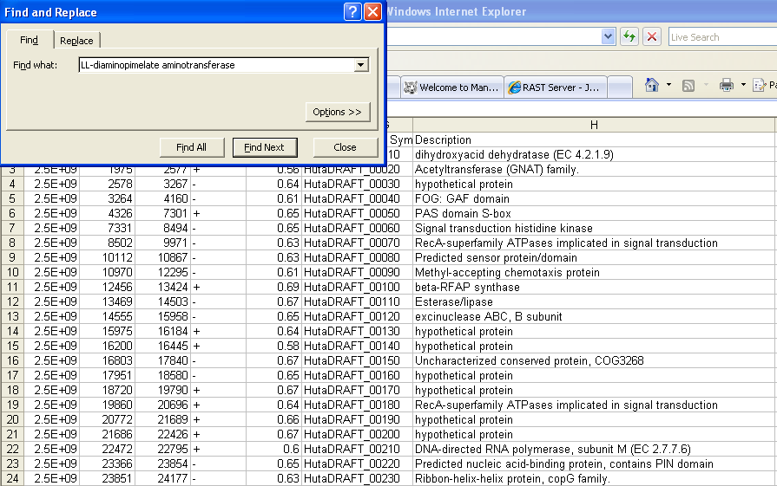

If no results come up, try searching for the E.C. number, as the initial annotation sometimes misses them. Be sure to also check for any alternative names that the enzyme might have, listed in the EXPASY entry.

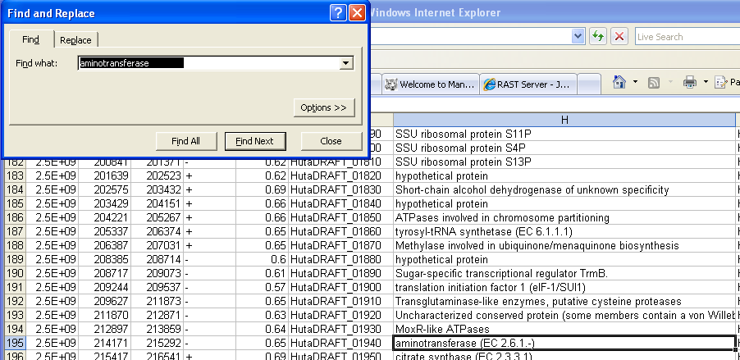If you can’t find the enzyme in question, try looking for a more general search term. For example, LL-diaminopimelate aminotransferase does not appear in any of the three databases; neither does its E.C. number. But searching for aminotransferases brings up a few unassigned aminotransferases, with no EC number or definite function listed, which may perform the same function as LL-diaminopimelate aminotransferase.

For now, take note that LL-diaminopimelate aminotransferase (2.6.1.83) did not appear in any of the three genome annotations. Since that route from start to finish is now unavailable, let’s look at the others.

The remaining three possible routes all converge just before 5.1.1.7, so no matter which other genes we might find, that one must be present. Searching EXPASY for 5.1.1.7 gives us diaminopimelate epimerase.

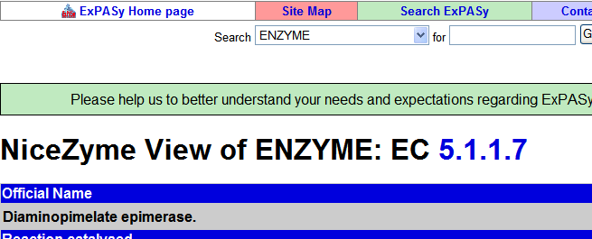

Searching for diaminopimelate epimerase in the genome database annotation spreadsheets, however, yields no results, and the other epimerases are specific or not designed for diaminopimelate.

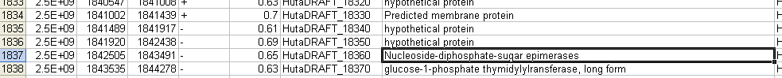

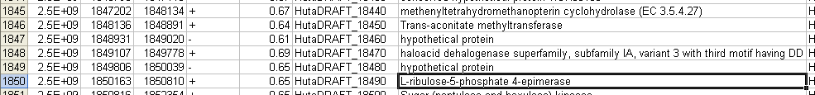

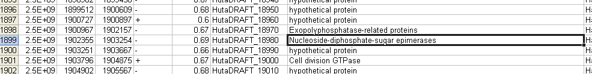

Only the JGI search result samples have been shown here, for brevity.

If this gene is missing, then none of the three alternate routes we had considered can connect the entry to the lysine pathway to the lysine product itself. It may be present but not detected, in which case the next step would be to run a BLAST search. Or, because those few unidentified aminotransferases appeared in the previous searches, perhaps the pathway completes through 2.6.1.83 or a similar gene.

Learning how to identify and manage pathway entrances and exits not only helps identify whether pathways are functional, it also speeds up the process of annotation by identifying important genes or genes that are most likely to be present.

