Splitting Genes to Make Multiple Pancakes
Karen Acker
Biology Department, Davidson College, Davidson, NC 28035
Spring 2007

Abstract

Splitting reporter genes and inserting sequences without altering protein function have proven to be very useful in protein tagging and observing protein-protein interactions. Now, a new role for split genes has emerged in the biological equivalent of the pancake problem. E. coli can function as biological computers to solve the pancake problem and thus far, two-pancake constructs have been built. Pancakes are defined by DNA regions flanked with 26 bp hixC sequences. In this project, I investigated the possibility of inserting hixC sites within the DNA sequence of GFP and TetA(C). As opposed to flanking genes with hixC sites, inserting hixC sites within a gene sequence increases the number of pancakes in a stack without increasing the number of genes. The TetA(C) gene with inserted hixC sites does not express functional TetA(C) protein. On the other hand, GFP tolerates a hixC insertion. I have built a functional GFP construct with hixC inserted between amino acids 157 and 158.

Introduction

The ability to split genes and insert foreign DNA sequences, particularly with reporter and antibiotic-resistant genes, is of great use for biological computers solving the pancake problem. The pancake problem is a mathematical puzzle that involves flipping a scrambled stack of pancakes into the correct order and orientation. When using DNA regions flanked with hixC sites as pancakes and hin proteins as spatulas, E. coli can be used to solve the pancake problem (Simpson, 2006). Hin cleaves and flips DNA by binding to the two flanking hixC sites. After one flip, the pancake is in the reverse orientation. Two-pancake constructs, with a pBad promoter and TetA(C) as the pancakes, have been built [pLac versions have also been built by Dr. Karmella Haynes, personal communication].
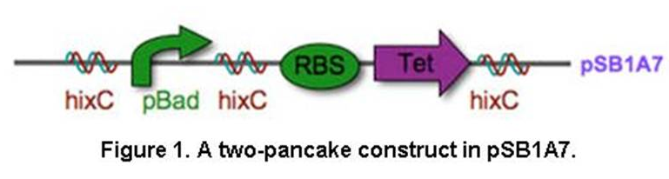
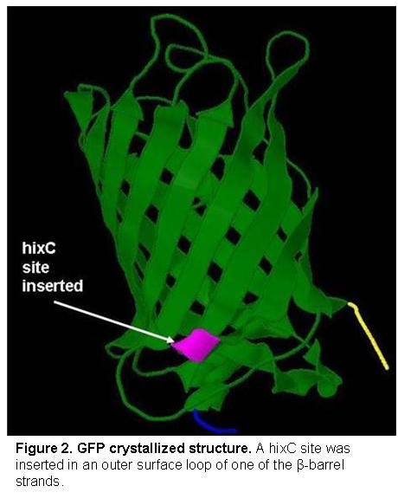
The optimal DNA pancake is a DNA region that codes for a protein with phenotypically detectable expression. Promoters, antibiotic-resistant genes, and genes coding fluorescent proteins fit this criterion. Yet, the number of suitable reporter genes for pancake constructs is limited, making the building of multiple-pancake constructs difficult. If hixC sites can be inserted in a gene sequence without altering the function of the gene product, the number of pancakes in a stack can be increased without increasing the number of genes. I attempted to insert hixC sites into the gene sequences of green fluorescent protein (GFP) and TetA(C), a tetracycline efflux protein.
GFP is a β-barrel protein with 11 antiparallel β-strands that surround a chromophore. The chromophore portion is responsible for GFP fluorescence and fluoresces when irradiated with ultraviolet light (Zacharias and Tsien, 2006). The most frequent use of GFP is as a reporter gene. GFP is an effective reporter protein because it is easily detected without invasive techniques or added substrate.
GFP toleration to insertions was discovered unexpectedly when semirandom mutagenesis inserted a six-residue peptide at position 145 of cyan fluorescent protein (a GFP variant) without affecting its fluorescence (Baird et al., 1999). Since this unexpected discovery, many other locations within GFP have been found to tolerate insertions. The insertion locations that have been the most successful are 154-155, 157-158, 172-173, and 194-195 (Hu and Kerppola, 2003, Ghosh et al., 1999, Paramban et al., 2004), and of these locations, 157-158 and 172-173 were the locations most accommodating to 20-residue insertions (Abedi et al., 1998). These sites are found in the β-turns that connect the β-strands of the barrel to one another and do not interfere with protein function because they are not near the chromophore. These studies have used split GFP for protein tagging and observing protein-protein interactions. These have shown that GFP can be cleaved and reassembled to yield a fluorescent protein (Magliery and Regan, 2006). In contrast with the split GFP reported in previous studies, the GFP I constructed is split only in its DNA form until it is re-ligated leaving a hixC site inside the sequence. Both GFP fragments are transcribed and translated together. Nevertheless, the results of these studies indicated ideal locations for the GFP splitting I planned on doing. I chose to insert a hixC site in 157-158 because this site has been the most consistently successful in these studies.
The second gene in which I attempted to insert hixC sites is the gene coding for the TetA(C) protein. TetA(C) is a tetracycline efflux protein that expels tetracycline from cells by coupling the efflux of one tetracycline molecule with the influx of a proton (McNicholas et al., 1995). There have been no previous attempts to insert foreign sequences in the TetA(C) sequence. Thus, I had to choose insertion sites based on my understanding of TetA(C) structure and function. Unfortunately, much less of the TetA(C) structure is understood than of GFP. Since it is a multi-domain transmembrane protein and thus insoluble, TetA(C) has not been crystallized. The elucidated secondary structure of TetA(C) comes from computer modeling (McNicholas et al., 1995; Figure 3).
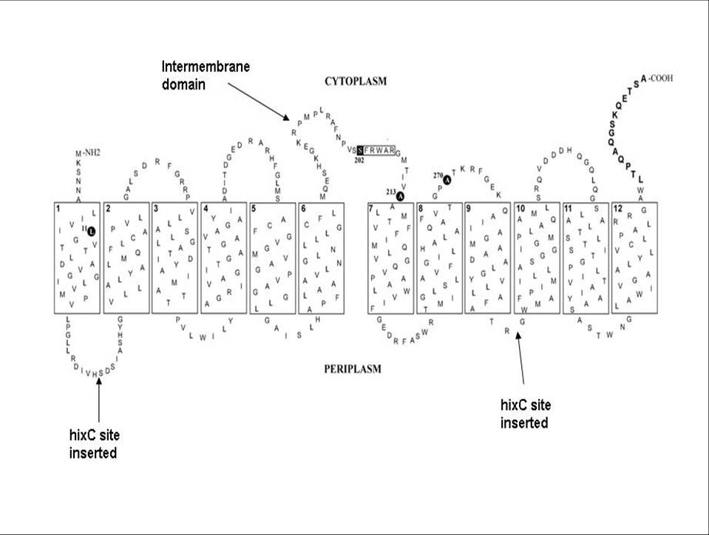
Figure 3. Model of 2-D topology of TetA(C). TetA(C) has 12 transmembrane domains. Loops between each transmembrane domain extend into the periplasm and cytoplasm. The intermembrane domain is the cytoplasmic region between domains 6 and 7 and is critical for TetA(C) function. HixC sites were inserted in periplasmic loops between domains 1 and 2, and 9 and 10 (diagram from Sapunaric and Levy, 2003, I added labels with arrows).

Mutagenesis of certain TetA(C) regions has revealed the regions critical for TetA(C) function. The most important regions for efflux function are located in the transmembrane domains and the cytoplasmic loops connecting the domains. The cytoplasmic domain of most importance is the intermembrane domain because it allows for interactions between the N- and C-Terminal (α and β, respectively) domains of the protein (McNicholas et al, 1995 and Sapunaric and Levy, 2003). Based on this knowledge of some of the important functional regions in the function of TetA(C), I chose two locations to insert hixC sites (Figure 3). Since the intermembrane domain plays a vital role in TetA(C) function, I chose periplasmic loops a few domains away from the intermembrane domain to avoid interference with the intermembrane domain function. Also, I avoided the transmembrane domains to avoid interfering with their function. I chose to insert one hixC sites between amino acids 37 and 38, and one between amino acids 299 and 300 (Figure 3).

Methods and Materials

E. coli and LB media

I built with amp-resistant pSB1A2 plasmids and transformed into Zymo Premade Z-Competent™ E. coli. I grew and maintained E. coli cells in LB Amp (100 µg/ml) liquid media or agarose plates.

BioBrick ends

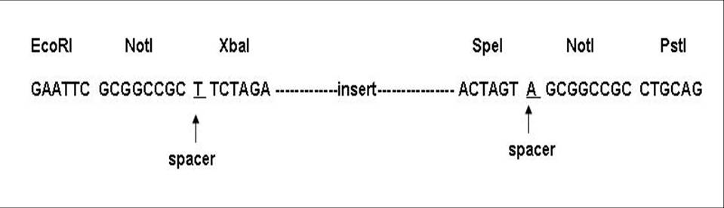
The BioBrick ends I used have one-base-pair spacers within the BioBrick prefix and suffix. Unlike the standard BioBrick ends designed by Tom Knight, which have a spacer between XbaI and the insert, and between the insert and SpeI (Knight, n.d.), the BioBrick ends I used have a spacer between the NotI and XbaI sites, and between the SpeI and NotI sites (Figure 4).

Figure 4. BioBrick ends with spacers. One base pair spacer was put between NotI and XbaI, and SpeI and NotI.
GFP primer design

The GFP variant I used was gfpmut3, a 240 bp GFP variant constructed by Anderson et al. (1998). I reviewed past literature to determine the ideal site in GFP to insert hixC. I chose to insert hixC between amino acids 157 and 158 based on other studies that successfully inserted short sequences into the GFP sequence in this location (Paramban et al., Zacharias and Tsien, Hu and Kerppola, Shyu et. al., Maghery et al.). When inserting a hixC site into a gene sequence using BioBricks, the two gene fragments are amplified separately and re-ligated with a hixC site in between. I designed four GFP primers to make two GFP fragments: GFP1 (aa 1-157) and GFP2 (aa 158-240). Each primer includes BioBrick ends and a 20 or 25 bp GFP primer.
A. GFP1 Forward 5’GCATGAATTCGCGGCCGCTTCTAGAATGCGTAAAGGAGAAGAACT 3’
B. GFP1 Reverse 5’GCATCTGCAGCGGCCGCTACTAGTTTGTTTGTCTGCCATGATGT 3’
C. GFP2 Forward 5’GCATGAATTCGCGGCCGCTTCTAGATAAGAATGGAATCAAAGTTAA 3’
D. GFP2 Reverse 5’GCATCTGCAGCGGCCGCTACTAGTTTATTATTTGTATAGTTCATCCATG 3’
Four added bases, EcoRI site, PstI site, XbaI site, SpeI site, added thymidine, start codon.

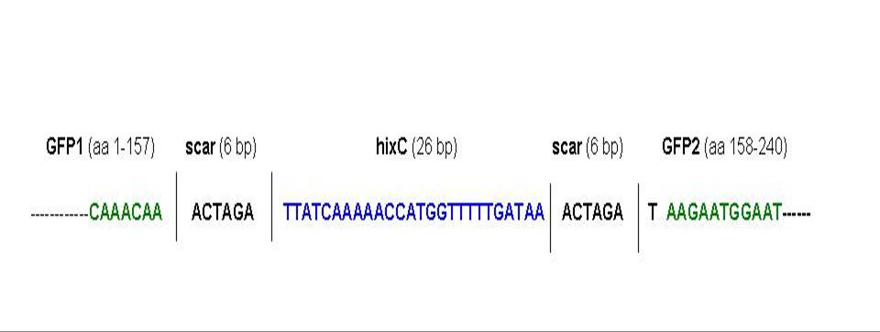
Since hixC plus two six-base pair scars is 38bp and not a multiple of 3, I added a thymidine (highlighted above) between the BioBrick end and the GFP2 forward primer to maintain the GFP2 reading frame. By adding one base pair upstream of GFP2, I made the hixC sequence 39 base pairs, i.e. a multiple of 3, which allows for the reading frame to be maintained (Figure 5). I also could have inserted a base pair downstream of GFP1, but that allowed for 2 stop codons in the hixC sequence. The sequence of hixC inserted into GFP should look like this after ligation:

Figure 5. HixC sequence in GFP after ligation. A six base pair scar results after GFP1, hixC, and GFP2 are ligated together. The first base of GFP2, thymidine , was added to the GFP2 forward primer to maintain the reading frame.

TetA(C) primer design

I chose to insert hixc between amino acids 37 and 38 (between base pairs 111 and 112), and between amino acids 299 and 300 (between base pairs 897 and 898) based on the TetA(C) structure (Figure 3). I designed six primers to make five Tet fragments: Tet1 (aa 1-37), Tet2 (aa 38-299), Tet 3 (aa 300-397), Tet1/2 (aa 1-299), and Tet2/3 (aa 38-397).
E. Tet1 Forward 5’ GCATGAATTCGCGGCCGCTTCTAGAATGAAATCTAACAATGCGCT 3’
F. Tet1 Reverse 5’ GCATCTGCAGCGGCCGCTACTAGTATGGACGATATCCCGCAAGA 3’
G. Tet2 Forward 5’ GCATGAATTCGCGGCCGCTTCTAGATTCCGACAGCATCGCCAGTCA 3’
H. Tet2 Reverse 5’ GCATCTGCAGCGGCCGCTACTAGTTCGCGTCGCGAACGCCAGCA 3’
I. Tet3 Forward 5’ GCATGAATTCGCGGCCGCTTCTAGATGGCTGGATGGCCTTCCCCAT 3’
J. Tet3 Reverse 5’ GCATCTGCAGCGGCCGCTACTAGTTTAGGTCGAGGTGGCCCGGC 3’
Four added bases, EcoRI site, PstI site, XbaI site, SpeI site, added thymidine, start codon.

I added a thymidine (highlighted above) between the BioBrick ends and the Tet2 forward primer, and between the BioBrick ends and the Tet3 forward primer to maintain the reading frame.

PCR

I used 2X GoTaq® Green Master Mix by Promega, GFP-RBS and TetA(C) as DNA templates for amplification of GFP and Tet fragments, respectively, and the appropriate primers to amplify the following GFP and TetA(C) gene fragments: GFP1 (aa 1-157, bp 1-471, primers A&B), GFP2 (aa 158-240, bp 472-720, primers C&D), Tet1 (aa 1-37, bp 1-111, primers E&F), Tet2 (aa 38-299, bp 112-897, primers G&H), Tet 3 (aa 300-397, bp 898-1191, primers I&J), Tet1/2 (aa 1-299, bp 1-897, primers E&H), and Tet2/3 (aa 38-397, bp 112-1191, primers G&J). See Appendix A for reagent concentrations and temperature cycle.
I verified the PCR products by running 5µl of each in a 1.5% gel stained with ethidium bromide for 35 minutes at 120V.

Cleaning and Concentrating PCR products

To remove unwanted nucleotides (i.e. primers and GoTaq dNTPs) from my PCR products, I cleaned and concentrated them using the Zymo DNA Clean & Concentrator™ -5 Kit (# D4014). I eluted with 10 µl dH20.

Cloning PCR products

Cleaned and concentrated PCR products were digested with EcoRI and PstI, ligated into pSB1A2 cut with EcoRI and PstI, and transformed into E. coli cells. Cloned cells were plated on LB Amp plates (100 µg/ml). Cloned PCR products were sent out for DNA sequencing. See cloning section below for kits and methods used.

Assembling and Cloning Constructs

Miniprep
To isolate plasmids from E. coli cells, I initially used the Promega Wizard Plus Kit (#A1460) and protocol. I switched to the Zymo Zyppy™ Plasmid Miniprep Kit (#D4020) which is more efficient and gives higher DNA yield and concentration. I eluted the DNA with 50 µl Zyppy Elution Buffer. I used Dr. Hayne’s modified Zyppy protocol (See Appendix C).
Double restriction digests
I digested 1-2 µg insert and vector with the appropriate enzymes (EcoRI, XbaI, SpeI, or PstI) and appropriate buffer (http://parts.mit.edu/wiki/index.php/Double_Digest_Guide).The protocol I used can be located here: http://www.bio.davidson.edu/courses/Molbio/Protocols/ digestion.html. I deviated from this protocol in the digest reaction volume and incubation time. The digest reactions were 40-60 µl depending on the concentration of the DNA being digested, and were incubated at 37ºC for 12-16 hours.

Gel electrophoresis in preparation for gel purification
I separated the digested fragment from the plasmid by running 40 µl of the digest reactions in a 1% or 1.5% (depending on the size of the insert and vector) agarose gel stained with ethidium bromide.

Gel purify insert and vector
I used a razor blade and the Fisher Biotech Transilluminator FB-TIV 80 to cut out the appropriate bands from the gel (Figure). I used the QIAquick ® Gel Extraction Kit (#28704) and protocol to extract and purify DNA from the gel bands. To increase the DNA concentration, I eluted with 30µl Buffer EB and let it stand for 1 minute prior to centrifuging.

Ligations and Transformations
To ligate inserts into pSB1A2 vectors, I used 50 ng vector and determined how much insert to use with the following formula:
X ng of insert = 2 * (bp insert) * (50 ng linearized plasmid)
(size of plasmid in bp)

This formula takes into account the needed 2:1 ratio of insert:vector. I used the reagents from Promega LigaFast™ Rapid DNA Ligation System (#M8225) and used the protocol found here: http://www.bio.davidson.edu/courses/Molbio/Protocols/ligation.html. I deviated from this protocol by making 20 µl ligation reactions and using 1.5 µl of T4 DNA ligase.
To transform cells with ligated plasmids, I used Invitrogen Top10 One Shot Chemically Competent Cells in the beginning of the semester, but eventually switched to Zymo Premade Z-Competent™ E. coli cells. Unlike the One Shot cells, Zymo cells do not need to be heat-shocked or incubated with the ligation reaction for a long period of time. I followed the protocol that comes with the Zymo cells, but deviated in the ligation mix:cell volume ratio by adding the ligation mix to Zymo cells in a 1:5 ligation mix volume to cell volume ratio. After incubating on ice for 15 minutes, I plated 25-50 µl of transformed cells on LB Amp agarose plates (100 µg/ml) using glass pipet ‘hockey sticks.’ I made sure to sufficiently spread the transformed cells so that they were absorbed into the gel. This ensured the growth of distinct separated colonies. I incubated the plates at 37º C for 12-15 hours, but no more than 15-16 hours to avoid the growth of satellite colonies, colonies that do not have the antibiotic-resistant plasmid but grow in areas where antibiotic has degraded.
When performing ligations and transformations reactions, it is necessary to have a negative control reaction for each vector used. In each control reaction, I used Buffer EB from the QIAquick ® Gel Extraction Kit (#28704) instead of the insert. The control is necessary because it indicates the percentage of cells with plasmids that re-ligated without an insert. When the experimental and control plate colony numbers are compared, the approximate percentage of cells on the experimental plate with the correct insert can be determined.

Verifying cloning

To verify successful ligations and transformations, I compared the number of colonies on the experimental plate(s) to their control plate. I used the growth ratio to determine the number of colonies to pick and verify from the experimental plate. I grew the experimental colonies and one control colony in liquid LB Amp overnight. I miniprepped them and digested a small amount of DNA with EcoRI and PstI in a 20 µl digest reaction. Typically, I made an enzyme/buffer master mix since I used the same enzymes and buffer for each miniprep. I ran the digested plasmids in a 1% or 5% gel stained with ethidium bromide. Lanes with two bands of the correct size indicated successful cloning. One band is the plasmid (typically the larger one) and the other is the insert (Figures 10&11). In the control lane, one band is the plasmid, and the other is the part that was in the vector prior to the ligation. This band will be smaller than the inserts in the other (experimental) lanes. I streaked successfully cloned cells onto LB Amp (100 µg/ml ) plates and made glycerol stocks (Appendix B).

Building constructs with BioBricks

Since only two building parts can be assembled at a time, I put my parts together in parallel (Figure 6B). When assembling two parts together, I always used the larger part as the insert because it is difficult to gel purify small base pair fragments. Below is an illustration of one of the ligations I performed (Figure 6A).
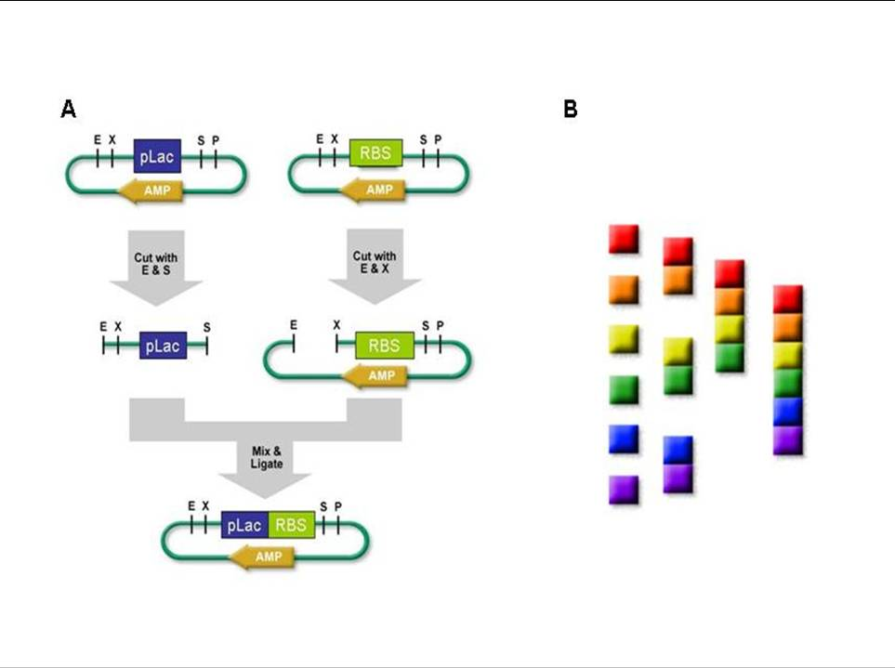
Figure 6. Assembling BioBrick constructs. A. Schematic diagram of ligating two parts together. In this diagram, pLac, the larger fragment is ligated upstream of RBS. B. Assembling parts together in parallel (images from BioBrick registry, http://parts.mit.edu/registry/index.php/Help:Contents)

GFP construct
To build the GFP construct pLac-RBS-GFP1-hix-GFP2 (Figure 8), I assembled all of the components in three phases of building. In Phase 1, I performed a prefix insertion of the pLac insert into the RBS vector: I digested pLac with EcoRI and SpeI, RBS with EcoRI and XbaI, and ligated pLac upstream of RBS (Figure 6). In Phase 2, I performed a postfix insertion of a GFP1 insert into a pLac-RBS vector: I digested GFP1 with XbaI and PstI, pLac-RBS with SpeI and PstI, and ligated GFP1 downstream of pLac-RBS. I also did a postfix insertion of a GFP2 insert into a hixC vector: I digested GFP2 with XbaI and PstI, hixC with SpeI and PstI, and ligated GFP2 upstream of hixC. In Phase 3, I did a prefix insertion of pLac-RBS-GFP1 insert into hixC-GFP2 vector: I digested pLac-RBS-GFP1 with EcoRI and SpeI, hixC-GFP2 with EcoRI and XbaI, and ligated pLac-RBS-GFP1 upstream of hixC-GFP2.
Tet constructs
I built the following Tet constructs: pLac-RBS-Tet1-hixC-Tet2/3 (Tet1-2/3)and pLac-RBS-Tet1/2-hixC-Tet3 (Tet1/2-3), and initiated the building of pLac-RBS-Tet1-hixC-Tet2-hixC-Tet3 (Tet-123), by assembling all of the components in two phases of building. In Phase 1, I performed postfix insertions of Tet1 and Tet1/2 into a pLac-RBS vector and of Tet2, Tet2/3 and Tet3 inserts into hixC vectors. In Phase 2, I did a prefix insertion of pLac-RBS-Tet1/2 into a hixC-Tet3 vector, a postfix insertion of hixC-Tet2/3 into a pLac-RBS-Tet1 vector, and a postfix insertion of hix-Tet2 into a pLac-RBS-Tet1 vector. I did not proceed with the building of Tet-123.

Tet Resistance Assay

I tested the Tet constructs for Tet resistance by streaking cells onto 1) Amp 100 Tet 50, 2) Tet 50, and 3) Amp 100 µg/ml plates (control). For each sample I tested, I used one toothpick to pick colonies and streaked them in this order: Tet 50, Amp 100 Tet 50, and Amp 100. Streaking experimental plates first, and then using the same toothpick to streak the control plate, controls for the loss of cells that may follow the first streak. Cell growth on the control plate ensures that cells were transferred from the toothpick to the experimental plate.

Results

Inserting hixC sites into GFP and TetA(C)

hixC site

Before inserting a hixC site within a gene sequence, I took into consideration the presence of stop codons and the amino acids hixC codes for. I took into account the presence of stop codons within the hixC sequence when determining where to add an extra base pair needed to maintain the reading frame. I avoided stop codons by adding an extra thymidine upstream of the second gene fragment of each construct (Figure 5).
Once I knew where to add the extra base pair, I looked at the amino acids hixC encodes. HixC codes for mostly polar amino acids and some hydrophobic amino acids (Figure 7). HixC should have a similar amino acid pattern to the regions around its insertion location so as not to affect protein folding and function. I made sure that the insertion locations I chose in GFP and TetA(C) had a similar hydrophilic amino acid pattern.
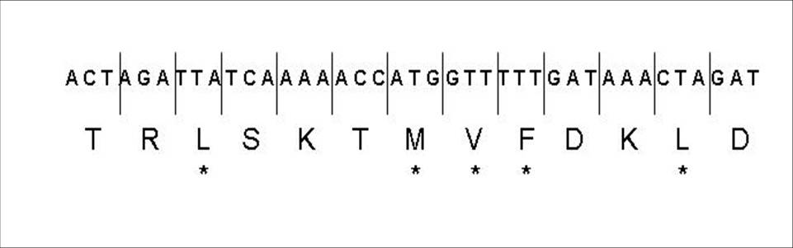
Figure 7. Amino acids coded by hixC sequence. The starred amino acids are hydrophobic. Threonine (T) and serine (S) are neutral, arginine (R) and lysine (K) are basic, and aspartic acid (D) is acidic.

One hixC site in GFP

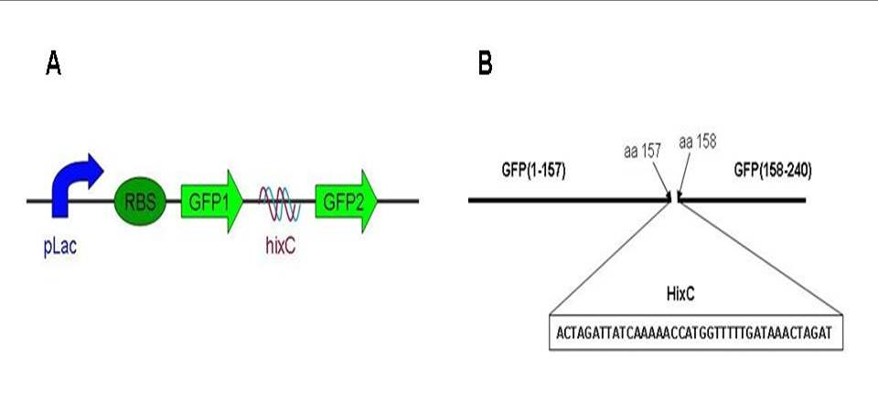
I designed one GFP construct with a hixC site inserted between amino acids 157 and 158 (Figure 8).

Figure 8. A hixC site was inserted between amino acids 157 and 158 of GFP. A. The design of the final GFP construct. B. The hixC sequence and insertion location. The hixC sequence includes the 6-base scars that flank it after ligation, and the extra base pair added upstream of GFP2.

Two hixC locations in TetA(C)

My goal was to build a Tet construct with two hix sites in two different locations. I first needed to build two constructs, each with hixC site in one of the locations, to determine if both locations were good insertion spots.
I designed three Tet constructs: one with a hixC site between amino acids 37 and 38 (Figure 9A&B), one with a hixC site between amino acids 299 and 300 (Figure 9C&D), and one with a hixC site in each location (Figure 9E&F). I completed the Tet1-2/3 and Tet1/2-3 constructs.

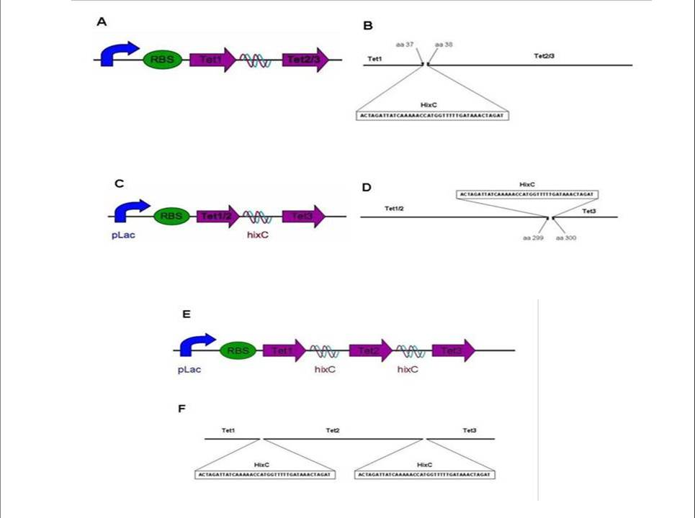

Figure 9. HixC sites were inserted in two locations in the TetA(C) sequence. Three Tet constructs were designed and two were built. A & B. Tet1-2/3. One hixC site was inserted between amino acids 37 and 38. C & D. Tet1/2-3. One hixC site was inserted between amino acids 299 and 300. E & F. Tet-123. Design of TetA(C) construct with a hixC site inserted in two locations: between aa 37 and 38, and between 299 and 300. This construct was not built to completion.

Building and cloning constructs

pLac-RBS
Before assembling my constructs, I built a pLac-RBS part. pLac is a promoter and is necessary for transcription because it provides binding regions for RNA polymerase. RBS is the ribosome binding site in the mRNA that binds to the ribosome to initiate translation. Both pLac and RBS need to be upstream of the gene sequences for transcription of these genes to occur.

GFP construct

I successfully cloned the 985 bp GFP construct. In the gel verifying the GFP construct, the large bp band is the plasmid and the smaller band is the GFP construct cut with EcoRI and PstI (Figure 10). The control lane contains hixC-GFP2 vectors that were not ligated with pLac-RBS-GFP1. the hixC-GFP2 fragment is the small band in lane 4 (Figure 10).
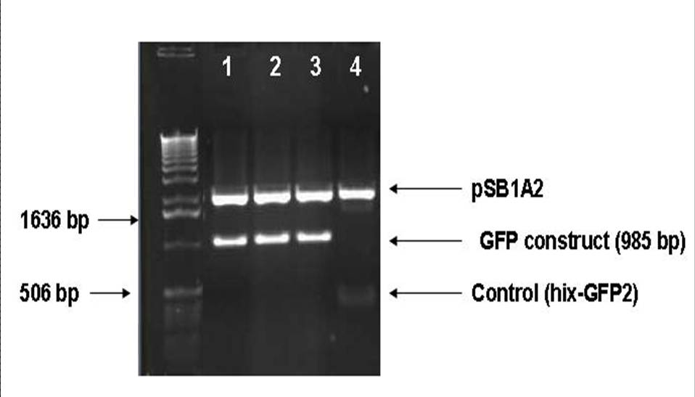

Figure 10. Final GFP construct was successfully cloned. 1% agarose gel stained with ethidium bromide ran for 40 minutes at 110V and 400mA. Plasmids were isolated from E.coli transformed with the final GFP construct and digested with EcoRI and PstI. 1, 2, and 3. Each lane is clone containing the final GFP construct in pSB1A2. Larger band is plasmid and smaller band is GFP construct. 4. The control lane contains pSB1A2 and hixC-GFP2, and no pLac-RBS-GFP1 insert. 1 kb DNA ladder was used.

Tet constructs

Both 1456 bp Tet constructs were successfully cloned. Each Tet construct is 1456 bp. Some of the Tet1/2-3 lanes have three bands (Figure 11B, lanes 1&2). These bands correspond to the empty plasmid, the Tet construct, and hix-Tet3, which was in the vector into which pLac-RBS-Tet1/2 was ligated. The hix-Tet3 band (or any part in the vector prior to the ligation) is seen when the plasmid did not ligate with the insert. Lanes 1 and 2 in Figure 11B have DNA from more than one colony, some colonies with and some without the construct.
Cells transformed with Tet1-2/3 or Tet1/2-3 either formed prominent colonies, similar to the colonies on the control plate, or small, indistinct, lawn colonies(Figure). Thus, I picked both prominent and small indistinct colonies from the plates. Of the colonies I picked from the Tet1-2/3 plate, the only successful colony was an indistinct colony. All of the Tet1/2-3 colonies I picked had the construct, but only the prominent colony gave a uniform cell population of all cells with the construct and a 1:1 plasmid:insert ration (Figure 11B, lane 4).
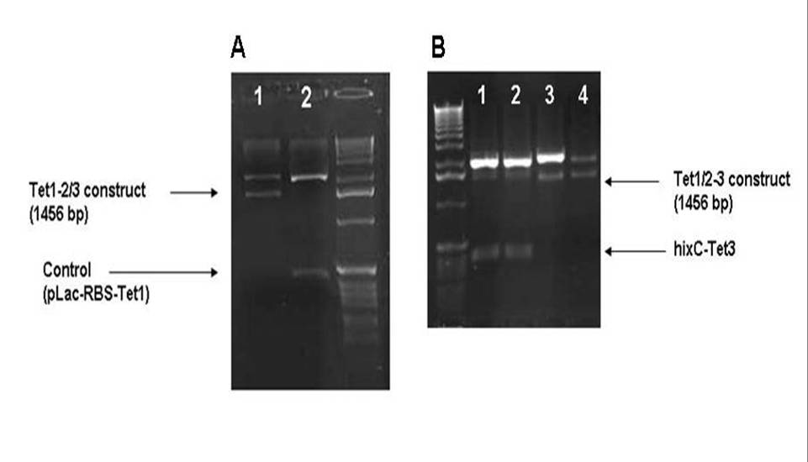
Figure 11. Final Tet1-2/3 and Tet1/2-3 constructs were successfully cloned. Plasmids were isolated from E.coli transformed with final constructs, and digested with EcoRI and PstI. A. 1.5% agarose gel stained with ethidium bromide ran for 45 minutes at 100V and 400mA. 1. Final Tet1-2/3 construct from indistinct colony cut out of pSB1A2. Larger band is pLac-RBS-Tet1 vector and smaller band is Tet1-2/3 construct cut out of plasmid. 2. Control lane with plamid and pLac-RBS-Tet1, and no hix-Tet2/3 insert. B. 1% gel ran for 40 minutes at 110V and 400mA. 1& 2. Plasmids from indistinct colonies with and without construct. The large bright bands in each lane are plasmid, 1456bp bands are Tet1/2-3 construct, and smallest bands in lanes 1 and 2 are hix-Tet3. 1 kb DNA ladder was used. 3. Final Tet1/2-3 construct from indistinct colony cut out of pSB1A2. High plasmid:insert ratio. 4. Plasmids from prominent colony. 1:1 plasmid:insert ratio.

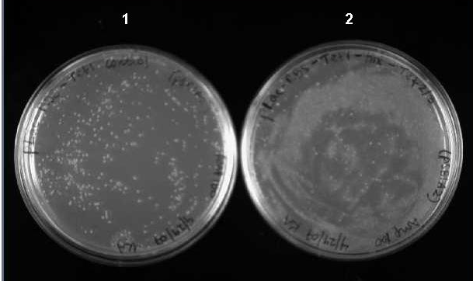

Figure 12. E.coli cells transformed with Tet1-2/3 construct form lawn colonies. Cells that do not possess a Tet construct (1) and cells possessing the Tet1-2/3 construct (2) were observed and photographed under epi white light. The cells transformed with Tet1-2/3 or Tet1/2-3 (data not shown) form small, flat, indistinct lawn colonies. These cells are plated on Amp 100µg/ml plates.
GFP construct expresses functional GFP

After cells were transformed with the GFP construct and incubated overnight at 37ºC, I did not observe fluorescence under UV light. When I observed the cells again under UV light after they had been in the fridge for a few days, I observed fluorescence (Figure 13). I also observed cells with the GFP intermediate pLac-RBS-GFP1, but these cells did not fluoresce under UV light (data not shown).

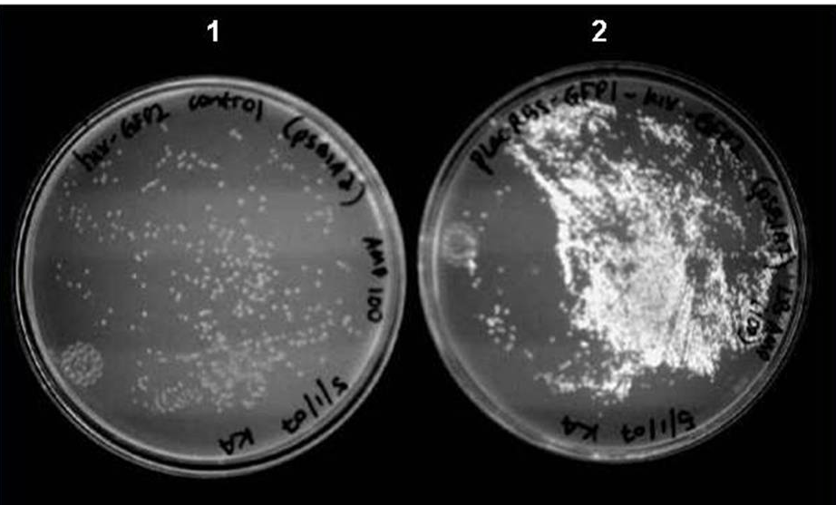

Figure 13. E.coli cells transformed with GFP construct fluoresce under UV light. Cells that do not possess the GFP construct (1) and cells possessing the GFP construct (2) were observed and photographed under trans UV light. These cells are plated on Amp 100µg/ml plates

TetA(C) constructs do not express functional TetA(C)

When cells transformed with either of the Tet constructs or one of the pLac-RBS-Tet intermediates were plated on Tet plates, only the positive control grew (Figure 14). I streaked the two final Tet constructs: Tet1-2/3 and Tet1/2-3, the Tet intermediates: pLac-RBS-Tet1-hix-Tet2, pLac-RBS-Tet1, and pLac-RBS-Tet1/2, a negative control: hix-GFP2, and a positive control Tet_{B}RBS. hixC-GFP2 served as the negative control because it does not have a Tet fragment of any kind, and thus cannot be Tet resistant. I borrowed cells with a Tet_{B}RBS part from Dr. Karmella Haynes to use as a positive control. Dr. Haynes had established that Tet_{B}RBS confers Tet-resistance.

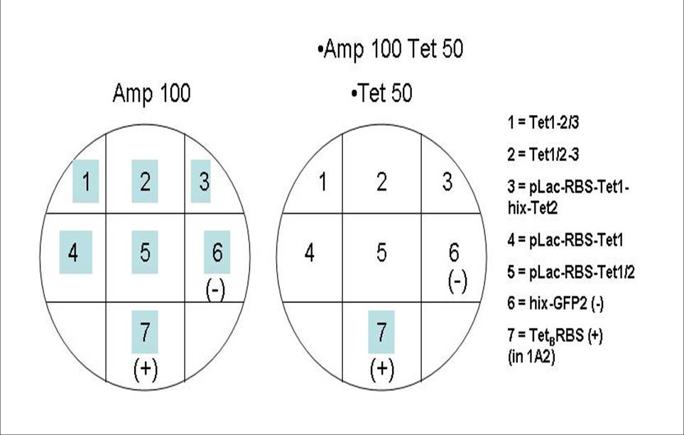
Figure 14. Tet1-2/3 and Tet1/2-3 constructs do not confer Tet resistance.
Final and intermediate Tet constructs were streaked on Tet 50µg/ml and Amp 100 Tet 50 (plate on right represents both Amp 100 Tet 50 and Tet 50) to test for Tet resistance. The Amp 100 plate served as a control. Neither the final constructs nor the intermediates confer Tet resistance. Shading represents cell growth. + is the positive control strain, - is the negative control strain.

Discussion
In this study, I built a GFP construct with an internal hixC site, and two Tet constructs, each with a different internal hixC site. GFP and TetA(C) have proven to be very different in their abilities to function normally when holding a foreign internal sequence. I discovered, from my project and previous studies, that GFP is quite versatile and accepts sequence insertions in many locations. Due to its β barrel structure and buried chromophore, there are many ideal locations to insert a sequence without interfering with GFP function . I picked a location in GFP, between amino acids 157 and 158, that has proven to accept foreign sequences, and successfully inserted a hixC site without altering GFP’s ability to fluoresce.
On the other hand, TetA(C) does not function properly with sequence insertions in either of the two locations I chose. I built two constructs, each with a hixC site in a different location, and neither expressed functional TetA(C) protein (Figure 14). After transforming E. coli cells with either of the Tet constructs, I observed that the majority of transformed cells formed colonies with a very different appearance from those transformed with non-Tet constructs. Not only were the Tet colonies smaller and flatter, they were very indistinct. These small colonies grew very close together and formed a lawn on the plate (Figure 12).
Since TetA(C) is know to adversely affect cell growth rate, viability, and susceptibility to antibiotics (Griffith et al., 1994), I hypothesized that the indistinct colonies, as opposed to the prominent colonies, had a Tet construct that expressed functional TetA(C) protein. Yet, my results revealed that both the prominent and indistinct colonies consisted of cells with a Tet construct (Figure 11). Only the prominent colonies gave me a uniform cell population because the indistinct colonies were so close together that I picked out multiple colonies when trying to pick only one. Thus, I saw multiple insertion bands in gel lanes with DNA from indistinct colonies (Figure 11 B).
The Tet resistance assay revealed that the Tet constructs I built do not express functional TetA(C) protein. Although the cells were adversely affected by the expressed product of the Tet constructs (Figure 12), this was not due to the presence of a functional TetA(C) protein. Even though they were not functional TetA(C), the expressed products of the Tet constructs may have maintained the unfavorable side effects of TetA(C) on cells.
Based on my results, I conclude that TetA(C) does not tolerate internal sequence insertions. However, since much of TetA(C) structure and function remains unclear, I cannot jump to that conclusion. I may have picked locations that play a key role in TetA(C) function. Thus, there may be other locations within TetA(C) that would more willingly accept a sequence insertion. It is also possible that the primarily polar hixC sequence interfered with the transmembrane domains adjacent to it. Transmembrane proteins in general may not tolerate sequence insertions. The lack of information regarding TetA(C) structure leaves room for many possible explanations of why the Tet constructs do not express functional TetA(C). Until more is understood about TetA(C) structure and function, further efforts to split TetA(C) and insert a sequence without affecting protein function may be futile.
Although split TetA(C) will not be of use in building larger pancake constructs, split GFP adds two DNA regions to the pancake pool. Split GFP will be useful as two DNA pancakes for two reasons: it fluoresces when each fragment is linked by a hixC site, and the individual GFP fragments (GFP1 and GFP2) do not fluoresce on their own. If the individual GFP fragments fluoresced when preceded by a promoter and ribosomal binding, there would be no way to differentiate between one GFP fragment and two joined GFP fragments, and the identification purpose of GFP would be null. Thus, split GFP can contribute to the building of larger pancake constructs. Since GFP has shown to tolerate insertions in many locations in previous studies, GFP may be split further to make three or four pancakes.

References

Abedi MR, Caponigro G, and Kamb A. Green fluorescent protein as a scaffold for intracellular presentation of peptides. Nucl. Acids Res. 26: 623-630 (1998).

Andersen JB, Sternberg C, Poulsen LK, Bjorn SP, Givskov M, and Molin S. New unstable variants of green fluorescent protein for studies of transient gene expression in bacteria. Appl. Environ. Microbiol. 64.6: 2240-6 (1998).

Cabantous S, Terwilliger TC, and Waldo GS. Protein tagging and detection with engineered self-assembling fragments of green fluorescent protein. Nature biotechnology. 23: 102-107 (2004).

Ghosh I, Hamilton AD, and Regan L. Antiparallel leucine zipper-directed protein reassembly: application to the green fluorescent protein. J. Am. Chem. Soc. 122: 5658-5659 (2000).

Griffith JK, Cuellar DH, Fordyce CA, Hutchings KG, and Mondragon AA. Structure and function of the class C tetracycline/H+ antiporter: three independent groups of phenotypes are conferred by TetA(C).

Hu CD and Kerppola TK. Simultaneous visualization of multiple protein interactions in living cells using multicolor fluorescence complementation analysis. Nature Biotechnology. 21: 539-545 (2003).

Knight T. Idempotent vector design for standard assembly of biobricks. n.d. <http://web.mit.edu/synbio/release/docs/biobricks.pdf. > Accessed January 2007.

Magliery TJ and Regan L. Reassembled GFP: detecting protein-protein interactions and protein expression patterns. Green Fluorescent Protein: Properties, Applications, and Protocols, 2nd ed. Eds. Martin Chalfie and Steven R. Kain. 2006.

Magliery TJ, Wilson CGM, Pan W, Mishler D, Ghosh I, Hamilton AD, and Regan L. Detecting protein-protein interactions with a green fluorescent protein fragment reassembly trap: scope and mechanism. J. Am. Chem. Soc. 127:146-157 (2005).

McNicholas P, Marion M, Guay GG, Rothstein DM. Genetic analysis suggests functional interactions between the N- and C-Terminal domains of the TetA(C) efflux pump encoded by pBR322. Journal of Bacteriology 117.18: 5355-5357 (1995).

Paramban RI, Bugos RC, and Su WW. Engineering green fluorescent protein as a dual functional tag. Biotechnology and Bioengineering. 86.6: 687-697 (2004).

Sapunaric FM and Levy SB. Second site suppressor mutations for the serine 202 to phenylalanince substitution within the interdomain loop of the tetracycline efflux protein Tet(C). Journal of Biological Chemistry 278.31:28588-28592 (2003).

Shyu YJ, Liu H, Deng X, Hu CD. Identification of new fluorescent protein fragments for bimolecular fluorescence complementation analysis under physiological conditions. BioTechniques. 40: 61-66 (2006).

Simpson, S. A bacterial computer to solve the pancake problem. Biology Dept. Davidson College (2006).

Zacharias DA and Tsien RY. Molecular biology and mutation of green fluorescent protein. Green Fluorescent Protein: Properties, Applications, and Protocols, 2nd ed. Eds. Martin Chalfie and Steven R. Kain (2006).

Appendices

Appendix A: PCR

100µl PCR reaction: 50µl 2X GoTaq Green Master mix
1µM (10µl of 10µM) Forward Primer
1µM Reverse Primer
1ng DNA template (GFP or TetA(C))
29 dH₂O

Temperature Cycle
(Half-GFP program in the PTC-100™ Programmable Thermal Controller):

Step 1: 95° C 5 minutes
Step 2: 95° C 1 minute
Step 3: 47.24° C 1 minute
Step 4: 72° C 30 seconds
Repeat steps 2-4 29X

Appendix B: Making Glycerol Stocks

- Heat sterile glycerol in microwave for 30 seconds
- Pipet 150 µl glycerol into a cryo tube and allow to cool.
- Pipet 850 µl of a 2 mL overnight liquid culture into cryo tube.
- Shake tube very hard.
- Place tube in -80ºC freezer.

Appendix C: Zyppy Miniprep – modified Zyppy protocol by Dr. Haynes

- Pellet 1.5 mL of a 2 mL overnight liquid culture (max. speed, 3 min.)
- Discard 900 µl of the supernatant (leave 600 µl in the tube with the pellet.
- Resuspend the pellet in the remaining 600 µl supernatant by pipetting up and down.
- Add 100 µl of 7x Lysis Buffer (Blue). Mix by inverting the 6 times.
- Add 350 µl of cold Neutralization Buffer (Yellow). Mix thoroughly.
- Centrifuge at 11,000 – 16,000 x g for 4 minutes.
- Pour the supernatant into the Zymo-Spin II column.
- Place the column into a Collection tube and centrifuge for 15 seconds. Discard the flow-through and place the column back into the same Collection tube.
- Add 200 µl of Endo-Wash Buffer to the column. Centrifuge for 15 seconds.
- Add 400 µl of Zyppy Wash Buffer to the column. Centrifuge for 30 seconds.
- Transfer the column into a clean 1.5 mL microcentrifuge tube than add 50 µl of Zyppy Elution Buffer directly to the column matrix and let stand for two minutes at room temperature. Centrifuge for 15 seconds to elute the DNA.

