Design and testing of one-time Flippable Hix Sites for use in Biological Computers
Bruce Henschen
Biology Department, Davidson College, Davidson, NC 28035
BIO 372, Spring 2007

Abstract

Davidson College is currently working on biological applications of the Pancake Problem, in which Salmonella Hin recombinase is used to flip DNA ‘pancakes’ that are flanked by symmetrical 26 bp Hix sites in the DNA. I propose multiple mechanisms for mutating these Hix sites to engineer pancakes that can only be flipped once by Hin, enabling better control over the Hin flipping mechanism. These mutations included insertions, deletions, and point mutations in the Hix site. In addition, a restriction enzyme and phenotype-based screen was proposed to test the functionality of the Hix mutants. All mutants were cloned into vectors and assembled as Hix mutant:Hix wt paired constructs to test functionality independent of other mutant. Data from wt constructs was compared with data from a pilot Hix mutant construct and showed that restriction enzymes provide a more reliable, although imperfect, screen for flipping activity. Data also revealed that an insertion mutation caused Hin to alter the properties of the Hix plasmid, causing damage to the plasmid and altered function. Further study should analyze the effect of point mutations on Hix site functionality and should develop a more reliable screen for determining the orientation of a segment of DNA between Hix sites.

Introduction

At the iGEM Synthetic Biology conference in 2006, Davidson College presented work on using E. coli to solve mathematical problems by using a system of DNA flipping mechanisms (Campbell et al., 2007). According to the mathematical problem, called the burnt pancake problem, one must determine the least number of pancake flips it takes to have randomly-arranged pancakes oriented in the right order and direction. In E. coli, genes and promoters in random combinations were used as DNA pancakes; the bacteria were able to flip the DNA elements using a combination of the Salmonella Hin recombinase protein and the HixC sites in DNA that Hin recognizes.
The Hin recombinase system in Salmonella sp. allows the bacterium to undergo flagellar phase variation, or changes in flagellum surface protein types to evade a host’s immune system (Adams et al., 1997; Glasgow, et al., 1989; Sanders and Johnson, 2004). In vivo, Hin recombinase flips a promoter flanked by 26 bp symmetrical DNA sites called Hix sites, changing which antigen is produced by the cell at any given time. The two Hix sites on either side of the promoter vary slightly from one another and are labeled HixL and HixR. Symmetric HixC sites have been synthesized that work in the same fashion as the other binding sites (Lim, 1992). Outside its normal function, Hin recombinase can be used to flip any DNA sequence that is flanked by HixC sites and complexed with a Recombinational Enhancer DNA site (RE) and the Fis and HU proteins.
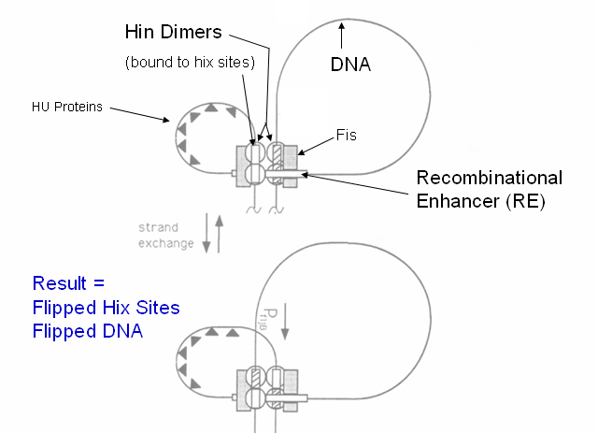
The Hin protein consists of a homodimer in which each monomer binds to one half of the roughly symmetrical Hix site. In vivo, these dimers complex with the Fis and HU proteins to form homotetramers (diagrammed in Figure 1), which induces a conformational change in all four Hin proteins to expose DNA-cleaving regions. Cleavage of each DNA strand occurs via a two-bp overlap cut in the middle of each Hix site, followed by rotation of two of the Hin proteins in the tetramer bound to DNA segments, which results in DNA strand exchange (Dhar et al., 2004). The process is complete when the two new strands are ligated together and the complex, or the invertasome, decomposes (Heichman et al., 1991). In both E. coli and S. typhimurium, DNA flipping has been observed (Dr. Haynes, unpublished), showing that E. coli possess the required protein elements for flipping when supplied with two HixC sites and RE. It is unknown how many times Hin inverts the two segments of DNA before the DNA segments are ligated together, so the same two sequences may be flipped again after the reaction is complete. The main goal of my research is to determine whether the activity of Hin can be better controlled using mutated Hix sites. If Hix sites can be designed such that Hin can flip a region of DNA only once, these sites would help us regulate the number of DNA flips that can occur in a construct. Limiting the number of DNA flips available to E. coli allows us to regulate the problem more precisely, requiring E. coli to solve the pancake problem in a limited number of steps.
Figure 1. Hin/Hix mechanism, adapted from Hughes, et al., 1992.
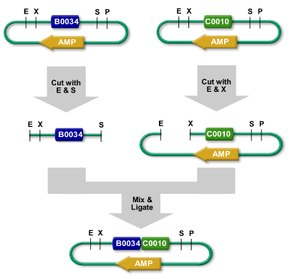
The Biobrick system of assembling sequential DNA elements, developed by Dr. Tom Knight at MIT (Knight, 2001), is a useful aid in determining whether the activity of mutated Hix sites when exposed to Hin recombinase. This system of constructing a series of connected DNA sequences revolves around using a set of restriction enzyme sites that flank insert sequences. Two sites flank each side of a desired “Biobrick” part – EcoRI and XbaI on the left, and SpeI and PstI on the right. Because XbaI and SpeI share conserved sequences in their cut sites, ligation of one part with an Xba sticky end and another part with a SpeI sticky end result in a 6 bp “mixed” site that cannot be cut with any restriction enzyme. Therefore, parts can be constructed, ligated together, and cut out completely with specific combination of restriction enzyme digestions. Figure 2 shows a typical process for ligating two Biobrick parts together. Using Biobricks, I can build a construct of DNA elements that can allow me to determine how many times Hin can flip a sequence of DNA in between two mutated Hix sites.
Figure 2. Procedures for BioBrick Standard Assembly.

Materials and Methods
(some adapted from Simpson, unpublished)

Bacteria used:
To begin, I used E. coli JM109 cells grown in previous semesters from the Davidson College Freezer Stocks. After growing stocks of previously transformed E. coli, I used pSB1A2 plasmids in these cells to make my Biobrick constructs. When transforming ligated parts, I used either Promega JM109 competent cells (Part # 44-0301) or Zymogen JM109 Z-competent cells (Catalog # T3003) for ligated plasmids. After following the protocols included with each cell type, cells were plated on LB plates with Ampicillin (100 µg/mL) and grown at 37 °C for 10-16 hours.

To isolate plasmid DNA from grown cells, I picked colonies using sterile toothpicks, dropped them into LB Amp⁺ (100 µg/mL) broth, and grew the clonal populations for 10-16 hours. After growing the cultures, I followed the protocols included in two types of kits: Promega Wizard SV Minipreps Kit (Promega part # A1460), and Zymogen Zyppy Plasmid Miniprep kit (Zymogen part # D4036, D4019, and D4020), to isolate plasmid DNA.

Validation of part identity:
To determine whether ligations were successful, I used agarose gel electrophoresis to compare the size of the Biobrick part with the known length of the part. Gels were poured using “How to Pour an Agarose Gel,” written by Dr. A. Malcolm Campbell, and found here: http://www.bio.davidson.edu/courses/Molbio/Protocols/pourgel.html. Once gels were poured using Promega Agarose (Promega part # V3121), digested samples were loaded next to the Invitrogen 1 kb ladder (catalog no. 15615-016; ladder information found at http://www.bio.davidson.edu/courses/Molbio/Protocols/gels2002/1kbladder.pdf) to quantify the size of the part.

Restriction Digestions:
DNA was digested using “How to Digest DNA with Restriction Enzymes,” written by Dr. A. Malcolm Campbell and found here: http://www.bio.davidson.edu/courses/Molbio/Protocols/digestion.html. The following restriction enzymes were used to digest DNA: EcoRI; XbaI; SpeI; PstI; PvuII, all ordered from Promega. Double digestion protocols were found here: http://parts.mit.edu/wiki/index.php/Double_Digest_Guide.

DNA Purification:

After running DNA on an agarose gel, the DNA must be removed from the gel before being ligated into another part. To perform DNA purification, I used Qiagen QIAQuick Gel Extraction Kit (catalog #28704). I stored collection tubes for future use according to a protocol developed by Dr. Haynes.

DNA Quantification:
To determine the amount of DNA in a sample, I used a NanoDrop Optical Density Reader.

Ligations:
To ligate parts together, I used “How to Ligate DNA,” written by Dr. A. Malcolm Campbell, and found here: http://www.bio.davidson.edu/courses/Molbio/Protocols/ligation.html.

Annealing of ssDNA Oligonucleotides:
Annealing of single-stranded oligos was performed according to “Building dsDNA with Oligos,” a protocol written by Dr. A. Malcolm Campbell and found here:
http://www.bio.davidson.edu/courses/Molbio/Protocols/anneal_oligos.html.

FACS Analysis of Flourescence:
To measure the amount of GFP fluorescence in a particular culture, I grew cultures in 2mL LB Amp⁺ (100 µg/mL) broth for 10-16 hours prior to the analysis, and placed them in the refrigerator after this time. Serial dilutions (10,000 and 100,000-fold) were made of each sample to be analyzed. Samples were analyzed using Dr. Sarafova’s FACS machine and Cytosoft software (Cytosoft Data Acquisition and Analysis Software, version 5.0.1). A complete protocol for FACS analysis can be found in Appendix D. Supervision by Dr. Sarafova is highly recommended when using the FACS.

Making Freezer Stocks:
After construct intermediates and full constructs were ligated together and verified, cells were grown in 2mL cultures with Ampicillin (100 µg/mL) overnight, then transferred into 15% warm glycerol (850 µL cells/150 µL glycerol) and placed in -80° C. A record of freezer stocks, stored plates, and minipreps is listed in Appendix A.

Results
Design of oligonucleotides for Hix mutant sites

There are two aspects of the Hin/Hix structure that could be altered – the Hin protein and the HixC site. I decided to focus the study on manipulation of the HixC site (Figure 3), since modifying an enzyme is more difficult than a DNA sequence. (for additional information about how Hin-Hix interactions play a role in the study, view http://www.bio.davidson.edu/courses/genomics/2006/henschen/hin.html). From the data in Feng et al. (1994) and Hughes et al. (1992), it appears that nucleotides at base-pair positions +/- 1, 2, 4-6, and 9-13 are involved in DNA binding or cutting (Figure 3). Altering these base pairs could affect Hin binding to the Hix site before recombination
5’ 3’
-12 -10 -9 -6 -5 -4 -2 -1 1 2 4 5 6 9 10 12
T T A T C A A A A A C C A T G G T T T T T G A T A A
A A T A G T T T T T G G T A C C A A A A A C T A T T
3’ 5’

Figure 3. wt HixC site sequence. Bases are numbered according to their distance from the middle of the symmetrical DNA site, where Hin cuts the DNA. DNA cutting is shown by the red line. Blue arrows indicate proposed places to mutate the Hix site, while brackets at the top indicate areas of DNA binding.

and therefore are not good targets for altering. Although some of these bp’s, such as +/- 3 and +/- 4, seem to be conserved in multiple species (Feng, 1994), they have not been shown to be involved in Hin binding and do not have a known function. From the data, I decided that the best places in the HixC site to modify were the bases between the cleavage site and the first DNA-binding site (between bases 2 and 4), base 7, and base 12 of the HixC site, where the DNA either does not play a role in Hin binding or has been shown to have altered Hin activity when altered (Hughes et al., 1992).
Two manipulations to the DNA might result in one-time flippable Hix sites (Figure 4). First, bases could be inserted in one Hix half-site and deleted in the other paired Hix half-site (Figure 4). Upon recombination, the inserted and deleted half-sites would combine with each other, resulting in a Hix site that had a cutting region 36º altered from the Hin binding domain (Lim et al., 1992). Hin is a flexible protein and could theoretically bind to a site with one insertion or deletion (Glasgow et al., 1989), but when recombined, it would not be able to cut rotated DNA in the proper location, resulting in one non-functional Hix site and one fully-functional HixC site.
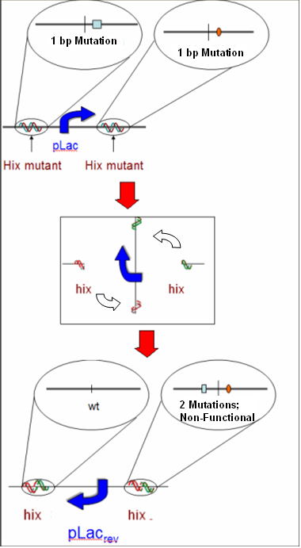
Other studies have examined the activity of Hin when certain base pairs in HixC are altered (Hughes et al., 1992). In particular, mutations in bases 3, 7, and 11 reduced, but did not eliminate, Hin flipping activity. If one Hix half-site with one mutation is paired with a Hix site with another, unique mutation, recombination of the two sites would create one wt HixC site and one Hix site with two mutations in it (Figure 4). While both mutants cause low Hin flipping activity independently, a double mutant could produce very little or no Hix recombination. In addition, sites could be designed with symmetrical mutations in each, such that when recombined, each Hix site would contain two different mutations and would be nonfunctional.
Figure 4. Method of using mutations to create one wt hix site and one mutated site upon recombination by Hin.
I used both insertion and deletion mutations, as well as point mutations, when designing Hix sites for use in the experiment. The full sequences of the Hix site designs are in Appendix B. I first designed a set of oligonucleotides with truncated biobrick ends, to protect against the possibility of mutation during oligo synthesis. However, efforts to clone these into vectors were unsuccessful (see below), so new oligos were designed with full biobrick ends as replacements. The next step, after these sites were designed, was to determine how to test whether Hin was able to flip a segment of DNA once, more than once, or not at all. The first assay developed is diagrammed and described in Figure 5. To build these parts, I used the ligation plan in Figure 6.

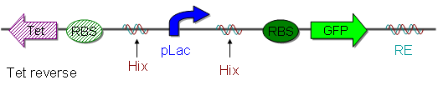

Condition | pLac Orientation | Phenotypic Effect
No Flipping | 100% Forward | Green Cells under UV light,  No survival on Tetracycline-coated plates
Flipping only once | 100% Backward | No Green Flourescence,  Survival on Tetracycline-coated plates
Flipping Multiple times  (wt) | 50% Forward,  50% Backward | Green Cells under UV light,  No survival on Tetracycline-coated plates
Figure 5. Diagram of the Hix functionality assay and Table explaining theoretical expected phenotypes for each possibility of Hix functionality

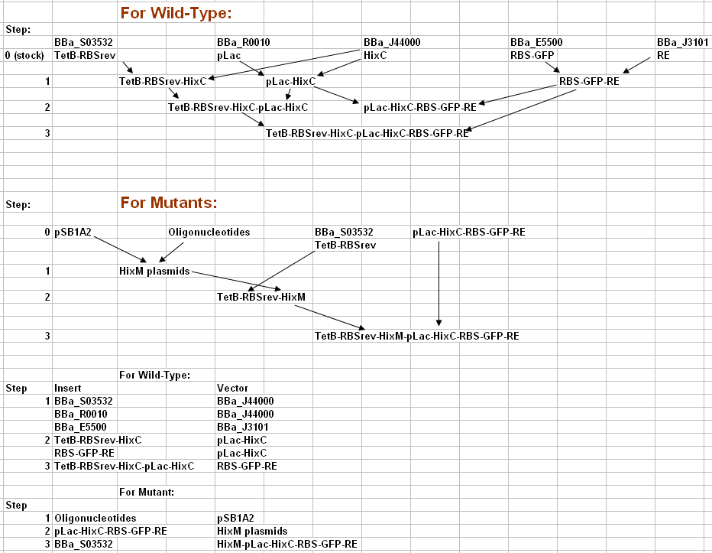
Figure 6. Proposed ligation plan for all parts created. Each part (mutants and wild-type) can be created in three ligation steps using intermediates from previous steps.
Building of Constructs and Intermediates

Building the constructs used to test Hix site functionality requires construction intermediates. First, I ligated together TetB-RBSrev (BBa_S03532) and HixC (Bba_J44000), pLac (BBa_R0010) and HixC, and RBS-GFP (BBa_E5500) and RE (BBa_J3101). Each of these ligations was run in duplicate in order to increase the chances that colonies with successful ligations would grow. Figure 7a shows that although the first two ligations were successful, the ligation of RBS-GFP into RE did not work for any of the clones tested. Additional colonies miniprepped from the ligation plate showed unsuccessful ligations when digested with EcoRI and PstI as well. However, Figure 7b shows that colonies from the duplicate, parallel ligation contain the correct part and had ligated the two pieces successfully.
a
a
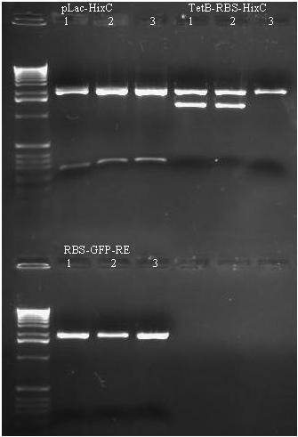
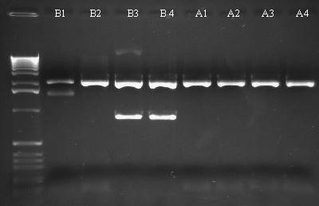
Figure 7a. Construction of intermediates. Positive ligations are seen in pLac-HixC 1-3 and TetB-RBS-HixC 1-2.
Figure 7b. Construction of intermediates. Positive ligation seen in lanes B3 and B4 for RBS-GFP-RE.
b
The next round of ligations included ligation of TetB-RBSrev-HixC into pLac-HixC to make a second intermediate, TetB-RBSrev-HixC-pLac-HixC (confirmation gel shown in Figure 8a). A final intermediate was made – pLac-HixC-RBS-GFP-RE, confirmation gel on Figure 8b.

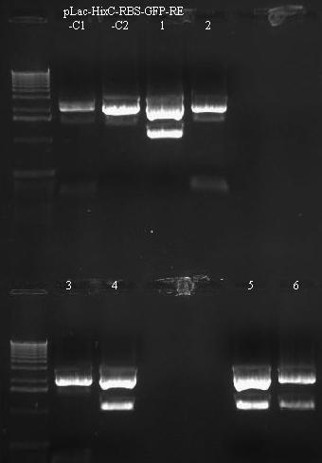
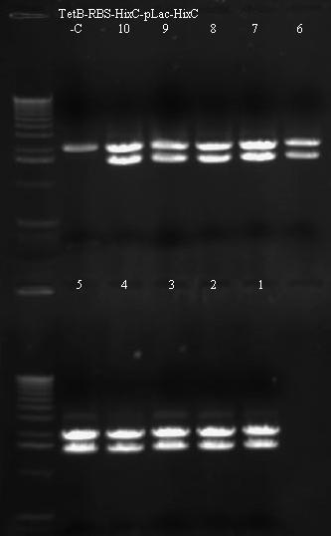

Figure 8a. 0.7% agarose gel, run for 35 min @ 150 V, to verify TetB-RBS-HixC-pLac-HixC ligation. All lanes show successful ligation; plasmid from lane 7 was preserved.

Figure 8b. 0.8% gel, run at 120 V for 35 min. Confirmed ligations of pLac-HixC-RBS-GFP-RE reside in lanes 1, 4-6; plasmid used in lane 1 was preserved.

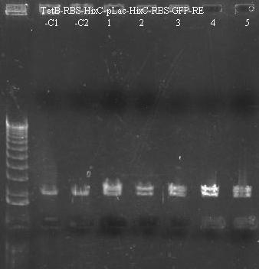
After completing the assembly of intermediates, I was able to complete the full wt construct – TetB-RBS-HixC-pLac-HixC-RBS-GFP-RE (Figure 9). While completing the ligation of the wt construct, I attempted to clone the received oligonucleotides into vectors. I chose the oligo Hix1 (i+4TL), which has a “T” insertion at base pair +4, to be a pilot for development of a protocol for all mutant oligos. My first set of oligonucleotides were designed with XbaI/SpeI sticky ends to save cost and reduce mutation risk, but these would not successfully clone into the vector pSB1A7. I originally had wanted to use this different vector since it included Transcriptional Terminators beyond the Biobrick ends that prevented read-through transcription. However, cloning Hix1 into pSB1A7 was not accomplished for two possible reasons. First, cutting plasmid with XbaI and SpeI produces complementary sticky ends; these ends of the plasmid are located near each other relative to oligonucleotides floating in solution around them, so plasmid cut with these two restriction enzymes has a greater chance of ligating back together without the oligo insert without incorporating a Hix. Second, the TT sites in pSB1A7 are inverted repeats, which makes it extremely difficult to ligate another inverted repeat sequence of HixM (mutant) or HixC into the plasmid due to DNA geometry and the tendancy of complementary DNA to fold in on itself. To solve the problems, I redesigned the oligonucleotides to include full Biobrick ends (with EcoRI and PstI sticky ends) and ligated them into pSB1A2, the vector that the wild-type part was constructed with. After ligation of this part was complete, I performed the same procedure on Hix2-7. Ligation of Hix1 into this plasmid is shown in Figure 10a, while ligation of Hix2-7 into this plasmid is shown in Figures 10b, 10c, and 10d.
Figure 9. 0.4% gel, run at 150 V for 35 min. Confirmed ligations of TetB-RBS-HixC-pLac-HixC-RBS-GFP-RE reside in lanes 1-5; plasmid used in lane 1 was preserved.

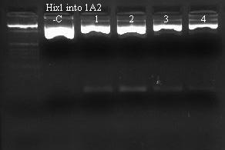
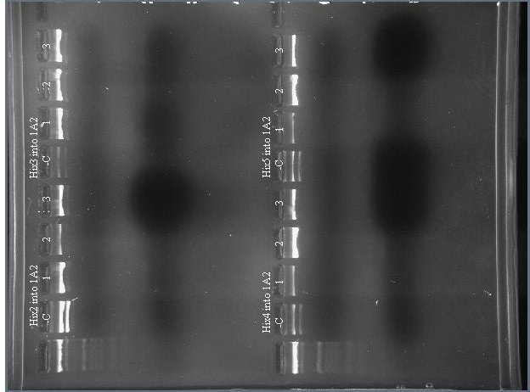
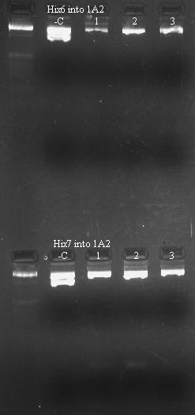
b
c

a
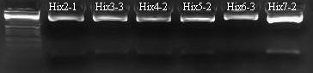
d
Figure 10a-d. 2.5% gels of E and P digestions to confirm HixM plasmid cloning into 1A2. Positive ligations include:
Fig. 10a – Hix1 1-4
Fig. 10b – Hix2-1, Hix3-2 and 3,
Hix4-2, and Hix5-2
Fig. 10c – Hix6-2 and 3, Hix7-1 and 2.
Fig. 10d = confirmation of results from gels b and c.
Plasmid DNA preserved from Hix7-2 and from lanes on 12d.

c

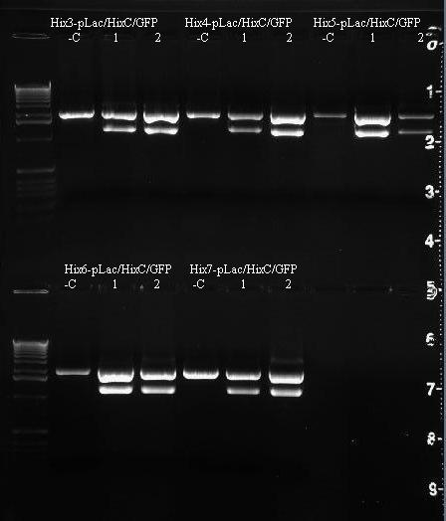
According to the ligation plan, these cloned HixM vectors can ligate with intermediates created in previous steps to create HixM:HixC constructs in two additional steps – ligation with TetB-RBS, followed by ligation with pLac-HixC-RBS-GFP-RE. These HixM-HixC pairs will be tested using phenotype and restriction enzyme analysis before testing HixM-HixM pairs to determine Hin flipping ability on isolated Hix mutants. Confirmed ligations for Hix mutants into pLac-HixC-RBS-GFP-RE are shown in Figure 11.
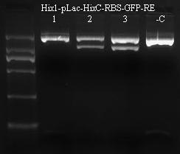
b
a
Figure 11a-b. 1% gels of E and P digestions of HixM-pLac-HixC-RBS-GFP-RE. Confirmed ligations reside in all experimental lanes except Hix1-1. Plasmid preserved from lanes:
Hix1: 3
Hix3-7: 2 for all 5 versions.
b
a

In the previous step, Hix2 plasmid was lost and was not used in the final ligation step, but the part was ligated with TetB-RBS in the next step along with the other Hix mutants. Figure 12 shows the completed ligations of Hix1 and Hix3-7, as well as the confirmation of TetB-RBS-Hix2. These parts were stored, freezer stocks were made, and full constructs with Hix2-7 paired with HixC will be used in further analysis. The Hix1:HixC full construct was used in phenotype and restriction enzyme analysis by comparing data to the HixC:HixC wild-type construct.
a
b
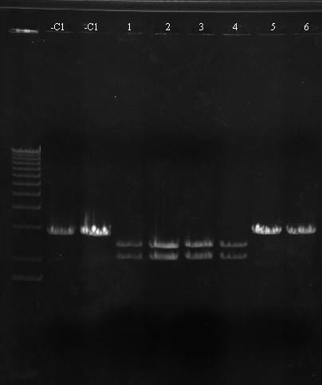
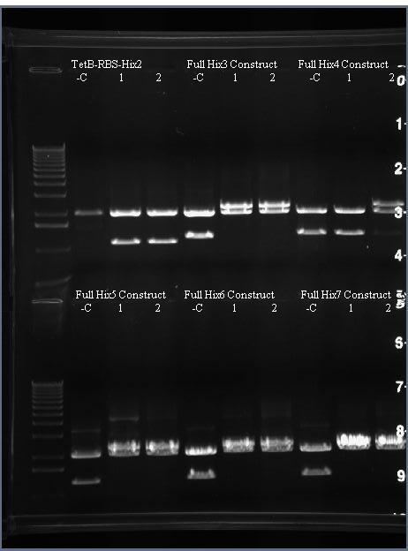
a
b

Figure 12a-b. 0.5% gels confirming plasmid identity:
Hix1 full construct: Gel a 1-4
TetB-RBS-Hix2: Gel b 1-2
Full Hix3-7: exp. Lanes in Gel b
Plasmid preserved from arrowed lanes

Results from Phenotype Analysis

The assay in Figure 5 shows that, theoretically, pLac should transcribe either tetracycline resistance or GFP, depending on which way the promoter is pointing. Because the promoter begins in the direction of GFP, cells that do not have flipping-capable plasmids would not survive on tetracycline coated plates. If the Hix sites allow only one DNA flipping event, pLac in all plasmids in a cell would point toward TetA(c), enabling the cells to survive on Tet-coated plates but without green flourescence. However, if the promoter could be flipped multiple times, then approximately half of the promoters would be pointing toward TetA(c) and half toward GFP at any given time, causing cells to fluoresce green on Tet plates.
During the course of the study, other research showed that pLac not only promotes genes in the forward direction but also has a slight non-inducible backwards-promoting capacity, causing TetB to be produced when pLac is pointing toward GFP (Dr. Karmella Haynes, personal communication). Since tetracycline resistance is conferred through transcription and translation of a small amount of the TetA(c) gene, any transcription of TetA(c) from the backward-promoting activity of pLac means that all cells are tetracycline resistant. One option would be to use a different promoter, such as pBad, used previously in experiments at Davidson College. However, construction of parts had already begun, and pBad is a weaker promoter than pLac, so I chose to include pLac in the final design. Therefore, GFP expression, quantified using FACS analysis, could be used to determine pLac orientation. The predicted effects of flipping on GFP expression are tabulated in Figure 13. TetA(c) is toxic in high concentrations; it is possible that cells that have pLac reversed produce too much Tetracycline resistance and die as a result, providing another screen for testing the direction of pLac.
Condition | pLac Orientation | Effect
No Flipping | 100% Forward | 100% expression of GFP
Flipping only once | 100% Backward | Minimal Green Flourescence  Possible death due to overproduction of TetA(c)
Flipping Multiple times  (wt) | 50% Forward  50% Backward | Reduced expression of GFP
Flipping Multiple times  (wt) | 50% Forward  50% Backward | Possible death due to overproduction of TetA(c)
Figure 13. Table for determining pLac orientation based on FACS and cell survival.

I used Flourescence-Activated Cell Sorting (FACS) to determine GFP levels in each construct. In preparation for analysis, I cotransformed the HixC:HixC plasmid with the Hin expression cassette (obtained from Dr. Haynes) and plated the cotransformed cells on Amp⁺ Kan⁺ plates to determine whether it was possible to observe flipping in the wild-type. Once these cells were grown and the cotransformation was confirmed to be successful by comparing it with control Amp/Kan plates without the addition of Hin, I grew overnight cultures of the cotransformed cells in LB Amp⁺ medium with IPTG, which induces the pLac promoter and therefore induces expression of the gene that pLac is pointing toward in the BioBrick construct and the Hin protein. To look for flipping, I attempted to compare GFP expression using FACS (Figure 14). These data come from multiple attempts at using the FACS. In each attempt at using FACS data, GFP expression in wt constructs Hin +/- and IPTG +/- was widely variable – sometimes GFP expression was synchronized and sometimes it was not in the same cell type, and different relative levels of expression were seen in different trials. FACS data can only be compared in terms of relative expression levels in a single trial; however, Figures 14c and 14d show a clear decrease in GFP expression as a result of IPTG addition, while addition of IPTG from Figure 14e to 14f shows a dramatic decrease in expression. In the presence of Hin, IPTG appears to increase GFP expression, but without Hin the additino of IPTG can cause GFP expression to decrease. Because IPTG is a synthetic version of lactose and therefore blocks the Lac repressor from binding to pLac, IPTG should cause an increase in expression of GFP, but the data in Figures 14c and 14d show a decrease, possibly due to overexpression of either GFP or TetA(c) that is toxic. The data seen, however, is widely variable and does not show any clear trends.

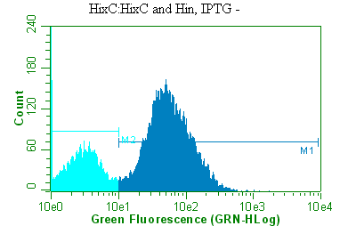
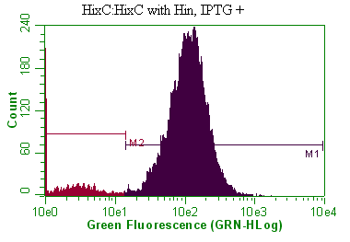
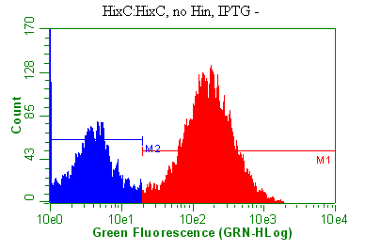
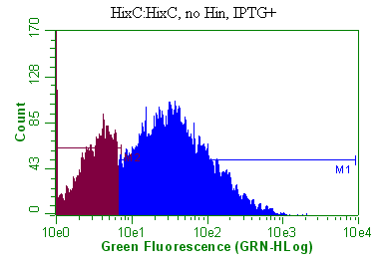
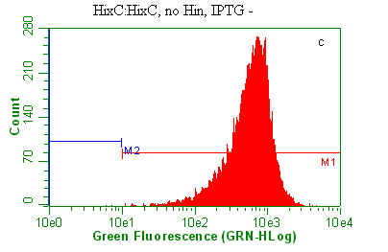
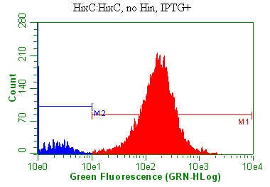
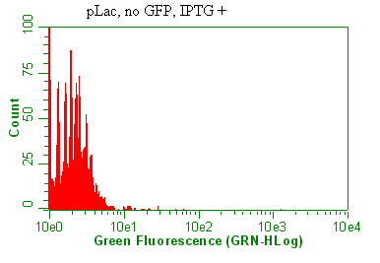
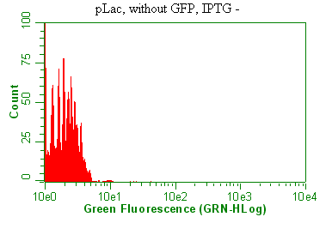
g
h
e
f
c
d
b
a

Figure 14. FACS Data gathered on multiple days. Graphs display number of cells counted at variable levels of GFP Fluorescence. Graphs collected on the following days:
A-D: Gathered on 4/4/07
E-H: Gathered on 4/22/07 (controls appear very similar to A and B)

Results of Restriction Digest Analysis:

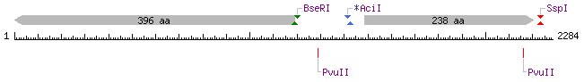
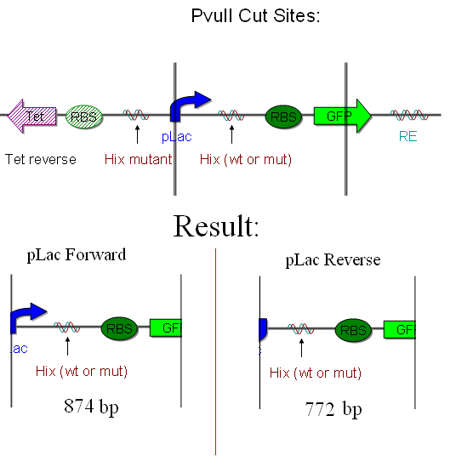
In addition to using phenotypic data to determine pLac orientation, a DNA-based method of determining flips that involved using restriction enzymes was designed with the aid of Dr. Haynes. In this method, I cotransformed the Hin and Hix plasmids into cells cells using Amp⁺ Kan⁺ plates to select for cells that had incorporated both types of plasmids. Colonies were grown in overnight cultures containing Amp, Kan, and IPTG to induce Hin expression and flipping, if possible. Third, I mini-prepped the overnight cultures to isolate all of the plasmid DNA present in the sample, which would consist of unflipped plasmids, possibly flipped plasmids, and plasmids containing only Hin. Samples from the miniprep were transformed into new cells onto Amp⁺; since Amp plasmids are more numerous than Kan plasmids, because only Amp selection was in place, and because cells normally only incorporate one plasmid each, it was assumed that surviving cells contained a BioBrick plasmid but not a Hin plasmid, thereby “freezing” the pLac promoter in one orientation while multiplying that particular plasmid in a colony. These colonies were mini-prepped and digested using PvuII, a restriction enzyme that cuts according to the map in Figure 15. Because PvuII produces fragments of different sizes based on the orientation of pLac, agarose gel electrophoresis could be used to separate these two possible bands that can be produced. As two additional pieces of evidence to back up the restriction digest, I struck the colonies analyzed on the gel and looked at the cells under UV light to determine whether they expressed GFP, and I ran an EcoRI/PstI digestion of the colony’s plasmid to determine whether the original biobrick construct was still intact after Hin flipping. Using the DNA-based and fluorescence-based methods of analysis, I compared a control HixC:HixC pair with a Hix mutant:HixC pair to determine whether Hix mutants function when paired with paired wt sites.
Figure 15. Restriction digsst map from NEBcutter (http://tools.neb.com/NEBcutter2/index.php), as well as a graphical interpretation of the effects of cutting with PvuII.
I performed a separate cotransformation of Hix1 and HixC with the Hin expression cassette to gather fresh cells separate from the ones analyzed using FACS, since cotransformed cells have shorter viability than transformed cells (Dr. Haynes, personal communication). Colonies from the cotransformations were compared to negative controls, verified, and then isolated for induction of Hin, followed by miniprepping. Through mini-prepping, I acquired aliquots of plasmid DNA from the cotransformation cells that had been exposed to Hin. I transformed these aliquots into E. coli using the same amount of plasmid in each transformation. Almost no colonies grew on the Hix1 plate, while the HixC plate appeared to have too many colonies to count.
Colony | Glowing under UV Light
HixC G-1 | -
HixC G-2 | -
HixC G-3 | -
HixC G+1 | +
HixC G+2 | +
HixC G+3 | +
HixM G+1 | -
HixM G+2 | -
HixM G+3 | -
HixM G-1 | -
HixM G-2 | -
HixM G-3 | -

Figure 16. Colonies glowing under UV light.
Using a UV light, I picked colonies that appeared to glow green and colonies that appeared to not glow from the Hix1 and HixC plates. Green flourescence is indicative of GFP expression, which is a signal that the pLac promoter was not flipped (or flipped 180°). To verify that the colonies picked were +/- GFP, I struck the colonies to allow further growth and analyzed them under UV light (Figure 16). A picture of the plate is available in Appendix C.
I digested plasmid from the second transformation of Hix1 into HixC on Amp⁺, Kan⁻ plates using PvuII, along with PvuII digestion of the Hin expression cassette, and the Hix1 and HixC constructs without Hin exposure, as controls (Gel ran from digestion shown in Figure 17). In addition, I digested the 12 plasmid samples with EcoRI and PstI and ran an agarose gel to compare sizes (Figure 18).
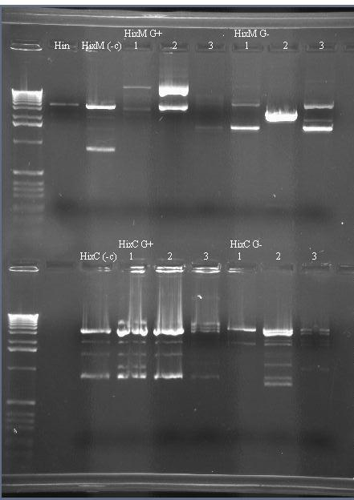
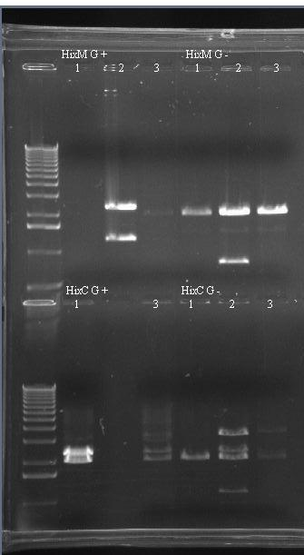

Figure 17. 1% agarose gel, ran at 120 V for 40 min, of PvuII digestions described above.
Hin = sample ran without BioBrick constructs
HixM and HixC (-c) = samples without Hin
Figure 18. 0.8% agarose gel, ran at 80 V for 1 hour, of EcoRI and PstI digestions described above. No DNA available for HixC G+ 2 sample.

Finally, overnight cultures from these samples were made after the digestions were run. Toothpicks from these cultures were used to streak Amp+, Amp+ Kan+, and Amp+ Tet+ plates. Growth on Amp Kan is indicative of the presence of the Hin plasmid, while growth on Amp Tet is indicative of an intact BioBrick site, since TetA(c) is transcribed. Growth on these plates was monitored and recorded in Figure 19.

Colony | Growth on Amp | Growth on Amp/Kan | Growth on Amp/Tet
HixC G-1 | + | - | +
HixC G-2 | + | + | +
HixC G-3 | + | - | +
HixC G+1 | + | - | +
HixC G+2 | + | - | +
HixC G+3 | + | - | +
HixM G+1 | + | - | +, but less
HixM G+2 | + | - | -
HixM G+3 | + | - | -
HixM G-1 | + | - | -
HixM G-2 | + | - | -
HixM G-3 | + | - | -

Figure 19. Colony growth on multiple types of plates.

Discussion
Discussion of Experimental Design

While developing the assay to determine the effectiveness of each HixM:HixM pair, I determined that neither the DNA nor the fluorescence-based methods of screening can differentiate between plasmids that flip multiple times and plasmids that have weak Hin activity and flip at such a slow rate that only 50% of the plasmids flip. Some Hix sites could have weak functionality, such that half of the promoters flip once while the others do not flip at all. This result would show the same phenotype and the same gel bands as cells that were allowed to flip readily. Methods must be determined to differentiate between constructs with weak activity vs. constructs with full DNA flipping capability. Despite this initial uncertainty, I was able to gather data using phenotypic analysis and DNA-based analysis.

Discussion of FACS Data

These data confirm that pLac is a highly leaky promoter, producing variable levels of transcription with equal amounts of input. Because these results only observed data for HixC:HixC constructs, Hin should be able to functionally flip the pLac promoter. Theoretically, pLac flipping would cause a relative decrease in GFP production, since half of the plasmids would be pointing away from GFP, but Figures 14 g and h show that GFP expression increases relative to IPTG⁻ samples (that should not exhibit flipping because of repression of pLac by LacI). Although absolute data between different FACS runs cannot be compared, the data in Figure 14 show that GFP production moderately decreased as a result of IPTG addition on 4/4/07, but on 4/18/07 the expression level decreased a lot more. Although these data are interesting and confirm that pLac is a leaky promoter with highly variable transcription levels, results from the FACS analysis show that it is difficult to determine the orientations of the BioBrick plasmids in a cell from the amount of GFP expression in the cells. Because I was trying to analyze the relative levels of GFP in a cell, this extreme amount of variability made it difficult to determine whether flipping had actually occurred in the cells analyzed. Overall, the FACS data showed that phenotypes may not be the best way to examine flipping events, since phenotypes can vary immensely from cell to cell.
Gathering data using flow cytometry was also suspended due to lack of time in the semester; these data might be revisited at some point to draw more conclusions from them. It may be possible that, with more data and replication of the methods above, some conclusions can be made about pLac orientation from GFP expression levels. However, the theoretical “leakiness” of pLac makes me wary of using phenotypes at all to determine pLac orientation. Instead, a DNA-based method using restriction enzymes might provide more reliable information about pLac orientation. Because an assay to determine pLac direction must be highly sensitive, further study should not rely solely on FACS data to observe flipping.

Discussion of Restriction Enzyme-based Data

The gel from the PvuII digestion, shown in Figure 17, shows some interesting characteristics about the Hix1:HixC and HixC:HixC plasmids post-exposure to Hin. HixC G⁺ 1-3 include prominent bands close to the 1018 marker, bands that are above the lower band in HixC G⁻2. I conclude, therefore, that HixC G⁺ 1-3 have a prominent band at 874 and therefore have plasmids with pLac pointing right, supported with data from Figure 16 that shows that these colonies glow under UV. Lane G⁻2, therefore, contains a band at 874 and a band slightly lower, at approximately 772. This lane implies that the colony has plasmids with pLac pointing both ways. Although the cells are supposed to be “frozen” due to retransformation, this lane appears to signal that they are not frozen in place! In addition, the Hin digestion bands are approximately in the same places as other bands in the HixC lanes, further implying that Hin was incorporated into the Amp+, Kan- colonies and flipping occurred when it should not have. From this gel, I first conclude that this method of determining flipping does not fully “freeze” the pLac promoter in one location. Furthermore, comparison of this lane with that colony’s data in Figure 19 shows that, even after multiple rounds of growth without selection for Kanamycin, these cells still retained the Kanamycin plasmid that includes Hin. Hin is present in these cells, causing flipping after the cells were predicted to drop the Kan plasmid for efficiency’s sake. Because these cells were grown up multiple times before plating on Amp⁺, Amp⁺ Kan⁺, and Amp⁺ Tet⁺, other cell types might have had Hin in them but dropped the plasmid during one of the growth phases without Kan selection, such as an overnight culture.
Freezing the promoter in one orientation is essential to using restriction enzymes to determine orientation, since flipping causes the cut DNA lengths to change. A new method must be developed to “freeze” the pLac promoter in one conformation or another; possible methods include performing a cotransformation, cloning colonies on Amp⁺ Kan⁺ plates (along with an Amp⁺ Kan⁻ control plates) and selecting the colonies that do not grow on Amp⁺ Kan⁺. Unfortunately, this method slows down this process of determining pLac orientation even further.
Another possible way to get rid of Hin would be to add restriction enzymes to a miniprep that would cut the Hin plasmid without cutting the pSB1A2 or pSB1A7 construct. Addition of these restriction enzymes would prevent Hin from being transformed, since it would be linearized. I created restriction maps for Hin inside its circular plasmid (pSB3K3) and the full wt construct in its circular plasmid (pSB1A2) and compared restriction enzyme cut sites between the two sequences. Many enzymes were listed as being unique to pSB3K3 + Hin (Figure 20), but when searching for the sequences in the wt construct and plasmid, I

AsiSI | BsoBI | NsiI | SacII | XcmI  Figure 20. Initial list of enzymes possibly unique to Hin + pSB3K3 vs. pSB1A2 and construct.
AvaI | BspDI | PaeR7I | SmaI | XhoI
BsgI | ClaI | PflMI | StuI | XmaI
BsmBI | DraIII | PspXI | TliI
BsmI | HindIII | SacI | TspMI
received the message, “Enzyme cuts the sequence but not listed here” (New England Biolabs). Although NEBcutter lists enzymes that cut specific sequences, the lists do not appear to be all-inclusive, showing that a new technique must be used to determine unique restriction enzyme sites in Hin + pSB3K3.
In Figure 17, the HixC-HixC lanes show some plasmids that do not cut in the proper places. Colonies from HixC G⁻ 1 and 3 do not appear green under UV light and appear to have no bands in the ~1kb range. These plasmids appear to have interacted with Hin in a way that prevented from PvuII from cutting at the proper place or from cutting at all. What Hin does exactly is unknown, but it is clear that Hin is not performing its job with 100 % precision, from the data in Figure 17. Hin lack of precision could be a problem for the establishment of bacterial computers, since lack of precision would create a computer that only produces an output some of the time, decreasing the reliability of the system. These results should be replicated using other batches of cotransformed cells to determine whether lack of precision persists.
The inprecision of Hin is supported by the EcoRI and PstI digestion in Figure 18, which shows unexpected digestion of plasmid in both HixC-HixC and Hix1-HixC lanes. Proper digestion with EcoRI and PstI would result in bands that look similar to HixC G⁺1, which shows a doublet (both bands larger than 2036). In HixC G⁻2, bands appear at multiple places on the gel, and HixC G⁻1 and HixC G⁻3 show no signs of a doublet. Therefore, EcoRI and PstI digestion of the plasmid does not occur as predicted in all Hix1-HixC pairs as well as in all HixC-HixC pairs that do not express GFP. These data support the inprecission of Hin, since some wt constructs did not appear to work properly, as well as the damaging effect of Hin on the mutant plasmids. However, these results are without HixC or Hix1 Hin⁻ control lanes and should be verified in the subsequent testing of this Hix1-HixC paired construct.
Although the HixC-HixC lanes in the gel include some lanes that show correct cut plasmid lengths, the Hix1-HixC paired constructs do not appear to show any bands below 1 kb in Figure 17. In addition, none of the Hix1:HixC plasmids show predicted EcoRI and PstI digestion in Figure 17, which would be a doublet like the one seen in HixC G[FP]⁺1. The designation for each colony – Hix1 G⁺ and G⁻ – are more arbitrary in this population, since none of the cells expressed GFP in a significant amount (Figure 16); regardless, neither G⁺ and G⁻ showed bands below 1 kb on the PvuII gel. It is noticeable, however, that multiple, arbitrary bands appear in each lane at and above the 2 kb marker. These bands, because they seem to appear at random, suggest that something is happening to the plasmids in these cells, but that something does not include precise Hin flipping and/or correct digestion of the plasmid using PvuII. I hypothesize that Hin recognized the mutated Hix1 site and attempted to flip the intervening pLac, but instead was unable to complete the task and caused damage to the plasmid, resulting in a ‘jumbled’ plasmid that prevents PvuII from cutting at the correct places. Glasgow (1989) reports that “the [Hin] dimer binds both half-sites of hix sequences containing 2, 3, or 5 bp cores,” a finding that illustrates the fact that Hin is flexible and could bind to Hix1. After complexing with the DNA, however, the cutting mechanism cannot cut in the proper location due to the addition of a base pair and instead nicks the DNA or otherwise damages the plasmid. Subsequently, not many plasmids survive to be incorporated into retransformed cells, supported by the fact that almost no colonies grew on the Hix1 cotransformation plate.
Data in Figure 19 support the DNA-damage theory of Hin activity on the Hix1:HixC paired constructs. All of the colonies grew on Amp⁺ plates, and all HixC:HixC constructs grew on Amp⁺ Tet⁺ plates, but only one Hix1:HixC construct grew on Amp⁺ Tet⁺ (Figure 19). Since these cells do not produce tet resistance (with the exception of HixM G+1), the plasmids could be damaged such that the Biobrick end of the construct is jumbled, while the ampicillin end of the plasmid remains intact, allowing the plasmids to still be functional. HixM G⁺1 might be jumbled enough to prevent proper enzymatic digestion but not enough to prevent RNA polymerase binding and transcription of TetA(c). Since this colony appeared to grow less than the others, TetA(c) expression in these cells might be spotty and unreliable.
This mechanism of altered Hin activity could be due to the pairing of the Hix1 site with a HixC site that does not include a complementary deletion on the Hix site paired with Hix1. Although it is possible that Hin functionality could be restored by pairing this Hix1 sequence with a deletion-mutated Hix, such as Hix2, I believe that it is more likely that Hin causes damage to the plasmid before inversion takes place, or during the inversion process. If this is true, Hin would not be able to invert any segment flanked by this Hix1 sequence.
The conclusion that Hix1, in this study, did not seem to effectively enable DNA flipping implies that future efforts should be focused on other ideas for one-time flippable Hix sites such as the use of point mutations instead of insertion and deletion mutations. In this idea, the Hix site would not change length and could get around the problem of inprecise Hin activity, although point mutations would lead to a weakening of overall Hin functionality. In addition to focusing efforts on point-mutated Hix sites, future research should include designing a way to prevent pLac flipping after plasmids have been retransformed onto Amp⁺ Kan⁻ plates. A PCR-based approach for flipping assays could be more sensitive at detecting pLac orientation (Dr. Haynes, personal correspondence), but use of this method necessitates that Hin stops activity after retransformation. Efforts should be made to determine the mechanism of Hin damage to the Hix1-HixC plasmids through pairing Hix1 with the deletion mutation Hix2 and testing Hin functionality. Finally, further study on the efficiency of Hin flipping should be tested, including replicating the PvuII and EcoRI/PstI results seen in Figures 17 and 18. Although this study provides preliminary results for the inefficiency of the Hin inversion reaction and the ineffectiveness of insertion mutations as one-time flippable Hix sites, results should be replicated and expanded in future work.
Finally, an additional look at the oligonucleotide designs in Appendix B show some problems with design that should be remedied. Under the original plan, Hix sites 1 and 2 include mutations on opposite Hix half-sites. Originally, these sites were supposed to create mutants that recombined to create an insertion/deletion mutant, but simple reasoning shows that the two mutated half-sites will simply exchange places. The original pairings of Hix sites, therefore, is incorrect. Hix 5 and Hix7 can still be recombined and paired, and work on pairing these sites with HixC and with each other can still be pushed forward, the insertion/deletion mutants in Hix 1-4 will need to be paired with unsynthesized nucleotides in order to function correctly. Because of this design and results seen above, I advise focusing future efforts primarily on using the Hix point mutants instead of insertion/deletion mutants. This project focused on comparing data between HixM-HixC pairs and wt pairs, but the study should have as its ultimate goal the study of HixM-HixM pairs, to test whether paired mutant Hix sites can produce one-time flippables.

Acknowledgements

I would like to thank Dr. A. Malcolm Campbell and Dr. Karmella Haynes for their constant practical and theoretical help during the project. I would also like to thank Dr. Sarafova for her advice and use of her FACS analyzer. Finally, Karen Acker and Dr. Heyer supported me in troubleshooting and general lab efforts, and their support was greatly appreciated.
Works Cited

Adams, Curtis W., et al. 1997. “Role of arginine-43 and arginine-69 of the Hin recombinase catalytic domain in the binding of Hin to the hix DNA recombination sites.” Molecular Microbiology 24(6):1235-1247.

Campbell, A. Malcolm, et al. “Davidson 2006.” iGem 2006 Wiki site. Last updated 19 February 2007, <http://parts.mit.edu/wiki/index.php/Davidson_2006>.

Dhar, Gautam, Erin R. Sanders, and Reid C. Johnson. 2004. “Architecture of the Hin Synaptic Complex during Recombination: The Recombinase Subunits Translocate with the DNA Strands.” Cell 119:33-45.

Feng, Ji-An, Reid C. Johnson, and Richard E. Dickerson. 1994 Jan. 21. “Hin Recombinase Bound to DNA: The Origin of Specificity in Major and Minor Groove Interactions.” Science 263:348-355.

Glasgow, Anna C., Michael F. Bruist, and Melvin I. Simon. 1989. “DNA-binding Properties of the Hin Recombinase.” Journal of Biological Chemistry 264(17): 10072-10082.

Heichman, Karen A., Ivan P.G. Moskowitz, and Reid C. Johnson. 1991. “Configuration of DNA strands and mechanism of strand exchange in the Hin invertasome as reveales by analysis of recombinant knots.” Genes and Development 5:1622-1634.

Hughes, Kelly T. et al. 1992. “Sequence-specific interaction of the Salmonella Hin recombinase in both major and minor grooves of DNA.” The EMBO Journal 11(7):2695-2705.

Knight, Tom. 2001. “Idempotent Vector Design for Standard Assembly of Biobricks.” Unpublished, MIT. Available online at http://dspace.mit.edu/bitstream/1721.1/21168/1/biobricks.pdf.

Lim, Heon Man, Kelly T. Hughes, and Melvin I. Simon. 1992. “The Effect of Symmetrical Recombination Site hixC on Hin Recombinase Function.” Journal of Biological Chemistry 267(16):11183-11190.

New England Biolabs. “NEBcutter v2.0.” Found at http://tools.neb.com/NEBcutter2/index.php.

Sanders, Erin R., and Reid C. Johnson. 2004. “Stepwise Dissectino of the Hin-catalyzed Recombination Reaction from Synapse to Resolution.” Journal of Molecular Biology 340:753-756.

Simpson, Samantha. Unpublished manuscript. “A Bacterial Computer to Solve the Pancake Problem.” Davidson College, 2006.
Appendix A – Parts Built and Location of Stocks
Minipreps are stored in the -20 C fridge; freezer stocks in -80 C in a small blue box.
Miniprep Label | Part | Vector | Date Verified | Miniprep | Glycerol Stock | On a Plate
1:a | TetB-RBSrev (BBa_S03532) | pSB1A2 | 02/09/2007 | X |  | X
2 a, b | HixC (BBa_J44000) | pSB1A2 | 02/09/2007 | X |  | X
3 | pLac (BBa_R0010) | pSB1A2 | 02/09/2007 | X |  | X
4 | RBS-GFP (BBa_E5500) | pSB1A2 | 02/09/2007 | X |  | X
5 | RE (BBa_J3101) | pSB1A2 | 02/09/2007 | X |  | X
6 | pLac-HixC | pSB1A2 | 02/18/2007 | X | X | X
7 | TetB-RBSrev-HixC | pSB1A2 | 02/18/2007 | X | X | X
8 | RBS-GFP-RE | pSB1A2 | 02/26/2007 | X | X | X
9 | TetB-RBS-HixC-pLac-HixC | pSB1A2 | 03/22/2007 | X | X | X
11 | TetB-RBS-HixC-pLac-HixC-RBS-GFP-RE | pSB1A2 | 03/27/2007 | X | X | X
10 | pLac-HixC-RBS-GFP-RE | pSB1A2 | 04/03/2007 | X | X | X
12 | Hix1 | pSB1A2 | 04/05/2007 |  | X | X
13 | Hix1-pLac-HixC-RBS-GFP-RE | pSB1A2 | 04/15/2007 |  |  | X
14 a, b | Hix2 | pSB1A2 | 04/23/2007 | X | X | X
15 | Hix3 | pSB1A2 | 04/23/2007 | X | X | X
16 | Hix4 | pSB1A2 | 04/23/2007 | X | X | X
17 | Hix5 | pSB1A2 | 04/23/2007 | X | X | X
18 | Hix6 | pSB1A2 | 04/23/2007 | X | X | X
19 | Hix7 | pSB1A2 | 04/19/2007 | X | X | X
20 | TetB-RBS-Hix3 | pSB1A2 | 04/30/2007 | X | X | X
21 | TetB-RBS-Hix4 | pSB1A2 | 04/30/2007 | X | X | X
22 | TetB-RBS-Hix5 | pSB1A2 | 04/30/2007 | X | X | X
23 | TetB-RBS-Hix6 | pSB1A2 | 04/30/2007 | X | X | X
24 | TetB-RBS-Hix7 | pSB1A2 | 04/30/2007 | X | X | X
 | Hix2-pLac-HixC-RBS-GFP-RE | pSB1A2 | 05/03/2007 | X |  | X
26 | TetB-RBS-Hix3-pLac-HixC-RBS-GFP-RE | pSB1A2 | 05/03/2007 | X |  | X
27 | TetB-RBS-Hix4-pLac-HixC-RBS-GFP-RE | pSB1A2 | 05/03/2007 | X |  | X
28 | TetB-RBS-Hix5-pLac-HixC-RBS-GFP-RE | pSB1A2 | 05/03/2007 | X |  | X
29 | TetB-RBS-Hix6-pLac-HixC-RBS-GFP-RE | pSB1A2 | 05/03/2007 | X |  | X
30 | TetB-RBS-Hix7-pLac-HixC-RBS-GFP-RE | pSB1A2 | 05/03/2007 | X |  | X

Miniprep Label | Part | Vector | Date Verified | Miniprep | Glycerol Stock | On a Plate
1:B | TetB-RBS (E/S Cut) | pSB1A2 |  | X
 | pLac-HixC-RBS-GFP-RE (X/P Cut) | pSB1A2 |  | X
 | HixC Post-Cotransformation | pSB1A2 |  | X
 | HixM Post-Cotransformation | pSB1A2 |  | X
25 | TetB-RBS-Hix1-pLac-HixC-RBS-GFP-RE | pSB1A2 | 04/18/2007 | X | X | X
 | Hix3 (E/X Cut) | pSB1A2 |  | X | N/A | N/A
 | Hix4 (E/X Cut) | pSB1A2 |  | X | N/A | N/A
 | Hix5 (E/X Cut) | pSB1A2 |  | X | N/A | N/A
 | Hix6 (E/X Cut) | pSB1A2 |  | X | N/A | N/A
 | Hix7 (E/X Cut) | pSB1A2 |  | X | N/A | N/A
 | TetB-RBS-Hix3 (S/P Cut) | pSB1A2 |  | X | N/A | N/A
 | TetB-RBS-Hix4 (S/P Cut) | pSB1A2 |  | X | N/A | N/A
 | TetB-RBS-Hix5 (S/P Cut) | pSB1A2 |  | X | N/A | N/A
 | TetB-RBS-Hix6 (S/P Cut) | pSB1A2 |  | X | N/A | N/A
 | TetB-RBS-Hix7 (S/P Cut) | pSB1A2 |  | X | N/A | N/A
 | Hix1 (S/P Cut) | pSB1A2 |  | X | N/A | N/A
 | Hix1-pLac-HixC-RBS-GFP-RE (E/X Cut) | pSB1A2 |  | X | N/A | N/A
Appendix B – Oligonucleotide Design
Designation

i+4TL m+3G_CL
Mutation at +3 from a G to a C
“insertion at +4 of a T – Left Site”

Biobrick Ends

5’ 3’
GAATTCGCGGCCGCTTCTAGAG-----insert-----TACTAGTAGCGGCCGCTGCAG
CTTAAGCGCCGGCGAAGATCTC-----insert-----ATGATCATCGCCGGCGACGTC
3’ 5’
Wild-Type Site

5’ 3’
-13 -1 1 13
TTATCAAAAACCATGGTTTTTGATAA
AATAGTTTTTGGTACCAAAAACTATT
3’ 5’

WT Design (HixC):
5’ 3’
AATTCGCGGCCGCTTCTAGAGTTATCAAAAACCATGGTTTTTGATAATACTAGTAGCGGCCGCTGCA
GCGGCCGCTACTAGTATTATCAAAAACCATGGTTTTTGATAACTCTAGAAGCGGCCGCG
5’ 3’

Hix1 – i+4TL

5’ 3’
AATTCGCGGCCGCTTCTAGAGCTAGATTATCAAAAACCATGGTTTTTTGATAAATACTAGTAGCGGCCGCTGCA
GCGGCCGCTACTAGTACTAGTTTATCAAAAAACCATGGTTTTTGATAATCTCTAGAAGCGGCCGCG
5’ 3’

Hix2 - d-4AR

5’ 3’
AATTCGCGGCCGCTTCTAGAGCTAGATTATCAAAACCATGGTTTTTGATAAATACTAGTAGCGGCCGCTGCA
GCGGCCGCTACTAGTACTAGTTTATCAAAAACCATGGTTTTGATAATCTCTAGAAGCGGCCGCG
5’ 3’

Hix3 – i+4GL

5’ 3’
AATTCGCGGCCGCTTCTAGAGCTAGATTATCAAAAACCATGGGTTTTTGATAAATACTAGTAGCGGCCGCTGCA
GCGGCCGCTACTAGTACATGTTTATCAAAAACCCATGGTTTTTGATAATCTCTAGAAGCGGCCGCG
5’ 3’

Hix4 - d-3CR

5’ 3’
AATTCGCGGCCGCTTCTAGAGCTAGATTATCAAAAACATGGTTTTTGATAAATACTAGTAGCGGCCGCTGCA
GCGGCCGCTACTAGTACTAGTTTATCAAAAACCATGTTTTTGATAATCTCTAGAAGCGGCCGCG
5’ 3’

Hix5 - m+3G_CL

5’ 3’
AATTCGCGGCCGCTTCTAGAGCTAGATTATCAAAAACCATGCTTTTTGATAAATACTAGTAGCGGCCGCTGCA
GCGGCCGCTACTAGTACTAGTTTATCAAAAAGCATGGTTTTTGATAATCTCTAGAAGCGGCCGCG
5’ 3’

Hix6 - m-7A_CR
5’ 3’
AATTCGCGGCCGCTTCTAGAGCTAGATTATCACAAACCATGGTTTTTGATAAATACTAGTAGCGGCCGCTGCA
GCGGCCGCTACTAGTACTAGTTTATCAAAAACCATGGTTTGTGATAATCTCTAGAAGCGGCCGCG
5’ 3’

Hix7 - m+11T_CL
5’ 3’
AATTCGCGGCCGCTTCTAGAGCTAGATTATCAAAAACCATGGTTTTTGACAAATACTAGTAGCGGCCGCTGCA
GCGGCCGCTACTAGTACTAGTTTGTCAAAAACCATGGTTTTTGATAATCTCTAGAAGCGGCCGCG
5’ 3’
Appendix C – Pictures of Plates
Colonies on Amp⁺ under UV-light
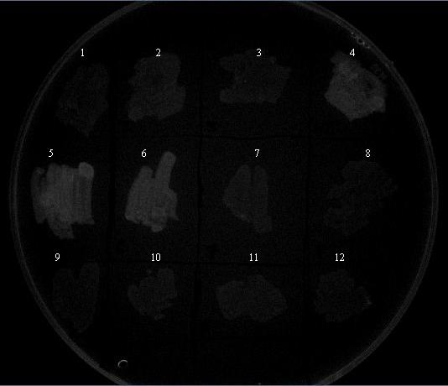
- HixC G-1
- HixC G-2
- HixC G-3
- HixC G+1
- HixC G+2
- HixC G+3
- HixM G+1
- HixM G+2
- HixM G+3
- HixM G-1
- HixM G-2
- HixM G-3
Colonies on Amp+ plate, under Epi-White
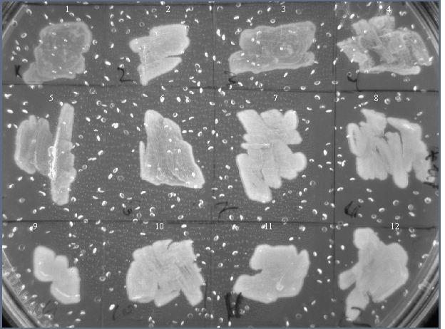

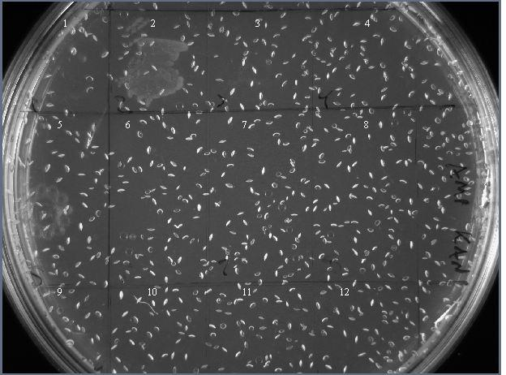
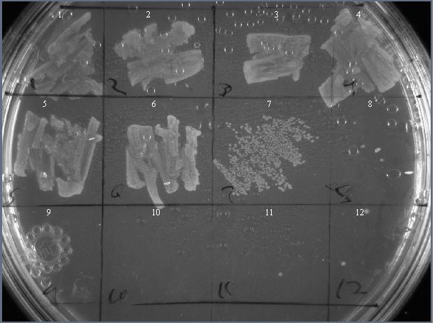
Colonies on Amp+ Kan+ plate, Epi-White
Colonies on Amp+ Tet+ plate, Epi-White
Appendix D – Protocol for using Dr. Sarafova’s FACS

NOTE/DISCLAIMER: The FACS analyzer is a sensitive piece of equipment and is cherished by Dr. Sarafova. The first time you use it, you should contact her for a tutorial (sosarafova@davidson.edu). This protocol should be used as an overall guideline, not a specific set of instructions, which should be learned from Dr. Sarafova.

Background: See http://media.pearsoncmg.com/bc/bc_campbell_genomics_2/medialib/method/FACS.html for information on how FACS works and how it can be used.

- Grow 2mL overnight cultures of the cells that you want to analyze. Make sure you grow control cells for each run, i.e. cells that you are sure will not express your phenotype. Ensure that the cells are still in log growth phase during the time you analyze the samples, because this is when they are expressing the phenotype that you are analyzing. There are a couple of ways of ensuring this:
  - Grow cultures overnight, then 2-3 hours before the experiment pipet 200-300 µL cells into a new 2mL culture (with the applicable antibiotics!) so that they will be growing healthily when you begin.
  - Time the FACS run so that you can make cultures 10-12 hours before the beginning of the experiment, so that cells are in log phase when beginning.
- The machine works by running cell solutions through a very small tube, so the FACS reader can only read a certain number of cells at a time. To prevent clogging of the machine, you must dilute your cell cultures.
  - Make serial dilutions in TE buffer:
    - 100x (10 µL in 1 mL TE)
    - 1000x (1 µL in TE)
    - 10,000x (10 µL from 100x in 1 mL TE)
    - 100,000x if cell cultures appear very cloudy (1 µL from 100x in 1 mL TE).
- Take the serial dilutions over to the FACS analyser and start the program (Cytosoft). Disconnect the computer from the internet, as this takes up too much RAM, and log in the local computer.
- Click on Cytosoft Pro to open data acquisition
- Ideally, the first step should be to calibrate the machine; however, the calibration beads are not in their listed concentration and calibration is currently inaccurate. Therefore, skip this step unless Dr. Sarafova has ordered more calibration beads.
- You now need to create a “Worklist,” which tells the machine which samples to read and what the samples are. Create a new worklist, click on wells that you will put cells in, and label them. Adjust settings as per recommendation, but default settings should suffice.
- Before running any samples, you need to adjust the read settings to get the right levels of readings. Run the control sample by loading 400 µL into a tube (looks like a vial that tapers down into a capillary tube toward the middle) and placing the tube into a well. Since you are starting the experiment after this step, go ahead and load all the other samples as well in their correct places.
- Start the worklist, but then click “Adjust settings” on the next dialog box. The sample should begin running, and cells should appear on the graphs as red dots. Since this is the control, you want the machine to read these as “zeroes.” Adjust the voltage slider bars and the gain as per recommendation to get these cells in the 0-10 range on the flourescence histogram. Try not to let the redings go past 10, but a few residual cells at 10² is ok.
  - You should begin with your most dilute culture and work up from there. Ideally, the machine should be reading around 200 cells/µL, and it will generally tell you if concentrations are too small or large. Use the dilution that gives you the optimal cell concentration, but use the same dilution for all cultures (don’t use a 100x for one and a 10,000x for another).
- As a final check, you should adjust settings for a positive control, to make sure that the machine reads them as positive. Don’t adjust the setting much here, just check to see if they’re read as positive.
- Now you’re ready to experiment! Resume the worklist and gather data.
- After data has been collected, be sure to save it!
- After all samples for the day have been run, you need to clean the machine. Close Cytosoft Pro and click “Clean and Shut Down.” This process takes approx. 30 minutes, but you can analyze the data while it is running.

