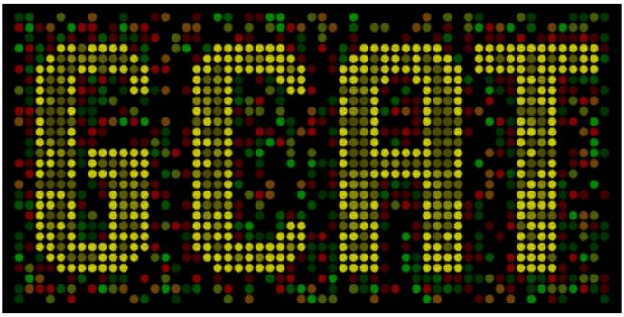

The Genome Consortium for Active Teaching
put synthetic biology in your curriculum

APPLICATION RECEIPT DUE DATE: 5 pm eastern time, JANUARY 10, 2014.

GCAT is pleased to announce a synthetic biology faculty workshop for the summer of 2014 hosted by HHMI’s Science Education Alliance (SEA). This workshop is funded by NSF and HHMI. You can learn more about synthetic biology at this web site: www.bio.davidson.edu/projects/gcat/GCATSynBio.html .

The goal of this workshop is to prepare 15 pairs of faculty to spend the 2014-15 academic year getting ready for undergraduate-lead research in synthetic biology during the summer of 2015. We will train participants how to do the wet lab methods and how to think differently to prepare for synthetic biology. By the end of the workshop, we want each team to have mapped out possible research projects and implementation plans.

Workshop is FREE, and travel will be reimbursed upon completion of the workshop.

The 2014 workshop dates are:
Arrive at University of Maryland – Baltimore Campus (UMBC) Campus
BWI is closest airport.
Participants will stay in UMBC dorms
(workshop starts in the afternoon of Tuesday, June 24.)
Workshop all day Wednesday and Thursday, June 25 - 26
Workshop until noon on Friday, June 27
Depart Friday afternoon

- Instructors will be Drs. Jeff Poet and Laurie Heyer (mathematicians) and Drs. Todd Eckdahl and Malcolm Campbell (biologists), Katie Kendig (philosopher/ethicist).
- Participants: 15 teams of two faculty members
- Each team will be composed of a cell/molecular biologist and a non-biologist (chemist, mathematician, computer scientist, ethicist, perhaps biochemist if in different department, etc.) Teams can be composed of faculty from two nearby institutions, though that might be more difficult to sustain.
- Teams must apply no later than January 10 and will be notified of their preliminary selection before February 1, 2014.
- Selected participants must collect some baseline information about their students as the final step of their application.
- HHMI will pay for room and board with single rooms and private bathrooms.
- NSF funds will cover travel and lab supplies.
- Mini-registry of standardized parts will be given to participants as a starter kit.
- Participants are strongly encouraged to bring laptops, a few loaners will be available.

We hope that all 15 schools will have their students present their research from the summer of 2015 at research venues to be discussed at the workshop. A tentative schedule is attached.
For Faculty Teaching Undergraduates
June 24 - 27, 2014 at UMBC, Baltimore, MD
Application Deadline JANUARY 10, 2014

Applicant name #1_________________ Rank and Dept.____________________________

Applicant name #2_________________ Rank and Dept.____________________________

Institution(s) #1____________________#2 if different______________________

Mailing Address #1_________________________________________________

Contact Phone #1 _______________ Contact Email #1______________________

Contact Phone #2 _______________ Contact Email #2______________________

Current courses taught Person #1: _________________

Current courses taught Person #2: _________________

Field of expertise #1: ___________________#2: _____________________

How do you plan on using synthetic biology in your teaching and/or research?
#1:

#2:

Please describe the time and other resources available for you to conduct undergraduate-based research in the summer of 2015 or in teaching labs during the academic year.
#1:

#2:

Do you have prior experience with synthetic biology and/ or undergraduate research? _____________
If yes, please explain:
#1:

#2:

Demographics. Please fill out this table to help us understand the undergraduates served at your institution.
Group | Percentage of institutional undergraduate population
African Americans
Hispanics
Native Americans
Native Hawaiians/Alaskans
Optional: your ethnicity | #1 #2

Last Question: Why are you applying for this workshop? Help us understand why you want to attend. Keep your answer to less than one page please.

EMAIL APPLICATIONS TO: A. Malcolm Campbell macampbell@davidson.edu

APPLICATION RECEIPT DUE DATE: 5 pm eastern time, JANUARY 10, 2014.
Neither HHMI nor GCAT uses quotas for any workshop. We encourage all faculty to apply but we will emphasize the potential impact for faculty who teach at MSIs, or those faculty members who are themselves members of underrepresented groups.
