113 Lab Learning Objectives

Week 8: synthetic lab #7

Learning Objectives for Promoter Discovery

Skills
- Produce graphical data for oral and written presentations.

Cognitive
- Employ a scientific approach to answering biological questions and test hypotheses.
- Analyze experimental data and reach logical conclusions.
- Synthesize experimental results for oral and written presentations.

Week 8: Information and Natural Selection lab #4

Learning Objectives for Environmental Information and Natural Selection

Skills
- Read DNA sequence and search for SNPs using ApE software.
- Determine your PTC tasting phenotype and compare with prediction.

Cognitive
- Analyze experimental data and reach logical conclusions.
- Connect environmental information to evolution using lab experiment as example.
- Explain what TAS2R38 has to do with taste and natural selection.
- Predict PTC tasting capacity and text experimentally

Week 8: Information and Evolution Lab #1

Learning Objectives for Bacterial Evolution

Skills
- Pipet accurately.
- Work with bacterial cells using sterile technique.
- Make dilutions of stock solutions.

Cognitive
- Employ a scientific approach to answering biological questions and test hypotheses.
- Describe the big idea of evolution based on lab experiences.
- Explain how antibiotic resistant bacteria can appear quickly in the population.

Bio113 Week 8

Before you come to lab

1) How will you interpret the data if you are not either of the two classic genotypes for PTC tasting?

2) Predict what you will see on your plates containing E. coli or B. subtilis and the 4 paper discs soaked in antibiotic solutions.

3) Watch this short movie called “Why does evolution matter now?”

4) Answer each of these four questions in two sentences or less.

A) What is PTC and what determines your sensitivity to this compound?

B) Why would we evolve to taste bitter? Which allele is the original allele for humans?

C) Why does evolution matter now, as presented in the video?

D) What is a Gram stain? What are E. coli and B. subtilis, Gram positive or Gram negative?

Week 8
The first rule of antibiotics is try not to use them, and the second rule is try not to use too many of them. —Paul L. Marino, The ICU Book

In Lab:

Evolution: Directed Evolution of Antibiotic Resistance in Bacteria (a 6 week project)

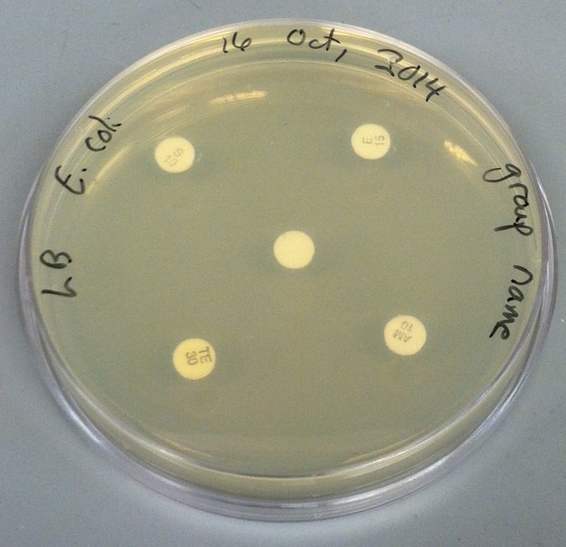
1) Today you will design an experiment to determine which of these antibiotics is effective on Escherichia coli and Bacillus subtilis. You have LB agar plates and paper discs soaked in one of these four antibiotics.

ampicillin

tetracycline

erythromycin

streptomycin

Information and Evolution: Genetics of Perceiving Danger Module (an 8 week project)

2) Determine your TAS2R38 genotype using your .seq and .ab1 files. Determine your SNPs and whether you are homozygous or heterozygous for each one. Then predict your phenotype and see if you can taste the PTC paper. Emergency chocolate or jelly beans will be available for everyone – tasters and non-tasters.

Synthetic Biology Promoter Discovery Module

3) Spend the rest of your time preparing for your oral presentations next week.

Hints for Your Oral Presentation
If biology were taught in the form of stories, it would never be forgotten.
modified quote from Rudyard Kipling, The Collected Works

Everyone knows speaking in front of a group can be uncomfortable, and it is especially hard the first time. You will make some mistakes - that’s part of the learning process. The best preparation for presentations is to understand what you did, especially why you set the experiment up the way you did in order to answer a specific scientific question. To maximize everyone’s learning, you will not know which section you have been assigned to present until one hour before your presentation. Therefore, each person must fully understand the research you conducted and all four sections of the oral report.
Each group will give an oral presentation about their research. The presentation should be organized in a manner similar to your scientific reports, with four sections: Introduction, Material and Methods, Results, and Discussion/Conclusion. In groups of four, each person will present one of the sections. In groups of three, Introduction and Methods sections are presented by the same person. You have access to the grading rubric I use to evaluate presentations. Furthermore, the students listening to your presentation will be on the lookout for common mistakes that you should avoid. They will be using an iBOP Bingo card to help all students avoid common mistakes.

1) The Introduction includes background information, the reasons for doing the experiment, and your hypothesis/experimental question. The introduction should connect what has been learned in the classroom to what has been going on in the lab. Start with big ideas and general themes and move to specific concepts and your research.

2) The Materials and Methods should include your experimental design, where you describe the samples you are testing and the controls you have incorporated into the experiment. In addition, you can do a very brief overview of the major procedures you performed. Remember to consider your audience: all the groups did a similar experiment, so there is no need to repeat “standard” protocols. Include procedures that are different from the standard protocol, and be sure to present enough of your protocol so that everyone is clear as to exactly what you did. Use concentrations rather than volumes when talking about solutions.

3) The Results should be a clear and concise display and explanation of your data. Your data should be distilled down to the important facts, and not necessarily every piece of data you collected. For example, do not read all the contents of a table. However, don’t make the mistake of showing a figure and saying, “This is what we got” and then saying nothing else. Verbally walk us through the figure. Point out important parts of each figure.

4) Finally, the Discussion will be your interpretation of your results. What do your data mean? Discuss whether or not your data support your hypotheses. Do you have reason to believe your data were inaccurate? However, don’t blame “human error” for variations unless you know a mistake was made. What would you do next time to investigate the problem further? References follow the discussion but they do not need to be presented orally, only visually.

Please realize that any questions that you are asked by your classmates or the instructor are not meant to be punitive or threatening. So, don’t be afraid of questions - they are intended to further our collective understanding of your scientific investigation.
Your group’s presentation should last no more than 15 minutes including three minutes for Q&A. Each person in your group must speak during the presentation. The use of visual aids is very important. That’s why we give you ample time to produce figures during lab time.
In preparing your presentation, you may find it helpful to keep the following questions in mind as your rehearse your presentation prior to the final one in lab:
1. Did you clearly state the question(s) you were trying to answer?
2. Was it clear what you did in order to answer your question?
3. Did you explain your results, especially any inconsistent or unexpected results? Do not forget to address the controls.
4. Did you convey why you did the different conditions in your experiment?
5. Did you explain what your data meant? Did you answer the question from number 1 above?

Your group will be critiqued in two ways. First, your classmates will evaluate your presentation.
In addition to iBOP Bingo, each person will review other groups by responding to the following two questions:

1) What were the strengths of this presentation?

2) What improvements could be made by this group?

When making comments about the presentation of others, keep in mind the five questions listed above, as well as other things such as whether the group was organized, if everyone participated, if their conclusions were valid, etc. These comments are meant to be helpful suggestions and not a slap in the face. You may use your iBOP Bingo cards when evaluating each group.
I will be interested in similar categories, especially how clearly you present your material, whether you display understanding of what you did and why you did it, and if the data supported your conclusions. You will receive a group grade, but the most important aspect of this exercise is to become comfortable talking in front of a group and to have fun with your presentation. We will use CATME to fairly distribute the group grade to make sure no one person dominated the group and no one was a freeloader and did very little work.

What to do in lab today and how to organize an oral presentation?
- Start with an overall outline and stick to the big points, not the details. Map out the key points you want to make. Be sure to keep the data as the centerpiece of your PPT or Keynote presentation. Think graphically and not with lots of words. Avoid the common mistake of very wordy slides with no visual representations. Rule of thumb: 1 slide per minute unless you are going to use sequential slides to gradually reveal information the way we do in the classroom.
- Prepare the figures before you get bogged down in methods or introduction since figures are your data. Present clear figures with large fonts and good color choices that can be seen from the back of the room. Label the axes and indicate the appropriate units. Use color sparingly and only if necessary. Avoid default colors and gray backgrounds for graphs generated by Excel.
- Once the figures are completed, work on the discussion section. What do all your data mean? How will you communicate your conclusions to the audience?
- With the results and discussion completed, go back and prepare the introduction. It makes sense to construct the introduction after results and discussion since now you know what you need to introduce.
- The methods and references sections should be written last. These typically require the least amount of creativity but they are essential to scientific communication and integrity. Plagiarism is presenting information as if you are the original source when in fact you obtained the information from another source, including the Bio113 laboratory manual.

Be sure to send each person in your lab group a copy of any files you generated today. Remember, the oral presentation is graded collectively and no one knows which section he or she will present until one hour before lab begins. Therefore, each of you is responsible for learning the entire presentation and helping your labmates learn the material well enough to present the information. The number one goal is always to maximize learning and this method will prevent individuals from knowing just one section of the oral presentation.

