Instructions for Week 1 Serial Dilution Graphs

- For each series A - D, your task is to generate a graph that shows the relationship between the fold dilution (x-axis) and the absorbance at 585 nm of light (y-axis).
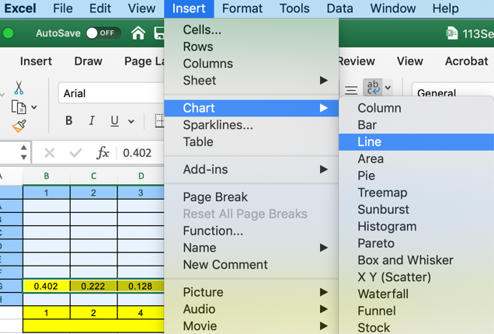
- To do this, highlight the data you want to graph by clicking and dragging over the data.
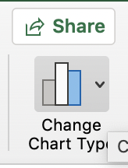
- From the “Insert” menu at the top of the window, choose “Chart” and “Line” plot (see screenshot for Mac example).
- When the graph appears, click once on it and choose from the top right “Change Chart Type”. You may have to make your Excel file wider to see this option.
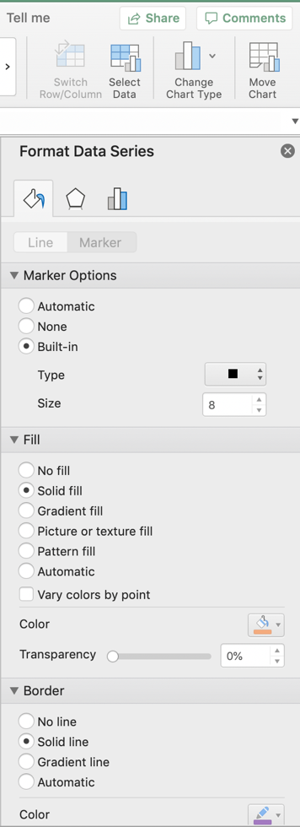
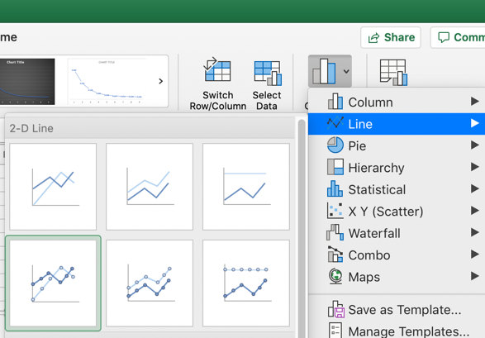
- You will see a new menu appear, choose “line” and then the “Line with Markers” that is highlighted with the light green outline in this screenshot. All this does is put some symbols where you have data to connect the lines more clearly.
- When the graph appears, right click on it and choose “Move chart…”. In the dialog box that appears, choose “New sheet” to place the graph in a new tab by itself. You can rename this tab if you want.
- Rather than accepting the default colors chosen by Microsoft, choose you own marker shape, color, size. To do this, quickly double-click on one marker. This should highlight all the markers and open a new “Format Data Series” panel on the right side of the graph (screenshot). Click on the “Marker” tab and choose the shape, size, fill color and line color of your markers. Make the marker bigger so they would be visible even if the graph is shrunk to a very small size. In this example, the marker is set for a square, size 8, orange fill, purple outlines.
- After setting the marker shape, choose the “Line” tab and change the color of the line connecting the markers, and increase its size to 3. Purple and orange are distinguishable by people who are color-blind which includes about 7% of all males. Teal is a third color that is distinguishable by color-blind people. To choose teal, click on the color square, choose “more colors” and the crayon option will let you choose teal. At this time, your graph should look like the screenshot here:
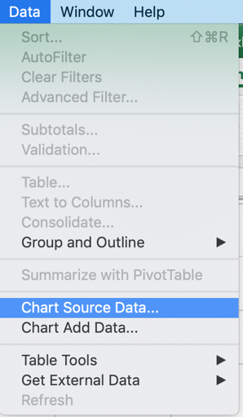
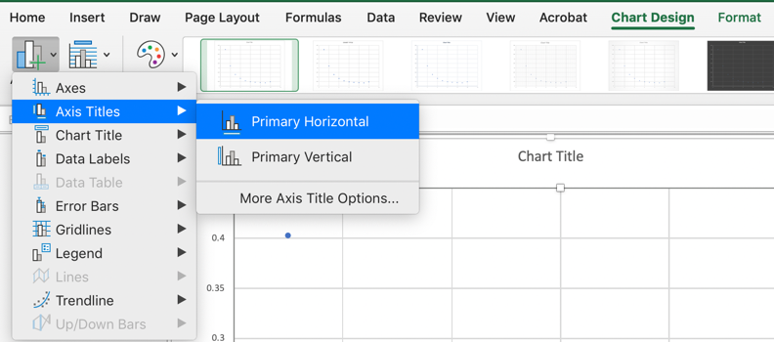
- Now label the two axes. Click once on the graph to select it so that small white squares appear around its perimeter. Choose the “Chart Design” menu above (green font) in this screenshot. On the far left, choose “Add Chart Element” and then “Axis Titles”. You will need to name both axes to match your data. Absorbance data are often labeled “OD” for optical density, followed by the wavelength of the light used. What wavelength did we use this week to quantify the blue dye? Consult your lab manual to confirm.
- Next, you need to label the x-axis so that each data point is above the fold dilution. Select the graph again, choose the “Data” menu at the top, and select “Chart Source Data”.

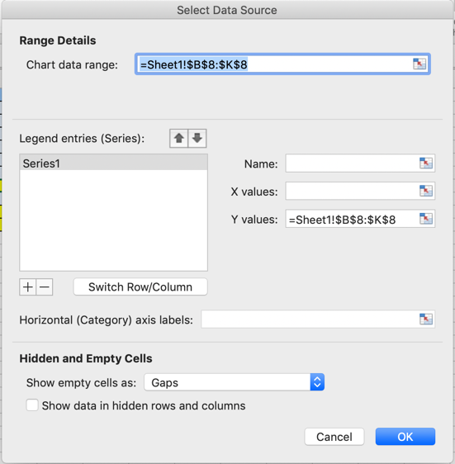
- In the new dialog box that appears, click on the small symbol circled in purple in the screenshot at the end of the box labeled “Horizontal (Category) axis labels:”. This will allow you to click and drag on the cells containing the dilution series you calculated previously.

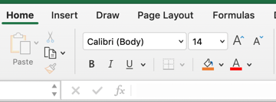
- Once you have everything labeled, you should make the font sizes bigger. Click once on the text you want to enlarge. Choose the “Home” menu at the top and then choose the font, size and color you want. For figures, you want a bigger font than you would use for text because figures are often reduced when inserted into lab reports. The minimum size should be 14.

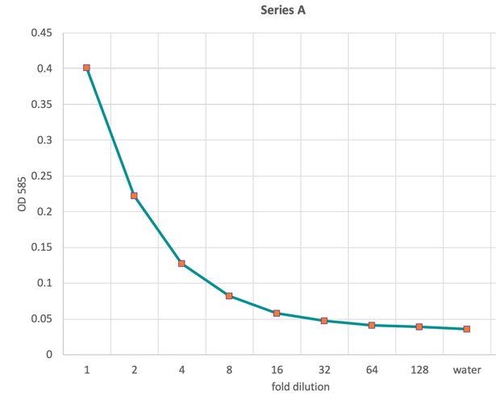
- At this point, you should have produced a graph that looks like this. Notice how small the marker is and all the text. The default settings would have been too small to see in this example.
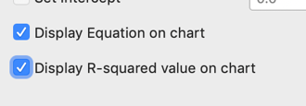
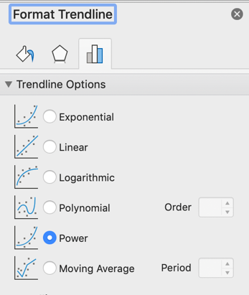
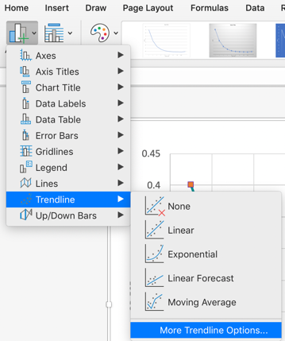
- Now it is time to generate a line of best fit. The purpose of this line is to show how close your data are to a theoretical perfect fit. Select the graph by clicking it once. Under the “Add Chart Element” menu, choose “Trendline” and then “More Trendline Options…”. A new dialog box will appear on the right side. In this box, choose the “Power” option. This should generate a dotted line that nearly matches your data. Also select the two boxes at the very bottom that say “Display Equation on chart” and “Display R-squared value on chart”. These two mathematical expressions help you know how the trendline was generate (equation) and how closely your data are to the theoretical line. The highest possible R-squared value is 1.00. Click and drag the text to an open space in your graph, change the font size to about 18, and then alter the trendline so it is more visible.
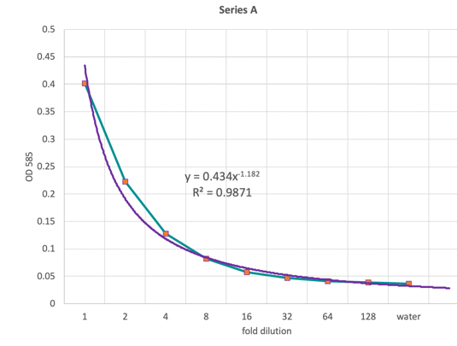
- Now you should have a graph that looks like this:

