Halomicrobium mukohataei, a recently annotated halophile, may use potassium homeostasis to maintain osmotic balance and appears to have all enzymes necessary to utilize the citrate cycle
By: Karen Hasty
Abstract
The halophile Halomicrobium mukohataei was isolated over fifteen years ago yet we know surprisingly little about this organism. Both Joint Genome Institute (JGI) and Rapid Annotation using Subsystem Technology (RAST) annotated the genome of H. mukohataei this year. In order to survive in a high salinity environment, halophiles must avoid the salting out effect where proteins come out of solution due to high salt concentrations. One way an organism may overcome this phenomenon is to balance osmotic pressure by taking solutes, such as potassium (K⁺), inside the membrane. To determine whether Halomicrobium mukohataei utilizes potassium homeostasis to maintain osmotic balance in a high salinity environment, I identified the genes related to potassium using JGI and RAST annotations. I BLASTed genes associated with potassium against whole genomes of all other species whose genomes have been annotated. I discovered sequence conservation of potassium machinery among halophiles. Very little information about potassium utilization by halophiles exists in the literature thus far, making any determination of the role of potassium in maintaining life in these species difficult at this time. Additionally, I compared the RAST annotation of H. mukohataei’s genome to nine related halophiles to determine which proteins are unique to this species and which proteins are conserved in all ten species. I used the list of conserved proteins generated by this process to determine if citrate cycle machinery was conserved in these halophiles. I searched for enzymes from the citrate cycle that appeared to be missing from the genome according to RAST in several different databases. Seven enzymes were missing in this species, none of which appear to be necessary for the completion of the citrate cycle. All citrate cycle machinery was highly conserved among the ten halophiles compared in this study. Because all necessary citrate cycle enzymes are present and highly conserved, it appears that the citrate cycle is important for the survival of H. mukohataei and related species.

Introduction
Halomicrobium mukohataei is a species of halophile that was isolated from salt flats in Argentina in 1991 (Sugiyama et al., 1994). This species of archaea consists of facultative aerobes that grow preferentially at temperatures around 45˚C. H. mukohataei has flagella and is motile (Ihara et al., 1997). Aside from these facts and a few more minor details, we know little about this species. In March 2009, the DOE Joint Genome Institute (JGI) annotated the genome of H. mukohataei, but until recently, this annotation information has remained largely untouched. In addition to this annotation, Rapid Annotation using Subsystem Technology (RAST) annotated the genome in September 2009. We can learn much about this species by reviewing the information provided by these annotations on both a small and large scale. On a small scale, this project sought to determine if H. mukohataei utilizes potassium homeostasis to maintain life in a high salinity environment. On a larger scale, we compared this species to nine other halophiles to determine the importance of the citrate cycle for this organism.
Potassium Homeostasis
In order for an organism to survive in a high salinity environment, the species must overcome many challenges. With a high concentration of solutes outside the cell wall, if no precautions are taken against such a harsh environment, an organism could experience the salting out effect. Salting out occurs when solvent molecules (water) are drawn almost exclusively towards salt ions creating partial charges on the proteins present in a high salinity environment. These partial charges cause the proteins to become more electrically attracted to other proteins than the surrounding solvent causing the protein to precipitate out of solution (Arakawa & Timasheff, 1984). Since proteins are responsible for almost every molecular process that occurs within an organism, the loss of proteins due to high salt concentrations would be disastrous to the ability of an organism to survive.
In order to sustain life in high salinity environments, many halophiles and other halophilic microorganisms have developed methods to overcome this salting out phenomenon. One method of survival involves balancing osmotic pressures. By drawing high concentrations of solutes into the membrane of the organism, internal osmotic pressure equalizes with external pressure allowing water to stay inside the cell and prevent salting out. The types of solutes used to balance osmotic pressure may be organic, such as glutamate, glycine betaine, and N-alpha-acetyllysine, or inorganic, like potassium (Oren et al., 2002). It appears that organic solutes are more widely used by microorganisms, including halophiles, to balance osmotic pressure. Nevertheless, some species, such as H. salinarum, utilize potassium in order to maintain life in a high salinity environment. Studies of solute concentration inside the cell membrane of this species show high concentrations of potassium and low concentrations of organic solutes. Potassium enters the organism through both passive and active transport mechanisms (Figure 1).
Outside cell
Inside cell
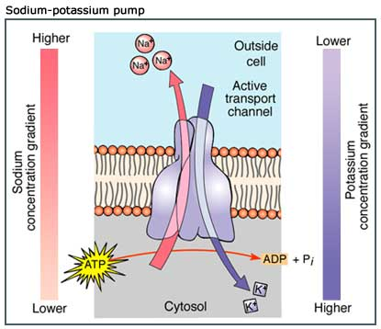
Figure 1. This figure depicts some of the ways that potassium can be transported into the cell. At the top, the figure depicts active transport of potassium into the cell membrane. The bottom of this figure shows how potassium can be actively transported into the cell using a sodium-potassium symporter mechanism (Thomas Learning, Inc, 2002). By drawing solutes into the cell, water must follow in order to maintain osmotic balance. With a high concentration of sodium outside the cell, such transport of ions becomes more important to sustaining life.

An operon, KdpFABC, encodes an ATPase driven pump that actively transports potassium across the membrane. Deletion of this operon is detrimental to the survival of H. salinarum, especially in environments with relatively low potassium concentrations (Strahl and Greie, 2008). Salinibacter ruber also appears to use potassium homeostasis to balance osmotic pressure in high salinity environments (Oren et al., 2002).
Since Halomicrobium mukohataei is not only capable of living in high salinity environments, but requires a high salt concentration to survive, it is possible that this species utilizes potassium homeostasis in order to overcome the salting out effect. To investigate this possibility, I identified genes related to potassium homeostasis and compared these genes with other species’ genomes to determine if potassium homeostasis machinery is highly conserved among halophiles. I searched the H. mukohataei genome for the presence of the KdpFABC operon. Additionally, I reviewed literature for information about potassium homeostasis in species that share potassium machinery with H. mukohataei. Potassium machinery was highly conserved among halophiles. However, I found no evidence of the KdpFABC operon in the H. mukohataei genome. Also, there has been no significant research into the importance of potassium homeostasis with many of the species that share potassium machinery with H. mukohataei. Due to these conflicting results, it is impossible to say whether or not potassium homeostasis plays a role in the survival of H. mukohataei in high salinity environments.
Citrate Cycle
To determine which other pathways are important to the survival of this species, we compared the genomes of Halomicrobium mukohataei and nine related halophiles. We used the results of these pair wise comparisons to find genes related to pathways that were conserved among these species. Because the citrate cycle is a very important pathway for most aerobic species, I chose this cycle as one pathway to focus on. The citrate cycle is a series of enzyme catalyzed reactions that works in conjunction with glycolysis and oxidative phosphorylation to convert sugar to energy. The citrate cycle begins when pyruvate, which was produced through the breakdown of glucose through the process of glycolysis, is converted to acetyl-CoA. Then, an enzyme facilitates the addition of acetyl-CoA to a four carbon molecule called oxaloacetate. A series of enzyme catalyzed reactions begin that oxidize the acetyl-CoA creating NADH molecules that will be used to create ATP in oxidative phosphorylation. In the last step, an enzyme catalyzed reaction regenerates oxaloacetate allowing the cycle to occur again when glycolysis produces a new molecule of pyruvate (Purves et al., 2004). Figure 2 depicts the steps in the citrate cycle.
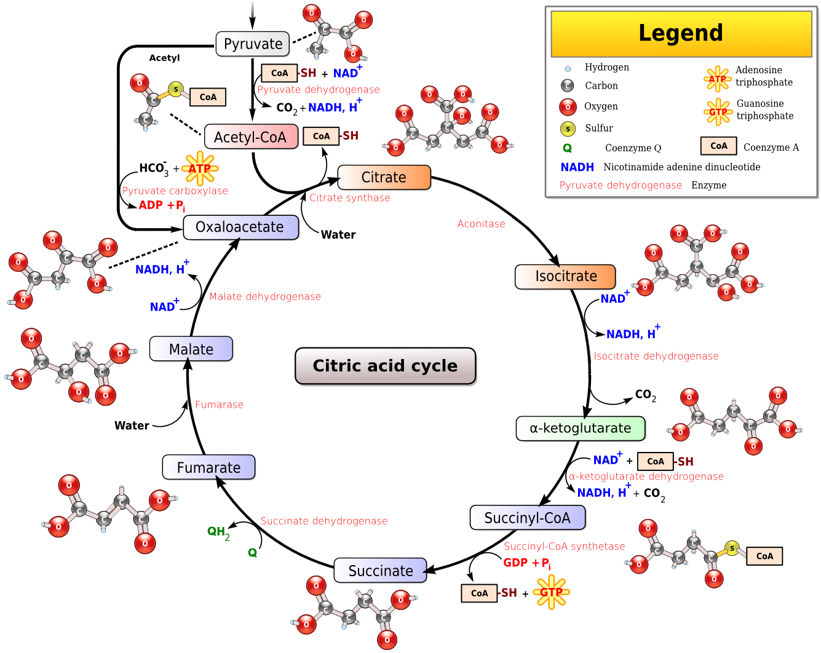
Figure 2. This figure shows the steps in the citrate cycle. Notice that a series of enzyme catalyzed reactions oxidize acetyl-CoA releasing three molecules of NADH which are used in oxidative phosphorylation to form ATP. The enzymes required for this cycle theoretically ought to be present in order for an organism to complete this cycle.
Depending on the species of interest, different enzymes appear to be necessary for this cycle to occur. In Figure 3, a depiction of this cycle shows that some steps and enzymes are not necessary for the cycle to occur properly.
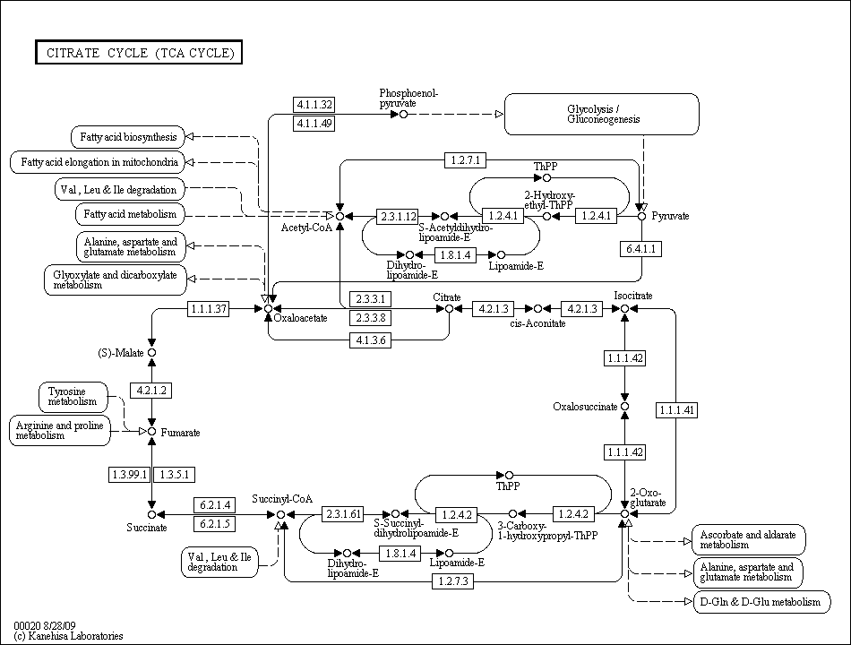
Figure 3. This image shows a generic KEGG map of the citrate cycle. Notice that some enzymes like 1.1.1.41 (circled in red) are not required if other enzymes such as 1.1.1.42 (circled in blue) are present.
We compared H. mukohataei to nine other species to determine whether citrate cycle machinery is highly conserved among halophiles. I searched for the enzymes that appeared to be missing from this species according to RAST using several different databases. After filling in gaps in the cycle and determining that machinery for the citrate cycle is highly conserved among halophiles, I concluded that the citrate cycle is probably important for the survival of H. mukohataei and related species.

Methods
Potassium Homeostasis
I searched both the JGI and RAST annotations of the H. mukohataei genome for any gene names containing the word potassium or K⁺ using the find function in a web browser. In order to determine whether the genes annotated by these servers were the same, I compared start and stop codons. After finding potassium-related genes, I used BLASTn and RAST to compare these H. mukohataei genes to whole genomes of other species. BLASTn compares a query sequence (potassium related genes from H. mukohataei) to all genomes that have been annotated. I determined the sequence of the KdpFABC operon in the H. salinarum genome using NCBI. I utilized a BLASTx search to translate this nucleotide sequence and compare the resulting amino acid sequence to the amino acid sequences in the H. mukohataei genome. Additionally, I searched the NCBI conserved domain database using the KdpFABC operon sequence as a query to determine which parts of this sequence are highly conserved.
Citrate Cycle
In order to compare the H. mukohataei genome to related halophiles, Olivia Ho-Shing created a Perl script that found all genes that were unique to H. mukohataei and all that were conserved when compared to another species. The program used the complete proteome in fasta format from each species to find these conserved and unique genes. We obtained the proteomes from RAST. We used this Perl script nine times to compare H. mukohataei to nine other halophiles including Haloarcula sinaiiensis, Haloarcula valismortis, Haloarcula californiae, Haloferax dentrificans, Haloferax mediteranei, Haloferax volcanii, Haloferax sulfurifontis, Haloferax mucosum, and Halorhabdus utahensis. We used a second program created by Bill Hatfield to create a list of proteins that were conserved in all ten species and a list of genes that were completely unique to H. mukohataei.
To determine which genes of the citrate cycle were present in H. mukohataei, I consulted the KEGG map of the TCA cycle from the SEED viewer on RAST. I determined the names of the enzymes found in RAST by viewing the details page for these genes. I searched the list of conserved genes for these citrate cycle genes by using the ‘Find’ function in a web browser and looking for the gene name, part of the gene name, or EC number within the list.
To find the enzymes of the citrate cycle that were missing from the KEGG pathway in RAST, I found sequences from related species that contain these enzymes using an NCBI nucleotide search. I compared these sequences to the complete H. mukohataei proteome using a BLASTx search. I sorted the results of this search based on e value in excel. I compared the top hits from this search to all other annotated genomes using a BLASTn search to determine the function of these proteins. I utilized another BLASTn search to compare the nucleotide sequence of citrate cycle enzymes obtained from NCBI to the total genome of H. mukohataei. Finally, I compared the KEGG map of the citrate cycle in JGI to the KEGG map found in RAST to determine if any genes were annotated in one map but not the other.
Results
Potassium Homeostasis
JGI annotated ten genes related to potassium homeostasis, and RAST annotated thirteen genes. Once I compared stop and start codons, I found seven genes that were unique to RAST as well as four unique to JGI. JGI and RAST annotated only six genes that were identical in both annotation systems (Figure 4).

Figure 4. This Venn-diagram shows the relationship between genes called in JGI and RAST. Four genes called were unique to JGI, RAST annotated 7 unique genes, and 6 genes were annotated in both JGI and RAST.

Using BLASTn to find these seventeen genes in other species, I found seven distinct species that have similar potassium machinery. These similar sequences from related species had low expect values and came from genes encoding potassium machinery. The species with similar potassium machinery are Halorhabdus utahensis, Halorubrum lacusprofundi, Halobacterium sp. NRC-1, Halobacterium salinarum, Haloarcula marismortui, Natronomonas pharaonis, and Halogeometricum borinquense. The genome matches for these species included the complete query sequence and had very low expect values suggesting high conservation of potassium machinery among halophiles (Figure 5).
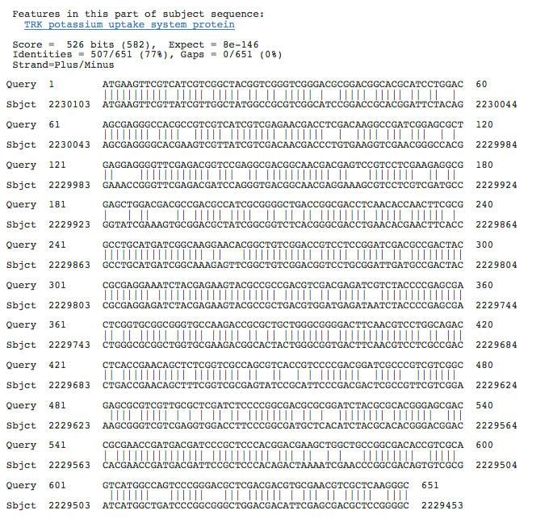
Figure 5. This is a screenshot of the BLASTn results for a K+ transport system gene called in JGI. The similar sequence shown here is from the species H. marismortui. This example is representative of all the comparisons. The sequence coverage is very high and there is a very low expect value of 8e⁻¹⁴⁶ suggesting that this potassium transport gene is conserved.

RAST results only display genomes that have been annotated by RAST, so I did not discover as many species with similarity to H. mukohataei’s potassium machinery using RAST. Figure 6 shows a screen shot of BLAST results showing sequence similarity using the Trk system potassium uptake protein trkA-3 as an example.
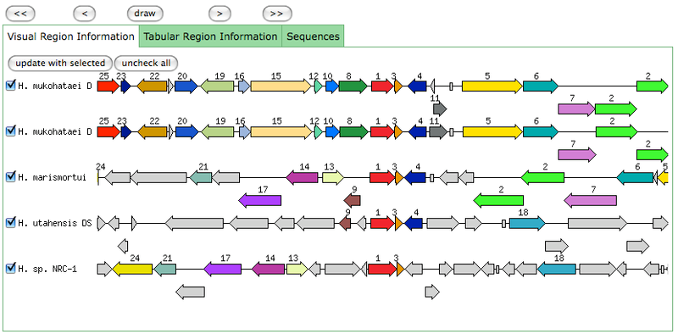
Figure 6. In the SEED viewer in RAST, each gene called has a chart similar to this one showing other species that also have the gene of interest. Only genomes sequenced with RAST are included. This screen shot shows the Trk system potassium uptake protein trkA-3 gene (the red arrow labeled 1 in the figure) in its location in the H. mukohataei genome compared to other species. There are two versions of the H. mukohataei genome simply because one is a draft genome sequence and the other a finalized version.

The similarity between H. salinarum potassium machinery and H. mukohataei deserves further attention since we know H. salinarum utilizes potassium to maintain life in a high salinity environment (Strahl and Greie, 2008). I compared the KdpFABC operon of H. salinarum to the entire H. mukohataei genome using BLASTx in an attempt to discover parts or the whole of this operon. I used an amino acid sequence comparison because amino acid sequences tend to be more highly conserved among different species. There was less similarity between the genes for this operon and the H. mukohataei genome than the similarity found when comparing potassium machinery across species. I discovered only three regions of similarity between this operon and the H. mukohataei genome. All three of these regions are located within the B gene of the KdpFABC operon. The regions are all labeled as ‘Heavy metal translocating P-type ATPase’ within the H. mukohataei genome. Since we know the KdpFABC operon has an ATPase function as part of the potassium transport system in which it is involved, it is possible that the similarity in sequences is related to the ATPase function instead of potassium homeostasis (Figure 7).
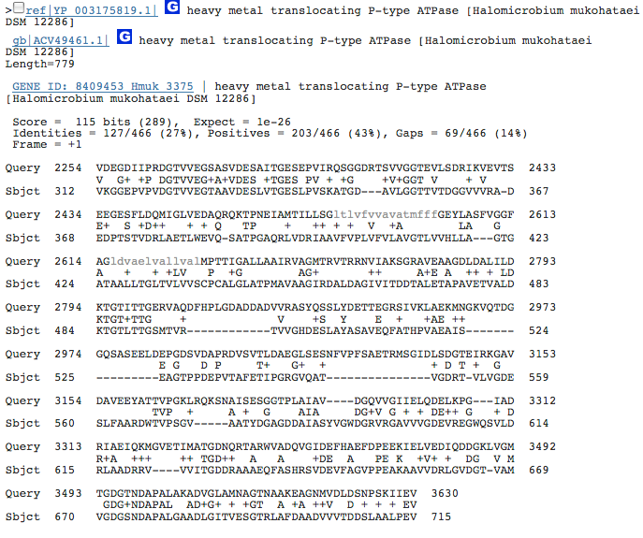
Figure 7. This screen shot shows one of three Blastx results for the comparison between the H. salinarum operon KdpFABC and the H. mukohataei whole genome. I found amino acid similarity only for a small portion of KdpFABC. All regions of similarity are within the heavy metal translocating P-type ATPase of H. mukohataei and it is unlikely that these regions are related to potassium transport. The similarity between these sequences is most likely related to ATPase function.

I searched the conserved domain database to determine which parts of the KdpFABC operon are highly conserved. One hit in this database was for ATPase function. This conserved sequence implies that it is possible that the function of the conserved portion of this sequence in H. mukohataei is solely related to ATPase function (Figure 8).
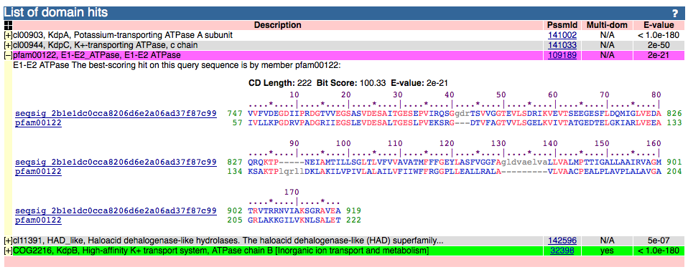
Figure 8. This figure shows the conserved domains contained within the KdpFABC operon. One of these domains is the E1-E2 ATPase. This hit implies that the similarity between the KdpFABC operon may be due to the conservation of ATPase function.

Very little information was available in the literature about potassium homeostasis in the six species sharing potassium machinery with H. mukohataei. Only one website mentioned potassium in conjunction with H. sp. NRC-1 and this discussion was limited to declaring that potassium related pathways do exist in this organism (Hong & Pogliano, 2007). It appears that the research into potassium homeostasis and halophiles may be a very new exploration with few published results thus far.
Citrate Cycle
The KEGG map in RAST found thirteen genes of the citrate cycle in H. mukohataei. In Figure 9, RAST annotated all enzymes colored green within the H. mukohataei genome while RAST did not annotate all genes colored white.
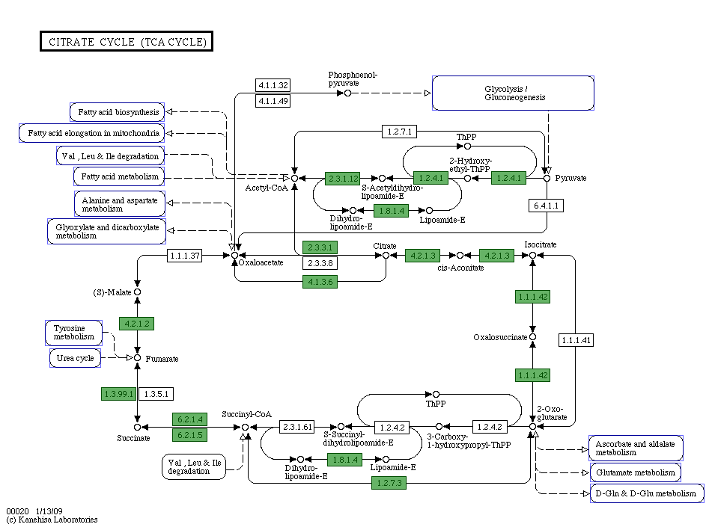
Figure 9. This is the KEGG map of the citrate cycle found in the SEED viewer of RAST. All green boxes represent enzymes found within the RAST annotation of H. mukohataei. RAST did not annotate ten genes in the citrate cycle shown in white.

When I consulted the list of conserved proteins from all ten species, all thirteen genes found in RAST were conserved in all ten halophiles compared. When I searched for sequences on NCBI for genes missing from the citrate cycle KEGG map in RAST, two genes appeared to have sequences in the H. mukohataei genome. Enzyme 1.1.1.41 had a sequence within the H. mukohataei genome on NCBI. However, when searching for this gene within both RAST and JGI, a gene with the EC 1.1.1.41 did not appear to exist (Figure 10).
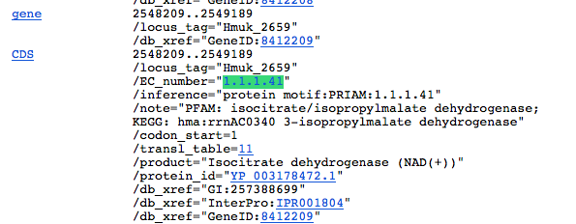

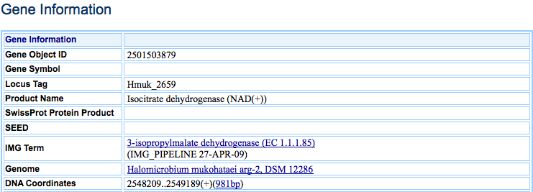
Figure 10. The top part of this figure shows a screen shot of the NCBI list of genes in the H. mukohataei genome. Enzyme 1.1.1.41 is present in this NCBI listing. However, when I found this sequence location in JGI, JGI shows a different enzyme with EC number 1.1.1.85 in this location. The second part of this figure shows the enzyme annotated in JGI.

Additionally, a BLASTn of this sequence compared to all annotated genomes did not reveal any similarity to enzyme 1.1.1.41, isocitrate dehydrogenase. The second enzyme found in NCBI was 1.1.1.37, malate dehydrogenase. In RAST at this location, there is an L-lactase dehydrogenase annotated. JGI found a malate dehydrogenase at this location. A BLASTn of this sequence compared to all annotated genomes found significant similarities to malate dehydrogenases in other species (Figure 11).

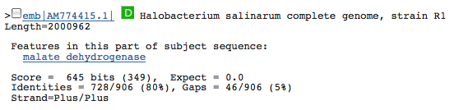
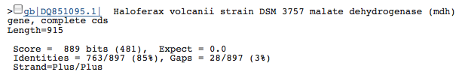
Figure 11. The top picture in this figure shows the details page in JGI of the enzyme 1.1.1.37, malate degydrogenase. The second and third images in this figure show the top two hits of a BLASTn search of this sequence compared to all other annotated sequences. The expect values are very low and suggest that this sequence is in fact a malate dehydrogenase.

Because I obtained the total proteome from RAST, it is possible that this annotation service completely missed some of the genes of the citrate cycle in the H. mukohataei genome. To determine if RAST did not annotate some of the missing genes, I compared the nucleotide sequences of citrate cycle enzymes obtained from NCBI to the total H. mukohataei genome using BLASTn. I found one more missing protein through this protocol. JGI annotated enzyme 1.3.5.1, succinate dehydrogenase, but RAST did not have any gene in this location (Figure 12).
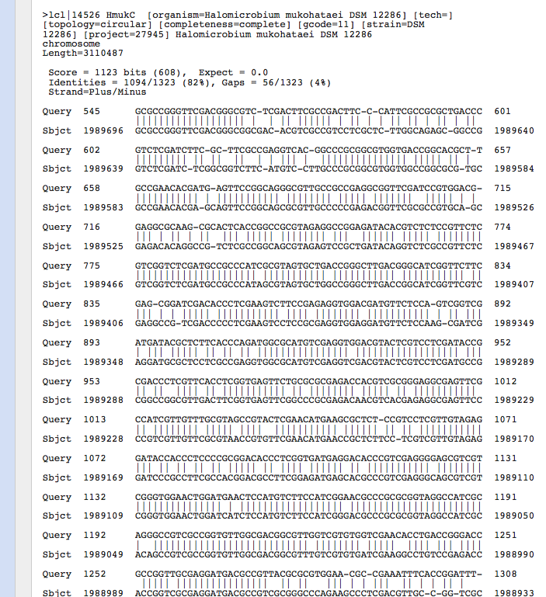
Figure 12. This image shows the results of the BLASTn alignment of the NCBI sequence for enzyme 1.3.5.1, succinate dehydrogenase, from a similar species compared to the total genome of H. mukohataei. The expect value is very low suggesting a good match. When I searched for this location in JGI and RAST, I found that the enzyme was present in JGI but not in RAST.

Also, when comparing the JGI KEGG map of the citrate cycle to the KEGG map from RAST, I discovered another missing enzyme: enzyme 6.4.1.1, acetyl-CoA carboxylase (Figure 13). JGI annotated this enzyme while RAST did not.
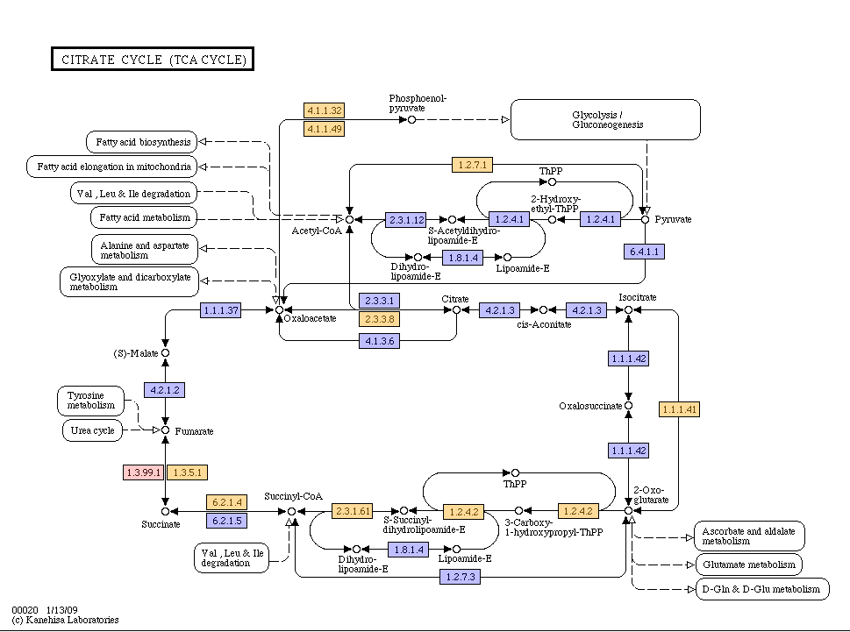
Figure 13. This figure shows the KEGG map of the citrate cycle found in JGI. Blue boxes represent enzymes found by JGI in H. mukohataei. Orange boxes represent enzymes found in related species and red boxes have not been found in similar species. Using this map, I discovered enzyme 6.4.1.1, acetyl-CoA carboxylase (circled in red). Also, enzyme 1.3.5.1 (circled in blue) is orange in this figure when it ought to be blue since JGI annotated this enzyme in the H. mukohataei genome.
Discussion
Potassium Homeostasis
JGI and RAST annotated seventeen distinct genes related to potassium in the H. mukohataei genome. However, only six of these genes existed in both the JGI and RAST annotations. Because a relatively large amount of potassium machinery exists in the genome of this species, it is probable that the species utilizes potassium in some manner. Additionally, the species comparisons of potassium machinery using BLASTn show that cellular potassium systems are highly conserved among halophiles. This conservation could be due to a number of different factors. Potassium homeostasis could be essential to maintaining osmotic balance in a high salinity environment causing evolutionary selection pressure to conserve these potassium related genes. It is also possible that these organisms utilize potassium for a different purpose causing the conservation of potassium machinery. For example, microorganisms often use potassium to control cytoplasmic pH. Perhaps H. mukohataei utilizes potassium for this purpose (Booth 1985).
Because H. mukohataei does not have the components of the KdpFABC operon within its genome, it is clear that this species is not transporting potassium in the same way as H. salinarum. However, this finding does not rule out the possibility of H. mukohataei utilizing potassium homeostasis in order to balance osmotic pressures in a high salinity environment. Since very little information on potassium homeostasis in halophiles exists, more wet laboratory experiments are needed to determine how halophiles use potassium. For instance, a study in which the concentrations of both organic and inorganic solutes located inside of H. mukohataei’s membrane would begin to shed light on how these organisms maintain an osmotic balance in a high salinity environment. It is clear that potassium plays some important role in the survival of halophiles such as H. mukohataei, but at this early stage in the study of these organisms, the exact nature of the role of potassium remains undefined.
Citrate Cycle
It seems that the citrate cycle is necessary for the survival of this species since the machinery for this cycle is highly conserved among all ten halophiles in this study. Also, in laboratory studies of other halophiles, the citrate cycle appears to be an important process for these organisms (Ghosh & Sonawat, 1998). Although the RAST KEGG map seems to show an incomplete citrate cycle, H. mukohataei is probably capable of completing the cycle. There would be no use to have the majority of the enzymes necessary for the cycle if the TCA cycle could not be completed in this organism. A statement on the KEGG website explains that some species seem to lack all necessary enzymes for the TCA cycle, but these organisms still manage to utilize this process: “According to the genome sequence data, many organisms seem to lack genes for the full cycle, but contain genes for specific segments” (KEGG, 2009). This statement seems to imply that the citrate cycle can occur without all necessary enzymes present. However, from this study, it is very clear that the available sequence data is often flawed. According to RAST, ten enzymes appear to be missing from the citrate cycle in H. mukohataei. However, with more searching and data base comparisons, it appears that only seven of these enzymes do not exist in the H. mukohataei genome (Figure 14).
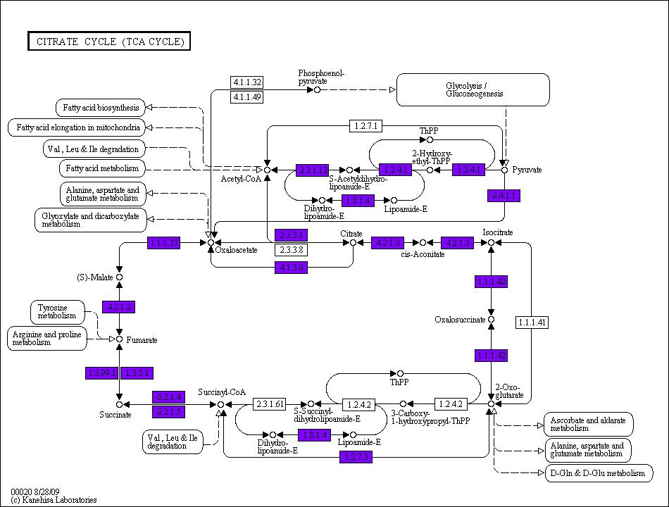
Figure 14. This is the KEGG map that I produced as a result of this study. Only seven enzymes appear to be missing from the genome, none of which appear to be necessary for the completion of the citrate cycle.

Furthermore, the enzymes missing from the cycle do not appear to be necessary to complete the citrate cycle. In each instance where an enzyme is missing, there is a different enzyme present that can bypass that part of the cycle. Also, it is quite possible that annotation services have missed one of these enzymes in the annotations of many other species causing this enzyme to be left out of many different annotations. Without a similar sequence from a related species available to compare to the H. mukohataei genome, this enzyme would continue to appear to be missing from the genome. Regardless of the inaccuracies and differences in different annotation programs, it is very probable that the citrate cycle is an important process for H. mukohataei and related halophiles.
In the future, we can use the list of conserved proteins in H. mukohataei and related species to dissect other metabolic pathways to determine which enzymes and pathways appear to be highly conserved. Such a comparison will be helpful to determining which processes are important for H. mukohataei and related halophiles to maintain life. Additionally, thorough examination of such pathways for enzymes that appear to be missing can help fill in gaps in the available data. With dozens of new organisms annotated daily, these mistakes in current annotations will be carried into new annotations. Future annotations will be more accurate if the current data bases are corrected.
Acknowledgements
I would like to thank Olivia Ho-Shing for her work to create the Perl script that we used in this project. Also, thank you to Bill Hatfield who created a program that saved us a lot of time. Thanks to Dr. Malcolm Campbell. Without your guidance and assistance this work would not have been possible. Finally, thanks to the entire Laboratory Methods in Genomics class at Davidson College from fall 2009. Without the ability to brainstorm as a group and sort through problems together, dissecting the H. mukohataei genome would have been a much more difficult task.

References
Arakawa, T & SN Timasheff (1984). Mechanism of Protein Salting In and Salting Out by Divalent Cation Salts: Balance between Hydration and Salt Binding. Biochemistry 23: 5912-5923.
Booth, I (1985). Regulation of cytoplasmic pH in bacteria. Microbiological Reviews 49(4): 359-378.
Ghosh, M & HM Sonawat (1998). Kreb's TCA cycle in Halobacterium salinarum investigated by C-13 nuclear magnetic resonance spectroscopy. Extremophiles 2(4): 427-433.
Hong, S & Pogliano, K (2007). Halobacterium sp. NRC-1 – MicrobeWiki. < http://microbewiki.kenyon.edu/index.php/Halobacterium_sp._NRC-1> accessed October 3rd, 2009.
Ihara, K, S Watanabe, & T Tamura (1997). Haloarcula argentinensis sp. nov. and Haloarcula mukohataei sp. nov., two new extremely halophilic archaea collected in Argentina. International Journal of Systematic Bacteriology 47(1): 73-77.
KEGG (2009). Citrate cycle (TCA cycle) – Reference Pathway < http://www.genome.jp/kegg/pathway/map/map00020.html> accessed November 29th, 2009.
Oren, A, M Heldal, S Norland, & EA Galinski (2002). Intracellular ion and organic solute concentrations of the extremely halophilic bacterium Salinibacter ruber. Extremophiles 6:491-498.
Purves, WK, D Sadava, GH Orians, HC Heller (2004). Life: The Science of Biology, 7th Edition. New York: W H Freeman & Co.
Strahl, H & J Greie (2008). The extremely halophilic archaeon Halobacterium salinarum R1 responds to potassium limitation by expression of the K+-transporting KdpFABC P-type ATPase and by a decrease in intracellular K+. Extremophiles 12:741-752.
Sugiyama, Y., N Yamada, Y. Mukohata (1994). The light-driven proton pump, cruxrhodopsin-2 in Haloarcula sp. Arg-2 (bR+, hR-), and its coupled ATP formation. Biochimica et Biophysica Acta 1188(3): 287-292.
Thomas Learning, Inc (2002). Chapter 5 – Active Transport < http://bioactive.mrkirkscience.com/05/ch5c4.html> Accessed December 5th, 2009.

