An Exploration of DNA Repair Mechanisms and CRISPR sequences
in Halomicrobium mukohataei
Sarah Pyfrom, Olivia Ho-shing, Katie Richeson,
Claudia Carcelen, Megan Reilly and Karen Hasty
Abstract:
In an attempt to better understand its ability to survive in adverse conditions and its relationship to other halophiles, I studied H. mukohataei’s DNA repair mechanisms and CRISPR sequences. Using JGI and RAST’s annotation of the H. mukohataei genome, I searched for DNA repair mechanisms, finding evidence for a photoreactivation as well as Base-excision repair pathways. A comparison of photolyase genes across several species showed that a conserved sequence may be the source of halophile’s ability to survive high levels of UV radiation. In an attempt to learn more about H. mukohataei’s relationship to other halophiles, we compared CRISPR Direct Repeats, spacers and associated proteins across multiple halophilic species. Our results varied in their ability to determine accurate evolutionary relationships.

Introduction:

Halomicrobium mukohataei is a halophilic archaea found in large salt flats. Like other halophiles, it can withstand –even thrive in—high salt environments. The salt plains where it is found are open and exposed to the elements. There is little protection from the sun and therefore its potentially damaging UV rays. I chose to investigate H. mukohataei’s ability to withstand UV radiation; specifically how its DNA repair process might enable it to survive the mutational effects of UV light.
UV light is responsible for any number of damaging effects on a cell’s proteins and other macromolecules. However, DNA is the largest and most exposed molecule in the cell and easily absorbs UV radiation (Smith, 2009). Mutations often result from this absorption. The most common form of damage by UV light is the formation of pyrimidine dimers. Dimers are two adjacent pyrimidines that become covalently bonded to one another, either T-T (most common), T-C or C-C (least common). This causes an imperfection in the double helix structure that the photolyase can recognize and correct (Chandrasekhar et al, 2000 and Pyrimidine Dimers, 2009).
Deoxyribodipyrimidine photolyase is an enzyme that breaks the covalent bonds formed in pyrimidine dimers in a process called photoreactivation. If these dimers are not repaired, then cytosines involved in dimers are much more likely to be deaminated and converted to uracil. If this happens, then errors may be made during transcription or translation of that section of DNA (Cannistraro et al, 2009).
This photoreactivation process is common to almost all archaea and bacteria. Similarly, CRISPR sequences can be found in almost all archaea and bacteria. CRISPRs are Clustered Regularly Interspersed Palindromic Sequences. The sequences are not strictly palindromic but show conserved Direct Repeats separated by non-identical spacers (Figure 1).

Figure 1: Diagram showing a basic CRISPR sequence. Direct Repeats are shown as yellow blocks and spacers as variably-colored rectangles. The leader sequence is shown in light blue and the shortened or degenerate DR is shown as a smaller yellow block towards the end of the CRISPR sequence.

As show in Reidun et al (2006), the spacers in between Direct Repeats are thought to be fragments of viral DNA that was somehow incorporated into the host DNA. It is surmised that the spacers may be involved in some form of RNA interference immune response to viral invasion. Proteins often associated with CRISPR sequences (called Cas-proteins) may be involved with the incorporation or removal of the spacers after the initial viral invasion or in response to a second infection. While their exact function is not known, Figure 2 shows a proposed mechanism for how CRISPRs may be involved in viral defense.

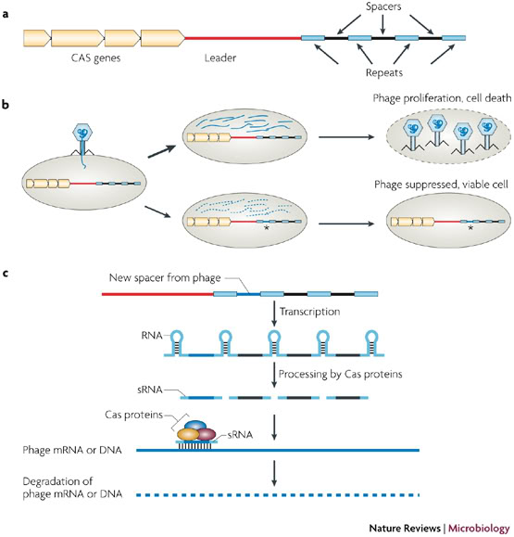
Figure 2: A proposed mechanism for how CRISPRs may be involved in an immunological response to viral invasion. A) A diagram showing the geographic relationship between the CRISPR sequence and CAS genes. B) Shows the two potential pathways of phage infection. The upper diagram shows phage proliferation followed by cell death. The lower diagram shows the inclusion of phage DNA into a CRISPR sequence within the host genome. C) Shows transcription of CRISPR sequence and formation of three-dimensional RNA hairpins. This is followed by processing by Cas proteins to form siRNA. A complex formed from Cas proteins and siRNA from CRISPR spacers then breaks down invading viral DNA or mRNA.

Methods:

DNA Repair: I used BLASTn to verify JGI’s annotation of the three photolyase genes found in H. mukohataei. I also used COBALT to create an alignment of the photolyase genes in H. mukohataei and the nine other halophiles used in the Proteome Compare.
Proteome Comparison: We used a program created by Olivia Ho-shing to compare nine different proteomes with the proteome of H. mukohataei. The nine proteomes came from the following species: Haloarcula sinaiiensis, Haloarcula vallismortis, Haloarcula californiae, Haloferax denitrificans, Haloferax mediteranei, Haloferax volcanii, Haloferax sulfurifontis, Haloferax mucosum, Halomicrobium mukohataei and Halorhabdus utahensis. The program was designed to distinguish proteins that were conserved between the two compared species and proteins that were unique to H. mukohataei. Several of our classmates used the data from this comparison, along with JGI, RAST annotations and KEGG, to try and find genes within specific pathways that had been missed by the annotation services

CRISPR: Our first directive was to determine whether or not our species’ genome did, in fact, contain a CRISPR sequence. We submitted our genome and nine others, obtained from ____, to CRISPRFinder. After looking for the CRISPR sequence itself, we broke the project down into three smaller sub-projects: Direct Repeats, Spacers and CRISPR-associated Proteins. One member of our group endeavored to find out more about an aspect of the CRISPR sequences and how our species compared to the nine others we used for our whole-genome compare. This included running all ten of the species through CRISPRFinder and isolating their DRs and spacers.

CRISPR Direct Repeats: Olivia used BLASTn to search for sequences similar to the DRs found in our genome and the nine other halophilic genomes. She also used ClustalW to perform a multiple sequence alignment of the DR sequences and to produce a phylogenetic tree of her results, in an attempt to determine whether DR sequences could be an accurate determinant of evolutionary relationship.

CRISPR spacers: Katie used BLAST to search for significant hits within other species that matched H. mukohataei’s spacers. She also used BLASTn to search for viral fragments from within the complete genomes of H. vallismortis, Halorhabdus utahensis, Haloarcula sinaiiensis and Halobacterium salinarium R1. She acquired the genomes from either NCBI or RAST.

CRISPR-associated Proteins: I used BLAST to verify JGI’s annotation. I used ClustalW to create alignments and a phylogenetic tree based on Cas-protein amino acid sequence similarity. I used JGI’s H. mukohataei database in order to find and diagram Cas-proteins in relation to the CRISPR sequence.

Results:

DNA repair:
I began by looking for papers concerning related halophiles and their ability to withstand the negative effects of UV radiation and exposure. One paper (Baliga et al, 2004) found that halophiles have an increased ability to survive high levels of UV radiation due to a photolyase gene.
I began my search of our species’ genome with a hunt for photolyase genes. In JGI I found one deoxyribodipyrimidine photolyase (DDPs), one DDP-related gene and a DNA repair photolyase. I first wanted to be sure that JGI had accurately identified the genes as photolyases so I BLASTed the nucleotide sequences of all three and only the first DDP showed strong identity with a photolyase in another halophiles. Knowing that amino-acid sequences are often more highly conserved than nucleotide sequences, I BLASTed the amino acid sequences of all three genes and found a wealth of similarities which all suggested that the first two genes were deoxyribodipyrimidine photolyases (see figures S4 and S5), with the third gene suggested as a member of the Radical SAM protein family. Further research showed that the Radical SAM family is a diverse group of proteins responsible for reductive cleavage of S-adenosylmethionine and may be involved in DNA repair (Sofia et al, 2001).
The BLAST hits with the most significant alignments for H. mukohataei’s DNA repair photolyase included Radical SAM proteins in H. marismortui, Lyngbya sp. and Cyanothece sp. PCC 8802. H. marismortui is a closely related halophile and the latter two species are cyanobacteria found in exposed mats in Mexico and rice paddies respectively (Lucas et al, 2009 and Omoregie et al, 2004).
BLAST results from the JGI-labeled dideoxyribodipyrimidine photolyase brought up significant hits in H. marismortui, Natronomonas pharaonis and Haloquadratum walsbyi DSM 16790. N. pharaonis was isolated from soda lakes in Egypt and Kenya. Haloquadratum walsbyi DSM 16790 was isolated from solar salterns in Australia and Spain. These are large, shallow ponds of seawater from which the water has evaporated, leaving behind salt deposits. (Soliman et al, 1982 and Burns et al, 2007).
Finally, I was curious as to what similarities there were between H. mukohataei’s photolyases. I used ClustalW to perform a multiple alignment with the amino acid sequences of all three photolyase genes within the H. mukohataei genome. The three photolyase proteins had a very low alignment score of 38.

Genome comparisons:
Olivia’s program compared whole proteomes from nine halophiles with H. mukohataei’s proteome. The program presented both proteins that were conserved between H. mukohataei and each halophile and those that were unique to H mukohataei.
Several members of our group chose to study the comparisons to deduce which genes were conserved or unique in specific metabolic pathways. They found that JGI and RAST differed in their annotations and their own research lead them to believe that some of the pathways in H. mukohataei that were annotated by JGI and RAST were more actually complete but unidentified by the annotation services. In several instances Claudia, Karen and Megan all found that JGI and RAST had different annotations, which labeled the same gene in different places or simply did not recognize the same genes at all.
In their attempts to fill the gaps left by the annotation process, they discovered several likely gene-candidates within the genetic data that were unnoticed by JGI, RAST or both.

CRISPR :

Direct Repeats:
For each questionable or confirmed CRISPR sequence, a consensus sequence of the Direct Repeats (DR) for that CRISPR is presented. We wanted to determine whether or not the consensus DR sequence might be conserved within or across the 10 species we looked at for our genome comparison project. CRISPR sequences (and therefore DRs) were found in eight of the nine halophiles we chose to study. H. vallismortis did not have any confirmed sequences when run through CRISPRFinder.
Olivia found that BLASTing the DRs found in H. mukohataei brought up significant matches in Haloarcula marismortui, Halorhabdus utahensis and Natronomonas pharaonis. Of these three significant alignments, two were already included in the list of nine halophiles we intended to use in our study. Olivia then produced a multiple alignment of all the DR sequences found in the other eight halophiles as well as our species and N. pharaonis. Using ClustalW, she created a phylogenetic tree based on sequence similarity of the ten species (Figure 3).

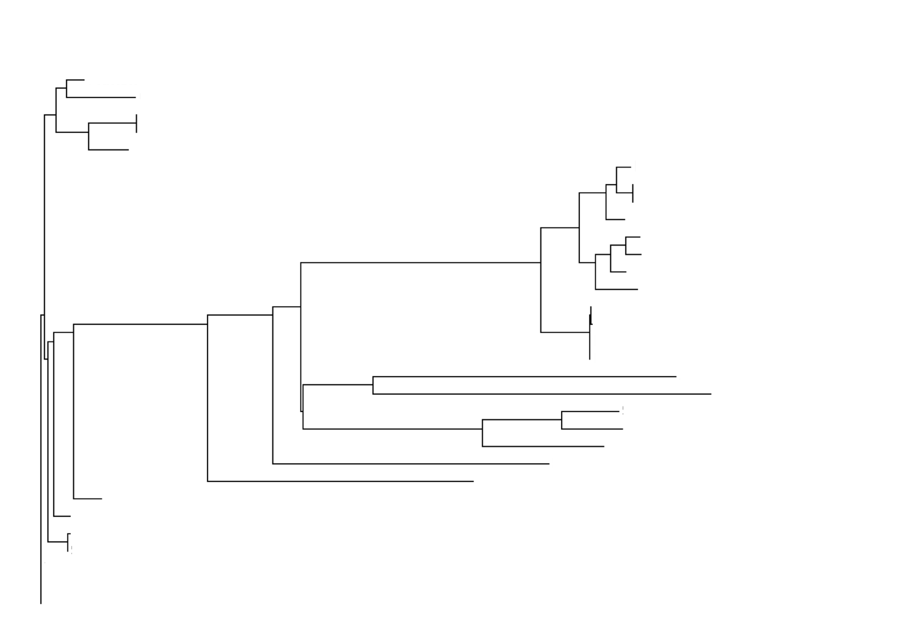
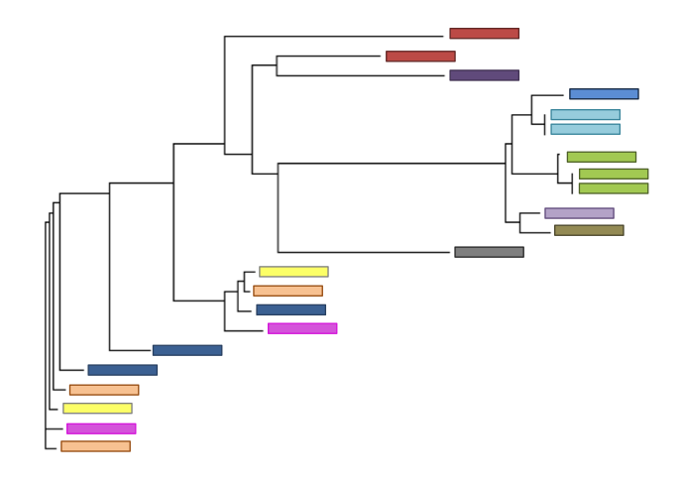
b)
a)

H. californiae
H. denitrificans
H. marismortui
H. mediterranei
H. mucosum
H. mukohataei
H. sinaiiensis
H. sulfurifontis
H. utahensis
H. volcanii
N. pharaonis
H. vallismortis

Figure 3: Phylogenetic trees showing sequence similarity of a) 16s rRNA and b) DR sequences from the ten halophiles shown in the legend below.

As shown in Figure 3a, the 16srRNA tree was more effective at grouping species together. Groupings of H. mukohataei, H. sulfurifontis and H. denitrificans can clearly be seen. In 3b, species are more spread out and the Direct Repeats did not seem to accurately cluster many species together. The two trees also show very little similarity to one another.

Spacers:
CRISPR spacers have been shown to contain fragments of viral genomes in some species (Lillostel et al, 2006). Katie, another member of the group, explored whether our spacers contained any viral fragments and, if so, whether closely related halophiles also shared the same viral footprints.
BLASTn results from all the spacers within the H. mukohataei genome found three viral hits with E-values below 0.009: Archaeal BJ1 Virus, Burkholderia phage and Mycobacterium phage. Katie then searched for fragments from the same three viruses in four other, related halophiles. She intended to pinpoint whether any viral hits were within CRISPR sequences or not.
All four related halophiles had significant hits within their genome when BLASTed against the entire viral genomes of the three viruses found in the H. mukohataei spacers. However, the hits were not within CRISPR sequences in any of the four genomes, other than in our own.

CRISPR-associated Proteins
JGI originally detected four CAS-protein families within the H. mukohataei genome: Cas1, Cas2, Cas3, Cas4, TM1800, TM1801. I first wanted to determine possible functions for these proteins. (Find Paper name) Many attempts have been made to characterize and define the biological process for these proteins, though none have firmly decided upon a definitive role. Cas1 is commonly thought to be a high-affinity nucleic acid binding protein that can bind to DNA, RNA or a DNA-RNA hybrid. Some think it promotes the hybridization of complementary nucleic acid strands. Others believe it to be some form of integrase that is involved in the capture of new viral particles into the host’s CRISPRs (Lillestol et al, 2006). Cas3 shares properties with helicases and Cas4 with exonucleases. Both of these proteins were originally suspected to be involved with some kind of DNA repair or metabolism (Lillestol et al, 2006). TM1800 and TM1801 are a loosely defined family of Cas-proteins with a wide range of accepted properties.
Using the data from the Proteome Compare, I was able to determine which species closely-related to H. mukohataei had the same Cas-proteins (Table 1). H. vallismortis and H. volcanii did not show any signs of containing Cas-proteins similar to those found in H. mukohataei. According to CRISPRFinder, H. vallismortis had no CRISPR sequences at all, whereas H. volcanii did. Most of the other halophiles had most of the Cas-proteins found in H. mukohataei.

Species | Cas1 | Cas2 | Cas3 | Cas4 | TM1800 | TM1801
H. vallismortis
H. volcanii
H. sulfurifontis | X |  |  | X
H. californiae |  |  | X |  | X | X
H. sinaiiensis | X |  | X | X | X | X
H. utahensis | X | X | X | X | X | X
H. mucosum | X | X | X | X | X | X
H. mediteranei | X | X | X | X | X | X
H. denitrificans | X | X | X | X | X | X
H. mukohataei | X | X | X | X | X | X
Table 1: A table showing the six Cas-proteins found in H. mukohataei originally labeled by JGI. An x denotes the presence of that protein in the genomes listed to the left. All data was based off of Olivia’s Proteome Compare program output.

I then wanted to determine how Cas-proteins in different species were related to one another. It has been suggested that CRISPR sequences acquire new spacers on one end of the CRISPR unit. This means that they grow predictably and it may be possible to detect evolutionary relationships between species by comparing the order and kind of spacers conserved within the CRISPR. I wanted to see if the same was true for Cas-Proteins. It seems likely that they would perform a highly specialized task and conservation among species could lead to similarities altered only by evolutionary distance.
I used ClustalW to produce a phylogenetic tree based on the protein sequences for the Cas proteins found in eight halophiles, including H. mukohataei (Figure 4). I expected similar proteins to cluster together or for proteins from the same species to cluster together. However, as you can see in the figure below, proteins seemed to cluster almost randomly with one cluster of TM1801 proteins, a cluster of Cas2 proteins, a cluster of Cas4 proteins and a cluster of H. sulfurifontis genes.
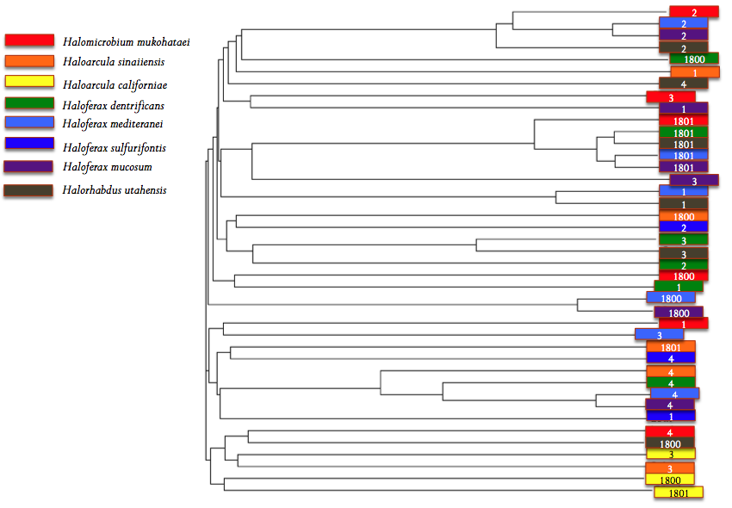

Figure 4: Phylogenetic tree of eight halophiles’ Cas-protein amino acid sequences. The legend to the left shows which species is associated with which color in the phylogram. The colored boxes are also labeled by kind of Cas protein (1 = Cas1, 2= Cas2, etc.). The red boxes indicate clusters of similar genes.

JGI later changed its annotation of the Cas-proteins. The new annotation suggested that H. mukohataei had seven Cas-proteins rather than six (Figure 5). Cas1 and Cas2 remained the same while Cas3 was changed to a hypothetical protein. Cas4 was shortened while the TM1800 and TM1801 family Cas-proteins were relabeled as Cas5 and Csh2 respectively. Finally, two hypothetical proteins in the original annotation became labeled as Csh1 and Cas6. Also note in Figure 5, that JGI labeled two transposases between the CRISPR sequences and the Cas-proteins.
I wanted to create a new phylogenetic tree based on JGI’s new annotation but was confounded by a lack of data. Cas proteins in different species might be related but labeled differently so it is very difficult to search for Cas proteins in other species for a comparison. The Proteome Compare data gave me a universal labeling system, through which I was able to make more specific comparisons. Due to the time and effort necessary for just a few whole-proteome comparisons, I was unable to create new inter-species comparisons based on the new JGI annotation.

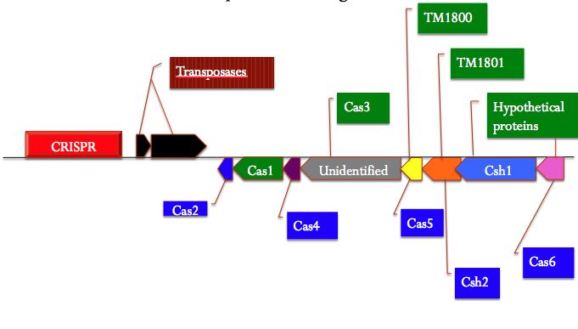
Figure 5: A diagram showing the order in which Cas proteins appear in the H. mukohataei genome, relative to the CRISPR sequence. The diagram shows both the original (green) and new (blue) gene labels based on JGI’s annotation.

Discussion:

DNA Repair:
The fact that the H. mukohataei photolyase genes did not show any significant alignment suggests that they may serve different functions within the cell. It is possible that the presence of multiple photolyase genes could contribute to H. mukohataei’s success in open and exposed salt flats.
The significant alignments with cyanobacteria are not surprising. These species are also found in exposed conditions and likely deal with damage due to UV radiation. Perhaps it is due to their similarities that both of these species are able to withstand such difficult environments. It is, however, odd that more similarities with other halophiles did not appear. Most of them are found in salt flats, like H. mukohataei, and therefore deal with similar selection pressures.

CRISPR:
Spacers:
While multiple inquiries into CRISPR spacers have found that the spacers are viral remnants, it is not overly strange to discover only a few viral footprints within H. mukohataei’s spacers. Out of all the viruses that this species might come in contact with, only a very few have actually been sequenced; as low as 2% by Katie’s estimate. Therefore, it is likely that some of the spacers may be viral fragments that were not recognized by BLAST’s database. The information it is drawing from is vast by anyone’s standards but not anywhere near complete. More recent research has also determined that, even among closely related species, spacers can be radically different due to constantly changing viral populations (Makarova et al, 2006). This is another possible reason why more similar viral fragments were not found even in the closely-related halophiles that we studied.
Direct Repeats:
We have also learned that Direct Repeat sequences are not necessarily the most accurate way to determine evolutionary relationships between halophiles. The Direct Repeats are variable within a species as well as between species and this causes problems when building a phylogenetic tree. Even within a CRISPR, the Direct Repeats can vary, making it more reasonable to use the consensus sequence like Olivia did, but less reliable (Lillestol et al, 2006).
In a recent paper, it has been discovered that the Direct repeats may be involved in the creation of stable, 3 dimensional RNA constructs that aid in the signaling and binding of Cas-proteins (Kunin et. al, 2007). Perhaps future inquiry into this aspect of Direct Repeats would shed more light on their variability within and across genomes.
CRISPR-associated proteins:
Upon first glance, most Cas-proteins appear to be involved in DNA repair. Their hypothesized functions as exonucleases, helicases and other assorted DNA repair functions seem to support this theory. However, the scientific community at large agrees that their association with CRISPR sequences is unlikely to be mere coincidence. Makarova et. al could not find Cas genes or gene families that were orthologous to known eukaryotic siRNA system proteins. However, like the Cas-proteins, slicer and dicer (components of the eukaryotic siRNA system) are endonucleases and helicases respectively. Though we have not identified the exact function of the Cas-proteins yet, it is not unreasonable to think that we might discover their purpose in a prokaryotic and archaeal immune response (Makarova et al, 2006).
Transposases have also been noted as having a relationship with CRISPR sequences. In many species—including Mycobacterium tuberculosis—transposases have been found inserted within CRISPR sequences. It has been suggested that CRISPR sequences might be attractive in some way to transposases in order to manufacture their excision, or to interrupt the function of the CRISPR sequence. It has also been surmised that it would be evolutionarily beneficial to attract transposases to a section of the genome whose interruption would not be massively detrimental to the cell (Tyson et al, 2008). The fact that these genes exist within the H. mukohataei genome makes it highly likely that the CRISPRs and proteins are functional in creating an immunological response should H. mukohataei suffer a pathogenic infection as well as a potential “safe area” for transposase interaction.
As for JGI’s annotation it is likely that they identified the first six genes based on existing knowledge of Cas-proteins and later updated its information based on new research. As time progresses, we will likely discover new families and purposes for each Cas-gene. While this updating process brings new information to our fingertips, it also brings with it a warning about how reliable any present annotation might be.

Reliability of Annotation Services:
At several times during my inquiry into the H. mukohataei genome, I was forced to acknowledge inconsistencies and shortcomings within the annotation services I chose to use. RAST failed to identify both photolyases and CRISPR sequences within our species’ genome. JGI also altered its annotation to completely change the position and names of several proteins. These programs are limited by a lack of human intuition. And, even if a program were to correctly identify all the genes it could based on present knowledge, our understanding of the genome is constantly changing. What we believe to be true today could be disproved tomorrow. That is why it is necessary to investigate the results given to us by websites such as JGI and RAST. They provide us with a starting point to begin our research but it is up to us to verify their findings.

Future Research:
A lot of research has been conducted on DNA repair mechanisms, but I do think that the scientific community at large would benefit from continued research specifically in halophilic DNA repair. As scientists work to create new organisms that could potentially help in real world situations, they must take into account real world conditions. Most laboratories do not have high levels of UV radiation, unlike the open ocean or a waste dump, yet these are the places that engineered organisms are being sent. If they are unable to survive in the environment they were created to help, then what good can they do? These organisms are also created to very exact specifications. Mutations that do not kill them might render them incapable of performing the function they were meant to or might even alter that function (potentially in a harmful way). With knowledge of our organism's (and other halophiles) more efficient UV-radiation-induced DNA damage repair, perhaps genomicists will be able to assist in the development of better bio-tools.
In future, I think looking at CRISPR sequences as a whole would be most beneficial. The evolutionary relationships most often spoken of in the literature are between the synteny and acquisition of spacers. They tend to be added to one end of the CRISPR sequences and, when species diverge from one another, each new species acquires different spacers (Lillestol, et al, 2006). Looking just at proteins, spacers or direct repeats by themselves would not be as helpful as taking into consideration how the entire CRISPR and CRISPR-associated genes are organized on the chromosome.
I also believe that we are depending too much on previously acquired hypotheses in order to formulate new ideas. Starting by comparing new data to old data is beneficial and provides us with a starting place for our research. However, the scientific community seems to have only gone so far as to say that Cas-proteins are associated with CRISPRs and may be involved in a novel form of siRNA immune response. It has been discovered that at least one Cas-protein interacts with CRISPR sequences in S. solfataricus (Peng et al., 2003). Perhaps looking at immunoprecipitation of Cas-proteins to determine whether they interact with each other post viral-invasion or with RNA molecules in vivo would be a possible next step for researchers.

Works Cited:
Bakke, P., arney, N., DeLoache, W., Gearing, M., Ingvorsen, K., Lotz, M., McNair, J., Penumetcha, P., Simpson, S. Voss, L., Win, M., heyer, L., Campbell, M.(2009). Evaluation of Three Automated Genome Annotations for Halorhabdus utahensis. PLoS ONE 4(7): e6291. doi:10.1371/journal.pone.0006291

Baliga, N., Bjork, S., Bonneau, R. (2004) Systems Level Insights into the Stress Response to UV Radiation in the Halophilic Archaeon Halobacterium NRC-1. Genome Rs. 14, 1025-1035. doi:10.1101/gr.1993504

Base excision repair. (2009, September 21). In Wikipedia, The Free Encyclopedia. Retrieved 13:33, October 6, 2009, from http://en.wikipedia.org/w/index.php?title=Base_excision_repair&oldid=315237793

Burns DG, Janssen PH, Itoh T, Kamekura M, Li Z, Jensen G, Rodríguez-Valera F, Bolhuis H & Dyall-Smith ML (2007) Haloquadratum walsbyi gen. nov., sp. nov., the square archaeon of Walsby, isolated from saltern crystallizers in Australia and Spain. Int J Syst Evol Microbiol 57: 387–392.

Cannistraro, V., Taylor, J. (2009). Acceleration of 5-Methylcytosine Deamination in Cyclobutane Dimers by G and Its Implications for UV-Induced C-to-T Mutation Hotspots. Journal of Molec. Biol. 392(5), 1145-1157. doi: doi:10.1016/j.jmb.2009.07.048.

Chandrasekhar, D., Van Houten, B. (2000). In vivo formation and repair of cyclobutane pyrimidine dimers and 6-4 photoproducts measured at the gene and nucleotide level in Escherichia coli. Mutation Research/Fundamental and Molecular Mechanisms of Mutagenesis. 450(2) 19-40. doi: doi:10.1016/S0027-5107(00)00014-2.

Huberman. (2006). Base Excision Repair (BER). Retrieved from http://asajj.roswellpark.org/huberman/DNA_Repair/ber.html

Kunin V, Hugenholtz P. (2007). CRISPR — a widespread system that provides acquired resistance against phages in bacteria and archaea. Nat Rev Microbiol 6: 181.

Lucas S., Copeland A., Lapidus A., Glavina del Rio T., Dalin E., Tice H., Bruce D., Goodwin L., Pitluck S., Sims D., Meincke L., Brettin T., Detter J.C., Han C., Larimer F., Land M., Hauser L., Kyrpides N., Mikhailova N., Pakrasi H.B., Sherman L. (2009). Complete sequence of chromosome of Cyanothece sp. PCC 8802.EMBL/GenBank/DDBJ databases.

Makarova, K., Grishin, N., Shabalina, S., Wolf, Y., Koonin, E. (2006) A putative RNA-interference-based immune system in prokaryotes: computational analysis of the predicted enzymatic machinery, functional analogies with eukaryotic RNAi, and hypothetical mechanisms of action. Biol Direct 1:7.
Omoregie, E. Crumbliss, L., Bebout, B., Zehr, J. (2004). Determination of nitrogen-fixing phylotypes in Lyngbya sp. and Microcoleus chthonoplastes cyanobacterial mats from Guerrero Negro, Baja California, Mexico, Appl. Environ. Microbiol.,70, 2119–
2128.

Peng, X., Brugger, B. Shen, L., Chen, Q., She and R.A. Garrett. (2003). Genus-specific protein binding to large clusters of DNA repeats (Short Regularly Spaced Repeats) present in Sulfolobus genomes. J. Bacteriol. 185:2410-2417.

Pyrimidine dimers. (2009, September 2). In Wikipedia, The Free Encyclopedia. Retrieved 13:31, October 6, 2009, from http://en.wikipedia.org/w/index.php?title=Pyrimidine_dimers&oldid=311546199

Reidun, L., Redder, P., Garrett, R., Brugger, K. (2006). A putative viral defense mechanism in archaeal cells. Archaea. Vol 2. Retrieved from http://archaea.ws.

Smith, Kendric,. (2009) BASIC ULTRAVIOLET RADIATION PHOTOBIOLOGY. Stanford University School of Medicine. Retrieved from http://www.photobiology.info/UVphotobiology.html.

Sofia, H., Chen, G., Hetzler, B., Reyes-Spinolda, J., Miller., N. (2001). Radical SAM, a novel protein superfamily linking unresolved steps in familiar biosynthetic pathways with radical mechanisms: functional characterization using new analysis and information visualization methods. Nucleic Acids Research 29(5), 1097-1106. Retrieved from http://nar.oxfordjournals.org/cgi/content/full/29/5/1097.
Soliman G.S.H, Truper H.G. (1982). Halobacterium pharaonis sp. nov., a new, extremely haloalkaliphilic archaebacterium with low magnesium requirement.
Zbl. Bakt. Hyg., I. Abt. Orig. C 3, 318-329
Tyson GW, Banfield JF. (2008) Rapidly evolving CRISPRs implicated in acquired resistance of microorganisms to viruses. Environ Microbiol.10(1):200–207.

