Halomicrobium mukohataei arg-2 is a species of halophilic Archaea annotated and made available to my colleagues and I through JGI and RAST. We explore ion homeostasis and halophilic ability to survive in salt salinity and the viral defense mechanism of CRISPR sequences in the context of Halomicrobium mukohataei .
We analyze different ion and ion-dependent pumps across species of halophiles, compare potassium homeostasis genes and search for confirmed potassium homeostasis mechanisms (KdpFABC operon) in Halomicrobium mukohataei and other halophiles. These results show that potassium homeostasis, although possibly controlled by various different mechanisms in different halophiles, appears to be necessary to the survival of many halophiles and may in fact be one reason behind the ability of halophiles to live in extreme salt conditions.
We also analyze the functionality of CRISPR sequences as a mode of viral defense within Halomicrobium mukohataei and other halophiles by exploring DR similarity and dyad symmetry, the presence of viral segments in spacers, and the efficiency/frequency of capturing viral DNA in spacers. From these analyzes we conclude that the hypothesized CRISPR viral defense mechanism can be supported by the presence of viral DNA in spacers and the conservation of DR sequences and dyad symmetry. We also conclude that the efficiency of viral uptake by spacers is rather low, possibly indicating a secondary role for CRISPR sequences in Archaea genomes.
Halomicrobium mukohataei:
Surviving High Salinity and CRISPR Sequences as Viral Defense
Katie Richeson, Olivia Ho-Shing, and Sarah Pyfrom, Claudia Carcelen and Karen Hasty
Department of Genomics, Davidson College, Davidson, North Carolina 28035

Introduction
Colleagues and I explored various facets of Halomicrobium mukohataei arg-2’s annotated genome, available to us through Joint Genome Institute’s (JGI) Adopt a Genome Project [http://www.jgi.doe.gov/ education/adoptagenome/index.html], which provides annotated genomes to colleges for educational purposes, and Rapid Annotation using Subsystem Technology (RAST) [http://rast.nmpdr.org/], an independent annotating company. Sequenced using the 454 and Sanger methods once first isolated, the entire genome of Halomicrobium mukohataei consists of two scaffolds and a plasmid. JGI indicates that our investigatory species possess 3,330,615 nucleotide bases, 3,456 genes and 3,399 protein-encoding genes.
Halomicrobium mukohataei is a species of Archaea originally isolated by Ihara et al. in 1997 from soil in Argentinean salt marshes. This rod-shaped single-cell microorganism is a mesophilic, heterotrophic facultative aerobe (Oren et al., 2002). More notably, Halomicrobium mukohataei is a “salt-loving” species of Archaea also know as a halophile (Oren et al., 2002).
In the following paper I will explore two main aspects of Halomicrobium mukohataei: I will address how halophiles are able to survive in high salinity environments, specifically focusing on maintaining homeostasis. The second part of my paper will address a novel area of research concerned with CRISPR sequences, which are non-coding portions of DNA in prokaryotes thought to act as a mode of viral defense. For the remainder of the paper, these two subsections will be divided and addressed separately.
Homeostasis and Halophiles
What makes Halomicrobium mukohataei able to survive in high salt concentrations- does the answer lie in this species’ genome? One hypothesis suggests that halophiles possess an obligate ability to maintain ionic homeostasis across its plasma membrane in the presence of high solute (salt) concentrations, which would explain their ability to survive in such extreme salt environments (Christner, 2009).
In order to survive, all organisms regulate their internal environment by maintaining homeostasis through the use of molecular channels and pumps; in particular, the use of ion and ion-dependent pumps maintaining osmotic pressure. Halophiles, including Halomicrobium mukohataei, must maintain such ionic homeostasis and osmotic pressure in high salt (and therefore high ion) environments, placing a unique stress on such “salt-loving” organisms. In particular "Halotolerant halophilic microorganisms . . . ‘tend to’ accumulate high solute concentrations within the cytoplasm," (Christner, 2009) in order to balance the extreme concentration of ions (Na⁺ and Cl⁻) outside the cell and maintain appropriate osmotic pressure.
Embedded in plasma members of halophiles, particularly Halomicrobium mukohataei, there are many different types of ion and ion-dependent transporters (pumps and channels) (Table 1).
Table 1. Description of transporters in Halomicrobium mukohataei’s periplasm
Transporter Name | Transports. . .
Tripartite ATP-independent periplasmic (TRAP)  (Shaw et al., 2006) | - C4-dicarboxylates malate, succinate and fumarate  - Essential for aerobic respiration
Energy-coupling factor (ECF)  (Neubauer et al., 2009) | - Micronutrients
Ni⁺² and Co⁺² transporters | - Charged Ni and Co ions
ATP-Binding Cassette (ABC)  (“ATP-binding cassette transporter,” 2009) | - Lipids, metabolic products, sterols, ect.
Potassium (K⁺) transporters | - Charged K ions
Table 1. The names of transporters in Halomicrobium mukohataei’s periplasm and what each relocates across the periplasm. All of the transporters above are ion or ion-dependent transporters as established by RAST annotation of Halomicrobium mukohataei’s genome.

Do the genomic reasons behind the ability of Halomicrobium mukohataei’s to survive in high salt concentrations lie in the genes of certain ion or ion-dependent transporters? In fact, Halobacterium salinarum (Strahl and Greie, 2008) and Salinibacter rubber (Oren et al., 2002) rely on the ionic K⁺ gradient in order to maintain homeostasis and therefore survive in high salt environments (Christner, 2009). Furthermore researchers identified a specific operon, known as the KdpFABC operon, which is necessary for Halobacterium salinarum’s K⁺ transport mechanism. Strahl and Greie note that the KdpRABC operon “. . . utilize’s’ organic solutes to equalize osmotic pressures in high salinity environments” (Strahl and Greie, 2008). Therefore research behind the ability of potassium transporter mechanisms to contribute to the survival of halophiles in high salt environments is strongly supported in Halobacterium salinarum, but does Halomicrobium mukohataei also possess the KdpFABC operon and similar potassium homeostasis genes?

CRISPR Sequences: Viral Defense Mechanism
Halomicrobium mukohataei’s genome, like most Archaea, houses CRISPR sequences, Clustered Regularly Interspersed Short Palandromic Repeats. CRISPRs are sections of non-coding DNA found in prokaryotes that vary in length and consist of many direct repeat (DR) segments separated by unique spacers of a similar length (Figure 1). Flanking the whole repeating unit is CRISPR associated proteins (CAPs) (LILLESTØL et al., 2006).

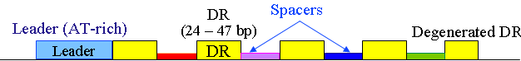
Figure 1. CRISPR diagram

Figure 1. Visual representation obtained from CRISPRfinder of a CRISPR sequence with 4 spacers and 5 DRs. A CRISPR sequence can have any number of spacers and DRs. CRISPR associated proteins are not illustrated above, but flank either side of the complete CRISPR.

Little is known about the function of CRISPR sequences, but scientists hypothesized since they discovered the CRISPR structure that CRISPRs played a role in segregation and partitioning of the genome (LILLESTØL et al., 2006). Scientists are more familiar with the structure of CRISPRs; in fact, programs based on searching for the unique CRISPR structure, such as CRISPRfinder, exist in order to locate CRISPR sequences in various prokaryotic genomes. With increasing data on the structure and presence of CRISPR sequences, the old partitioning hypothesis was recently questioned by the development of a new hypothesis: the use of CRISPRs as a mode of viral defense.
In 2006, LILLESTØL et al. proposed a progressive theory behind the purpose of CRISPRs. These researchers suggested that spacers are captured segments of viral DNA used later in conjunction with CAPs and DRs to bind to and prevent the translation of viral mRNA, thereby stopping viral replication and acting as a means of viral defense. In other words they suggested that CRISPRs combat viruses by utilizing an RNA interference-like mechanism.
When a virus infects a host the virus integrates its genome into the host’s genome in order to “hijack” the host’s transcription and translation “machinery.” Viruses rely on a myriad of techniques in order to integrate into its host’s genome, mainly the use of direct repeats and inverted repeats flanking the whole viral genome allow the virus to insert and excise its genome. Often times the whole viral genome does not excise, leaving leftover segments of viral DNA in the host’s genome, also known as viral footprints. The capturing of viral segments in the spacers of CRISPR sequences is a type of viral footprint, but more specifically it is a viral footprint strategically placed in order to later combat another viral attack. If the same virus attacks the cell with the CRISPR sequence spacer, the cell transcribes the viral genome and the CRISPR spacer sequence, which is complementary to a particular viral mRNA. The DRs and CAPs work in conjunction with the transcribed spacer in order to excise the transcribed spacer and convert it into siRNA, but not much else is known about the function of DR and CAPs in the viral defense hypothesis of CRISPR function. The siRNA then binds to the complementary viral mRNA preventing translation from occurring on the double stranded viral mRNA and thereby preventing the complete translation of the viral genome, which stops viral replication [LILLESTØL et al., 2006].
The use of CRISPRs as a type of defense mechanisms is a relatively new hypothesis and we decided to explore the validity, caveats, and efficiency of such a hypothesis in the CRISPR sequences of Halomicrobium mukohataei and other halophiles. We questioned the genomic evidence supporting functionality of DRs in the CRISPR rather than simply spacer insulation, which the literature would support as functionality in the CRISPR viral defense mechanism. Particularly, Kunin et al. supports the role of DR in the viral RNA interference mechanism, by showing evidence of dyad symmetry in DR sequences leading to stable RNA transcripts of DR. The fact that DR sequences form stable RNA transcripts indicates that CRISPR sequences most likely functions through an RNA intermediate, which is true for the viral defense hypothesis (Kunin et al., 2007). Once we explored the feasibility of the DRs playing a role in the viral defense mechanism, we explored the genomic connections behind the stable DR RNA structures and the existence of viral segments in CRISPR spacers. In particular we addressed the existence of viral DNA captured in the spacers of Halomicrobium mukohataei and other halophiles, along with the proposed efficiency of capturing viral DNA in spacers by comparing the number of viral footprints to the number of viral footprints captured in spacers themselves.
Methods
Ion Homeostasis
We utilized RAST in order to determine the number and types of ion and ion-dependent pumps in Halomicrobium mukohataei’s genome. For each of the ion and ion-dependent pumps, we completed a mega- Basic Local Alignment Search Tool (BLAST) [http://blast.ncbi.nlm.nih.gov/Blast.cgi] search. We determined the halophilic species’ most similar to the various ion and ion-dependent pumps in Halomicrobium mukohataei’s genome from visual screening of species frequency in the mega-BLASTn results. We utilized RAST in order to obtain the number and types of ion and ion-dependent pumps in these other species of halophiles and visually compared the number and types of each of these species to that of Halomicrobium mukohataei.
Based on our results from the above methods we continued our study into potassium homeostasis. We used BLASTn to compare Halomicrobium mukohataei’s potassium homeostasis genes (as determined and annotated by JGI) against the non-redundant database. Finally we searched Halomicrobium mukohataei’s genome for the KdpFABC operon, utilizing the BLASTx multiple-alignment and the National Center for Biotechnology Center (NCBI) [http://www.ncbi.nlm.nih.gov/] sequence for the KdpFABC operon and JGI’s Halomicrobium mukohataei genome.

CRISPR Sequences: Viral Defense Mechanism
We utilized CRISPRfinder [http://crispr.u-psud.fr/Server/CRISPRfinder.php] and Halomicrobium mukohataei’s genome sequence from RAST to determine the confirmed spacers and consensus direct repeat (DR) sequences for Halomicrobium mukohataei’s CRISPRs. We also used CRISPRfinder to determine the confirmed consensus DR sequences for a myriad of other halophiles and non-halophiles (randomly picked species with available genomes on NCBI or RAST). We utilized WebLogo 2.8 [http://weblogo.berkeley.edu/] in order to create a consensus DR sequence from a myriad of halophilic DR sequences (previously obtained from CRISPRfinder). EBI’s ClustalW2 [http://www.ebi.ac.uk/Tools/ clustalw2/index.html] aligned DR sequences from halophiles only and aligned the WebLogo consensus halophilic DR sequence to non-halophiles’ DR sequences.
For each of Halomicrobium mukohataei’s confirmed spacers, we completed a BLASTn search, changing the default setting to non-redundant (nr) database excluding eukaryotes and changing the match/mismatch score to (1,-1). Based on the viral results from the BLASTn findings, we chose 3 particular viruses to explore among Halomicrobium mukohataei’s genome and other halophiles’ spacers and genomes. Based on varying 16s rRNA phylogeny (16s rRNA phylogenetic tree created by group: note Katie presentation) to Halomicrobium mukohataei (Figure S1), we chose to explore 4 particular species: H. utahensis, H. salinarum R1, H. vallismortis, and H. sinaiiensis.
We used BLASTn multiple-alignment query sequence: viral genomes and subject sequence: halophile genomes (both genomes obtained from NCBI or RAST) to align viral and halophilic genomes in search for viral footprints. Again we altered the match/mismatch score to be (1,-1) and excluded eukaryotes in the nr database. We accepted as a significant alignment (viral footprint) any hit with an E-value less than 0.009. We used CRISPRfinder to obtain confirmed spacers for other halophiles. In order to determine if the virus had been captured not only inside the species’ genome, but also inside its spacers, we visually compared the contig and nucleotide location of such spacers to the significant viral footprints for the species.
Results
Ion Homeostasis
RAST annotated 21 different ion or ion-dependent pump proteins in Halomicrobium mukohataei’s genome. The mega-BLASTn results for each of the 21 different pump proteins indicated 6 prevailing species showing multiple hits with E-values below 3 x 10⁻⁵⁶ to the 21 proteins (Table 2). In further analysis, the comparisons between the number of particular types of pumps (obtained from RAST) between Halomicrobium mukohataei’s pumps and combinations of the 6 species highlighted a trend of consistently shared potassium homeostasis genes (Table 2).

Table 2. Halomicrobium mukohataei ion and ion-dependent pumps compared in number and type to 6 other halophiles
Halobacterium salinarum * | Halorubrum lacusprofundi *

 | Natronomonoas pharaonis | Halorhabdus utahensis | Haloarcula marismortui | Halobacterium sp
Total Shared Genes Based on Function | 578/769 | 444/622 | 570/792 | 652/838
Total Shared Membrane Transport Proteins | 8 | 3 | 7 | 15
Shared EFC Transporter genes | 0 | 0 | 1 | 4
Shared Potassium Homeostasis Genes | 3 | 3 | 2 | 2
Shared Ni and Co Transport genes | 0 | 0 | 1 | 5
Shared ABC Transporters | 2- did not share most of these | 0 | 0 | 0
Shared TRAP Transporters | 3 | 0 | 3 | 3
Table 2. Number and type of Halomicrobium mukohataei’s transporters (ion and ion-dependent pumps) shared among 6 other halophiles. These 6 were chosen based on similarity to Halomicrobium mukohataei’s pumps as determined by mega-BLASTn results. The data on the types and number of these transporters was not available through RAST for the two species on the end, which is indicated by *. Without data for these two species, comparisons could not be made to Halomicrobium mukohataei’s ion and ion-dependent pumps.

The above results indicate that halophiles share some transporters more frequently than others. Only the potassium homeostasis transporter genes are found in the genomes of all 5 halophiles studied, indicating high importance (Table 2). If all halophiles possess and require potassium homeostasis transport genes, then halophiles may depend on potassium transport for survival and possibly even survival in high salinity as previously suggested by Christner.
The conservation of potassium homeostasis transporter genes led us to explore potassium homeostasis in Halomicrobium mukohataei further as outlined above in methods. JGI identified 10 potassium homeostasis genes in Halomicrobium mukohataei’s genome. BLASTn results of each of these 10 genes showed hits/similarity to many other different halophiles with E-values below 6 x 10⁻⁴⁷ and identities above 65%. These similar species include H. marismortui, H. salinarum, Halobacterium sp. NRC-1, H. lacusprofundi, and N. pharaonis. The high similarity between Halomicrobium mukohataei’s and other halophiles’ potassium homeostasis genes highlights the conservation of not only number but also sequence and thereby likely the function of potassium transport genes. The conservation of potassium homeostasis gene sequence indicates a high dependency on these genes for survival and possibly survival in high salt environments.
Using BLASTx to search for the KdpFABC operon resulted in 3 significant hits all with an E-value below 1 x 10⁻²⁶ and positives above 43%. All 3 hits are heavy metal translocating P-type ATPase genes and are not involved in potassium homeostasis. These results appear to indicate that Halomicrobium mukohataei does not possess the KdpFABC operon necessary for potassium transport and survival in high salt environments in H. salinarum. Due to the conserved number and sequence of potassium homeostasis genes among halophiles, this finding does not negate the possibility that Halomicrobium mukohataei relies on potassium transport in order to survive in high salinity environments, but it does suggest that Halomicrobium mukohataei utilizes a different potassium homeostasis mechanism than H. salinarum’s KdpFABC operon.

CRISPR Sequences: Viral Defense Mechanism
CRISPRfinder indicated two confirmed CRISPR sequences in Halomicrobium mukohataei’s genome with a total of 77 unique spacer sequences and 2 consensus DR sequences. ClustalW2 alignment between different halophilic DR consensus sequences indicated a strong similarity between DR sequences of halophiles (red nucleotides) and the possibility of dividing the DR sequences into clusters of similar species (blue and green nucleotides) (Figure 2).

Figure 2. ClustalW2 alignment of various halophiles’ direct repeat (DR) sequences
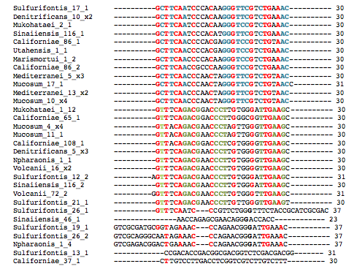

Figure 2. Various halophilic confirmed consensus DR sequences aligned using ClustalW2. The red indicates conserved nucleotides amongst almost all sequences, whereas the blue and green letters indicate possible clustering of halophiles according to chunks of similar DR sequences.
The high degree of conservation between halophilic DR sequences (denoted by red in Figure 2) indicates that DR sequences may possess an important function rather than just serve as separators for spacers. In order to further explore the possible functionality of DR, we studied conservation of dyad symmetry in DR sequences by creating a consensus halophilic DR sequence (Figure 3) and aligning that sequence with other non-halophilic DR sequences (Figure 4). The dyad symmetry, playing a role in creating the stable DR RNA intermediate (Kunin et al,. 2007), of the consensus sequence and the aligned sequences are indicated by black boxes in Figure 3 and red letters in Figure 4.

Figure 3. Consensus DR sequence for various halophiles

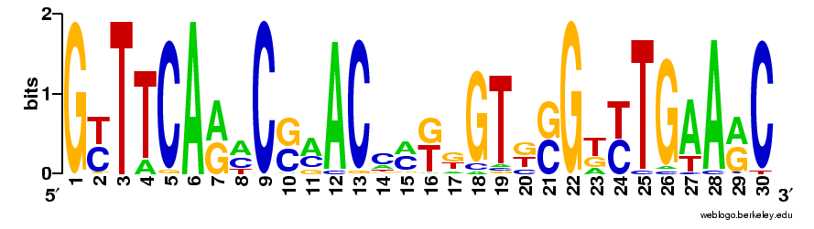
G T T T C A A A C G A A C C [AC] [GT] G G T G G G T T T G A A [AG] C

Figure 3. Consensus DR sequence for various halophiles’ DR sequences as created by WebLogo 2.8. The black boxes indicate dyad symmetry in the DR sequence, which is also known as inverted repeat sequences. These inverted repeat segments are thought to contribute to RNA stability of the DR sequences (Kunin et al., 2007).

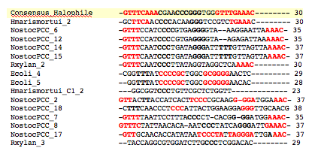
Figure 4. ClustalW2 alignment of consensus halophilic DR sequence and non-halophilic DR sequences

Figure 4. ClustalW2 alignment of halophile consensus DR sequence and non-halophile DR sequences. Red letters indicate inverted repeats or dyad symmetry within the DR sequences, which contribute to DR RNA stability. The bolded black letters are other examples of triplicates in the DR sequences, which may also contribute to stable DR RNA transcripts.

The dyad symmetry in the halophile consensus DR sequence is apparent (black boxes in Figure 3). The existence of such dyad symmetry indicates that DR sequences in halophiles form stable RNA molecules because the inverted repeats complementary base bind (Kunin et al., 2007). Such dyad symmetry exists in other non-halophiles indicating that dyad symmetry is a common component of DR sequences (Figure 4). Since dyad symmetry is a common component of DR sequences, it is common for DR sequences to form stable RNA transcripts, therefore indicating that DRs play some sort of role with an RNA intermediate (Kunin et al., 2007), such as the siRNA hypothesis of CRISPR functionality.

Once we gathered data to support the role of CRISPRs, specifically DRs, in a RNA intermediate mechanism we further explored the hypothesis of viral defense functionality of CRISPRs by analyzing the spacer sequences for Halomicrobium mukohataei and other halophiles. Halomicrobium mukohataei’s BLASTn spacer results presented 3 different possible viruses captured in Halomicrobium mukohataei’s spacers: Archaeal BJ1 Virus (E-value = 0.005) captured in spacer 2 of confirmed CRISPR 1, Burkholderia phage (E-value = 0.02) captured in spacer 14 of confirmed CRISPR 1, Mycobacterium phage (E-value= 0.31) captured in spacer 5 of confirmed CRISPR 2. The presence of viral segments in the spacers of Halomicrobium mukohataei’s CRISPRs lends support to the spacer functionality viral defense hypothesis because pieces of viral DNA do exist in the spacers.
Further BLASTn multiple alignments between these 3 viral genomes and Halomicrobium mukohataei’s plus the 4 other halophiles’ genomes indicated that all three viruses left significant footprints, although in varying degrees, in all 5 halophiles (Figure 5). The presence of viral footprints in all 5 species indicates that these 3 viruses have infected directly or indirectly all 5 halophiles.

Figure 5. Number of Significant Viral Footprints of 3 Viruses in 5 Halophiles
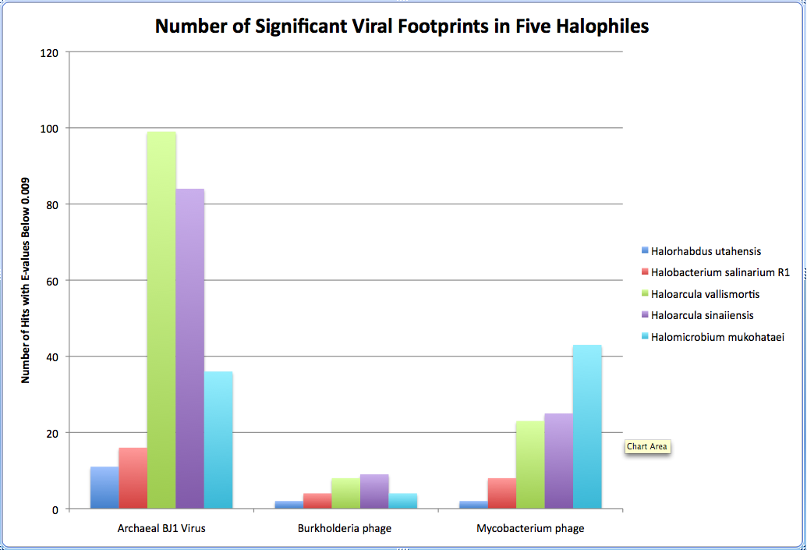

Figure 2. Bar graph representing the number of significant viral footprints for Archaeal BJ1 Virus, Burkholderia phage, and Mycobacterium phage in 5 different halophiles: H. mukohataei, H. utahensis, H. salinarum R1, H. vallismortis, and H. sinaiiensis. Note that these 3 viruses have left significant footprints in all 5 halophiles to varying degrees.

CRISPRfinder reported that H. vallismortis and H. salinarium contained confirmed CRISPRs (indicated by blue in Table 3), whereas H. utahensis and H. sinaiiensis do not contain any confirmed CRISPRs (at least according to CRISPRfinder) (indicated by red in Table 3). Visual alignment results indicated that these 3 viruses were only captured in the spacers of Halomicrobium mukohataei (as previously determined by BLASTn results of all Halomicrobium mukohataei’s spacers) and were not captured in any of the other species’ spacers (at least the species that have confirmed spacers) (Table 3).

Table 3. Summary for 3 viruses and 5 halophiles: existence of viral footprints, CRISPRs, and viral DNA captured in spacers
 |  | H. mukohataei | H. utahensis | H. sinaiiensis | H. vallismortis | H. salinarium
Archaeal BJ1 Virus
 | Viral Footprints? |  |  |  |  | 
 | CRISPRs? |  |  | 
 | Viral sequence in spacer? |  |  |  | N/A | N/A
Burkholderia phage
 | Viral Footprints? |  |  |  |  | 
 | CRISPRs? |  |  | 
 | Viral sequence in spacer? |  |  |  | N/A | N/A
Mycobacterium phage
 | Viral Footprints? |  |  |  |  | 
 | CRISPRs? |  |  | 
 | Viral sequence in spacer? |  |  |  | N/A | N/A
Table 3. Summary table outlining which species contain viral footprints for 3 different viruses, which species contain confirmed CRISPRs, and which species captured any of the 3 viruses in their spacers. The red species denote no confirmed CRISPRs and the blue species indicate the existence of confirmed CRISPRs. The N/A exists because one cannot measure whether or not a particular virus was captured in spacers if confirmed spacers do not exist in that species.

Even though all 3 viruses infected (directly or indirectly) all 5 species (as noted by the presence of viral footprints) (Figure 2), none of the viruses were captured in the spacers of any other halophile with CRISPRs besides Halomicrobium mukohataei (Table 3). These results also indicate there is no correlation between the number of viral footprints (infectious history) and the incorporation of the virus into the spacer. For instance Figure 2 denotes that H. vallismortis has about 100 Archaeal BJ1 viral footprints, but Table 3 indicates that this virus is not incorporated into the spacers of this species’ confirmed CRISPRs. Therefore, the capturing of viral segments in spacers appears to be random and does not occur with every exposure or more frequent exposure to the virus.

Discussion
Our overall analysis of Halomicrobium mukohataei’s ability to survive in high salt environments and the CRISPR functionality, particularly the viral defense mechanism, led to many interesting and enlightening conclusions. The following discussion segregates the two topics and individually explores findings, suggestions and inferences.

Ion Homeostasis
Conserved presence (Table 2) and sequence similarity among potassium homeostasis genes in various halophiles, indicates that potassium homeostasis genes, involved in the transport of K⁺ ions across the periplasm of Halomicrobium mukohataei, are important to survival and possibly survival in high salt environments since they are highly conserved in halophiles. In order to determine if these genes are particularly essential to survival in high salt environment, one would need to compare relative presence of potassium homeostasis genes in halophiles and non-halophiles. If the number and existence of potassium homeostasis genes was not conserved in non-halophiles, then one may hypothesize that these genes are specifically necessary for survival in high salinity environments.
Although conservation of potassium homeostasis transport genes appears to exist among a myriad of halophiles, other evidence suggests that different halophiles can regulate potassium homeostasis in different manners. Although Halomicrobium mukohataei’s 10 potassium homeostasis genes are shared among various halophiles, Halomicrobium mukohataei does not possess the KdpFABC operon, which is essential for potassium homeostasis and survival in high salt environments for H. salinarum (Strahl and Greie, 2008). The missing KdpFABC operon is not a concrete finding because it is possible for BLAST to mistake annotation of genes, particularly when the only difference between the gene found by the multiple-alignment search (heavy metal translocating P-type ATPase) and the gene in the KdpFABC operon responsible for potassium homeostasis in H. salinarum (potassium translocating P-type ATPase) is the molecule being transported. Due to the conserved presence and sequence of potassium homeostasis genes among halophiles, even if Halomicrobium mukohataei does not possess the KdpFABC operon, it does not negate the possible role of potassium homeostasis in the survival of Halomicrobium mukohataei in the presence of high salt. Instead, the lack of the KdpFABC operon may suggest alternate forms and mechanisms of controlling potassium homeostasis in different halophiles. We suggest more investigatory work into the presence of the KdpFABC operon in Halomicrobium mukohataei and other halophiles in order to determine if other potassium homeostasis mechanisms exist rather than the KdpFABC operon.
Overall the insight we gained into the potential reason behind why halophiles, particularly Halomicrobium mukohataei, can live in high salinity environments is exciting and opens a world of other possibilities and questions (only a few of which are explored above). The use of potassium homeostasis in order to maintain appropriate osmotic pressure in the presence of high external ion concentrations (Na⁺ and Cl⁻) is only one possible explanation behind the ability of halophiles to survive high NaCl concentrations and is certainly not the only explanation. In order to fully understand how halophiles survive in high salinity, a myriad of systems must be explored and therefore a systems biology approach may be relevant in order to explore the unique and obligate ability of halophiles to live in extreme salt environments.
CRISPR Sequences: Viral Defense Mechanism
Similar DR sequences among halophiles, conserved dyad symmetry in DR sequences among various halophilic and non-halophilic organisms, and the existence of viral DNA captured in the spacers of Halomicrobium mukohataei’s CRISPRs indicate that the functionality of CRISPRs in Halomicrobium mukohataei is based in some form of RNA intermediate involving viral mRNA transcripts, thereby supporting the use of CRISPRs as RNA interfering mechanisms for viral defense.
The conservation of DR sequences among halophiles (Figure 2) lends one to postulate that DRs possess some functionality, rather than just housing spacer sequences. The exploration behind conservation of dyad symmetry among DR sequences addressed a possible functionality of DRs. The conserved existence of dyad symmetry in most DR sequences explored (Figure 4), indicates the importance of dyad symmetry in the structure and functionality of DR sequences and supports the hypothesis that DR sequences are involved with RNA intermediates. We suggest more research behind the existence of dyad symmetry in DR sequences of various organisms and more specifically how this dyad symmetry plays a role in stabilizing RNA molecules and the viral defense hypothesis. Although our genomic explorations indicate an important functionality of DR and the conservation of dyad symmetry possibly being important to such functionality, we suggest further investigation behind the use of DRs in the hypothesized viral defense mechanism, specifically the relation of DRs to CAPs and spacers.
Once we established that the DRs have a function and play some sort of role in RNA intermediates, we explored deeper into validating the CRISPR viral defense hypothesis by focusing on Halomicrobium mukohataei’s spacer sequences. We confirmed the existence of three viruses in the spacers of Halomicrobium mukohataei. Surprised by the fact that out of 77 spacers, only 3 captured viral segments, we explored the availability of viral genomes in the BLAST nr database, which we used to determine what viruses were in which spacers. According to Entrez Genomes [http://www.ncbi.nlm. nih.gov/genomes/GenomesHome.cgi?taxid=10239] the BLAST nr database only contains 2,362 complete viral genomes, whereas basic estimates for the number of viral species in the ocean alone is among the hundreds of thousands (Angly et al., 2006). The lack of complete viral genomes available explains the small number of viral hits in the spacers of Halomicrobium mukohataei and therefore may indicate the presence of more viruses in the other 74 spacers of Halomicrobium mukohataei.
Armed with the knowledge that CRISPR sequences, particularly DRs, possess functionality concerned with an RNA intermediate and the knowledge that Halomicrobium mukohataei’s spacers actually contain viral DNA segments, we draw the conclusion that the proposed hypothesis of viral defense mechanism for the functionality of CRISPRs is founded in the scientific data of Halomicrobium mukohataei. Since CRISPRs have viral segments in transcribed spacers and the DR transcribed sequences play a role in some form of RNA intermediary structure, the connection between these two findings lends genomic evidence in support of the viral siRNA interference defense mechanism.
In addition to validating the CRISPR functionality viral defense hypothesis, we explored the caveat of the frequency and efficiency of certain viruses being captured by spacers. We concluded that the capturing of viral DNA in the spacers of particular halophiles was random and independent of the number of significant viral footprints and therefore independent of past viral exposure frequency (Figure 6). If the capturing of viral DNA in spacers is random and independent of viral exposure history (as noted by the number of footprints corresponding to infective past), then how effective are CRISPRs as a viral defense mechanism when most viruses are not even captured by the spacers? The apparent inefficiency and infrequency of capturing viral segments in spacers may indicate that viral defense is not the prevailing functionality of CRISPR sequences, but instead may indicate the existence of another function for CRISPR sequences. It would be useful to understand how and why species’ spacers capture viral segments so that we can further grasp and support the viral defense functionality of CRISPRs and the infrequency of viral capturing. We also suggest a more in-depth study to explore our results into the correlation between existence and number of viral footprints and the capturing of such a virus in the spacers of CRISPRs in various prokaryotes in order to understand the efficiency and frequency of capturing viral DNA in CRISPR spacers on a larger and broader scale.

Acknowledgments
We thank the whole Fall 2009 class of Genomics Laboratory Methods at Davidson College including the students: Megan Reilly and the aforementioned authors and the instructor: Dr. Malcolm Campbell. We also thank Davidson College for providing the laboratory materials and the American Society for Microbiology (ASM) 2008 Conference results made possible by Roche machinery for providing sequence annotation for a myriad of halophiles [http://edwards.sdsu.edu/halophiles/#RawData].

Supplemental Figures
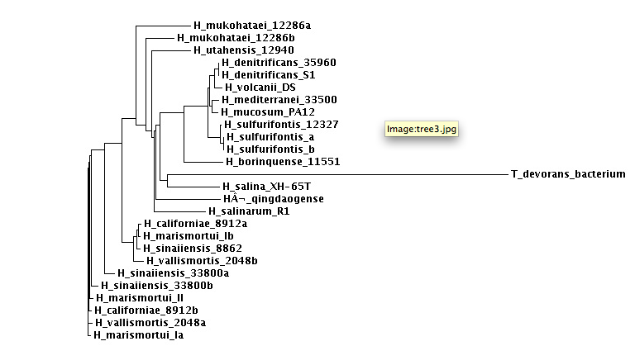
Figure S1. ClustalW2 16s rRNA phylogenetic tree for various halophiles

Figure S1. Phylogenetic tree created using ClustalW2 and 16s rRNA sequences obtained from NCBI and RAST. Used above in paper in order to choose 4 halophilic species to compare to Halomicrobium mukohataei viral spacer insertions.

References
Angly et al. “The marine viromes of four oceanic regions.” PLoS Biology. 2006; 4(11): e368. DOI:
10.1371/journal.pbio. 0040368.
“ATP-binding cassette transporter.” Wikipedia (2009) 2 Dec 2009 <http://en.wikipedia.org/wiki/ATP-
binding_cassette_transporter>.
Christner, Brent. “Prokaryotic Diversity: Lecture 24 The Halophilic Arcahaea.” Louisiana State University.
2009. 2 Dec 2009 <http://brent.xner.net/BIOL4125/Lectures/BIOL4125_S09_L24-HaloArch.pdf>.
Ihara et al. “Haloarcula argentinensis sp. nov. and Haloarcula mukohataei sp. nov., Two New Extremely
Halophilic Archaea Collected in Argentina.” International Journal of Systematic Bacteriology.
1997: 73-77.
Kunin et al. “Evolutionary conservation of sequence and secondary structures in CRISPR repeats.”
Genome Biology. 2007; 8: R61.
LILLESTØL et al. “A putative defense mechanism in archaeal cells.” Archaea. 2006; 2: 59–72.
Neubauer et al. “Two Essential Arginine Residues in the T Components of Energy-Coupling Factor
Transporters.” Journal of Bacteriology. 2009; 191(21): 6482-6488.
Oren et al. “Salinibacter ruber gen. nov., sp. nov., a novel, extremely halophilic member of the Bacteria
from saltern crystallizer ponds.” International Journal of Systematic and Evolutionary
Microbiology. 2002; 52: 485-491.
Shaw et al. “Purification, characterization and nucleotide sequence of the periplasmic C4-dicarboxylate-
binding protein (DctP) from Rhodobacter capsulatus.” Molecular Microbiology. 2006; 5(12): 3055-
3062.
Strahl H. and JC Greie. “The extremely halophilic archaeon Halobacterium salinarum R1 responds to
potassium limitation by expression of the K+-transporting KdpFABC P-type ATPase and by a
decrease in intracellular K+.” Extremophiles. 2008; 2(6):741-752.

