The Cysteine Metabolic Pathway in Halomicrobium mukohataei
Claudia M. Carcelén
Abstract
Halophiles are a class of extremophile within the domain Archaea. The halophile Halomicrobium mukohataei was isolated from a salt flat in Argentina within the past twenty years. There is very little information available on this organism and several other similar halophiles. While complete genome annotations have been made available through organizations including the United States Department of Energy’s Joint Genome Institute (JGI) and the Rapid Annotation Using Subsystem Technology (RAST), there still exist many ambiguities within these annotations. In the harsh, high salinity environment in which these organisms thrive, many halophiles that lack the ability to degrade sugars have adapted the ability to utilize amino acids, such as cysteine, as an energy source. Cysteine pertains to the study of H. mukohataei since a number of halophiles have been shown to exhibit unusually high residues of this amino acid in their proteins (Baliga et. al., 2004). I extracted the genome sequences of H. mukohataei as well as nine other halophiles and used a series of programs to compare and contrast the RAST annotations of these ten halophiles. I was able to determine a list of conserved proteins across all ten halophiles as well as a list of proteins unique to H. mukohataei. While the list of conserved proteins consisted majorly of well known proteins from important cell processes, the list of unique proteins consisted solely of hypothetical proteins. I also obtained the KEGG map of the cysteine metabolic pathways of H. mukohataei from both JGI and RAST and searched the proteins present to determine the level of conservation of these enzymes in the halophile genomes. Furthermore, I searched for proteins that were missing from the genome according to the KEGG pathway maps obtained from JGI and RAST, and cross-referenced protein sequences to attempt to eliminate any discrepancies between the two databases. While a number of enzymes were determined to be present and highly conserved in H. mukohataei, several could not be found. Seven of twenty-three enzymes in cysteine metabolism were missing. This however did not appear to have a detrimental effect on cysteine metabolism, since the KEGG map demonstrates a high level of connectivity and flexibility. It appears that cysteine metabolism is a highly conserved process, though a number of proteins are missing from the metabolic pathway. It is likely our organism has developed a mechanism to bypass certain stages or intermediates of the pathway.

Introduction
Little is known about halophilic microorganisms and the mechanisms that govern the necessary processes and metabolic pathways for their survival. Halophiles, or “salt-loving” organisms, are a class of extremophiles that thrive in high salinity environments, such as oceans and salt flats. Halomicrobium mukohataei was isolated from the soils of salt flats in Argentina in 1991, however since then, few studies have been done on this organism. Genome annotations for Halomicrobium mukohataei are available through the United States Department of Energy’s Joint Genome Institute (JGI) as well as through the Rapid Annotation Using Subsystem Technology (RAST). These genome annotations have enabled the scientific community an opportunity to explore the properties and metabolic pathways of this little known organism at the level of the genome.
The amino acid cysteine (C₃H₇O₂NS) is present in a number of proteins. Cysteine is a nonessential amino acid, indicating that it can be biosynthesized in the human body (Wikipedia, 2009). Cysteine is a monomer of the amino acid dimer, cystine, which is made up of two cysteine molecules linked by a disulfide bond (Wikipedia, 2009). Cysteine exists in two forms in nature, due to a chemical property of organic compounds called chirality, which designates the orientation of dissimilar substituents around carbon atoms in the molecule (Wikipedia, 2009). The property of chirality exhibits whether or not a molecule possesses the ability to be superimposed on its mirror image, and each of these mirror images is known as the L-enantiomer or the D-enantiomer (L indicating left handed, D indicating right handed). In nature, cysteine exists in abundance in the L-enantiomer form (see Figure 1) and minimally in the D-enantiomer form (Wikipedia, 2009). Both of these
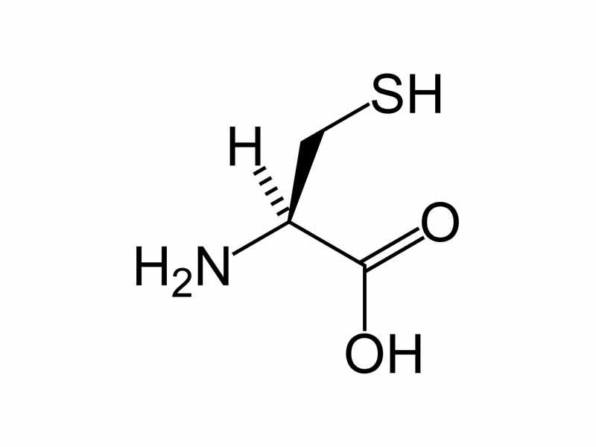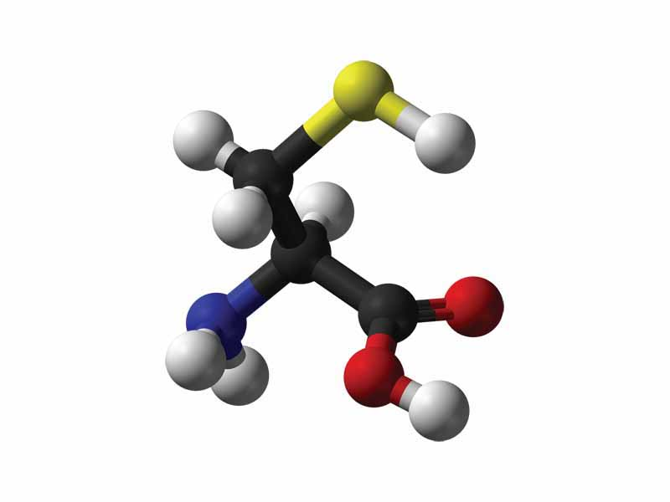

Figure 1. Models showing the compound L-cysteine, the most abundant enantiomer of the amino acid found in nature. Cysteine exists in two forms, due to the chirality of a molecule, or its ability to be superimposed on its mirror image. L-cysteine is located centrally within the cysteine metabolic pathway produced by KEGG.

forms are key members within the cysteine amino acid metabolic pathway (see Figure 2). Furthermore, this amino acid has key relevance to H. mukohataei because studies have shown that hyperthermophiles, such as this halophile, have higher densities of cysteine residues paired in disulfide linkages (Baliga et. al., 2004). These high densities of cysteine residues, in conjunction with structurally shorter loops, provide archaeal proteins with a higher level of stability (Baliga et. al., 2004). Cystein residues, unlike the amino acid cysteine itself, are molecules that have lost a molecule of water through dehydration and have bonded to another amino acid, thus forming a polypeptide, or protein. Thus, all units of a polypeptide chain are amino acid residues (IUPAC, 1997).Amino acid metabolism is an integral process required for the survival of H. mukohataei, and the cysteine metabolic pathway is located centrally and integrally within the metabolic pathways of this halophile (see Figure 2). Furthermore, a number of halophiles that lack the ability to degrade sugar derive their energy from the breakdown of amino acids and similar compounds typical of high salinity environments instead (Falb et. al., 2008). The ability of halophiles to utilize amino acids as a source of energy has important
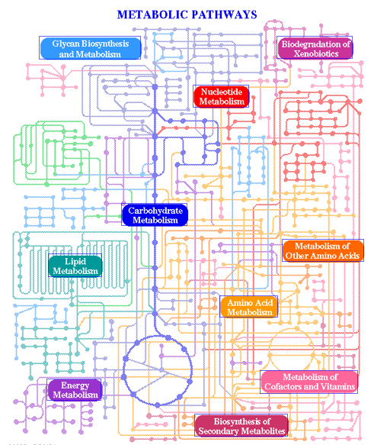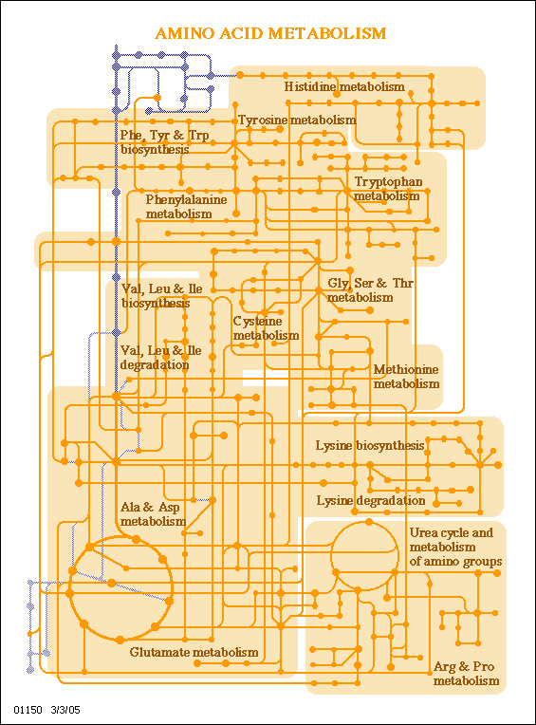
Figure 2. (L to R) The metabolic pathway map and amino acid metabolic pathway map as represented in KEGG through RAST. The interrelationships between these pathways and the processes they feed into make them relevant and likely to show conserved proteins.

implications regarding the findings, such as the conservation of proteins, for this study.
Methods
To begin this research, we obtained the proteomes of Halomicrobium mukohataei as well as the nine other halophiles that follow: Haloarcula californiae, Haloarcula sinaiiensis, Haloarcula valismortis, Haloferax denitrificans, Haloferax mediterranei, Haloferax mucosum, Haloferax sulfurifontis, Haloferax volcanii, and Halorhabdus utahensis. The proteomes of these were modified into FASTA format and subjected to a series of pair-wise comparisons using Perl script programs created by Olivia Ho-Shing. These programs produced a list of proteins conserved in both genomes and a list of proteins unique to H. mukohataei, which we then subjected to a program created by Bill Hatfield, which produced a final list of conserved proteins across all ten genomes.
KEGG metabolic pathway maps as well as a detailed list of the twenty-three proteins (see Figure 3) present in this pathway were obtained from the KEGG database, the JGI database, and the RAST database. In order to determine which proteins from the cysteine metabolic pathway are present in H. mukohataei as well as which proteins from this pathway they shared with the other nine halophiles, I examined both of the annotations of H. mukohataei available in JGI and RAST. First, I identified which genes in cysteine metabolism were identified as present in each of the annotations, and I compared and confirmed these using the NCBI BLASTx function to compare the sequences of each annotation to our organism’s genome in both JGI and RAST. In order to determine fill in the missing genes from the cysteine metabolism pathway, I obtained the gene sequences of each protein as annotated in both JGI and RAST and used the BLASTx function in NCBI and in RAST to find the protein in H. mukohataei. In an attempt to eliminate and account for the discrepancies in the genome annotations of JGI versus RAST, I also cross-referenced
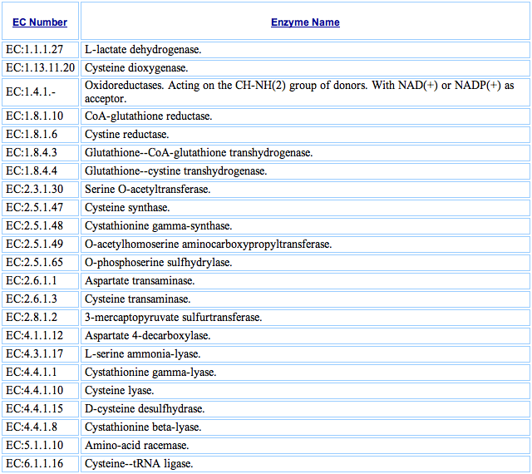
Figure 3. The cysteine metabolic pathway contains twenty-three polypeptide enzymes. These proteins were used to identify and extract gene sequences for comparison.
the gene sequences from JGI against the H. mukohataei genome annotation in RAST, and the gene sequences from RAST against the H. mukohataei genome annotation in JGI. Only annotation results with high scores above 200 and low E values, below 0.001 were used (see Figure 4). Furthermore, doing so allowed me to determine candidate proteins of hypothetical or unknown classification for the missing links in the pathway map.
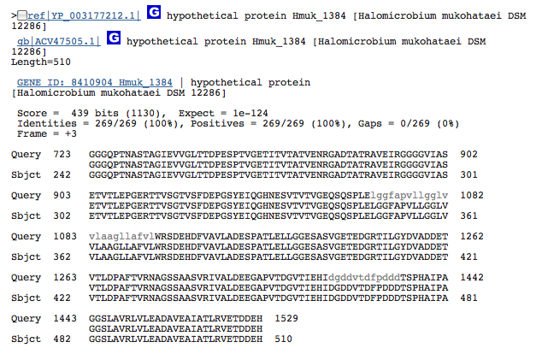
Figure 4. Example result from BLASTx of missing protein sequence against H. mukohataei genome. The validity of results was determined using the information shown in the blue box. High Score values and low E-values (below 0.001) were considered desirable, reliable hits.

Results
The genome comparisons of the ten halophiles produced a list of 759 conserved proteins across the ten halophiles compared, as well as a list of 79 hypothetical proteins unique to the genome of H. mukohataei. The conserved proteins list obtained was for the majority comprised of known proteins from cycles and processes that are well understood and documented. The list containing proteins unique to H. mukohataei consisted solely of hypothetical proteins.
From the two separate cysteine metabolism KEGG maps I obtained, I was able to perceive some ambiguities in the gene annotations of JGI and RAST. JGI identified the following four proteins as present in the H. mukohataei genome: EC:2.3.1.30 Serine O-acetyltransferase, EC: 2.5.1.47 Cysteine synthase, EC: 2.5.1.49 O-acetylhomoserine aminocarboxypropyltransferase, EC: 6.1.1.16 Cysteine—tRNA ligase. Alternatively, RAST identified as many as seven proteins as present, including the following: EC: 1.1.1.27 L-lactate dehydrogenase, 2.3.1.30 Serine O-acetyltransferase, EC: 2.5.1.47 Cysteine synthase, EC: 2.5.1.48 Cystathionine gamma-synthase, EC: 2.5.1.49 O-acetylhomoserine aminocarboxypropyltransferase, EC: 2.6.1.1 Aspartate transaminase, EC: 6.1.1.16 Cysteine--tRNA ligase (see Figure 5). When the gene sequences of these proteins were cross-referenced using both databases, the identification of all seven proteins identified by RAST was confirmed.
In order to determine if the missing proteins in the KEGG maps were present in the H. mukohataei genome, the protein sequences were searched using BLASTx in both NCBI and RAST. Using this method, I was able to find 6 candidate proteins for the missing pathway enzymes (see Figure 6): Hypothetical protein Hmuk_1384, valine dehydrogenase, NADPH-dependent FMN reductase, Hypothetical protein Hmuk_1517, Hypothetical protein Hmuk_2141, Hypothetical protein Hmuk_2635. Four of these six proteins however consisted of hypothetical proteins whose function is only predicted, but not experimentally tested or proven. Their sequence similarity to the proteins BLASTed against them enables us to predict their function, however there is still ambiguity as to whether the function of the protein is correctly annotated without the wet lab data.
According to JGI, seven of the proteins listed in the cysteine metabolic pathway were not present in any genomes within their online database, therefore these genes were difficult to analyze. I searched use the Find Gene and Find Function tabs in JGI and RAST to find protein sequences for these missing enzymes. I was able to procure sequences for three of the seven genes, yet four remained
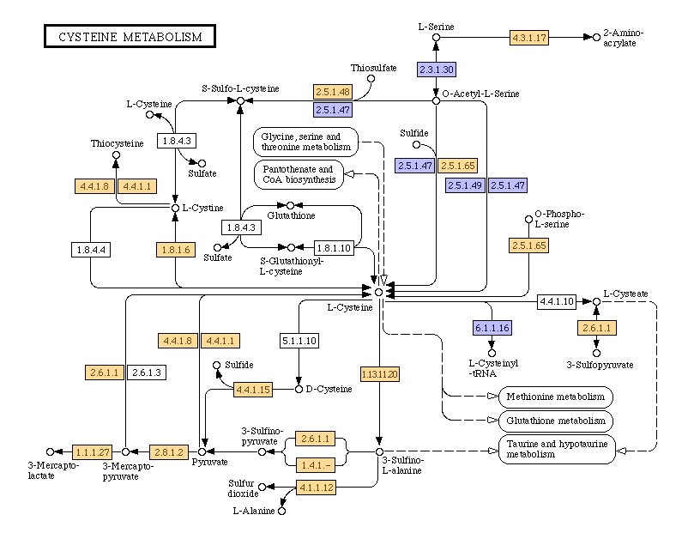
A
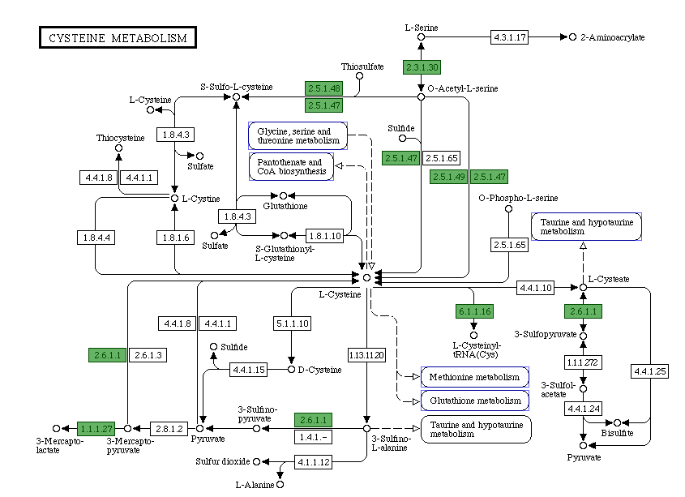
B
Figure 5. The cysteine metabolic pathway map in JGI(A) and RAST(B) match, while identifying different genes present in the genome of Halomicrobium mukohataei. JGI Identifies only four (marked in blue) of the designated twenty-three proteins as present, whereas RAST identifies seven (marked in green) proteins. The yellow boxes in figure 4A represent proteins identified by JGI in the genomes of other organisms in their database.
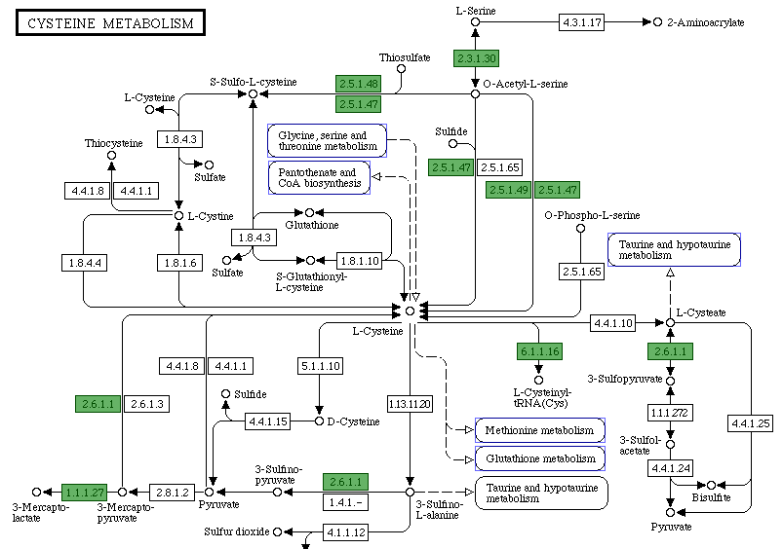

Figure 6. Candidate proteins to fill in the missing genes were determined using BLASTx in JGI and RAST. The enzymes encircled in blue were found within the genome of H. mukohataei, primarily as hypothetical proteins. Ten enzymes remain unidentified at this time.

unknown. These four that were excluded included EC:1.8.1.10 CoA-glutathione reductase, EC:1.8.4.3 Glutathione--CoA-glutathione transhydrogenase, EC:1.8.4.4 Glutathione--cystine transhydrogenase, and EC:2.6.1.3 Cysteine transaminase. I was able to find functional analogs in JGI, however none with enough similarities to these proteins to have statistical significance.

Discussion
The results from the whole genome comparisons of the ten aforementioned halophiles correspond with the background knowledge available on the nature of the conservation of proteins. Microorganisms such as these halophiles need thousands of proteins to maintain life. Given that these organisms are relatively closely related, they probably share a number of the same or conserved genes. The adaptation and evolution of certain proteins and processes that are beneficial to an organism will persist in the subsequent generations through evolutionary processes such as natural selection. A protein with a high degree of functionality is conserved in organisms the organisms that require that particular protein or enzyme within a given synthetic or metabolic pathway. We predicted that the conserved proteins list would consist of a much greater number of proteins than the unique proteins list, which it did. From the approximate 3500 genes annotated for H. mukohataei, 759 were determined to be conserved proteins across all ten halophiles compared. Alternatively, only 79 of the proteins were unique to only H. mukohataei.
The central pathway appears to be ‘bypassed’ or not used by Halomicrobium mukohataei in both KEGG maps from JGI and RAST. H. mukohataei possesses the necessary proteins to follow the metabolic pathway around the central pathway, involving Glutathione and S-Glutathionyl-L-cysteine (see Figure 7).
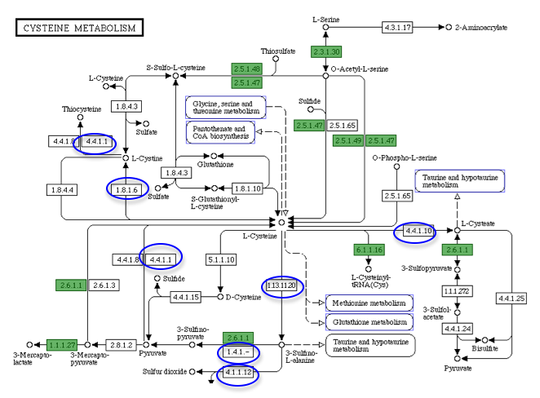
Figure 7. Halomicrobium mukohataei possesses the
Cysteine metabolism appears to be highly conserved across halophilic organisms
Our organism possesses mechanisms that enable it to go directly from one intermediate to another in the metabolic pathway, thereby eliminating the use of the central pathway, indicated by the yellow box.

These findings provide further evidence for the hypothesis that H. mukohataei and similar halophiles possess the necessary proteins to successfully complete and make use of the cysteine metabolic pathway. Furthermore, it appears that the missing proteins in the KEGG pathway map are not necessary for the metabolism of the amino acid cysteine. Furthermore, it is likely that we may observe similar trends in the metabolic pathways of other amino acids.
A significant observation is that the proteins identified, both before and after this research was conducted, do not appear to have the ability to produce the D-cysteine enantiomer of this amino acid. Both enzymes EC: 5.1.1.10 Amino acid racemase and EC: 4.4.1.15 D-cysteine desulfhydrylase are missing from the pathway, even following the inclusion of the enzymes found during my research. Both the enzyme that produces D-cysteine, EC: 5.1.1.10 Amino acid racemase, as well as the enzyme that converts it into another molecule, EC: 4.4.1.15 D-cysteine desulfhydrylase produced no positive results within the genome of H. mukohataei. This has most likely occurred since the D-cysteine enantiomer of the amino acid is not found in abundance in nature (Wikipedia), therefore few organisms possess the proper enzymatic machinery to metabolize this form of cysteine. The results of this study provide evidence for this claim.
Another possibility for the observations I encountered in this study is that the deficiencies within the annotation databases may have provided me with insufficient and possibly incorrect data. Many of the discrepancies observed in the gene sequences and their respective protein annotations did not match and showed grossly different results. Alternatively, when genome sequences from one database were run through the BLAST alignment tool, positive results were produced in both databases, yet under another protein designation. These inconsistencies prove problematic for the validity of scientific research employing these databases.
In conclusion, the findings of this research provide further insight into the genomic area of study for both H. mukohataei as well as other related halophiles. These observations provide evidence for the possibility that these ten species of halophiles may possess the ability to perform the break down of amino acids as an energy source instead of the traditional carbohydrates employed in the biological world. Furthermore, there is evidence that H. mukohataei possesses only the machinery necessary to break down the more common form of the amino acid, L-cysteine, and lacks the enzymes to break down the least common form, D-cysteine, which correlates with the abundance of both molecules as they are found in nature. Finally, it is necessary to evaluate the quality of the data being used. While large strides and numerous efforts have been made to achieve the level of scientific knowledge and data available today, it is imperative to reconsider the validity of the achievements that have been made. As has been shown in this research, as well as in the research of others, including my classmates, there are numerous inconsistencies within the databases themselves. In order to perform successful genomic research, these databases must be enhanced and re-evaluated for errors and effectiveness. Once this has been accomplished, genomic studies on such organisms will have a greater impact on our knowledge of these organisms.

Acknowledgements
I would like to thank Dr. A. Malcolm Campbell for his aid in the direction and execution of this project. Many thanks to Olivia Ho-Shing for the time and effort she contributed to the creation of the Perl scripts used in this research, without which this paper would not be possible. Many thanks as well to Dr. Laurie Heyer and Mr. Bill Hatfield for the their contributions to our computer programs and to the quality of our data results. I would also like to thank my Laboratory Methods in Genomics classmates for their contributions to the data used in this research as well as the invaluable knowledge and intuition that they provided in class discussion.

References

Baliga, Nitin S. et. al. "Genome sequence of Haloarcula marismortui: A halophilic archaeon from the Dead Sea." Genome Research 14 (2004): 2221-234.
DOE Joint Genome Institute. United States Department of Energy. Web. 29 Nov. 2009. <http://www.jgi.doe.gov/>.
“Chirality.” Wikipedia, the free encylopedia. Web. 25 Nov. 2009. <http://en.wikipedia.org/wiki/Chirality_(chemistry)>.
"Cysteine." Wikipedia, the free encyclopedia. Web. 25 Nov. 2009. <http://en.wikipedia.org/wiki/Cysteine>.
Falb, Michaela et. al. "Metabolism of halophilic archaea." Extremophiles 12 (2008): 177-96.
Ihara, K, S Watanabe, & T Tamura (1997). Haloarcula argentinensis sp. nov. and Haloarcula mukohataei sp. nov., two new extremely halophilic archaea collected in Argentina. International Journal of Systematic Bacteriology 47(1): 73-77.
IUPAC. IUPAC Compendium of Chemical Terminology. Vol. 2. 1997.Letley, Darren P., Joanne L. Rhead, Keith Bishop, and John C. Atherton. "Paired cysteine residues are required for high levels of the Helicobacter pylori autotransporter VacA." Microbiology 152 (2006): 1319-325.

Oren, Aharon, Rahel Elevi, Satoshi Watanabe, Kunio Ihara, and Angela Corcelli. “Halomicrobium mukohataei gen. nov., comb. nov., and emended description of Halomicrobium mukohataei." International Journal of Systematic and Evolutionary Microbiology 52 (2002): 1831-1835.
Rapid Annotation using Subsystem Technology. NMPDR. Web. 29 Nov. 2009. <http://rast.nmpdr.org/>.

