How to Determine the Origin of Replication in a Genome

This page was produced for an undergraduate course at Davidson College

At first it can be more than a bit confusing to try to find the origin of replication in the genome you’re studying. There are many different indicators that can point you in the right direction (and, sometimes, in the wrong one), and it is enormously helpful to have a clear idea of a simple protocol one can follow to narrow things down. Here’s what I propose:

Background Information

The origin of replication is a particular sequence in a genome at which replication is initiated; this is the site where the pre-replication complex is initiated. The search should be influenced by what type of organism you’re dealing with. The following table sums up some of the principal differences very well, and gives you an idea of what to look for in each situation:

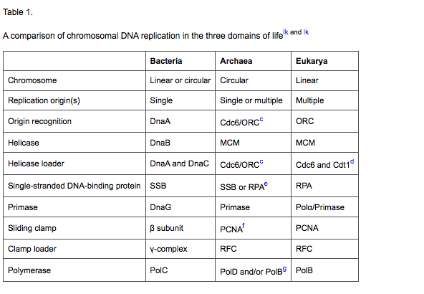

From www.sciencedirect.com

Knowing this basic information about each of the domains is very helpful both for searching for the origin, and for recognizing it when you’ve found it. You’ll also want to look for the following:

Genes point in opposite directions
The genes on either side of the origin of replication are usually read in opposite directions and point away from the origin, as you can see in this segment of the E. coli genome (which includes the gene dnaA)

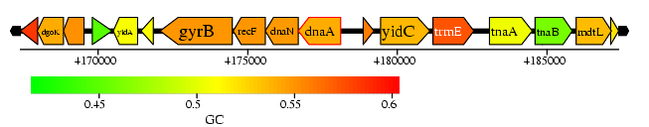
AT-rich region
The origin of replication usually occurs in a relatively AT-rich region of the genome.

DNA metabolism/replication genes
The genes most frequently situated near the origin, like dnaA in E. coli, are DNA metabolism genes involved in replication.

Frequency of replication
Genes closer to the origin of replication will tend to have more copies made, so you can track that frequency gradient to find any origins of replication.

The Search

Once you understand these essential characteristics of an origin of replication, you’re more than halfway there. Now it remains to understand how to carry out the actual search. I assume you will be using an in silico approach, searching databases for the origin of replication, whether found and annotated or not.

The Search
The simplest way to begin is to search a genome database for your genome. Often databases like SEED, JGI, and Manatee might be able to do this. Search gene functions for “replication”. In the SEED viewer and JGI (Manatee was malfunctioning at the time of testing), you obtain from this search a narrow field of genes that will contain the DNA origin binding proteins.

Use Table 1. above to see what genes you’re looking for: dnaA for prokaryotes, ORC for eukaryotes, or cdc6/ORC for archaea. The origin of replication is typically upstream of this gene in your genome, so once you find the coordinates of this gene, then you have a narrow range in which the origin of replication is expected to be.

Then use the other criteria listed above to check your putative origin. Find it in a genome browser and see if the genes are generally pointing in opposite directions away from the origin; see if you can track down the frequency of replication for the genes around the putative origin.

