GCAT Microarray:
Culturing Yeast, Isolating RNA, 3DNA Protocol

Written by Anne Rosenwald and Todd Eckdahl (Spring 2008)
Thanks to Mary Lee Ledbetter and Dave Kushner who provided resource materials and Consuelo Alvarez and Chuck Hauser for comments

Note that all of the information here, as well as ideas for implementation in a variety of classes and formats can be found at:

http://www.bio.davidson.edu/projects/GCAT/GCAT.html

We also urge you to join the GCAT Listserv – this community of undergraduate teachers is a great source of information and ideas.

Supply List

S288C yeast strain
YPD media (recipe is given here on p. 2, but more details on GCAT web site)
RNA isolation kit (we’re using the Ambion kit – www.ambion.com)
Agarose
1x Tris-Borate-EDTA (1x TBE), pH 8.3 (89 mM Tris-borate, 2 mM EDTA)
Ethidium bromide (10 mg/ml)
RNA standards
Genisphere Array 350 Ex kit (www.genisphere.com)
Reverse transcriptase (which can be ordered with the Genisphere kit)
100 mM DTT
Molecular Biology Grade Ethanol
3 M sodium acetate, pH 5.2
1 M Tris-HCl, pH 7.5
0.5 M NaOH / 50 mM EDTA
1x Tris/EDTA (1x TE), pH 8.0 (10 mM Tris / 1 mM EDTA)
Microcon YM-30 concentrators (www.millipore.com)
Yeast microarrays
Sonicated salmon sperm DNA
20x SSC
SDS (10% stock)

Equipment List

Shaking incubator to grow yeast cultures
Clinical centrifuge
Microcentrifuges
Vortex mixers
UV/visible spectrophotometer
Agarose gel electrophoresis apparatus and power supply
Hybridization chambers
Dry incubator or water bath
Heating blocks (not crucial if water baths and incubators are available, but handy)
Access to microarray scanner (i.e. via GCAT – see the web site for details)
Speedvac
Micropipettors, including ones that will measure out 1-2 μl volumes
Sterile, RNAse free tips appropriate for your micropipettors

Culturing Yeast

A strain of yeast commonly used by researchers is S288C. Most GCAT members also use this strain and share it with other members of the community. Information about S288C, as well as great information about other strains of yeast, yeast genes, yeast researchers, and other yeast resources, can be obtained at the Saccharomyces Genome Database (http://www.yeastgenome.org/straintable.shtml#S288C). Dave Kushner (Dickinson College) has a detailed protocol for growing yeast on the GCAT web site.

DeRisi et al. used S288C in collecting microarray data on the yeast diauxic shift from anaerobic to aerobic metabolism. Below is a procedure by which yeast can be cultured and harvested to measure the effect of this diauxic shift on gene expression. The goal is to collect yeast at a point early in the growth curve and at one or more later points.

- Transfer a colony or loop of S288C yeast to 5 ml YPD (5 g yeast extract, 10 g peptone, 10 g dextrose in 500 ml, autoclave) and incubate at 30ºC with shaking overnight.

- Transfer 1 ml of overnight into 200 ml YPD in a 500 ml flask and incubate with shaking at 30ºC.

- Check the absorbance at 600 nm after about eight hours and determine if it is the value you want to have for the early time point. If so, collect volumes of yeast culture in separate tubes that correlate with the capacity of the RNA isolation kit. The table shows some estimates for this. For example, 167 ml of yeast at an A₆₀₀ of 0.14 yields 3 x 10⁸ cells, the capacity of the Ambion RiboPure Yeast kit described below.
A₆₀₀ | cells / ml
0.14 | 1.8 x 10⁶
0.46 | 6.3 x 10⁶
0.80 | 1.1 x 10⁷
1.8 | 2.3 x 10⁷
3.7 | 4.8 x 10⁷
6.9 | 1.0 x 10⁸
7.3 | 1.2 x 10⁸

- Spin the yeast culture samples in a clinical centrifuge for 10 minutes at 4000 rpm.

- Pour off the supernatant and either refrigerate the pellets for use soon or freeze them for use later.

- Repeat steps 3-5 for one or more later time points. Reaching an A₆₀₀ of 6.9 may take 12-16 hours.

Prepare Total Yeast RNA

RNA can be prepared in any number of ways. Check the GCAT web site for options used by instructors and other experienced microarrayers for ideas. Dr. Dave Kushner (Dickinson College) has a protocol on the GCAT web site that involves an extraction with hot phenol. There are also a number of kits available, including the Total RNASafeKit from QBiogene, the RNeasy kit from Qiagen, and the RiboPure Yeast kit from Ambion. The kit we’re using is the one from Ambion.

Ambion RiboPure Yeast Protocol

Implementation note: This protocol, from yeast pellets, takes about an hour.

- To pellets with no more that 3 x 10⁸ cells, add the following and resuspend the cells by vigorous vortexing for 15 seconds.

480 μl lysis buffer
48 μl 10% SDS
480 μl phenol/chloroform/IAA

- Pour about 750 μl of cold Zirconia beads into a provided 1.5 ml screw cap tube, transfer the yeast cell mixture into the tube, and vortex for 10 minutes.

- Spin 5 minutes at 16,000 x g to separate aqueous and organic phases.

- Carefully transfer top aqueous phase to a 15 ml tube without disturbing the interface.

- Preheat 60 μl elution solution for each isolation to about 95ºC.

- Add 1.9 ml binding buffer to the sample in the 15 ml tube and mix thoroughly.

- Add 1.25 ml 100% ethanol to the sample in the 15 ml tube and mix thoroughly.

- Add 700 μl of the sample to a filter cartridge placed onto a supplied collection tube.

- Centrifuge for 30 sec at 14,000 x g.

- Discard flow-through

- Repeat steps 8 and 9 until the entire sample has been applied to the filter cartridge.
(Note: steps 8-11 can also be accomplished by fitting the filter cartridge onto a 5 ml syringe barrel connected to a vacuum source.)

- Wash the filter by adding 700 μl wash solution 1 and centrifuging for 1 minute at full speed. Discard flow-through.

- Wash by adding 500 μl wash solution 2/3 and centrifuging at full speed. Discard flow-through. Repeat this step.

- Centrifuge for 1 minute at full speed to dry filter.

- Transfer filter to clean 2 ml collection tube.

- Add 25 μl elution solution, preheated to about 95ºC, to the center of the filter.

- Centrifuge at full speed for 1 minute.

- Repeat steps 16 and 17. Isolated total RNA should be in a volume of about 50 μl.

Checking Quality and Quantity of RNA

Important implementation note: Although the Genisphere protocol we describe below is fairly robust, even with less than ideal RNA samples, we strongly recommend checking your RNA by gel before proceeding. It’s better and ultimately cheaper to make more RNA than to waste a microarray with bad samples.

- Measure RNA with UV spectrophotometer at 260 and 280 nm. The ratio of A₂₆₀ to A₂₈₀ should be between 1.8 and 2.2. This is an indication of the amount of protein contamination (including RNases) present in the samples. The RNA absorbs mostly at the lower wavelength while proteins absorb at the higher one. The concentration of RNA can also be estimated by the A₂₆₀ using the following formula:

RNA Concentration = A₂₆₀ x dilution factor x 40 ng/μl

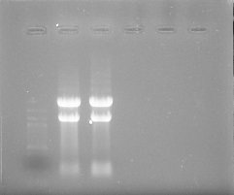
- Check quality by running 1 μg on a 1% agarose gel (denaturing loading buffers may be used). Ethidium bromide may be added to gel and buffer at 0.5 μg/ml for staining. As seen at right, two bright rRNA bands should be visible on a background smear of mRNA with a minimum of small molecular weight degradation products.

- Precipitate 10 μg aliquots of RNA for use in labeling procedure using 1/10 volume 3M sodium acetate, pH 5.2, and 2 volumes ethanol. Centrifuge at high speed for 10 minutes and air dry pellets (or use speed vac).

Labeling of Microarrays with Genisphere Array 350 Kit

This protocol is based on the Array 350 kit – other kits are available, differing in number of fluorophores attached to the dendrimer. The general web address is www.genisphere.com. This site has good pictures – take a look!

The capture reagents are dendrimers, incorporating many fluorophores into one capture molecule.

Two different cDNA preparations will each have a capture tag – each capture tag will bind to a different dendrimer tag, so that you will be able to visualize the amount of red and green fluorescence of the two cDNAs in the two different conditions.

Important Note:

The two dyes we are using for this experiment are called Cy3 and Cy5

Cy3 absorbs pink (looks pink to your eye) but fluoresces green.
Cy5 absorbs blue (looks blue to your eye) but fluoresces red.

One way to remember this: put the dyes in numerical order (i.e. 3, then 5), then fluorescent colors are in alphabetical order (i.e. green, then red)

Prepare cDNA with capture tag

Implementation note: These steps (cDNA synthesis and RNA degradation) can easily be accomplished in a 3 hour lab period. After the RNA degradation and concentration steps, store the cDNAs at -80ºC.

Your RNA samples will be provided as dry pellets containing 10 μg in microfuge tubes (separate tubes for the two samples)

cDNA synthesis

1. To each sample add (in this order):

10 μl DEPC-treated water (vial 10 from the Genisphere kit)
1 μl RT primer (vial 2)
One gets the Cy5 capture primer (blue) the other Cy3 capture (red). Be sure to write down which gets which here!
1 μl SuperaseIn (vial 4)

2. Mix by flicking the tube gently and flash spin.

3. Incubate 10 minutes at 75 – 80ºC in the heating block.

4. Incubate 2 minutes on ice.

5. Prepare a “master mix” for Reverse Transcriptase
For the pair of reactions add the following in order
8 µl Reverse Transcriptase Buffer (extra vial)
2 µl dNTP mix (vial 3)
4 µl DTT (100 mM)
2 µl Reverse Transcriptase Enzyme

6. Gently mix and flash spin, then aliquot 8 µl of the mix to each of your 2 tubes – the total volume/tube should now be 20 µl.

7. Incubate 2 h at 42ºC.

RNA degradation

1. To each tube: Add 3.5 µl 0.5 M NaOH / 50 mM EDTA to stop the reaction and degrade the RNA.

2. Incubate 10 minutes at 65ºC in heating block

3. Add 5 µl 1 M Tris-HCl, pH 7.5 to neutralize.

4. Mix the contents of both tubes together into one.

5. Rinse the now empty tube with 73 µl 1x Tris-EDTA, pH 8.0 (TE buffer) and combine with mixed cDNA samples. Total volume now should be 130 µl.

Alternative method to degrade RNA

1. Make sure contents of tubes are spun down.

2. Add 1 μl of RNase cocktail (RNase A at 4 mg/ml and RNase H at 1 unit/μl).
(Note: the RNase H is fairly expensive and may be omitted without significant effect)

3. Incubate at 37ºC for 15-30 min

4. Mix the contents of both tubes together into one.

5. Rinse the now empty tube with 88 µl 1x Tris-EDTA, pH 8.0 (TE buffer) and combine with mixed cDNA samples. Total volume now should be 130 µl.

Concentrating the cDNA
(read these instructions carefully before proceeding so you know what to do!)

1. Use a Microcon YM-30

2. Prepare the concentrator by adding 100 µl 1x TE, pH 8.0 to the reservoir

3. Spin 3 minutes at 13K rpm.

4. Transfer your sample (130 µl) to the reservoir.

5. Spin 9 minutes at 13K rpm.

6. Remove the reservoir – your cDNA is now concentrated on the membrane

7. Add 5 µl of 1x TE, pH 8.0 to the reservoir without touching the membrane.

8. Carefully invert reservoir over a fresh tube and spin 2 minutes at 13K rpm.

9. Carefully measure the amount of liquid recovered with a micropipettor (should be 3-10 µl).

10. Put the sample back in this tube (Implementation note: stopping point if necessary – freeze at -80ºC)

First Hybridization

Slide Preparation*
1. Incubate microarray slides for at least 60 minutes in 3x SSC, 0.1% SDS, and 0.1 mg/ml sonicated salmon sperm DNA at room temperature (this serves to block the non-specific sites on the slides).

2. Carefully dip the slides into distilled water and spin dry in a 50 ml conical tube with a kim-wipe in the bottom to collect the drips. Put the slide label side down to avoid scratching the array with the kim-wipe.

Alternative procedure for slide preparation:

After the incubation, blow the slide dry with air (connect a piece of tubing with a filter tip on the end to house air or to a nitrogen tank). Don’t blast the slide too hard or too long. Rather, the idea is to chase all the drops of water off the slide while it is held at an angle on a paper towel. If drops of water start to dry in place on the array, quickly immerse the slide back into water and start again. You are not trying to blow dry the slide, rather you are trying to push the liquid away from the spots. If you see streaks at this stage, rewet the slide. If you see dried-on streaks, you will have streaks in your final scan. Store dried slide in a conical tube until ready to hybridize.

3. Thaw the 2x formamide-based hybridization buffer (vial 7). Incubate at 55ºC for 10 minutes and mix well to make sure all crystals dissolve, then spin for 1 minute at 13K rpm to remove any residual particles. Don’t shake it up again!

4. Add enough DEPC-treated water to your concentrated sample to make 25 µl total.

5. Add 25 µl vial 7

6. Mix gently by flicking the tube and flash spin.

7. Incubate at 10 minutes at 80º, then keep at 42ºC until ready to put on slide

8. Transfer the entire cDNA sample (50 µl) to the center of your slide, carefully making a line down the length of the slide (don’t touch the slide with pipet tip! don’t introduce bubbles into the solution! – better to lose some of the solution than have bubbles).

9. Place the short edge of the cover slip on the short edge of the slide. Gently lower the cover slip onto the liquid with a syringe needle, but don’t let it fall all the way down. Pull the cover slip back up, then lower with the needle again, and this time, gently let the cover slip fall into place. Be very careful to avoid bubbles at this stage, too.

Fig. 1. Using needle to carefully lower Lifter Slip onto microarray using mock slide as guide (pictures from the GCAT web site courtesy of Dr. David Kushner [Dickenson College])
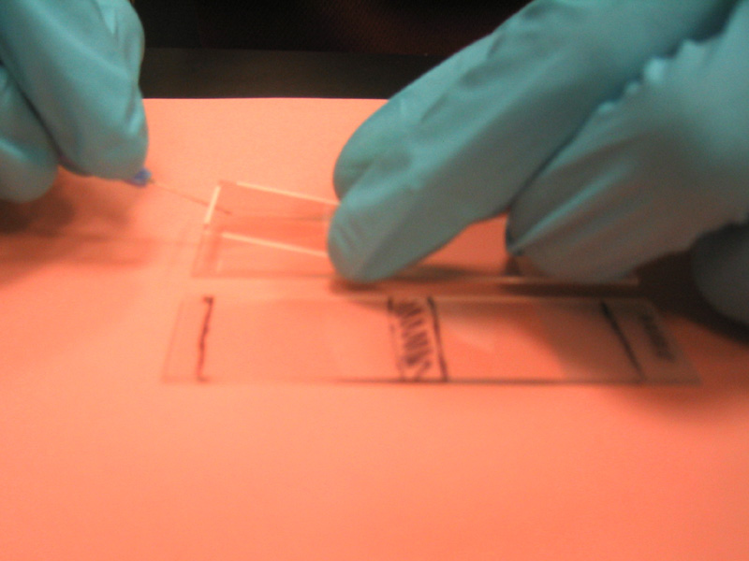

Fig. 2. First Lifter Slip in place on array next to mock slide.
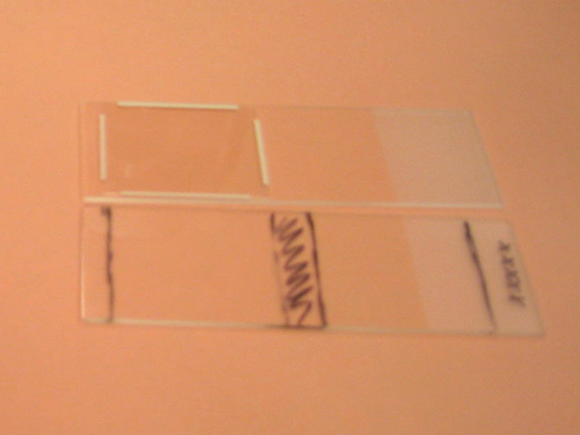

10. Place the slide into either a slide hybridization chamber or a 50 ml conical tube. Be sure to include some water in either case to keep the hybridization mix from evaporating (the chambers have wells that hold ~20 µl of water; for the conical tube, just add ~50 µl to the tube).

11. Incubate the slide at 37ºC overnight. (Implementation note: this step can go for several days if necessary, but check once in awhile to make sure there is still some water in the chamber).

Second hybridization

Tubes have been prepared for you containing the wash solutions. Read the labels carefully as they all contain similar ingredients, but at different concentrations.

Part I – washing the first hybridization mix off the slide

1. Carefully transfer your slide, coverslip side down, into a tube containing Room Temperature 2x SSC + 0.2% SDS. Slosh gently until the coverslip comes off – it may need a little nudge; carefully remove your slide and leave the coverslip behind. (You’re trying to avoid scratching the array with the cover slip)

2. Transfer the slide into 55ºC 2x SSC + 0.2% SDS and incubate for 15 min at 55ºC.

3. Transfer the slide into 2x SSC and incubate for 15 min at room temperature (shake gently periodically)

4. Transfer the slide into 0.2x SSC and incubate for 15 min at room temperature (shake gently periodically).

5. Place the slide label end first in a 50 ml tube with a kim-wipe at the bottom and spin 1 minute at 500 rpm (alternatively use the blow-dry method)

Part II – preparing the 2nd hybridization mix

1. Thaw 2x-formamide based hybridization buffer (vial 7) and incubate 10 minutes at 55ºC. Then spin 1 min.

LIGHT SENSITIVE STEPS FROM NOW ON!

2. Thaw both capture reagents (both vials 1, cover with foil!!!) and the antifade reagent (vial 8).

3. Mix 100 µl hybridization buffer (vial 7) and 1 µl antifade reagent (vial 8). This is your antifade-treated hybridization mix.

4. Vortex the vials 1 for 3 seconds then flash spin.

5. Mix:
25 µl antifade-treated hyb mix (your mix of vial 7 and vial 8)
20 µl DEPC-water (vial 10)
2.5 µl Cy3 capture reagent (vial 1)
2.5 µl Cy5 capture reagent (alternate vial 1)

6. Incubate 10 min at 75ºC. Then pipet 50 µl onto the washed and dried slide using the coverslip protocol from yesterday.

7. Incubate your slide at 37ºC for 2.5h. (Implementation note: this incubation can go overnight if necessary).

Second Wash and Scan

These solutions should have 1 mM DTT added to them to prevent oxidation of the fluorescent dyes. Remember to keep your slide in the dark as much as possible!!! Keep your tubes covered with foil during the incubations to help.

Washing the second hybridization mix off the slide

1. Carefully transfer your slide, coverslip side down, into a tube containing Room Temperature 2x SSC + 0.2% SDS + 1 mM DTT. Slosh gently until the coverslip comes off – it may need a little nudge; carefully remove your slide and leave the coverslip behind. (You’re trying to avoid scratching the array with the cover slip)

2. Transfer the slide into 55ºC 2x SSC + 0.2% SDS + 1 mM DTT and incubate for 15 min at 55ºC.

3. Transfer the slide into 2x SSC + 1 mM DTT and incubate for 15 min at room temperature (shake periodically)

4. Transfer the slide into 0.2x SSC + 1 mM DTT and incubate for 15 min at room temperature (shake periodically).

5. Place the slide label end first in a 50 ml tube with a kim-wipe at the bottom and spin 1 minute at 500 rpm (or use the blow dry method).

Store washed and dried slides in a conical tube covered with foil until ready to scan.

*Slide Pretreatment

Some slides need a pretreatment, others, such as those prepared for GCAT at Washington University, including these yeast arrays, do not. This process is used to redistribute the DNA on the slides, and helps with spot morphology and hybridization.

- Steam the DNA side of the slide over boiling dH₂O. Do not allow visible droplets to form on the slide.

- Immediately place the slide (DNA side up) on a heat block or hot plate set to 100ºC or slightly less to snap dry. Take off after 5 seconds.

- Repeat steam step, followed by drying step. Allow the slide to sit on the heat block for 1 minute this time. Allow slide to cool to room temperature.

Alternate Slide Pretreatment Protocol (from Charles Hauser, St. Edwards University)

1. Create a humidifier by placing slide (DNA side down) over warm water. Cover to create a humidified compartment (see Figure 3 below).

2. Place the slide (DNA side up) on a heat block or hot plate to 100ºC or slightly less to snap dry. Take off after 5 seconds.

3. Repeat humidified step, followed by drying step. Allow the slide to sit on the heat block for 1 minute. Allow slide to cool to room temperature.

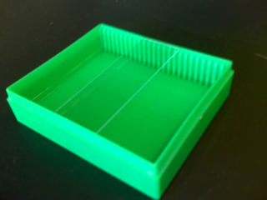 | 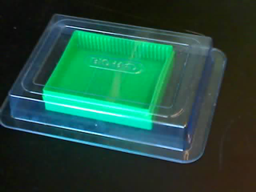

Figure 3: Humidifier chamber for slide pretreatment.

