The Design, Printing, and Analysis of “Teaching Chips”
Cowell, M.L., DeCelle, K.L. Gemberling, M.P., Campbell, A.M. (spring 2006)

Protocol for Pre-Hybridization

- With Diamond Etcher, make hash marks on the side of the slide to denote the region containing spots. Name and number slide at one end (the same end for each of the slides if you have an asymmetrical design or a design offset from the center of the slide). Be sure that you know which side the DNA is on by your labels.

Your
Design
Here

Name and Number Slide with Diamond Etcher
Hash marks with the Diamond Etcher

2. Start dH₂0 boiling over the Bunsen burner to be used in step 6.
3. Wash slides in 0.1% SDS in the Coplin jars for 2 minutes (RT).
4. Repeat Step 1.
5. Wash the slides in dH₂0, ideally in Coplin jar, for 2 minutes (RT). If you have multiple slides perform steps 6-8 on one slide and then move onto the next slide. Leave the remaining slides in the dH₂0.
6. Boil in dH₂0 for 2.5 min by holding each slide, DNA side down, in steam with
tweezers.
7. Place the slide in 95% ethanol for 1 minute (RT).
8. Spray with pressurized C0₂.
Protocol for Hybridization
1. Calculate how you would add equal volumes (1.33 µL each if using 6 oligos) of the six
DNA 61mer oligos at your desired concentrations so that the total volume of oligos is
8 μl. We used the 6 oligos: Cy3 and Cy5 for: Shy, Idh1, and Mhp.

2. The combined volume of all of the DNA oligos to hybridize 3 slides should be 8 µL.
Buffer #6 (50 μl)

0.5 μl
(8/6) μl
Calf Thymus DNA (2 μl)
Stock Solution
of one type of
oligo
Sterile dH₂0 to
dilute oligo to
desired
concentration
(It probably would have been better to make up 80 microliters of the total mixture to be
sure had had enough fluid to add a full 20 microliters to each slide.)

3. Graphical Depiction of Concept (Figure 1).

A
B
C

Figure 1: Graphical representation of mixing the 6 oligos in the appropriate concentration and then adding them to a tube containing Buffer #6 and Calf Thymus DNA. In this diagram, tube A represents a stock solution of oligos. 0.5 µl of liquid is taken from A and added to a variable amount of water depending on what the desired concentration is. 8/6 µl is then taken from B and added to tube C. All 6 oligos have separate stock solutions as well as tubes with variable amounts of water represented here by a single tube B. In this depiction, a dilution of only one oligo is shown. In reality 6 oligos must be diluted and then all six added to tube C.

Table 2: Specific volumes and concentrations of oligos used by Genomics Lab 2006
Concentration of Stock Oligos (ng/μl) (A) | Volume (μL) of Stock Oligos  from (A) for tube (B) | Total Volume (μL) Stock Oligos + dH₂0 (B) | Volume (μL) of dH20 in (B) without oligos | Desired Concentration of Oligos in (C) (ng/μL)
Cy3 idh1 2380 | 0.5 | 13.28 | 12.78 | 2.0
Cy5 idh1 3050 | 0.5 | 16.94 | 16.44 | 2.0
Cy3 Mhp 1730 | 0.5 | 9.61 | 9.11 | 2.0
Cy5 Mhp 3150 | 0.5 | 175 | 174.5 | 0.2
Cy3 SHY 2620 | 0.5 | 145.55 | 145.05 | 0.2
Cy5 SHY 2030 | 0.5 | 11.27 | 10.77 | 2.0

4. Add together diluted oligos, 2 μL of Calf Thymus DNA (266 ng/µL stock), and 50 μl
of 3DNA Buffer #6 for a final concentration of 60 μl in tube C.
5. Vortex this mixture.
6. Heat the oligos, Calf Thymus DNA, and Buffer #6 for 10 minutes at 80⁰ C.
7. Wash cover slip with isopropanol and dry with compressed C0₂.
8. Pipet 20 μl onto a slide. Immediately add a coverslip because the liquid dries very
quickly and can dry on the slide. Add the coverslip with 30 and 18 gauge sized
needles using appropriate technique. If bubbles occur, slant slide to a 45⁰ angle until
bubbles come out.
9. Incubate 12-18 hours at 42 degrees C.
10. Filter solutions in Coplin Jars using 0.45 μm filters if dust is a concern.
11. Warm a Coplin Jar without slides in Belly Dancer at 37⁰ C for ~10 minutes.
12. Put slides in Coplin Jar with 2X SSC/0.2% SDS for 15 minutes at 37⁰ C.
13. After taking slides out of Coplin Jar, set Belly Dancer to 54⁰ C for use in step ?
14. Put slides in Coplin Jar with 2X SSC for 10 minutes at RT. (While you’re waiting,
you can use tweezers to take the cover slips out of the 2X SSC/0.2% SDS Coplin Jar
used in the previous step.)
15. Put slides in Coplin Jar with 0.2X SSC for 10 minutes at RT.
16. Put slides in Coplin Jar with 95% EtOH for at least one minute. Since the next step
must be done individually, some slides will remain in the EtOH longer than a minute.
17. Dry each slide with pressurized C0₂ and do not allow ethanol to air-dry on slide.
Store slides in a closed container.
18. Vortex and centrifuge Cy3 and Cy5 dendrimer. Pipet 3.75 μl of Cy3 and Cy5
dendrimers and add to 67.6 μL Buffer #6.
19. Vortex mixture.
20. Heat dendrimers and Buffer #6 for 10 minutes at 80⁰ C.
21. While the dendrimers and Buffer is heating, hydrate the airtight slide chambers with
22 μL of fluid in the circular indentation near where the two halves snap together.
23. Wash the cover slip with isopropanol and dry with compressed CO₂.
24. Pipet 20 μl of dendrimer/buffer mix onto slide. Immediately add a coverslip because
the liquid dries very quickly and can dry on the slide. Add the 22 mm coverslips
with 18 and 30 gauge needles using appropriate technique. If bubbles occur, slant
slide to a 45⁰ angle until the bubbles come out.
25. Incubate the slides at 54⁰ C in the belly dancer for 2 hours.
26. After 2 hour incubation, place slides in 2X SSC/0.2% SDS which has been wrapped
in aluminum foil to try to prevent photobleaching.

*From this step on, put slides in Coplin Jars which have aluminum foil to prevent photobleaching.

27. Put slides in Coplin Jar with 2X SSC/0.2% SDS into belly dancer at 54⁰ C. for 15
minutes.
28. Place slides in Coplin Jar 2X SSC for 10 minutes at RT. (While you’re waiting, you
can use tweezers to take the cover slips out of the 2X SSC/0.2% SDS Coplin Jar used
in the previous step.)
29. Place slides in Coplin Jar 0.2X SSC for 10 minutes at RT.
30. Place slides in Coplin Jar 95% EtOH for at least one minute.
31. Remove slides one at a time and use pressurized CO₂ to dry the slide.
32. Put slides in a dark slide box and scan when ready.

Rasterbator Protocol
Website: http://homokaasu.org/rasterbator/

1: Find an image you would like to rasterize.
2: Go to the above website.
3: Click on the button that says Rasterbate your image.
4: Upload an image by following the instructions on the webpage.

***Note: the image cannot be larger than 1 MB ***

5: Select the size of the image you would like to produce. You can crop a picture at this
step. I would recommend for printing you select a max of two horizontal pages.
6: You will now be able to select various options before the program takes over.
On this screen one can select Dot size, which should be set at 7 or 10mm for
microarray printing.
You can also select to add a border and select color or black and white. These
options are unnecessary and do not need to be changed from the default. Once you
have selected the options you desire, Click Rasterbate!
7: A screen will appear that will let you view the progress of your pictures rasterbation.
This will allow you to view your place in the queue as well.
8: Your image will automatically download to your desktop and open in a PDF format.

Microarray Robot Printer Software
To begin your journey into microarray printing, first turn on your robot by switching on the main power unit (MPU), followed by the humidification control unit (HCU).
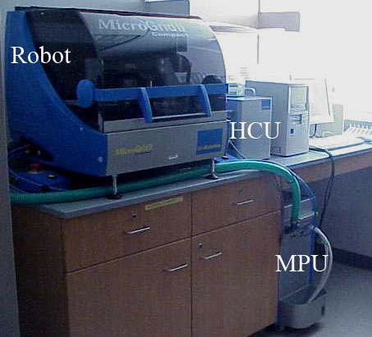
Figure 2. The robot and its components: Main Power Unit (MPU), Humidification Control Unit (HCU).

It is now time to explore the wonderful world of your TAS Application Suite. Once the program is opened, click on ‘New Microarray’ under the ‘File’ menu. The screen should appear like this:
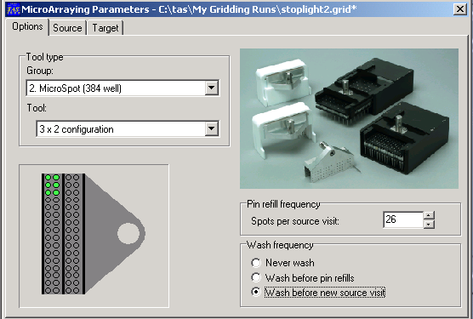
Options:
Under the options tab, you will define your well plate size (under ‘group’) and the pin configuration (under ‘tool’). ‘Spots per source visit’ represents the number of times each pin will touch the slides before returning to the 384-well plate (called the source). It is highly recommended that a new 384-well plate be used for each printing session, this will lower the chance of having pins clog. This number should not exceed 30 to ensure the pin does not run out of sample. Under ‘wash frequency’ you should choose ‘wash before new source visit,’ which ensures that no sample mixing of DNA occurs. Next, click on the ‘Source’ tab.

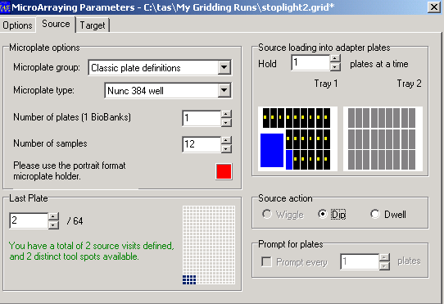
Source:
Under the ‘Source’ tab, you will define where and how the pins will print. Under ‘Microplate Group’ choose ‘Classic Plate Definitions’. Be sure that under ‘Microplate Type’ your specific well plate is selected. ‘Number of Plates’ is the number of source plates. This option should be set at one since the MicroGridII Compact only has the capacity to hold one microwell plate. The ‘Number of Samples’ is dependent upon the printing pattern and pin configuration you have chosen. In our study, we wanted to print from six wells in the following configuration:
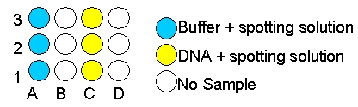
Figure 3. Sample placement in the 384-well plate.
We printed from this sample configuration using 3 pins. A 3x1 pin configuration is not a program option; therefore, we utilized the 3x2 pin configuration without loading the second column of pins into the tool.
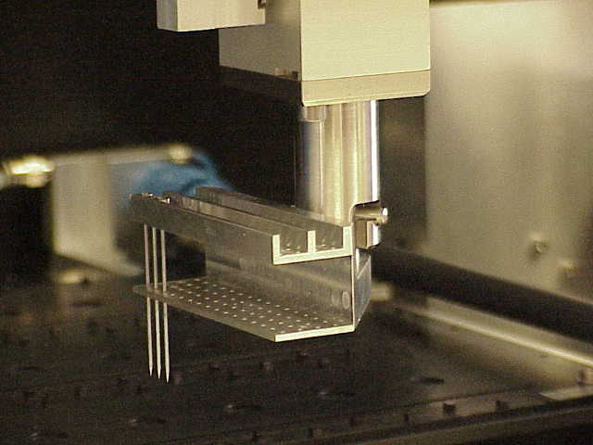
Figure 4. Robot arm and pin arrangement.

When a 3x2 pin configuration is chosen, the software assumes that 6 samples are present in the source in a corresponding 3x2 configuration, filling wells A1-A3 and B1-B3. When the ‘Number of samples’ tab is changed to 12, the software assumes that DNA samples occupy wells A1-A3, B1-B3, C1-C3, and D1-D3. The software is then able to obtain sample from wells A1-A3 and B1-B3 in one source visit, and sample from wells C1-C3 and D1-D3 in a second source visit. In order to print our design, we set the sample number at 12, loading our samples into wells A1-A3 and C1-C3. With this setup, we were able to utilize a 3x2 pin configuration with only 3 pins and 6 true samples. ‘Last plate’ defines how many different wells each pin will visit. For example, a 6-pin setup making two visits to the microwell plate will require a total of 12 sample wells. Pay attention to the text in this box; green means excellent (source visits and available tool spots match), black is acceptable (source visits are less than the available tool spots), and red indicates that a run cannot be initiated (source visits are greater than the available tool spots). Under ‘Source loading into adapter plates’ you must choose how many well plates the robot will hold at a time. Once again, this robot holds only 1 well plate. On the right side, you will see an overall picture of the slide positions. If slides appear red the problem must be addressed under the ‘Target’ tab. Under ‘Source action’ choose the ‘Dip’ option when using split pins (which is what we use). ‘Prompt for plates’ is not available in the MicrogridII Compact. Next, open the ‘Target’ tab.

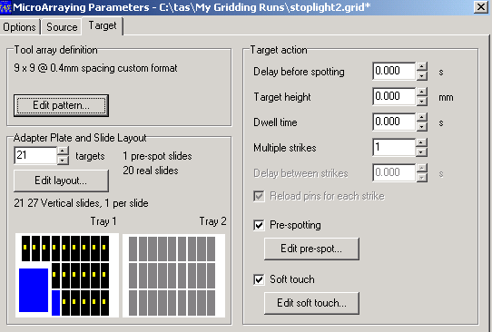

Target:
Options under the ‘Target’ tab are very project specific. We will guide you on our journey and try to explain the general logic (or lack thereof) of the software. Under the ‘Tool array definition’ you must click on the ‘Edit pattern’ button to inform the software of the design you previously created (e.g. the spotlight).
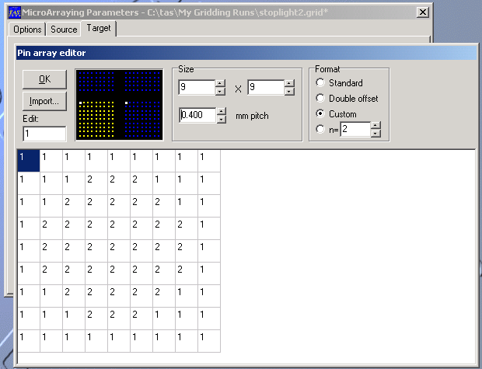
First enter the values for the size of the grid that each pin will print. Each numbered square represents one spot on the slide. In order to change the number of spots possible for each grid the value for pitch can be changed. The lower the value for pitch the more spots can be printed by one pin. It is recommended that the pitch value stay at or above 0.225mm. This will allow you to print a 20 by 20 grid, the max value, at which spots do not run together. The numbers in the boxes correspond to the positions of the samples in the 384-microwell plate. When you click on the yellow spots in the black box that appears at the top of the screen, the well plate coordinates are displayed as seen below:
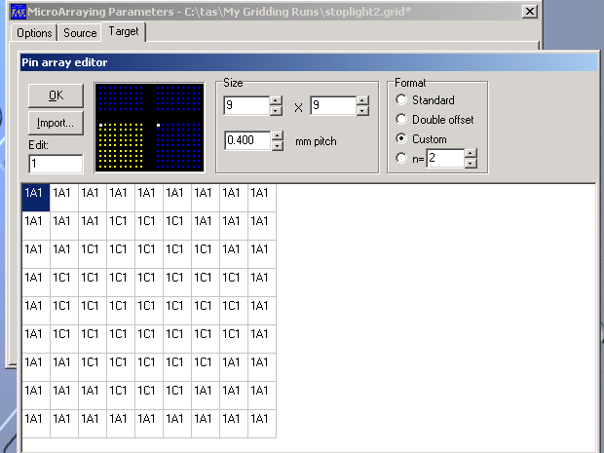
Under ‘Format’ click ‘Custom,’ as this allows you to create your own unique microarray pattern. Choose n = x (entering your desired number, i.e. n = 2 for duplicates) if you wish to print replicates of each sample on your slide. Click ‘OK’ to return to the main ‘Target’ window. Next under ‘Adapter Plate and Slide Layout,’ you will define the number of targets (slides) to be printed. Click on ‘Edit Layout’ button.

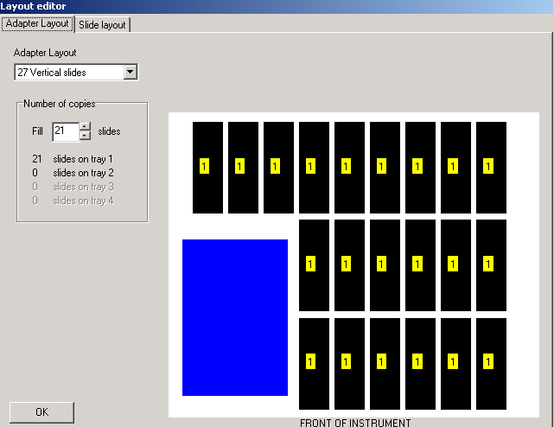
Then, under ‘Adapter Layout’ you must select 27 vertical slides from the pull down menu. See image below:

384-Microwell Plate

Click on the ‘Slide Layout’ tab to define the margins of your slide. Each margin can be changed independently and ultimately the design should be near the center of the slide. Each colored area (numbered 1, 2, 3, etc.; yellow 1 in our case) represents a full printing of your design, NOT the printing of each individual pin. Here you can determine how many times you would like your design to be printed on each slide. This option also allows you to make multiple programs into one design. By altering the margins you can print two programs adjacent to one another. This is the function that allowed the printing of our Davidson logo with four programs. If red appears under the ‘Source’ tab, the problem is likely due to your margin settings.
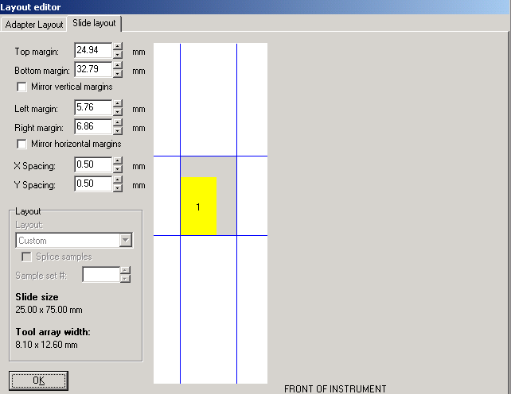
Click ‘OK’ to return to the main ‘Target’ window. Under ‘Target Action,’ the settings which appear in the image above are ideal for the robot. Pre-spotting removes excess liquid from the tip of the pin and ensures all subsequent spots are of equal size. If you choose to pre-spot, which is highly recommended, click on the ‘Edit pre-spot’ button. The ‘Number of pre-spots’ should be 1, confining the pre-spotting to a single slide. Under ‘Historical Options’, designate the number of ‘Multiple strikes’ to be 5. In our study, we accepted the default settings under ‘Pre-spotting protocol’, but for specific descriptions of other pre-spotting options consult the user manual.
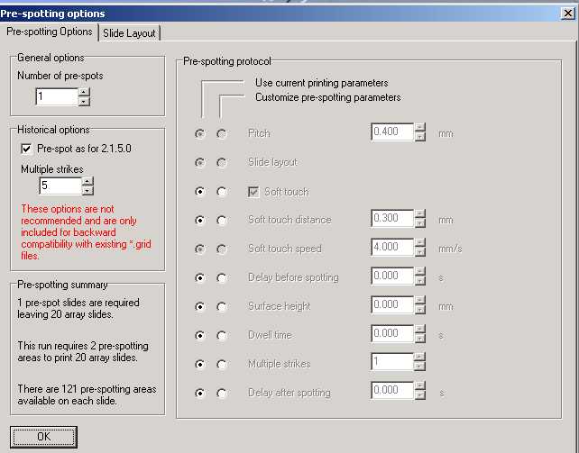
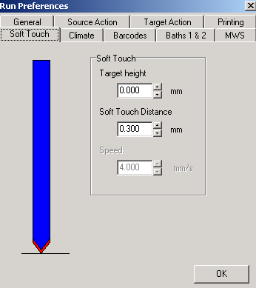
Click ‘OK’ to return to the target window. A left mouse button click on the ‘Edit soft touch’ button, transports you to a whole new world of decision making. This option slows the speed of the pins before they make contact with the slide. We recommend selecting a target height of 0.5mm and a soft touch distance of 0.3mm.

In this window, Under the ‘Climate’ tab, you can control the humidity settings. Below are the settings we chose. In the graph box, the yellow line represents the actual humidity inside the robot, the red line represents the minimum acceptable humidity, and the green line represents the target humidity that is to be
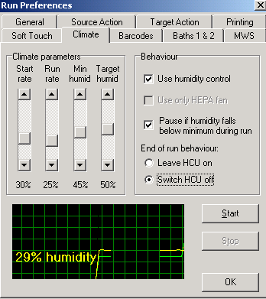
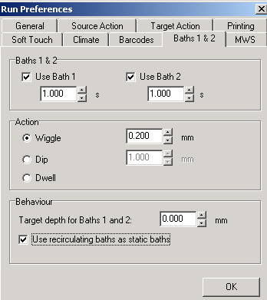
maintained throughout the run. If the machine humidity is not set correctly, the spots will not dry uniformly.

Next, under the ‘Baths 1&2’ tab, select both baths for washing. Set ‘Wiggle’ in the ‘Action’ box to no greater than 0.200mm. Be sure that ‘Use recirculating baths as static baths’ is selected. We left all other tabs at default settings.
Click ‘OK.’ You are now ready to roll! Click the green ‘GO’ button that appears in the tool bar at the top of the screen.
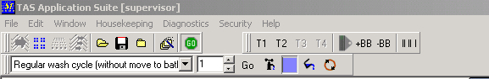
The program will then prompt you to load the tool. After loading the tool, close the lid and click ok. Next, you will be prompted to ‘clean and load tray 1, and click OK to switch on the vacuum.’ Be sure to push slides to the bottom left corner of each slide slot. If the slides are not in the proper position one can bring the slide tray to the front of the robot by pressing the T1 button, located in the tool bar at the top of the page.
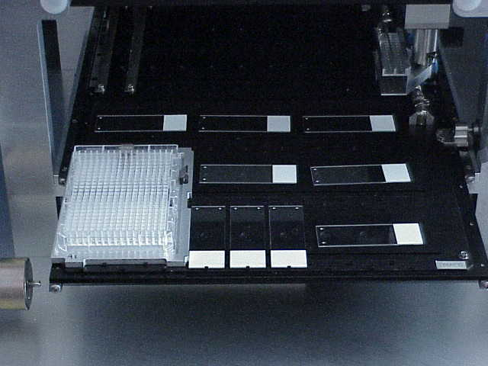
Figure 5. Tray 1 setup with slides covering holes that create the vacuum.

After the vacuum is activated, the program will prompt you to ‘check that the slides are held well. Check this by trying to move a slide and click ‘OK.’ The robot will begin its run automatically. Sit back and relax until the run is finished.
Do not click the ‘Stop’ button unless you wish to terminate your run. The ‘Pause’ button allows you to halt the program temporarily so that you can make minor adjustments to the program before continuing your journey.

Appendix G
For the Davidson LOGO, we used the following patterns:

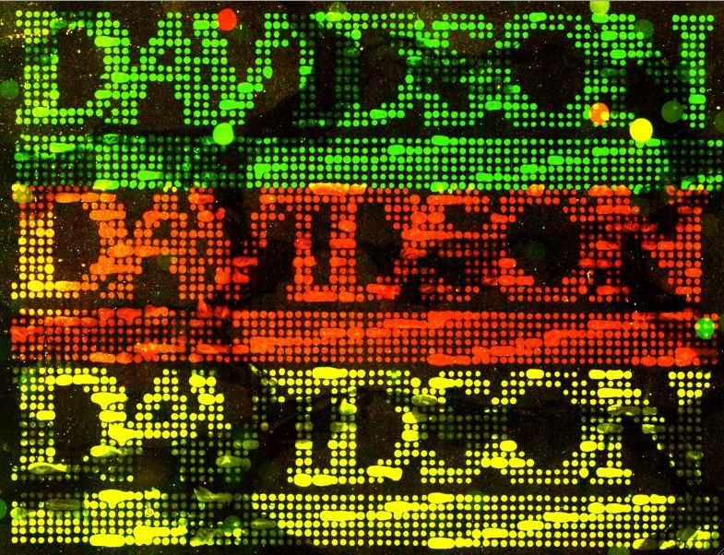

Grid Patterns

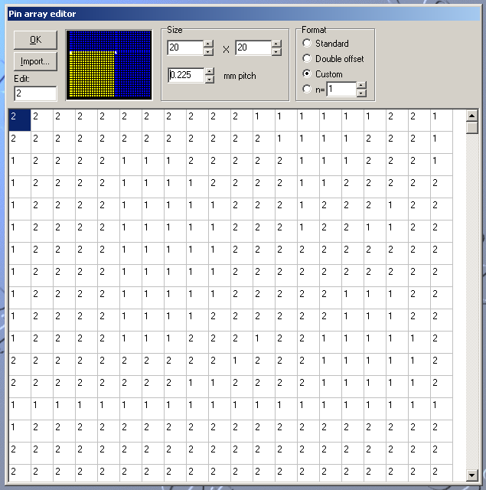
DA.grid

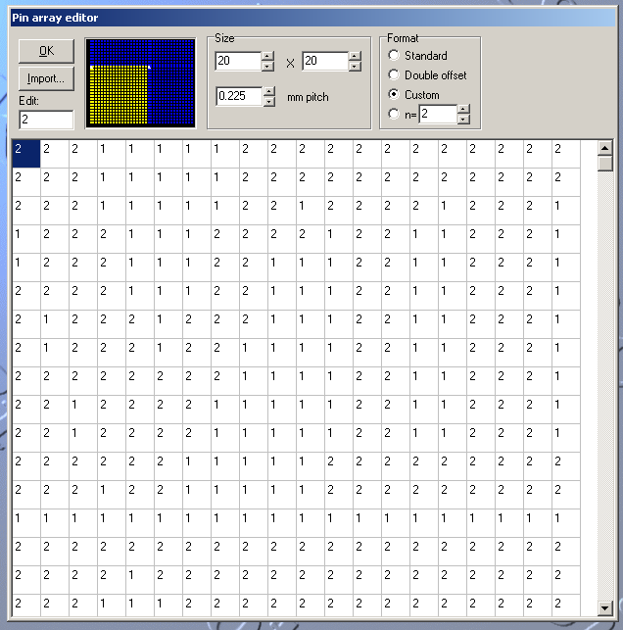
VI.grid

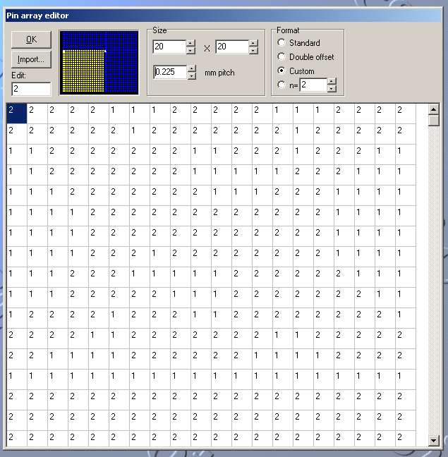
SO.grid

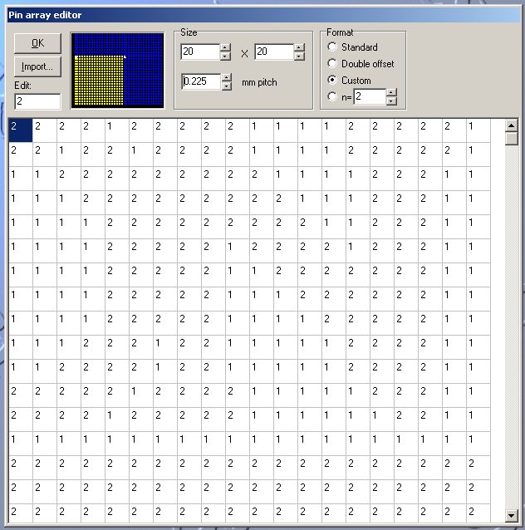
N.grid

References

Amore, A. Bossie, S., Citrin, M., Cobain, E., McDonald, M., Sole, M., Wilson, E., Choi, D., Oldham, E., Pierce, D. and Campbell, A.M. DNA Microarrays: How to Make Your Own Teaching Chips. Spring 2005. Davidson College.

Campbell, A.M. Personal Conversation. 3/10/06.

Oldham, E. E. 2003. Exploring the use of controls in DNA microarrays: a case study in quality control.

Pierce, B.D. and Campbell, A.M. Exploring the use of plasmids in DNA microarray technology. Fall 2002 & Spring 2003. Independent Research Paper.

Acknowledgements
We thank Emily Oldham, Dan Pierce, and the Genomics Lab 2005 (www.bio.davidson.edu/Courses/Bio343/LabMethods_Students_2005.html) for contributing their figures to us. We thank Dr. Campbell for his suggestions and guidance.

