- ABSTRACT.
DNA microarrays are a powerful new technology that allows rapid, high-throughput analysis of genome-wide expression patterns. To assess the accuracy and validity of this technology, PCR products of ten Saccharomyces cerevisiae genes were printed on glass slides in known concentrations. Ten pairs of oligonucleotide probes were designed with limited non-target binding, and experimental ratios were compared to predicted values. Surprising gene-dependent ratios were observed; when all ratios should have been precisely 1:1, some genes displayed characteristic ratio profiles. Alternative hybridization methods failed to correct all ratios to 1:1. Sources of experimental error in this multi-step process were documented. Prior to data exploration, researchers must either demonstrate that no aberrant genes are present, or identify aberrant genes and eliminate them from the study. A range of significance for ratio values must be determined prior to investigation for each microarray application. My findings indicate that future DNA microarray experiments must include more rigorous controls.

- INTRODUCTION.
DNA microarray technology has revolutionized the fields of genetics and molecular biology. With the recent sequencing of whole genomes from a variety of organisms, rather than examine cellular responses one gene at a time, we can now represent an organism’s entire genetic code on a single microarray the size of a microscope slide, and in a matter of hours, examine every gene’s response to a wide range of experimental stimuli. The literature contains over 4,000 publications since 1999 that implement microarray technology (1). Relatively little work, however, has addressed the accuracy and reliability of these data. This project explores a largely overlooked aspect of DNA microarray technology: quality control (2).
Microarrays work by exploiting a fundamental property of DNA—complementary base pair binding. After cDNA from each of two experimental conditions is fluorescently labeled (one red with Cy5 dye, the other green with Cy3 dye) and hybridized to the microarray, a scanner measures the fluorescence intensity of each channel, gridding software computes ratios describing the relative intensity of each color, and thus induction or repression of each gene transcript is assessed. A one-to-one ratio, therefore, describes equal amounts of signal, and thus equal amounts of gene transcript, from both the red and the green condition. Yet, if cDNAs are collected experimentally, and intensity ratios are the experimental result, how are we assured that the ratios are accurately reflecting gene transcription? This project will use known DNA sequences on the microarray slide and known probe sequences in the hybridization solution to achieve 1:1 ratios. Comparison of experimental ratios to predicted values will assess the accuracy and validity of DNA microarray technology.
Work on microarray quality control has increased in recent months. Many of these papers have focused on the statistical analysis of microarray data, and suggested various internal controls to reduce error (3-10). Others have focused on reducing sources of error during microarray production such as variation between spots, chip batches and fluorescent labeling methods (11-19). Scanning software can introduce more experimental error (20, 21). Several other papers have tried to both quantify and reduce noise (22, 23). Replicating data sets consistently is essential (24-28). False-positive and false-negative signal is a significant problem (29-33). Still other papers have attempted to assess the sensitivity of the microarray system in an effort to correlate fold changes to known changes in transcript (34-36). The combination of all these factors culminates into one crucial question: what signal is biologically significant? With this answer in hand, we can begin to group genes together into common expression profiles, understand molecular pathways within the cell, infer the functions of unknown genes, and genuinely reap the benefits of this powerful technology.
Researchers currently take two steps in implementing DNA microarrays. The first takes an experimental condition of interest and looks for general trends in cellular responses. Ratios are grouped into expression profiles to illuminate patterns, or classes of genes that work together and are commonly regulated. The second step takes the first further to focus on one or more isolated genes and infer precise transcriptional control (37). While the success of the first step is clear, applying microarray systems to experiments that have traditionally used more standard procedures such as Northern blots and RT-PCR remains difficult. Because microarrays are still a relatively young technology, important quality control parameters have yet to ensure that they can be used reliably in cases of small numbers of isolated genes. This second step will require rigorous positive and negative controls, as well as consistent experimental replicates, to ensure validity and accuracy. With further advances in quality control studies of DNA microarray technology, this second step will also be possible.
- MICROARRAY PRODUCTION.
In microarray studies, a 1:1 ratio between Cy3 and Cy5 fluorophores indicates equal gene expression between the experimental conditions. To test the precision of microarray technology, this project will use equal amounts of Cy3 and Cy5 fluorophores to compare experimental ratios to theoretical values, as well as catalog sources of error in the various steps of the methodology. To this end, an optimized experimental microarray was designed and produced. Equally-sized gene fragments from a selection of genes were spotted out in a wide range of concentrations. Control over both spot and probe concentrations will allow us to manipulate this system to achieve 1:1 ratios. Any factors that affect Cy5 to Cy3 ratio will be detected.
A. Gene Selection.
Peter Lowry selected ten Saccharomyces cerevisiae genes for study and one Drosophila melanogaster gene as a negative control. Information on the chromosome location and functions of these genes is given in Table 1.
Gene | Systematic Name | Chromosome | Brief Description of Function
CAT2 | YML042W | XIII | Carnitine O-acetlytransferase
DBR1 | YKL149C | XI | RNA lariat debranching enzyme
IDH2 | YOR136W | XV | Catalytic function in cellular energy metabolism
MDH3 | YDL078C | IV | Malate dehydrogenase, TCA cycle
UPC2 | YDR213W | IV | Cytoplasmic RNA polymerase II transcription factor
RAD9 | YDR217C | IV | Cell cycle control, DNA repair
SHY1 | YGR112W | VII | Codes for a mitochondrial protein required for full expression of cytochrome oxidase (COX)
IDH1 | YNL037C | XIV | Regulatory subunit in cellular energy metabolism
MHP1 | YJL042W | X | microtubule organization
RIM21 | YML294C | XIV | Unknown function
Hedgehog | -- | 3 | Cell cycle regulation during development
Table 1. Gene information (38).
500 base pair fragments of each gene were chosen based on diagnostic internal restriction enzyme sites and minimal sequence similarity to the yeast genome. Utilizing NCBI’s BLASTn program and an Expect value of 5,000, no significant similarity was found for any of the gene fragments.
When choosing 500mer fragments of the genes, base pair identity between the genes should be minimized to avoid probe sequences binding to non-target segments. To predict possible cross-talk between probes and the 500mer targets, base pair identity between the genes was assessed using Seqaln v. 2.0 (39). Table 2 shows the length of the longest string of matching base pairs between each 500mer fragment. Because this program reported only the maximum value for each alignment, equal and lesser lengths of matches could exist elsewhere along the 500mers.
GENES | CAT2 | DBR1 | IDH2 | MDH3 | UPC2 | RAD9 | SHY1 | IDH1 | MHP1 | RIM21 | Hedgehog
CAT2 | 500 | 9 | 9 | 9 | 11 | 8 | 9 | 9 | 9 | 10 | 11
DBR1 | 9 | 500 | 10 | 9 | 8 | 9 | 8 | 9 | 9 | 9 | 8
IDH2 | 9 | 10 | 500 | 10 | 9 | 8 | 8 | 10 | 9 | 8 | 8
MDH3 | 9 | 9 | 10 | 500 | 8 | 11 | 10 | 9 | 11 | 8 | 9
UPC2 | 11 | 8 | 9 | 8 | 500 | 8 | 8 | 8 | 9 | 10 | 8
RAD9 | 8 | 9 | 8 | 11 | 8 | 500 | 9 | 9 | 10 | 10 | 9
SHY1 | 9 | 8 | 8 | 10 | 8 | 9 | 500 | 13 | 9 | 9 | 9
IDH1 | 9 | 9 | 10 | 9 | 8 | 9 | 13 | 500 | 9 | 8 | 8
MHP1 | 9 | 9 | 9 | 11 | 9 | 10 | 9 | 9 | 500 | 8 | 8
RIM21 | 10 | 9 | 8 | 8 | 10 | 10 | 9 | 8 | 8 | 500 | 9
Hedgehog | 11 | 8 | 8 | 9 | 8 | 9 | 9 | 8 | 8 | 9 | 500
Table 2. Alignment of 500mer gene fragments. The longest string of base pair identity is shown. Blue indicates the longest strings of matches: 13 base pairs. Red shows the longest alignments for each pairwise comparison.

The longest string of matches among all eleven genes was 13 base pairs between IDH1 and SHY. The maximum length of matches was 10 or 11 base pairs for each pair of targets. At this stage of design, these values seemed sufficiently minimal to avoid cross-reactivity. Additional alignments are shown in Tables 8 and 9 on pages 11 and 12.
Because GC bonds form three hydrogen bonds compared to two in AT bonds, the GC content of a DNA fragment indicates how much kinetic energy must be applied to unwind a double-stranded helix into single-stranded pieces. Because the 500mers should denature similarly to allow the oligonucleotide probes to bind equivalently, the GC content range of the fragments should be as narrow as possible. Table 3 shows that the range of GC content for each 500mer fragment was 35.4% to 44.8% for the yeast genes, while the fly gene (Hedgehog) was higher at 62.8%.
GENE | GC (%)
CAT2 | 40
DBR1 | 36
IDH2 | 40.6
MDH3 | 43.6
UPC2 | 44
RAD9 | 35.4
SHY1 | 42.8
IDH1 | 44.8
MHP1 | 47.8
RIM21 | 39.6
Hedgehog | 62.8
Table 3. GC content of each 500mer gene fragment (Appendix A).
B. Isolation of Gene Fragments.
PCR products were used as targets for the microarrays (40, 41). The gene fragments were isolated from yeast genomic DNA using Taq PCR Master Mix (Qiagen):
  - 50 μL Master Mix (1.5 mM MgCl₂ stock)
  - 1 μL template DNA (see Table 6 for concentrations)
  - 1 μL Primer A
  - 1 μL Primer B
  - dH₂O to 100 μL.

The following reaction cycle was implemented on a PTC-100 Programmable Thermal Controller (MJ Research, Inc.):

- 95°C – 5 minutes
- 95°C – 1 minute
- 45°C – 1 minute
- 72°C – 1 minute
***Repeat 29 times steps 2 through 4.

Based on preliminary electrophoresis gel images, each gene was PCR amplified with an optimized MgCl₂ concentration. These values are shown in Table 4.
GENE | MgCl₂ (mM)
Hedgehog | 1.5
CAT2 | 2.0
DBR1 | 1.8
IDH2 | 2.0
MDH3 | 2.0
UPC2 | 2.0
RAD9 | 2.0
SHY1 | 2.0
IDH1 | 1.5
MHP1 | 2.0
RIM21 | 2.0
Table 4. MgCl₂ concentrations used to amplify each gene.
Figure 1 shows the PCR products for each of the eleven isolated 500mer fragments.
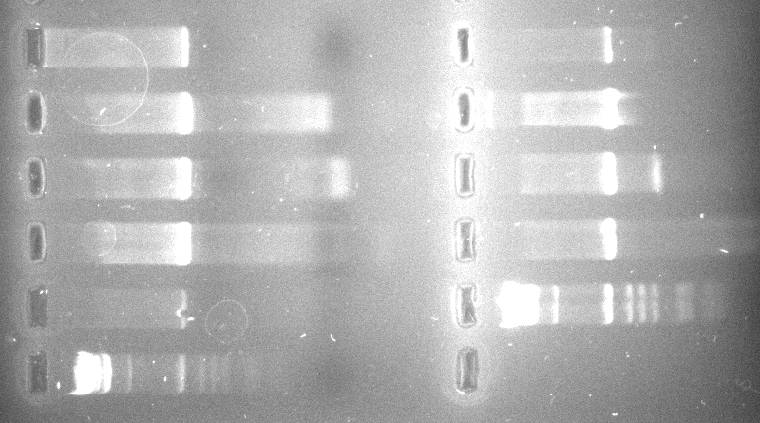
SHY RAD
IDH2 RIM
UPC IDH1
MDH MHP
CAT Ladder
Ladder
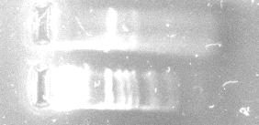
DBR
Ladder
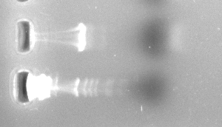
Hedgehog
Ladder
Figure 1. 500 base pair fragments of each of the eleven genes. Electrophoresis gels are 1.5% w/v agarose run at 100 V and stained with ethidium bromide.

Following confirmation of 500 base pair lengths for each gene, five 100 µL PCR reactions were performed and pooled.
To be certain the 500mers from Figure 1 are the indicated amplification fragments, an aliquot of each PCR product was digested with a diagnostic restriction enzyme. Table 5 indicates the restriction enzymes used and expected fragment sizes for each gene.
GENE | Bp Segment of Gene | Restriction Enzyme | RE fragments (bps)
Hedgehog (fly) | 1441-1940 | XhoI | 114 & 386
CAT2 | 1133-1632 | BglII | 100 & 400
DBR1 | 1-500 | ClaI | 96, 167 & 237
IDH2 | 591-1090 | EcoRV | 200 & 300
MDH3 | 470-969 | ClaI | 440 & 60
UPC2 | 1751-2250 | BglII | 42 & 458
RAD9 | 483-982 | EcoRV | 250 & 250
SHY1 | 548-1047 | EcoRI | 100 & 400
IDH1 | 341-840 | EcoRI | 50 & 450
MHP1 | 1432-1931 | ClaI | 150 & 350
RIM21 | 82-581 | EcoRI | 200 & 300
Table 5. One D. melanogaster and ten S. cervisiae genes with corresponding restriction enzymes and diagnostic fragment sizes.

The following restriction enzyme digest was prepared for each gene and incubated at 37°C:
- 10 μL PCR product
- 2 μL diagnostic restriction enzyme
- 2 μL corresponding buffer
- 2 μL 10X BSA
- 4 μL dH₂O

The digests shown in Figure 2 confirm the identity of the 500mer PCR amplification products as the desired gene fragments.

RAD 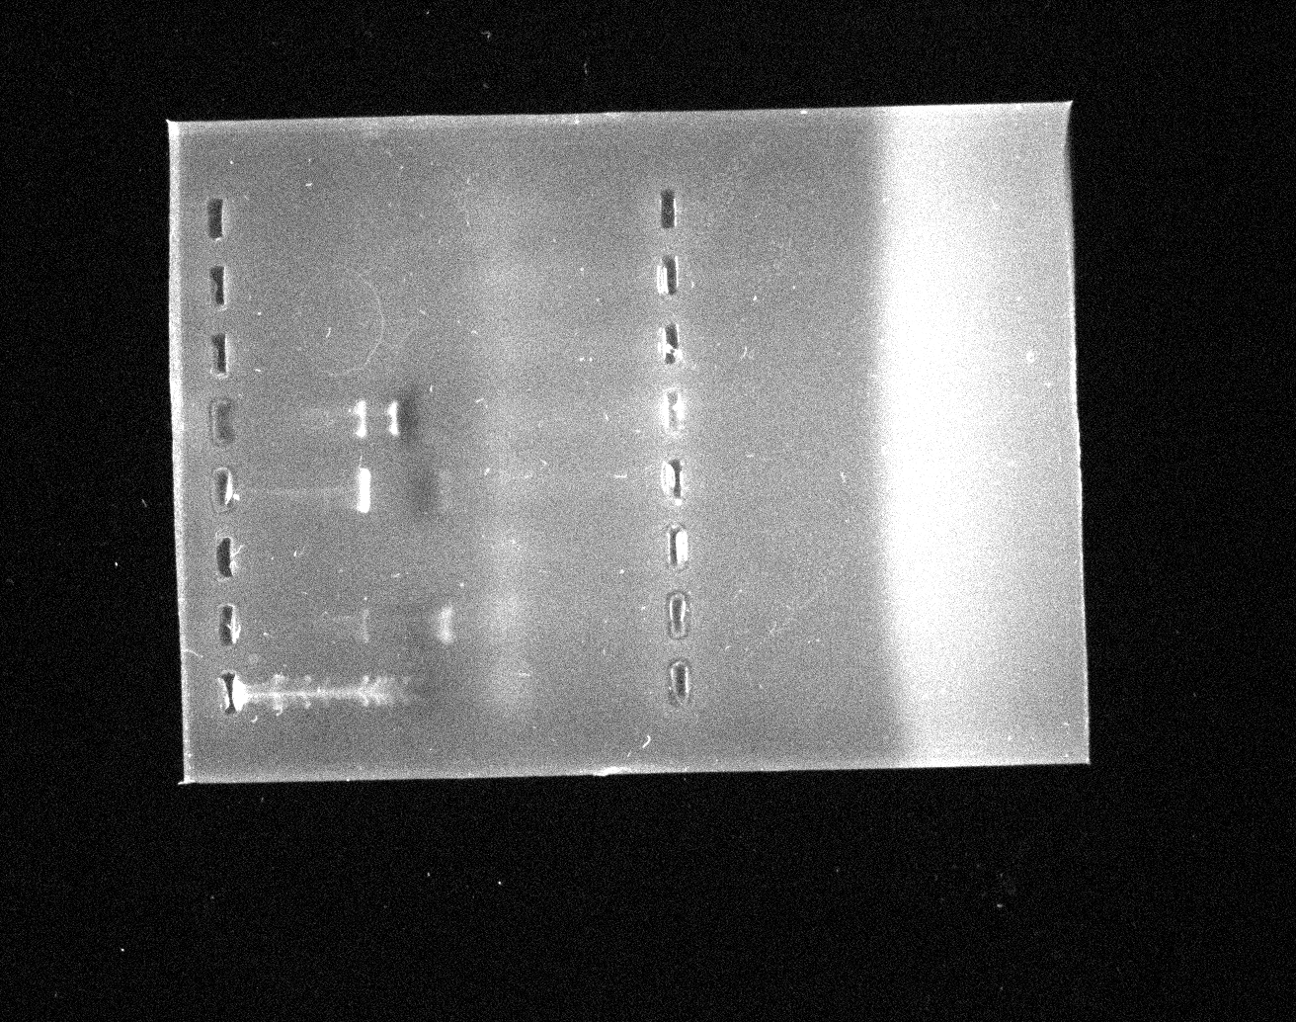 DBR 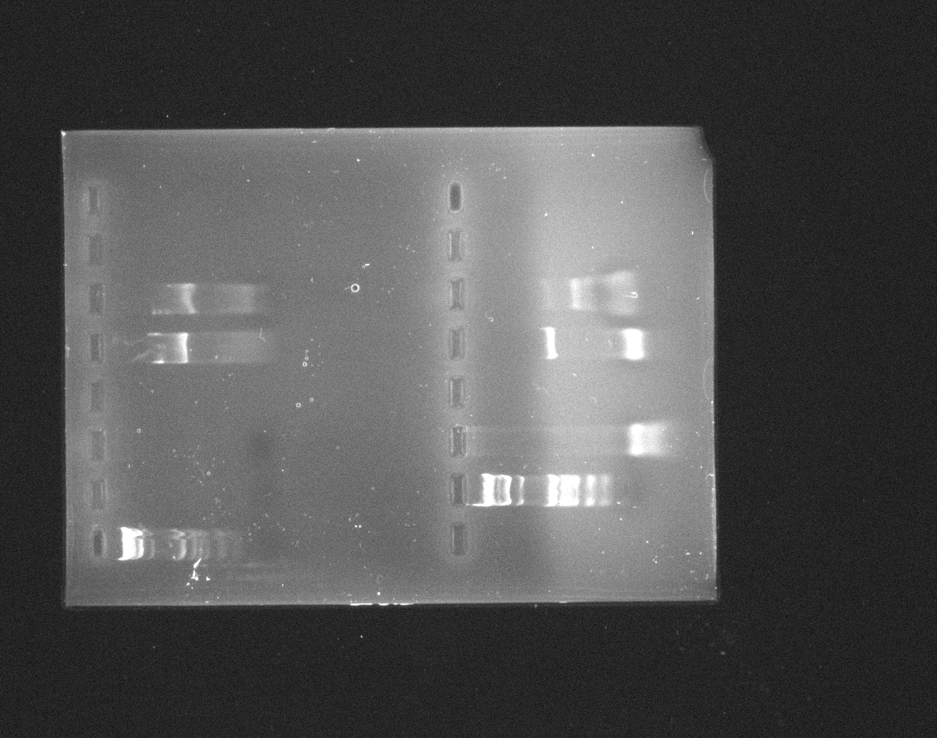
Ladder Ladder

SHY
Ladder

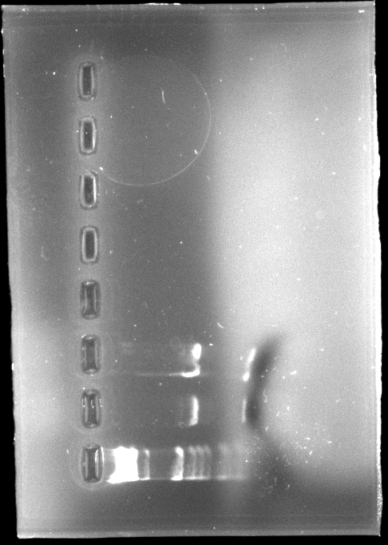
Hedgehog
Ladder

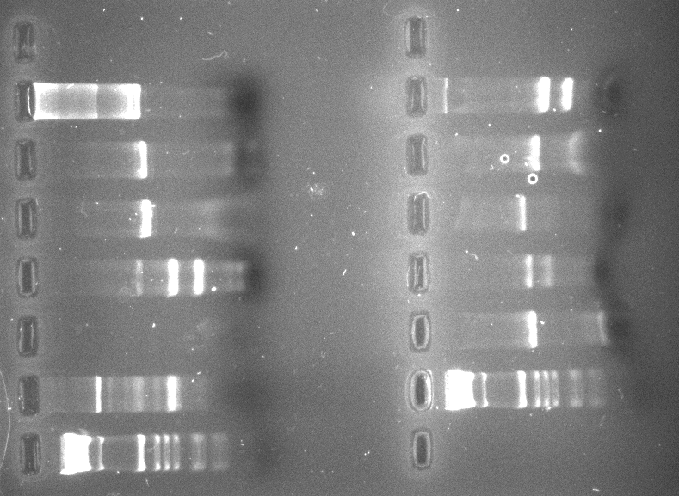
UPC
MDH
IDH2

Ladder
RIM
MHP
IDH1

CAT
Ladder

Figure 2. Electrophoresis gel images of diagnostic restriction enzyme digests for each of the eleven genes. Electrophoresis gel is 1.5% w/v agarose run at 100 V and stained with ethidium bromide.

The pooled PCR products (~500 μL) were concentrated by ethanol precipitation:
- Speed Vac PCR with heat to reduce volume
- Add 1/10 total vol. 3M NaAc (~50 μL)
- 2 vols. (PCR + NaAc) of 100% EtOH (~1000 μL total)
- Store -70°C for 30 min.
- Spin 10 min.
- Wash with 500 μL 70% EtOH
- Dry in Speed Vac
- Resuspend in ~50 μL dH₂O.

Optical density was measured and used to determine the DNA concentration of each PCR product. These results are seen in Table 6.
GENE | 260/280 | CONCENTRATION (μg/mL)
MHP1 | 0.095/0.056 = 1.69 | 1900
RIM21 | 0.091/0.062 = 1.47 | 1820
IDH1 | 0.147/0.092 = 1.60 | 2940
MDH3 | 0.112/0.076 = 1.47 | 2240
CAT2 | 0.209/0.153 = 1.37 | 4180
IDH2 | 0.222/0.151 = 1.47 | 4440
SHY1 | 0.176/0.118 = 1.49 | 3520
UPC2 | 0.168/0.113 = 1.49 | 3360
RAD9 | 0.199/0.148 = 1.34 | 3960
DBR1 | 0.096/0.053 = 1.81 | 1920
Hedgehog | 0.209/0.118 = 1.77 | 4180
Table 6. Optical density data for each gene and corresponding concentrations for PCR products.
Each PCR fragment was cloned into an E. coli plasmid. The following TOPO cloning reaction was used (Invitrogen):
- 0.1 μL PCR product
- 1 μL Salt solution
- 3.9 μL sterile H₂O
- 1 μL TOPO vector.

Following One Shot© Chemical Transformation, 100 μL was spread on an LB/AMP agar plate and incubated at 37°C overnight. Clones were confirmed using Mini-Preps (Qiagen) and additional agarose gel electrophoresis (data not shown). 850 μL of vortexed, stock cloned plasmid were mixed with 150 μL of sterile glycerol and stored at -80˚ C.
- Designing the 30mer Probes.
A 30mer oligonucleotide probe with 100% base pair identity to its target 500 base pair PCR fragment was designed for each yeast gene. The Java program (Appendix B) optimized: a) a narrow range of GC contents (42); b) limited hairpins; and c) limited self-binding. Though a similar probe design program has been published (43), we felt that this self-written program designed optimal probes for our particular application of the microarray system, and reduced any foreseeable error from cross-reactivity between the probes and their targets.
PROBE | bp REGION | SEQUENCE
CAT2 | 1172 -1201 | ACT ACg TTT gTC AgC AgT TgA ATA AAC TAg
DBR1 | 26 - 55 | Agg gTg CTg TCA TGG TCA gCT AAA CCA AAT
IDH2 | 1051 - 1080 | gAC TTg gCT ggT ACT gCT ACT ACT TCA TCA
MDH3 | 551 - 580 | TTg ggg gTC ATT CAg ggg AAA CCA TTA TCC
UPC2 | 2001 - 2030 | ACT ggA gCA ATA CgT TTC ATC TCA CCg CCT
RAD9 | 898 - 927 | gAT gAT CTC AgA gAA Cgg AAC AAT CAA ATA
SHY1 | 865 - 894 | gCT gTA AAC ggA ACg CAA gCT gTT gAT AAT
IDH1 | 451 - 580 | gAA CAT gAA TCC gTC CCT ggT gTA gTg gAA
MHP1 | 1843 - 1872 | AgT gAT ACC AAC ggT ACg AAC gCA gAT gAT
RIM21 | 425 - 454 | ACT TAA CgA TTT TTA TCA CgA Agg TgT TgC
Table 7. Optimized 30mer probe sequences.
Seqaln (39) was used in addition to the Java program to limit binding to other probes and binding to non-target 500mers. To assess any non-target binding between pairs of probes as well as between probes and targets, the optimized 30mer probes were aligned against themselves and against the 500mer fragments. The results of these analyses are seen in Tables 8 and 9.
GENES | CAT2 | DBR1 | IDH2 | MDH3 | UPC2 | RAD9 | SHY1 | IDH1 | MHP1 | RIM21
CAT2 | 30 | 6 | 5 | 4 | 7 | 4 | 5 | 5 | 4 | 4
DBR1 | 6 | 30 | 4 | 6 | 4 | 5 | 5 | 4 | 5 | 4
IDH2 | 5 | 4 | 30 | 4 | 6 | 4 | 4 | 5 | 5 | 4
MDH3 | 4 | 6 | 4 | 30 | 4 | 4 | 4 | 4 | 4 | 5
UPC2 | 7 | 4 | 6 | 4 | 30 | 6 | 4 | 4 | 4 | 4
RAD9 | 4 | 5 | 4 | 4 | 6 | 30 | 8 | 5 | 6 | 4
SHY1 | 5 | 5 | 4 | 4 | 4 | 8 | 30 | 4 | 7 | 5
IDH1 | 5 | 4 | 5 | 4 | 4 | 5 | 4 | 30 | 4 | 5
MHP1 | 4 | 5 | 5 | 4 | 4 | 6 | 7 | 4 | 30 | 5
RIM21 | 4 | 4 | 4 | 5 | 4 | 4 | 5 | 5 | 5 | 30
Table 8. 30mer probe v. 30mer probe alignments. Longest string of base pair identity reported.

 |  |  |  |  |  |  | 30mer Probes
 |  | GENES | CAT2 | DBR1 | IDH2 | MDH3 | UPC2 | RAD9 | SHY1 | IDH1 | MHP1 | RIM21
 |  | CAT2 | 30 | 6 | 7 | 7 | 8 | 7 | 6 | 5 | 7 | 7
 |  | DBR1 | 6 | 30 | 6 | 6 | 6 | 6 | 6 | 8 | 6 | 8
 |  | IDH2 | 7 | 7 | 30 | 7 | 6 | 6 | 7 | 6 | 6 | 7
 |  | MDH3 | 6 | 8 | 7 | 30 | 6 | 7 | 7 | 5 | 7 | 6
500merTargets |  | UPC2 | 7 | 8 | 8 | 8 | 30 | 6 | 8 | 7 | 6 | 7
 |  | RAD9 | 7 | 5 | 7 | 6 | 6 | 30 | 8 | 7 | 8 | 7
 |  | SHY1 | 6 | 7 | 6 | 6 | 5 | 8 | 30 | 7 | 7 | 7
 |  | IDH1 | 6 | 7 | 6 | 6 | 5 | 6 | 6 | 30 | 7 | 5
 |  | MHP1 | 6 | 7 | 5 | 8 | 6 | 6 | 8 | 6 | 30 | 7
 |  | RIM21 | 7 | 6 | 7 | 7 | 5 | 6 | 6 | 6 | 6 | 30
Table 9. 30mer probe v. 500mer target alignments. Longest string of base pair identity reported.

As in Table 2, red values indicate the longest string of matches for one pairwise comparison, while blue values show the longest string of matches for the analysis. When the probes were aligned against each other, the longest string of non-target matches was 8 base pairs between RAD and SHY, while some genes had a maximum length of only 5 base pairs when aligned with any other gene. In the probe to target comparison, the longest string of non-target matches was 8 base pairs and was seen in several genes. Again, we felt these values were sufficiently minimal to avoid cross-reactivity during hybridization. Further analysis of non-target binding is shown on pages 51-55.
Like the 500mers, the GC content of the 30mer probes should fall within a narrow range. As seen in Table 10, this range was 36.6% to 50%.
GENE | GC (%)
CAT2 | 36.6
DBR1 | 46.7
IDH2 | 46.7
MDH3 | 50
UPC2 | 50
RAD9 | 36.6
SHY1 | 43.3
IDH1 | 50
MHP1 | 46.7
RIM21 | 36.7
Table 10. GC content of 30mer probes (Appendix A).
- Chip Design.
The slide manufacturer recommended a PCR product concentration of 250 to 750 ng/µL for spotting on the microarray slides (44). The yeast gene SHY was chosen as a positive control, and the fly gene Hedgehog as a negative control. These spots were printed at a concentration of 250 ng/µL. From the optical density concentration data, the widest possible range of concentrations for each gene was 4096-fold, or 1600 to 0.39 ng/µL. A 1X concentration corresponds to 25 ng/µL, and the concentration gradient used in printing is shown in Table 11. All concentrations here and subsequently reported are prior to addition of 2X spotting solution (Micro Spotting Plus, ArrayIt Products) necessary for printing. Therefore, a 1X concentration of 25 ng/µL in solution corresponds to 12.5 ng/µL on the glass slide.
X DILUTION | CONCENTRATION (ng/µL)
64 | 1600
32 | 800
16 | 400
8 | 200
4 | 100
2 | 50
1 | 25
1/2 | 12.5
1/4 | 6.25
1/8 | 3.125
1/16 | 1.5625
1/32 | 0.78125
1/64 | 0.390625
Table 11. Dilution factors used for each gene.
The microarray was designed with a wide distribution of both genes and concentrations. A schematic map of the experimental microarray is shown in Figure 3.
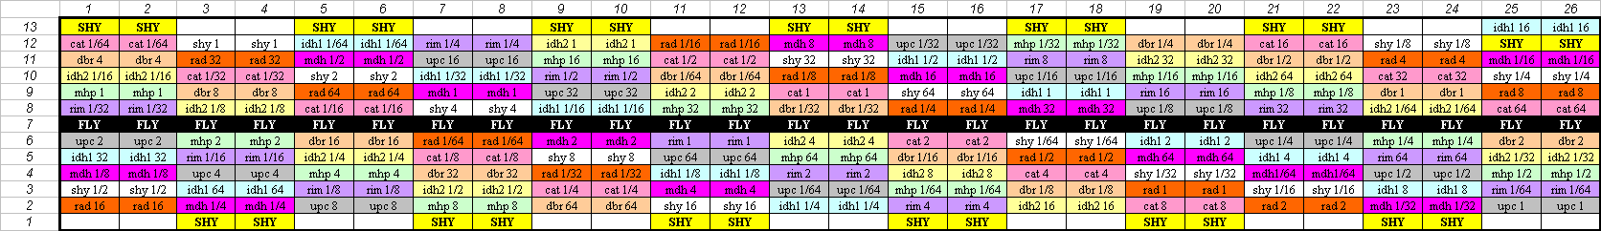
Figure 3. Map of one microarray metagrid. Each gene’s spots follow a diagonal from left to right, and each diagonal has the same pattern of concentrations.

Each spot was printed in duplicate and each slide had two identical metagrids. The metagrids were printed with 16 pins. Figure 4 shows the spots colored by pin number.
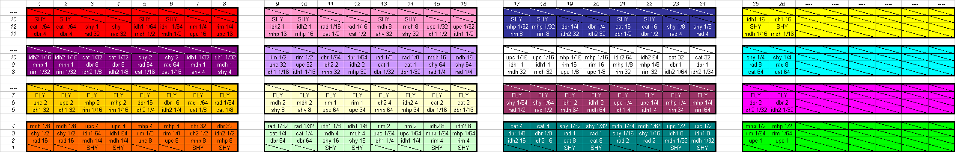

Figure 4. Map of the microarray separated by grid and color-coded by pin number. Boxes with hash marks are printed blanks (air).

A picture of a printed microarray is shown in Figure 5. The etched white corners enclose the two metagrids.

