Materials & methods
Calibration between fluorescence and protein concentration
We purified recombinant Venus YFP and mCherry RFP to serve as standards for quantitative immunoblotting. To do so, we overexpressed His-tag fusions of Venus YFP and mCherry in Escherichia coli and affinity purified each protein. Briefly, the sequences coding for a single Venus YFP and mCherry RFP ligated into pET30a+ bacterial expression vectors (EMD Biosciences, San Diego, CA). These plasmids were sequence verified and separately transformed into BL21 (DE3) competent cells (Invitrogen, Carlsbad, CA). Overnight cultures of each strain were back-diluted into fresh media, and isopropyl β-D-1-thiogalactopyranoside was added to induce protein synthesis. After two hours of induction, cells were pelleted by centrifugation and lysed under denaturing conditions; the cell lysate was applied to ProBond resin (Invitrogen, Carlsbad, CA) at pH 7.8 and the purified fluorescent proteins were eluted from the resin by stepping the pH to 4.0. The purified fluorescent proteins were exchanged into phosphate-buffered saline containing 1% Tween-20 by dialysis, and the final concentration of each purified protein was determined using SDS-PAGE followed by Coomassie staining.
To measure the average number of molecules of each fluorescent protein per cell, strain lysates and purified fluorescent proteins were probed by immunoblotting. Briefly, yeast cells from a series of strains were grown under inducing conditions, collected, counted, and lysed via fast-prepping twice. For each strain, three different dilutions of lysate were loaded alongside a series of the appropriate purified fluorescence protein in a 10% SDS-PAGE gel. After semi-dry transfer onto nitrocellulose, the Venus YFP and mCherry-containing proteins were probed using mouse monoclonal anti-GFP (EMD Bioscences, San Diego, CA) and a polyclonal rabbit anti-DsRed (Clontech Mountain View, CA). After exposure to HRP-tagged secondary antibodies, the blot was exposed to Western Lightning reagents and the resulting chemiluminescence was imaged using the FluorChem imaging system (Alpha Innotech, San Leandro, CA 94577).
While the YFP reporter proteins and YFP-tagged auto-feedback activator proteins appeared as a single band at the expected molecular weight, all the mCherry-labeled activator proteins showed multiple distinct bands at lower molecular weight in addition to the full length protein. Multiple bands also are present for two tandem copies of mCherry, suggesting that the fragmentation is specific to the mCherry sequence. The number of mCherry molecules was calculated by summing together the chemiluminescence intensity of all the bands and multiplying by the calibration factor generated from the purified mCherry concentration series.

Measurement of photobleaching rates
To determine the photobleaching rate, activator-reporter strains were grown to steady-state under inducing conditions, and then were transferred to an imaging dish as described in the main text. For each color of fluorescence, fifty images were acquired with a 1s delay between images. The volume change of individual cells and the change in the non-matured protein concentration are negligible over the ~1 minute required to acquire the photobleaching data. The relationship between red fluorescence and exposure time, t_{exp}, was well described by a single exponential decay:
[S1]
where k_{RFP,b} is the first-order photobleaching rate constant in s⁻¹.
The conversion of fluorescent Venus YFP into photobleached Venus YFP could not be well-described by a first-order or second-order rate laws. Therefore we empirically described the dependence of the yellow fluorescence on exposure time using a two-term exponential:
[S2]
where C is the weight of the first exponential component and k_{YFP,b1} and k_{YFP,b2} are the first and second components of the exponential decay, respectively.
While the fluorescence decay was consistently well-described by the above relationships, both the excitation light intensity and the photobleaching rate constant varied from experiment-to-experiment. Thus for each experiment, we measured the photobleaching rate on that day and used those rate constants in interpretation of our data.

Photobleaching correction for VenusYFP
Since the photobleaching of Venus YFP cannot be described by a first-order ordinary differential equation, we used an empirical, discrete approach to calculate the sum of the fluorescent and photobleached species in any image frame. We refer to this sum as the photobleach-corrected fluorescence intensity, I_{YFP,f+b}(j). This quantity in the first frame, I_{YFP, bleached} + I_{YFP}(1), is determined using the previously-determined parameters C, k_{YFP,b1}, and k_{YFP,b2} and the fluorescence intensity observed in that frame, I_{YFP}(1).
[S3]
For convenience, we subdivide both the photobleach-corrected intensity and the fluorescence intensity into calculated sub-populations:
[S4]
and
[S5]
where YFP_{b+f,calc}(i,j) and YFP_{f,calc}(i,j) are the photobleach-corrected intensity and fluorescence intensity in the jth frame of the sub-population which first appeared in the ith frame, (where i = {1,2,…j}). These populations are shown schematically in Supplementary Figure S4. For the first frame, the individual population for i = 1 population is the same as the overall population:
. [S6]
The fluorescence intensity of the ith sub-population in the jth frame, YFP_{f},_{calc}(i,j), decays as described by the two-term exponential and can calculated using the relation:
[S7]
Thus, the fluorescence intensity of the sub-population from the jth frame is the difference between the observed fluorescence intensity in that frame, I_{YFP}(j), and the intensity that would be expected from summing together the calculated intensities of the i = {1,2,…j-1}sub-populations in the jth frame.
[S8]
The intensities of the fluorescent subpopulations are directed related to the photobleach-corrected intensity of that subpopulation, and the total photobleach-corrected intensity corresponds to the intensity over all sub-populations.
[S9]

Measurement of maturation rates and protein stability
The in vivo maturation kinetics and protein stability of the Venus YFP- and mCherry RFP-labeled proteins were measured using the methodology of Gordon et al. (2007). Briefly, cells harboring the activator and positive reporter genes were grown under non-inducing conditions for ~ 24 hours, then switched to inducing conditions for ~ ½ hour. The cells were transferred to medium containing 1 mM cycloheximide, and imaged on an agarose pad containing 1 mM cycloheximide.
The reactions in which nascent polypeptides containing the YFP and mCherry fluorescent proteins become fluorescent are first-order in YFP and mCherry concentration, respectively. The time-dependent photobleach-corrected fluorescence intensity of either fluorescence was fit to:
[S10]
where I_{GFP}(0) is the initial photobleach corrected intensity, ΔI_{GFP} is the difference between the final and initial photobleach corrected intensities, and k_{GFP,ox} is the first-order rate constant for maturation.
Protein stability was assessed by monitoring the photobleach-corrected intensities of the respective proteins when maturation was completed. In the absence of an additional destabilizing sequence, e.g. the PEST sequence from S. cerevisiae Cln2p, YFP-labeled activators did not significantly degrade over ~200 minutes.

Analysis of time-lapsed microscopy images
We used timelapsed images to measure the kinetics of production of the yellow fluorescent reporter protein as a function of the red fluorescent activator. Cell ID segmented images into individual cellular regions, each of which contained a single nucleus, and reported a number of parameters including the area, the calculated volume (V), and integrated fluorescence intensity (S_{GFP}) of each cellular region.
The red fluorescence is an indication of the concentration of activator protein, however, non-fluorescent, i.e. non-matured, and photobleached activator proteins are present and presumably catalytically active. The concentration of non-fluorescent activator species, RFP_{u}, depends on the maturation rate of the mCherry chromophore and the production rate of these polypeptides at any time t, which we choose to describe with a third order polynomial (P_{RFP}). In addition, the change in the cellular volume as a function of time (dV/dt), and the volume each affect the time-derivative of the non-fluorescent species concentration:
[S11].
The concentration of the fluorescent activator protein, RFP_{f}, depends on the rate of conversion of non-fluorescent species into fluorescent species and the rate of conversion of the fluorescent species into bleached species. Since the photobleaching of mCherry follows first-order kinetics (Supplementary Fig S2), the time-derivative of the fluorescent concentration is given by:
[S12]
where t_{ratio} is the quotient of the time elapsed between images and the exposure time. Lastly, the concentration of bleached species, RFP_{b}, increases with the photobleaching rate and decreases with the ratio of the volume change to the volume:
[S13].
To find RFP_{b}, RFP_{f}, and RFP_{b} at any time, the initial concentration of these species must be specified at t = 0. Since zero time corresponds to the moment after the first exposure, the initial photobleached concentration is related to the initial fluorescent concentration by:
[S14]
We calculate the total concentration of catalytic activator proteins by specifying the initial values of RFP_{f} and RFP_{u}, calculating RFP_{b}(0) [S14], solving Eqn. S11-13 numerically using Matlab’s built-in ODE solver, and using least-squares fitting to determine the coefficients of P_{RFP}(t) which best fit the background corrected RFP fluorescence intensity per volume from an individual cell.
Likewise, the appearance of yellow fluorescence as a function of time is dependent on the production of reporter protein, as well as by two other time-dependent processes: the time required to form the chromophore and the exposure time-dependent irreversible destruction of the chromophore by photobleaching. As in the steady-state case, we assume that the production of non-fluorescent reporter protein depends on the catalytically-active activator concentration in a manner described by the Hill equation. Therefore the time-derivative of the non-fluorescent concentration, YFP_{u}, is given by:
[S15]
where s,β, K, and n are the Hill parameters described in the main text.
Because the photobleaching of Venus YFP is not described by simple first- or second-order kinetics (Fig 6B), we calculate the sum of the photobleached and fluorescent concentrations, YFP_{f} + YFP_{b}, using a discrete approach (see section above). Hence, the time-derivative of this sum is affected only by the change in volume and the maturation kinetics:
[S16]
We specify the initial conditions YFP_{u}(0) and YFP_{f} + YFP_{b}(0), numerically solve [S15]-[S16] using the total catalytic activator concentration at any time t, and minimize the L2 norm between the photobleach-corrected intensity and the calculated YFP_{f+b} to determine the best-fit β, K, and n for an activator-reporter pair.

Legends for Supporting Figures.

Supplementary Figure S1. Calibration between fluorescence intensity and molecules of fluorescent protein per cell. A) The relationship between the number of mCherry-containing proteins per cell as determined by quantitative immunoblotting and the average integrated fluorescence intensity per cell as measured by FACS and fluorescence microscopy. The conversion factors are 4.87 x ± 0.37 x 10⁻⁴ (R² = 0.89) and 2.60 ± 0.20 (R² = 0.89) intensity units/(molecule mCherry/cell) for FACS and microscopy, respectively. B) The same as A) except for Venus YFP-containing proteins. The slopes are 2.69 ± 0.17 x 10⁻⁴ (R² = 0.94) and 6.57 ± 0.81 x 10⁻¹ (R² = 0.86) intensity units/(molecule YFP/cell) for FACS and microscopy, respectively.

Supplementary Figure S2. Determination of photobleaching rate constants for the RFP variant, mCherry, and for Venus YFP. A) The average red fluorescence intensity per cell, I_{RFP}, for individual cells (red, blue, green, and light blue circles) as a function of t_{exp}, the exposure time. The data was fit to [S1] to determine to the first-order rate constant for mCherry photobleaching, k_{RFP,b}. The resulting best-fit curves are shown as red, blue, green, and light blue solid lines, respectively. B) The average yellow fluorescence intensity per cell, I_{YFP}, for individual cells (red, blue, green and light blue circles) as a function of the exposure time. Individual intensity traces were fit to [S2] to determine the two photobleaching parameters, k_{YFP,b1} and k_{YFP,b2} and their respective weights, C and (1-C).

Supplementary Figure S3. Determination of maturation rate constants for the RFP variant, mCherry, and Venus YFP. A) The average red fluorescence intensity per cell after correcting for photobleaching, I_{RFP,f+,b}, for individual cells (red, blue, and green circles) as a function of time elapsed since addition of cycloheximide (t). The data was fit to [S10] to determine the first-order rate constant for maturation of mCherry, k_{RFP,ox}, and the best-fits are shown as solid lines. Over several experiments, the average value of k_{RFP,ox} is 3.1 ± 1.3 x 10⁻⁴ s⁻¹ .B) The average red fluorescence intensity per cell after correction for photobleaching, I_{YFP,b+f}, for individual cells (red, blue, and green circles) as a function of elapsed time since the addition of cycloheximide. The data was fit to [S10] to determine the first-order rate constant for maturation of the YFP chromophore (k_{YFP,ox} = 1.03 ± 0.17 x 10⁻³ s⁻¹ as measured over several experiments). The lack of decrease in the photobleach-corrected YFP intensity indicates that the reporter protein is not appreciably degraded over ~200 minutes.

Supplementary Figure S4. Schematic illustration of the photobleached-corrected intensity calculation for Venus YFP. The black triangles show the photobleach-corrected intensity as a function of the frame number (j). Both the photobleach-corrected intensity and the fluorescence intensity in frame j are divided into j sub-populations, YFP_{f+b,calc}(i,j) and YFP_{f,calc}(i,j), shown as hollow black and solid green bars, respectively. The ith population is the new intensity that appears in the ith image. From the j = i image, the fluorescence intensity of the ith decays with a two-term exponential [S7].

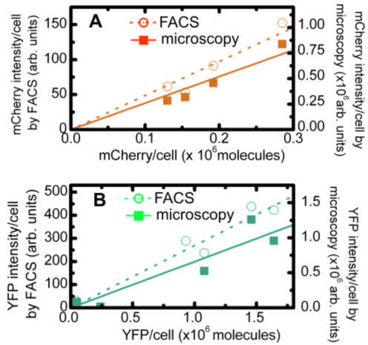

Supplementary Figure S1.

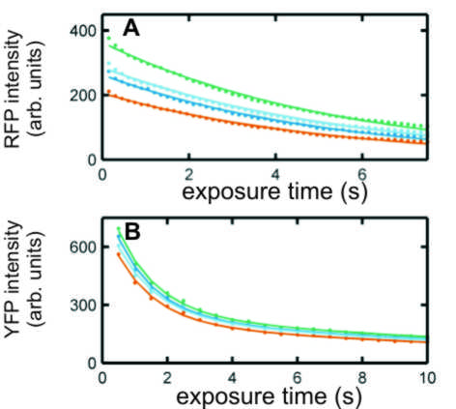

Supplementary Figure S2.

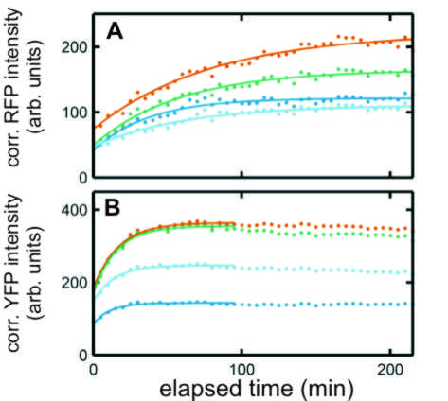

Supplementary Figure S3.

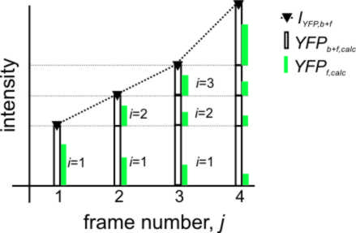

Supplementary Figure S4.

