Week 4: Test Promoter, Start Genotyping

Learning Objectives for Promoter Discovery

Skills
- Analyze fluorometry and spectrophotometry data
- Generate graphs in Excel to display quantitative data

Cognitive
- Integrate cell density and RFP fluorescence intensity to quantify promoter strength
- Design PCR experiment to amplify a targeted segment of DNA
- Explain how gel electrophoresis separates molecules by size

Pre-Lab

1) Watch 4 videos from list for week 4 lab
2) Download the PPT file with photos of overnight cultures

3) Answer each of these four questions in two sentences or less.

A) How will we measure promoter strength with the data collected today? How can you account for different cell densities?

B) How does PCR work and what does it produce?

C) How are we using PCR to determine whether we cloned the desired promoters or not?

D) What would the PCR results be if you have, or have not, successfully cloned the promoter?

Challenge to be discussed in lab groups: Using the information in the 4 questions above, explain why we are using PCR today? What could we possibly learn that we don’t already know after analyzing the Synergy machine’s data?

Information: Quantify Phenotype and Start Genotyping

In Lab
1) Based on the PPT file showing the overnight cultures, what do you expect to see in your graphs today?

2) Working in your lab groups, generate column graphs of your v1 promoters. But each person should work independently so you will know how to generate these graphs on the exam. Be sure to take into account the data from the LB amp tube that lacked any cells. What should you do with these data? If you do not know about the shortcut in Excel to perform the same calculation multiple times, be sure and ask. It has to do with getting a black + sign and dragging the corner. To make your analysis go smoothly, follow this sequence of manipulations:
- subtract background from all data
- generate ratios for each triplicate independently
- average the triplicate averages
- calculate standard error of the mean (SEM) which is done by dividing the standard deviation by the square root of the sample size. In the formula bar of Excel, type this command: =(STDEV(E8:E10)/SQRT(3)) where E8:E10 indicates where the 3 independent ratios are located. In your experiment, what was the sample size?
- graph the averaged ratios
- produce error bars using the SEM you just calculated. Do NOT use the standard error bars produced by Microsoft.
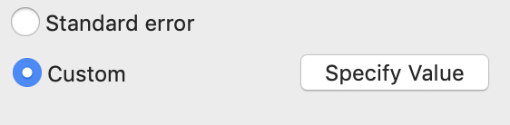
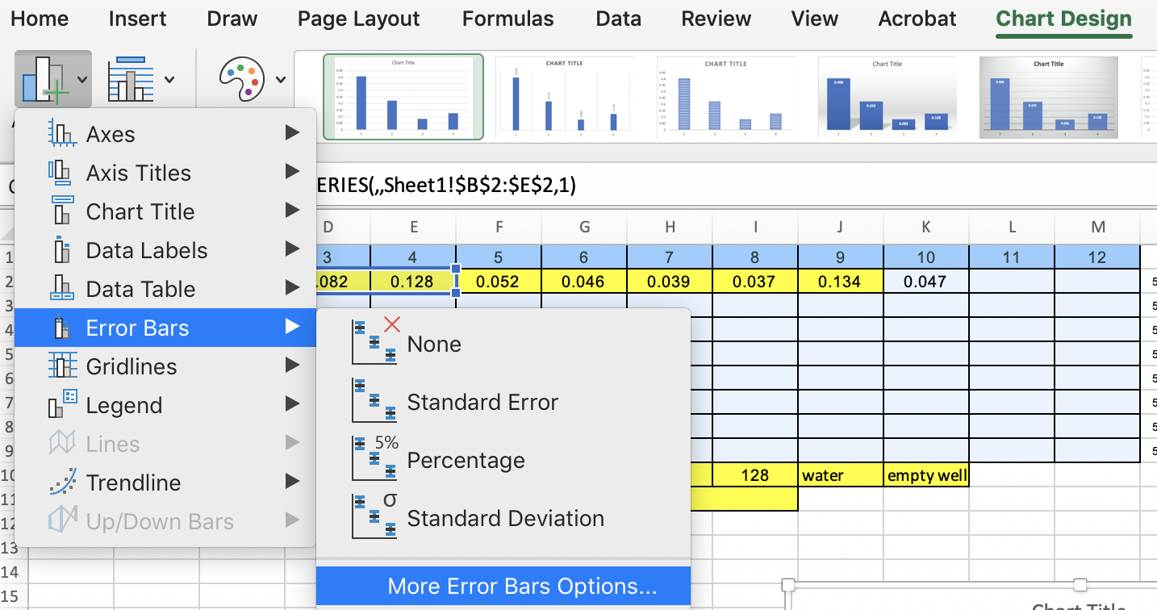
To generate custom error bars, select your graph by clicking on it once. From the “Chart Design” menu, choose “Error Bars” and “More Error Bars Options…” A new dialog box will appear on the right side of the graph. In that box, choose “Custom” and click on the “Specify Value” button. You can now click and drag through the SEM values you calculated. Do this for the positive and the negative directions to make two-sided error bars.
3) Show your graphs to the instructor before you leave today.
4) Complete CATME.

