Biology 113 Closed Book Take-Home Exam #2 – Chapters 4 - 7

There is no time limit on this test, though I have tried to design one that you should be able to complete within 3 hours. There are 6 pages in the exam, including this cover sheet and the data gallery. You are not allowed to look at someone else’s test, nor use your notes, old tests, the internet, any books, nor are you allowed to discuss the test with anyone until all exams are turned in no later than 2:20 pm on Monday October 12. The answers to the questions must be typed in this Word file unless you are asked to draw on a separate page, or you want to use scratch paper. If you do not write your answers in the appropriate location, I may not find them. Tell me where to look if you put your answer at the back of your test.

I have provided you with a “Data Gallery” in the form of figures and tables. To choose a figure in support of your answer, simply state Figure #x. You do NOT need to move the figure on your test. Do not assume how many of the data images you will use, or not use. Simply choosing the data is not sufficient support for your answer. You must explain the significance of the data and how they support your answer. I have given you sentence limits so be concise.

-3 pts if you do not follow this direction.
Please do not write or type your name on any page other than this cover page.
Email all your work (including Excel file) when finished with the exam.

Name (please print):

Read the pledge and sign if you can do so with honor:

_______________________________________

On my honor I have neither given nor received unauthorized information regarding this work, I have followed and will continue to observe all regulations regarding it, and I am unaware of any violation of the Honor Code by others.

How long did this exam take you to complete?

Lab Questions:
14 pts.
1)
a) Because of the bad weather, I decided to do some research instead of yardwork. The attached Excel file contains the data I generated from a positive control, a negative control and 3 clones that I hoped would contain an experimental promoter in pClone Red. The values in the Excel file are RFP/OD₆₀₀ with LB values already subtracted. Interpret the data for all 3 promoters based solely on the graph you generate within Excel. You will need to submit your Excel file as part of your answer. Word limit = 45 maximum for each promoter
promoter X1:
promoter X2:
promoter X3:

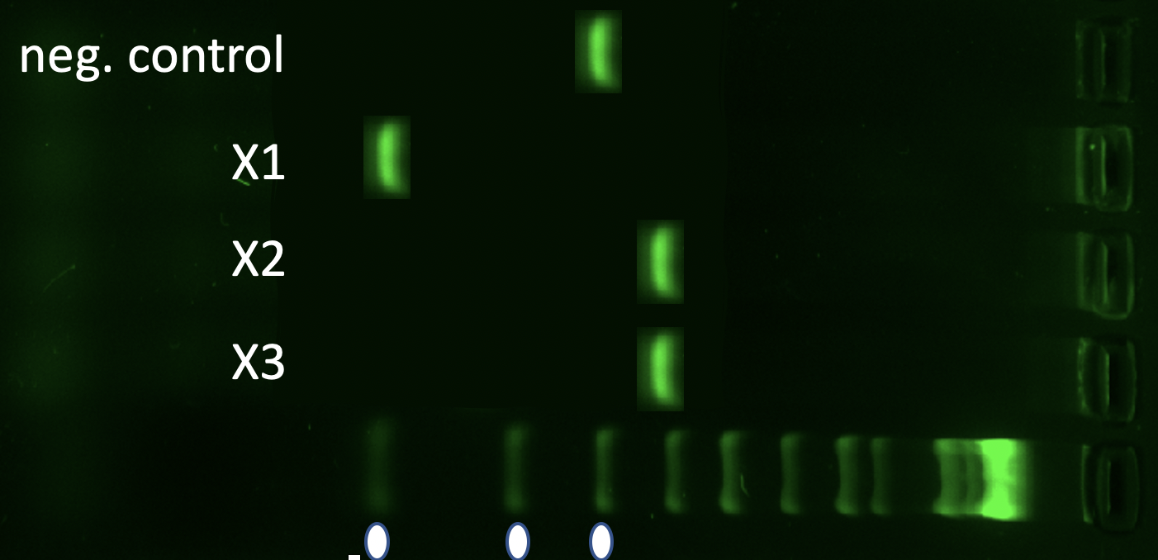
b) After seeing the fluorescence data, I decided to run PCR on all 3 experimental clones. Integrate the PCR results with the graph above to summarize your conclusions for all 3 promoters.
Word limit = 45 maximum for each promoter
promoter X1:
promoter X2:
promoter X3:

Class Questions:
26 pts.
2) You know the definition of evolution, the 4 mechanisms of evolution, and the 5 tenets of natural selection. I want you to integrate all of these into one question. Here is a list of items, all but one are figures from the data gallery. Explain how each item contributes to a plausible explanation for the origin of life and evolution of eukaryotes. Each explanation should construct a holistic paragraph that gradually builds a cohesive summary. The summation of your answers will be an explanation for life on Earth. Word limit = 35 maximum for each item
- Fig 2:
- Fig 1:
- Fig 29:
- Fig 6:
- Fig 15:
- Fig 22:
- Fig 12:
- Math argument:
- Fig 20:
- Fig 3:
- Fig 31:
- Fig 28:
- Fig 13:

18 pts.
3) Life is always adapting to change, including emergence of new pathogens.
a) Explain how figure 17 from the gallery could lead to beneficial or detrimental variation in a population of B cells. Word limit = 35 maximum
b) Connect your answer above to 2 mechanisms of evolution that are seen in allergic responses. Word limit = 35 maximum
c) Explain to a high school student why their allergic response gets stronger with each exposure. Support your answer with 3 figures. Word limit = 35 maximum for each figure
Fig __:
Fig __:
Fig __:

24 pts.
4) Unfortunately, America perpetuates systemic racism in many aspects of daily life.
a) Explain to an older relative that systemic racism in America has real biological consequences but racial categories cannot be defined biologically. Choose 2 figures to show biological consequences and 2 figures to show biological similarities among races. Word limit = 35 maximum for each figure
consequence 1:
consequence 2:
similarity 1:
similarity 2:

b) Race-based medicine is widespread and recalcitrant in America. Use 3 figures to explain to a younger relative why race-based medicine is a mistake based on historic bias and incomplete information. Word limit = 45 maximum for each figure
Fig 1:
Fig 2:
Fig3:

18 pts.
5) In proteins, structure determines function. Please answer these questions based on what we have learned so far in Bio113.
a) What makes an amino acid hydrophilic or hydrophobic? To answer this question correctly, you must describe the chemical basis for this physical property of amino acids. Word limit = 35 maximum
b) Does warfarin affect blood clot formation by allosteric or covalent modulation? Explain how you reached your conclusion. Word limit = 30 maximum
c) Use figure 18 to define signal transduction. Word limit = 40 maximum
d) Choose steps within figure 4 to supports these hallmarks of signal transduction. Explain why you chose each step. Word limit = 35 maximum for each selected step
amplification step:
specificity of shape step:
reset one particular step:

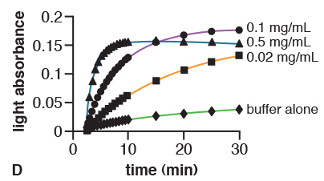
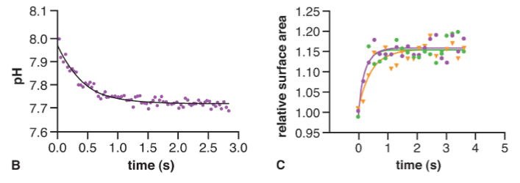
Data Gallery
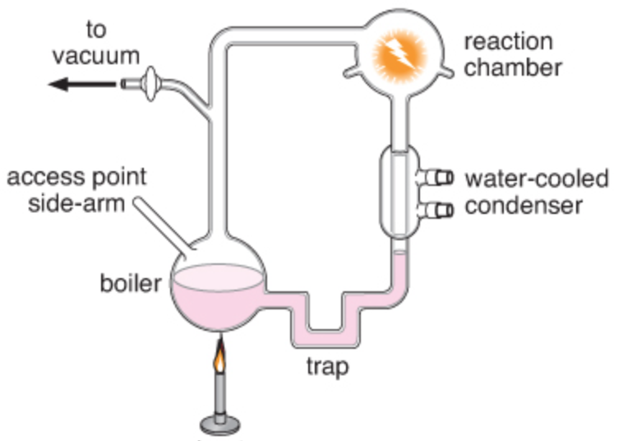
1 2 3

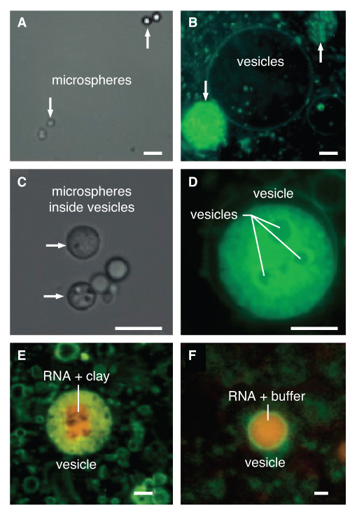
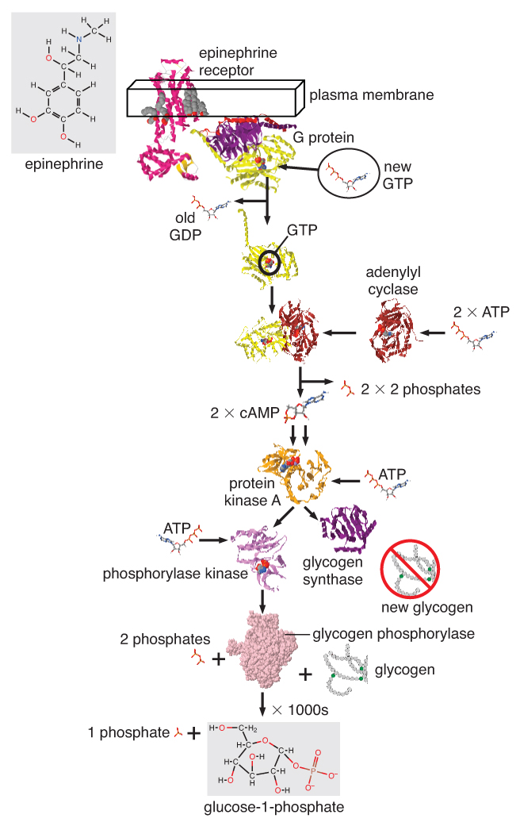
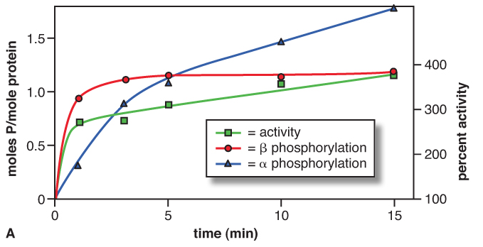
4 5 6

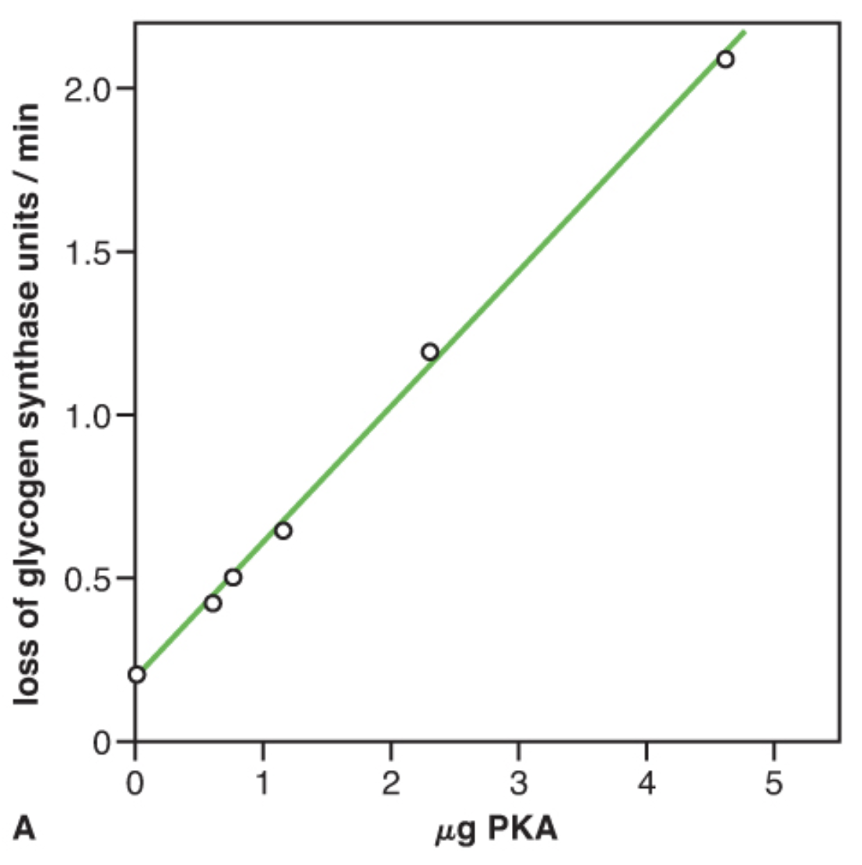

7
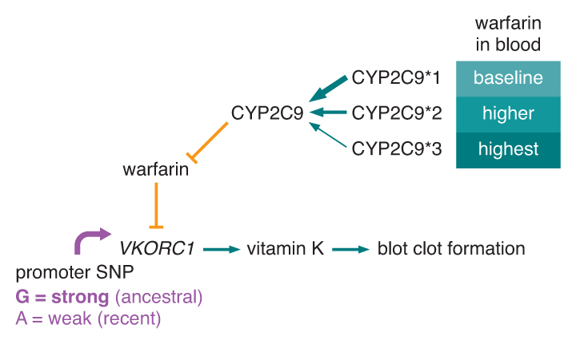

8

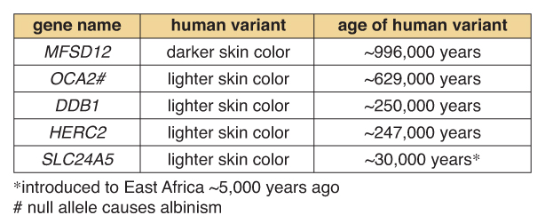
9

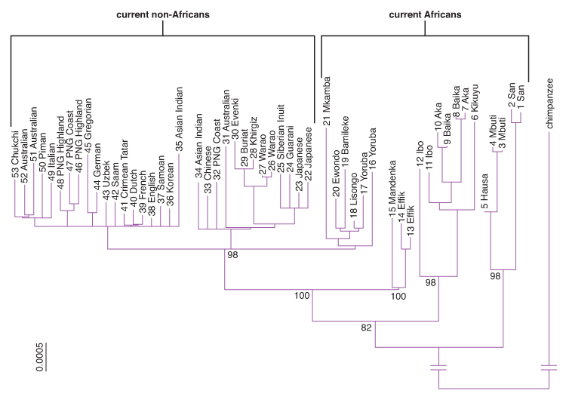
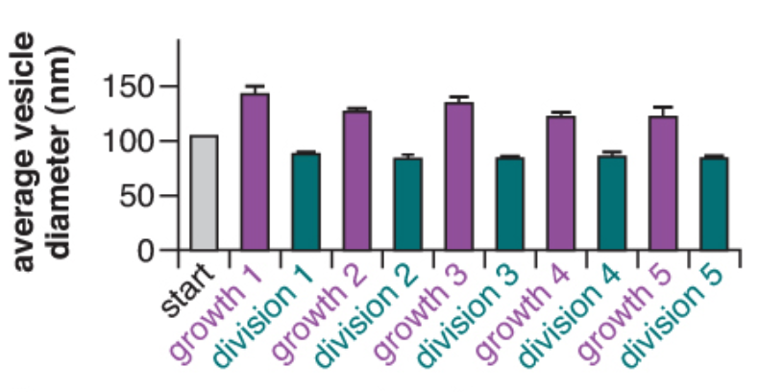
11 12
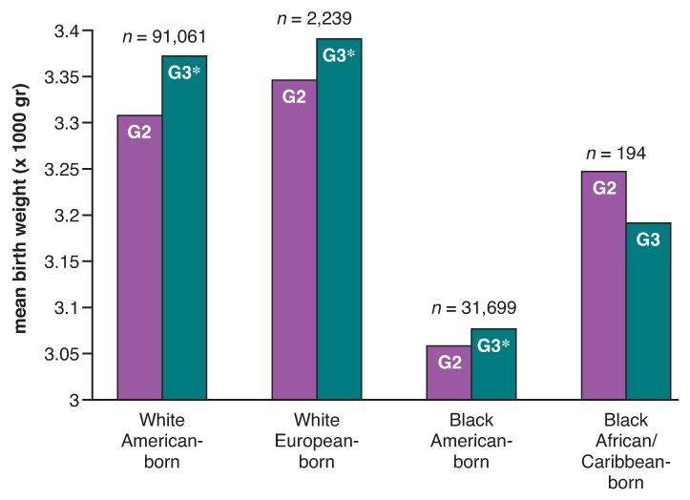
10

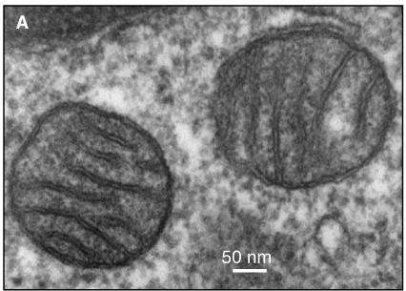
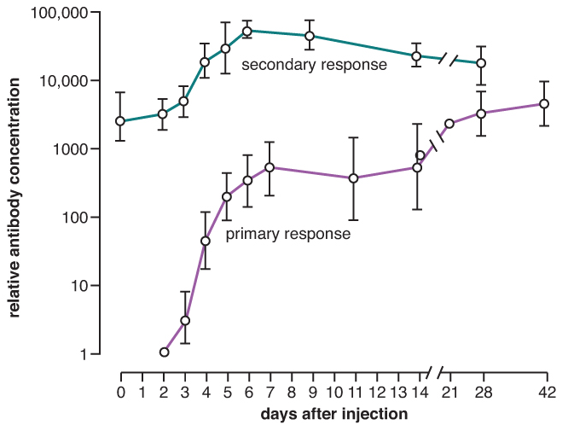
13 14

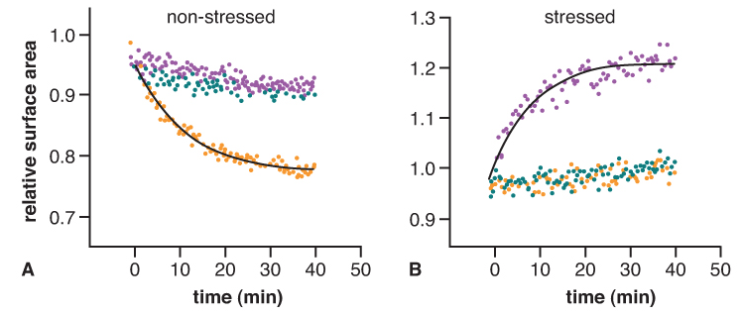
15

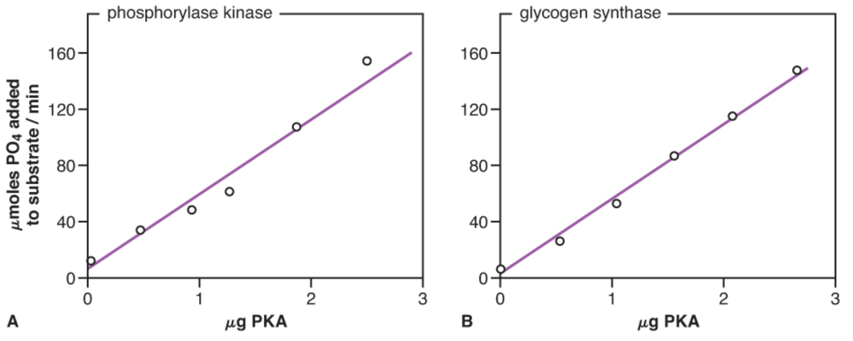
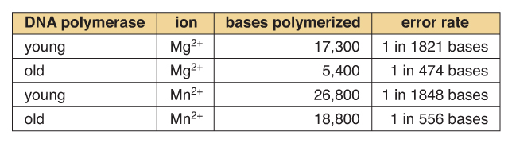
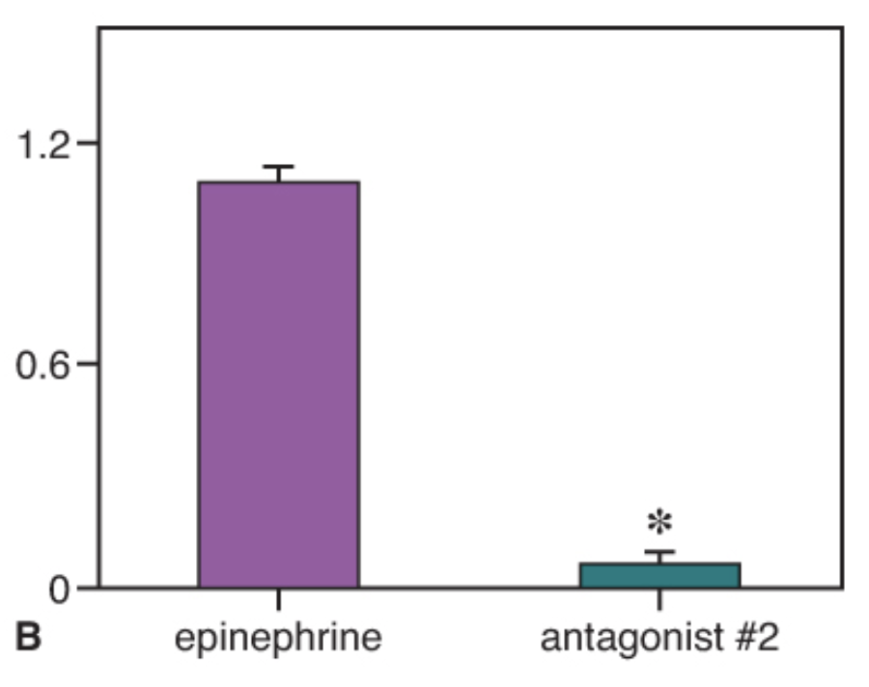
16 17 18

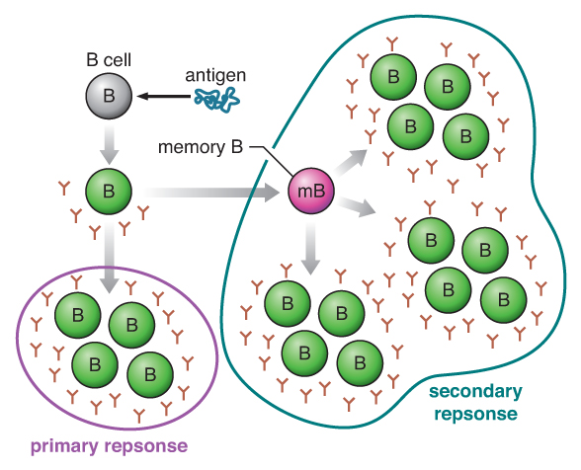

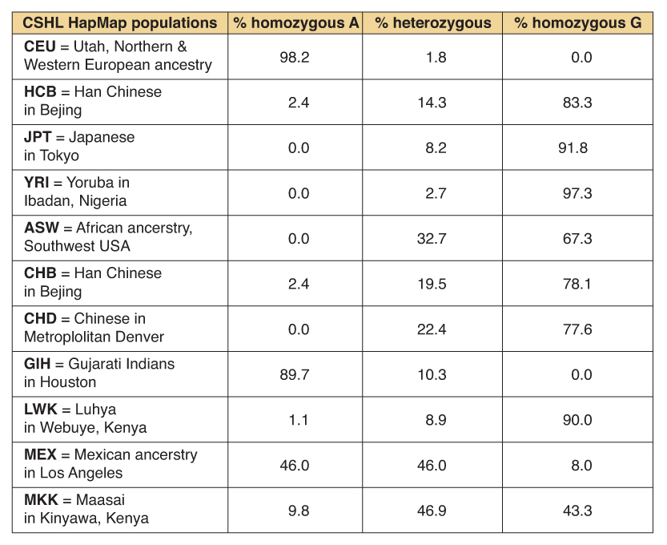
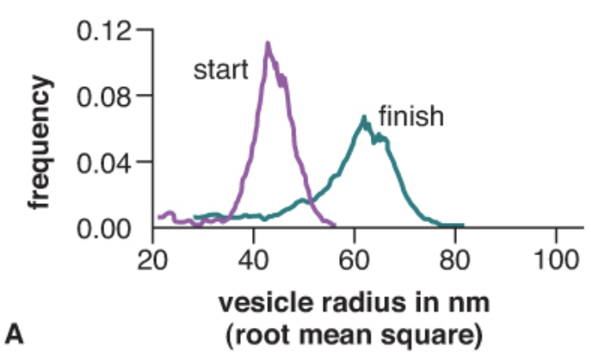
19 20 21

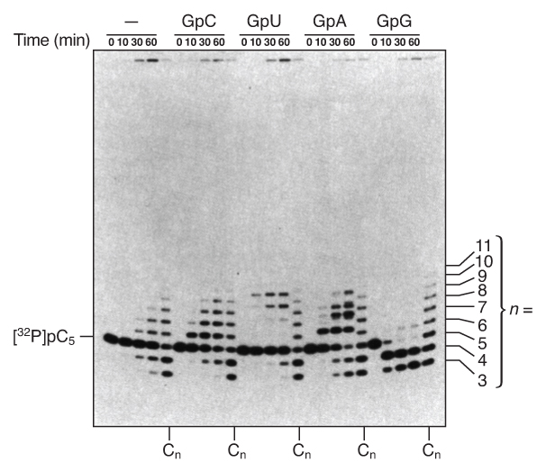
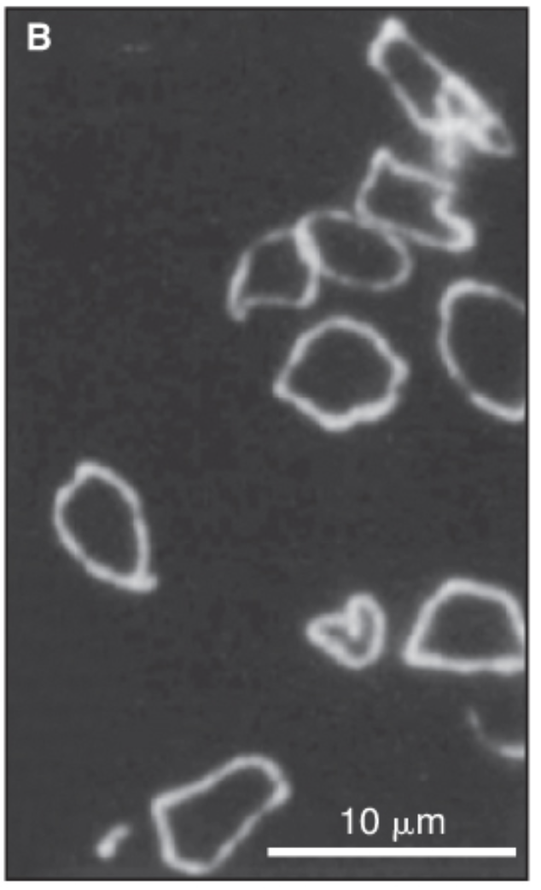

22 23 24
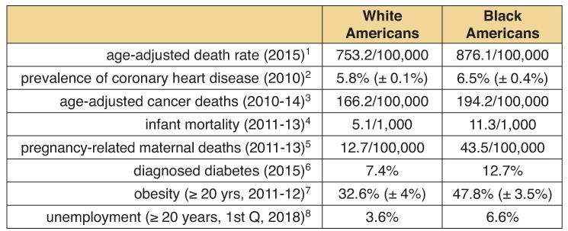

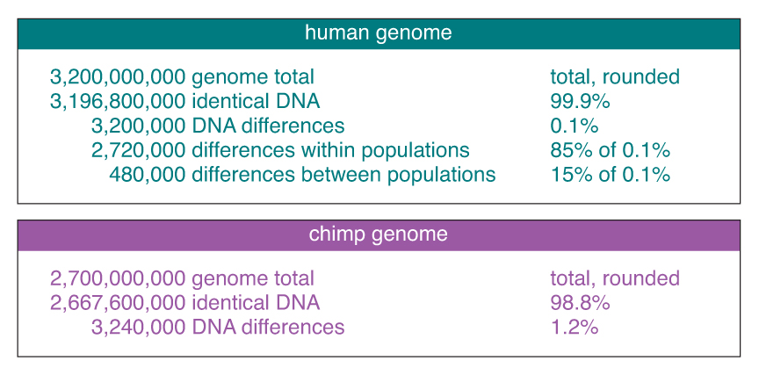
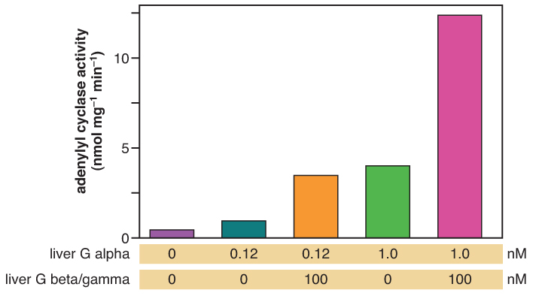
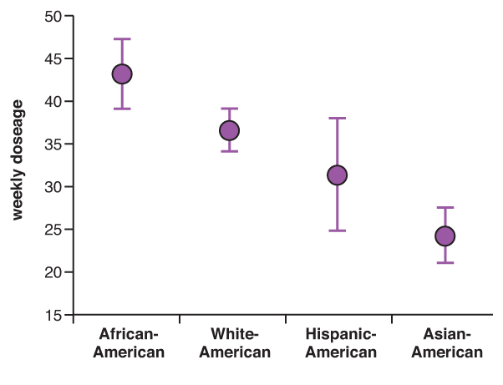
27
25 26

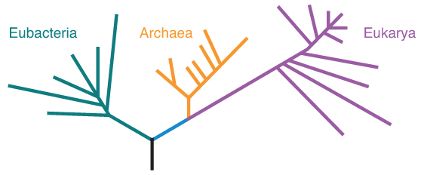
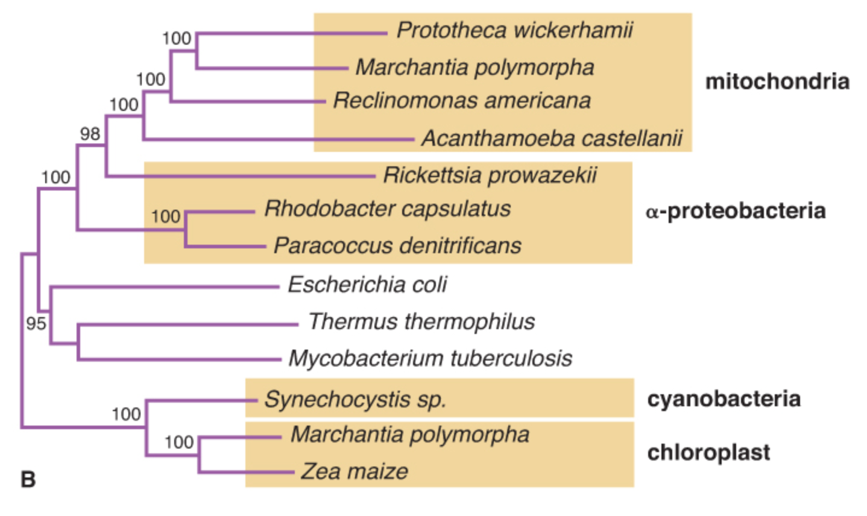
28 29 30
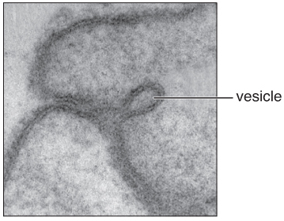

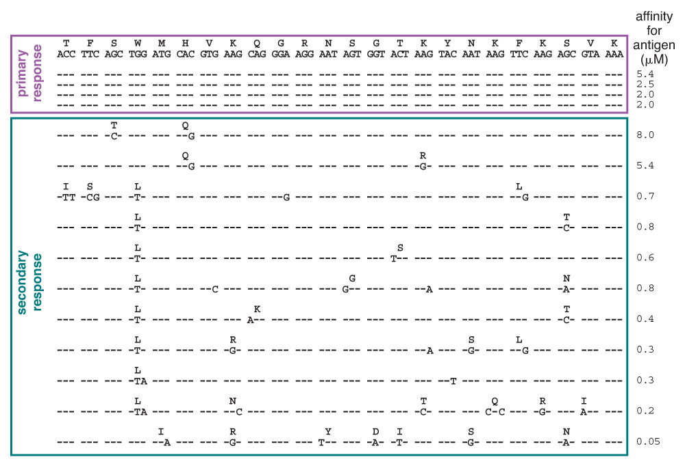

33

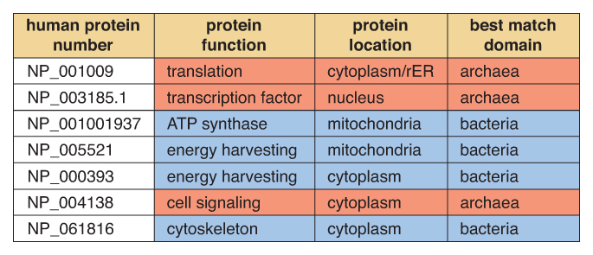
31
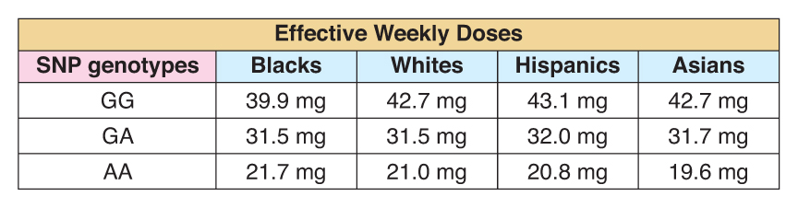
32

