Week 12: Compare Expected DNA to Actual DNA Sequence

Learning Objectives for DNA Control Element Discovery

Skills
- Read DNA chromats using free software.
- Compare two sequences using CLUSTAL omega.

Cognitive
- Employ a scientific approach to answering biological questions and test hypotheses.
- Analyze experimental data and reach logical conclusions.
- Describe the big idea of information based on lab experiences.
- Review the information contained within promoters and RBSs.
- Use protocols for molecular biology to clone DNA.
- Interpret Synergy data for fluorescence and optical density.
- Summarize the results from two rounds of experimentation with DNA control elements.

Pre-Lab

Before you come to lab

1) Read about DNA chromatograms and how to interpret them.

2) Answer each of these four questions in two sentences or less.

A) How close to the primer is the first readable base when doing Sanger sequencing?

B) How many copies of a plasmid are inside a single E. coli cell if the plasmid uses a “pUC” origin of replication?

C) Why would it be reasonable to expect the DNA from all the plasmid copies in a mini-prep to have exactly the same sequences of bases?

D) Why does PCR use two primers but Sanger sequencing only uses one primer?

Information: Interpret DNA Sequencing Results

In Lab

3) Download all the sequencing files and find your files. You will want to open the files called name.pdf, name.seq and name.ab1. The dot seq file gives you letters whereas the dot ab1 gives you the chromatograms. You can use the chromats to correct any errors the software made in the .seq file. Ideally, you will be able to view the chromats (.ab1) the same way that research scientists do, but if you have computer problems, you can use the PDF file.

4) Open the .seq files using TextEdit (Mac) or NotePad (Windows). These programs will open the files in the simplest possible way. Once you open the file, you will want to delete any N bases at the beginning of the sequence. This is background signal that happens with every sequencing reaction. After deleting the Ns, copy the first 150 bases and paste them into the Word file (called Clustal Prep.docx) included in the folder with all the data files. Paste them into the appropriately labeled locations. Also, find your top oligo sequence for V1 and V2 and paste them into the appropriate places.

5) Use Clustal omega to compare your expected DNA promoter with your actual sequences that you had synthesized. How well do the two sequences match? If your sequence has any internal N bases that you want to clarify, you can evaluate the chromat (.ab1) yourself and override any Ns based on the quality of the chromat. You have to submit your sequences using “fasta format” (see image below for example).
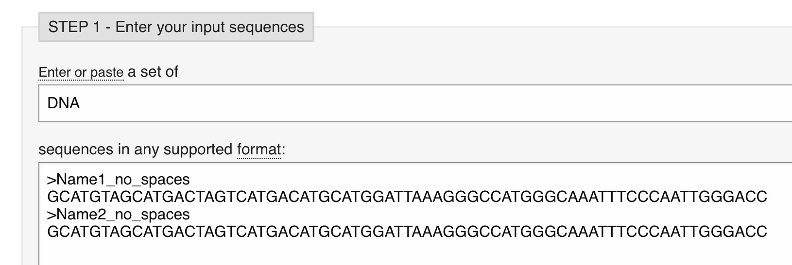

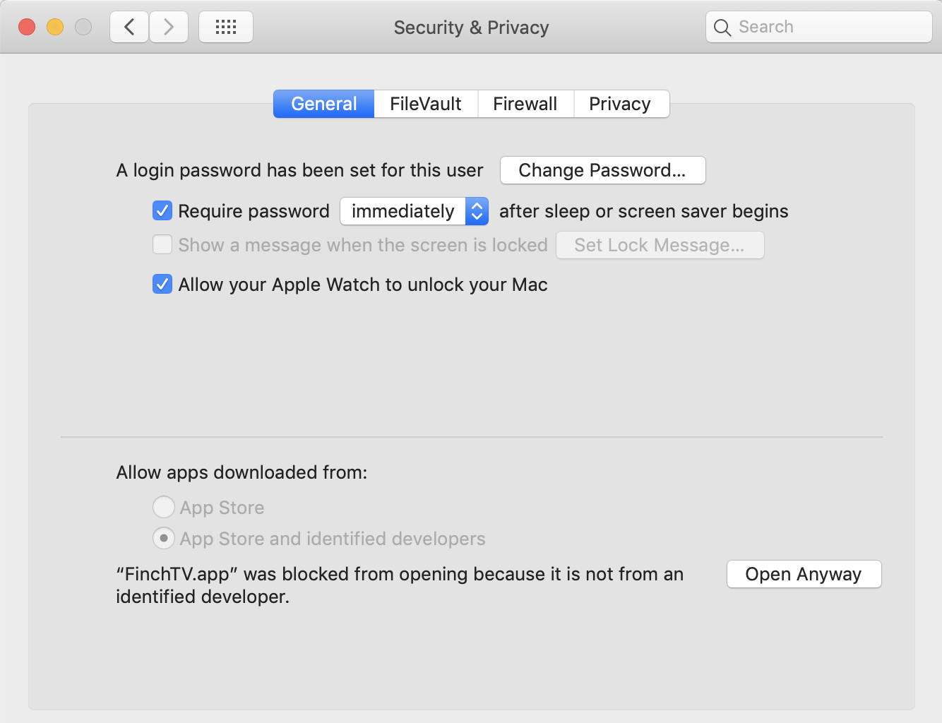

6) Before you come to lab, please download the free software (Mac and Windows) called FinchTV. (https://digitalworldbiology.com/FinchTV). On the Mac side, you will have to go to System Preferences, Security Settings, General. In the bottom left is a lock icon. Click on that and enter your computer password then click on the “Open Anyway” button shown here. This should allow you to view the chromats. If you cannot get this to work, then use the PDF file. We will discuss what you are supposed to see during the lab meeting.

7) Finalize all your data collection, figure preparation and methods. Each person will write his or her own laboratory report using the guidelines below.

