Yeast microarray using the Genisphere 3DNA Array 900 kit
David B. Kushner and Benjamin J. Tiede ’05
Department of Biology, Dickinson College, Carlisle PA 17013

It needs to be noted that the GCAT webpage already has several useful protocols for both working with yeast, using Genisphere kits, and handling microarrays. Under “General Resources” see Mary Lee Ledbetter’s 2003 ISB Workshop report (“3DNA method”) and Todd Eckdahl’s 2003 tips on working with microarrays (“Technical Tips”). Under “Yeast Resources” see Karen Bernd’s “Making Media and Growing Yeast,” and “Isolating Yeast RNA/mRNA” as well as Todd Eckdahl’s “3DNA Method for Making Probes, Pre-Hybe, Hybe, Wash for Microarray Hybridization.” These are excellent resources and these were referred to heavily upon developing this protocol. Note that the protocol below uses the acid phenol method of yeast RNA isolation (Bernd’s uses the spheroplast method) and uses lifter cover slips for the microarray hybridizations.

DBK wishes to also note that he received lots of invaluable help and advice on methods from Laura Hoopes and Anne Rosenwald.

The key to successful microarray work is being prepared. Several things MUST be done ahead of time, both in terms of acquiring materials and reagents, and for each “step,” having water baths, incubators, etc. turned on.

NOTE that when ordering the Genisphere 3DNA kit, ask for reverse transcriptase to be provided. Genisphere’s RT is fine for this work, but is separate from the labeling kit. However, you will need to buy DTT (see section G). Alternatively, you can buy Superscript II RT from Invitrogen (which comes with DTT), but it is expensive.

Outline of contents of this Protocol:
- Yeast growth media
- Plasmids
- Preparing competent yeast cells (for transformation)
- Transformation of competent yeast cells
- Growing yeast in liquid media for RNA isolation
- Isolation of RNA from yeast using heated, acid buffered phenol
- Preparation of cDNA from total yeast RNA using components from the Genisphere 900 kit
- cDNA hybridization
- Post cDNA hybridization wash/Cy dye hybridization
- Post Cy dye hybridization wash

A. Yeast growth media

As noted above, in the Yeast Resources page of the GCAT website, Karen Bernd has supplied information about growing yeast. Those of you not familiar with yeast will quickly learn that there are many subtly different ways that yeast can be handled. We report here the ways we grow yeast.

If you simply want to grow yeast under different conditions (in other words, you do not want/need to transform yeast with plasmids) or simply need to grow yeast to prepare for prepping transformation-competent yeast cells, “complete media” is used.

1. Complete media (YPDA). This is a simple mixture of yeast extract (Y), peptone (P), dextrose (D; also known as D-(+)-glucose), and adenine (A). The adenine helps prevent the yeast from “pinking,” and is optional. However, I always use adenine.

1a. Complete liquid (YPDA) media, 500ml:

In one 1L bottle, add 250ml ddH₂O, 5g yeast extract, and 10g peptone.
In a second 1L bottle, add 250ml ddH₂O and 10g dextrose.
Autoclave, cool to about 50°C, then, working near flame (sterile technique), combine and add 4ml adenine (1g/200ml ddH₂O, filter sterilized). Mix well.

1b. Complete solid (YPDA) media, 500ml:

This is good for about 20 plates (100x15mm Petri dishes):

In one 1L bottle, add 250ml ddH₂O, 5g yeast extract, and 10g peptone.
In a second 1L bottle, add 250ml ddH₂O, 10g dextrose, and 10g agar. The agar will not go into solution until autoclaved.
Autoclave, cool to about 50°C, then combine and add 4ml adenine (1g/200ml ddH₂O, filter sterilized). Mix well. Pour plates working near flame (sterile technique). After solidified, turn plates upside down and store at room temperature (RT) overnight. Bag plates agar-side up; plates can be stored for several months at RT.

2. Minimal media (synthetic defined (SD)). Such media is needed if yeast are to be transformed with plasmids (for plasmid selection/retention). Working with minimal media can be initially expensive (in order to buy all the amino acids needed to make “dropout powder”). However, prepared minimal media can be purchased (for example, CLONTECH/BD Biosciences sells this, and I imagine other sources are available) and may be worthwhile if, for example, working with yeast is to be a once-yearly lab exercise.

Dropout powder: When making a dropout powder, if you plan on transforming in one plasmid with a leucine marker, add all the amino acids EXCEPT leucine to the dropout powder. If transforming two plasmids, one with a lysine and one with a uracil marker, add all the amino acids EXCEPT lysine and uracil to the dropout powder.

Amino Acid Grams
Adeninesulphate 4
Arginine 2
Aspartic acid 10
Glutamic acid 10
Histidine 2
Isoleucine 3
Leucine 6
Lysine 3
Methionine 2
Phenylalanine 5
Serine 40
Threonine 20
Tryptophan 4
Tyrosine 3
Valine 15
Uracil 2

Add one amino acid at a time to a mortar and grind to a fine powder with a pestle. Add to a 250ml bottle.
Upon adding each mashed amino acid to the bottle, shake bottle well to obtain an even distribution of amino acids.

2a. Minimal liquid media, 500ml

To a 500ml bottle, add 100ml ddH₂O, 3.5g yeast nitrogen bases WITHOUT amino acids, and 0.7g of the appropriate dropout powder.
In a 1L bottle, add 400ml ddH₂O and 10g dextrose.
Autoclave, cool to about 50°C, then, working near flame (sterile technique), combine into the 1L bottle. Mix by gentle swirling.

2b. Minimal solid media, 500ml

To a 500ml bottle, add 100ml ddH₂O, 3.5g yeast nitrogen bases WITHOUT amino acids, and 0.7g of the appropriate dropout powder.
In a 1L bottle, add 400ml ddH₂O, 10g dextrose, and 10g agar. The agar will not go into solution until autoclaved.
Autoclave, cool to about 50°C, then combine into the 1L bottle. Mix by gentle swirling. Pour plates working near flame (sterile technique). After solidified, turn plates upside down and store at RT overnight. Bag plates agar-side up; plates can be stored for several months at RT.

3. Galactose media.

Sometimes yeast need to be grown in galactose, not dextrose. For example, if you transformed in a plasmid that allows you to inducibly drive expression of a gene via a GAL1 promoter. In such cases, simply omit dextrose from the above formulations. Then, after autoclaving and allowing media to cool, add 20% galactose (filter sterilized – do NOT autoclave galactose) to a final concentration of 2%. For example, when making 500ml media, omit 50ml water from one of the bottles so that after autoclaving and combining, add 50ml 20% galactose to make a final volume of 500ml with galactose at 2%.

B. Plasmids

If needed, plasmids for transformation into yeast do not have to be “ultrapure” – in other words, no CsCl banding needed. From 50ml o/n 2xTY bacterial culture, a traditional P1 P2 P3 solution plasmid prep with RNase step is sufficient. Minipreps are generally at too low a concentration for convenient use in yeast transformations if transforming 2 or more plasmids at once.

C. Preparing competent yeast cells (for transformation)

There are MANY ways this can be done. Zymo is but one company that sells a “quick-transformation” kit that works well for one or two plasmids, but the efficiency is not as great as making cells competent via the protocol below, which is easy and can be done in a few hours.

1. Using sterile technique (e.g. working near a flame), use a toothpick to scoop up a pinhead amount of yeast from a solid plate and drop toothpick into a 17x100mm tube with 5ml appropriate media (most often, since the yeast you grow will lack plasmids, you will use YPDA media). Grow at 30°C o/n, with agitation (the best is to use a culture wheel; if a wheel is not available, hard shaking (300rpm; place tube and some folded paper towels into a beaker and clamp the beaker into the shaker) is a satisfactory alternate.

2. Take an OD₆₀₀ reading of an appropriate dilution (1:50 is good for a saturated culture) of the o/n culture.

3. Dilute some of the o/n cells into 50ml media total to give a new OD₆₀₀ of 0.1.

4. Grow cells for 2-3 hours (for YPDA; if growing yeast with plasmid(s), minimal media is not as “rich” and it will take longer) until OD₆₀₀ is between 0.2 and 0.3 (the idea here is that you want to harvest the cells at early exponential phase).

5. Spin cells down (5min at 2000rpm in a clinical centrifuge). Remove media. Wash pellet with 5ml water. Spin. Remove water. Wash again. Spin. Remove water.

6. The volumes of solutions that follow are based on the OD₆₀₀ reading. If you had an OD₆₀₀ of 0.27, then add 270ul of ddH₂O to the cells and transfer the cells/water to a 1.5ml eppendorf tube. Add 270ul of 0.2M lithium acetate (LiOAc). Use a P1000 and measure the volume of cells, water, and LiOAc. Record.

7. Gently mix cells, then incubate for 2 hours at 30°C with occasional mixing.

8. Take the recorded volume from step 6 and divide that number by 5.67. This is the amount of sterile 100% glycerol to add to the competent cells to get final glycerol at 15%. Use a wide-bore tip if available for most accurate pipetting (pipetting glycerol slowly is helpful). Mix well, then aliquot 111ul into 1.5ml eppendorf tubes (from 50ml media, expect 7-8 aliquots). 111ul will be enough for 2 transformations. Immediately place 111ul aliquots into –80°C freezer for long-term storage. When using aliquots, do not refreeze after thawing if some cells are left over.

D. Transformation of competent yeast cells

This procedure takes about 90 minutes to 2 hours in the class setting. It is possible to transform yeast, obtain colonies, patch them, grow and harvest the yeast (see section E) in one week, though there is not room for “error.” You may prefer to do this 2 weeks before RNA isolation if you unclear about growth rate of your transformed yeast cells (see notes in section E).

Prepare ahead of time:

-- Make yeast cells competent (store at –80°C)
-- 70% PEG 3350 – a good idea to warm bottle/tube up a few hours ahead of time – at RT, 70% PEG is a solid, but will stay liquid for a few hours at RT, if warmed. The 70% PEG 3350 takes time to initially prepare. MOST of the volume of the solution comes from the PEG, so only a little ddH₂O at a time should be added when prepping. A little heat may be applied when dissolving PEG. When dissolved, the solution should be filter sterilized, which takes time as well due to its great viscosity.
-- 2 mg/ml sheared salmon sperm DNA (store at –20°C). Set up a boiling water bath for step 1 below.
-- 42°C bath
-- plasmids

For a 1-plasmid transformation, use 500 ng of each plasmid. For a 2- or 3-plasmid transformation, use 1 ug of each plasmid. This is because the odds of getting plasmids into one yeast cell decrease with number of plasmids.

1. Boil the 2mg/ml salmon sperm DNA (ssDNA) for 5 minutes; flash cool on ice; leave ssDNA on ice for now.
2. During boiling, get plasmids from –20°C and competent yeast cells from –80°C. Place on ice.
3. During boiling, ensure your PEG is liquid (VERY quick blast in the microwave is ok if stored in glass bottle; in polypropylene tube, heat in 50°C water bath briefly; cool a bit before use, but do not cool to the point the PEG starts turning white/solidifies).
4. In a final volume of 5ul, combine plasmid(s) and ddH₂O. Use a 1.5ml eppendorf tube.
5. Add 55ul thawed competent yeast cells to DNA/water.
6. Add 5ul of the ssDNA (from step 1).
7. Add 55ul of PEG (70%), light vortex to mix; incubate1 hour at 30°C.
8. Add 12ul of DMSO (helps open cells to let plasmid(s) in); place at 42°C for 6 minutes.
9. Add 800ul ddH₂O, mix by inverting tube, centrifuge for 5 minutes at 6000xg, aspirate water, and resuspend yeast cell pellet in 100ul ddH₂O.
10. Plate on correct dropout plates.
11. Grow agar side up at 30°C for 2-3 days.
12. Using a sterile toothpick, “patch” a few colonies out onto solid media – this can be a source of transformed yeast for multiple experiments.

E. Growing yeast in liquid media for RNA isolation

The key to a good microarray experiment is to only test one variable at a time. Therefore, if you are looking at, say, WT yeast vs. one of the yeast deletion strains, then the absence of one yeast gene is the variable. Therefore, isolating RNA from yeast harvested at different growth stages would introduce a second variable. Therefore, it is ideal to try and isolate yeast during the same stage of growth (for example, I aim to harvest at mid-exponential phase, at OD₆₀₀ near 0.5-0.6).
Previous published microarray experiments include those that look at what happens when yeast grow during diauxic phase (saturation).

As a rough estimation, for WT yeast in YPDA media, a saturated culture diluted to OD₆₀₀ 0.0001-0.0010 late one afternoon will often grow to mid-exponential phase by early the following morning. You should grow yeast ahead of time to learn its growth rate characteristics.

1. To grow yeast in liquid, during the afternoon of day 1, use a toothpick to sterilely transfer a pinhead amount of yeast from a patch on a solid plate to a 17x100mm tube with 5ml YPDA. Grow at 30°C on wheel (or with agitation in shaker – see Section C step 1), o/n.

2. During the morning of day 2, take OD₆₀₀ readings. Do the same in late afternoon. This will help you get an idea of growth rate.

3. Using the afternoon readings, subculture the yeast with the goal that in the morning, you will be able to harvest 8ml yeast in mid-exponential phase (OD₆₀₀ = 0.5-0.6). The degree of subculturing varies from yeast strain to yeast strain and if the yeast are being grown in YPDA or minimal media. As noted in the prelude to this section, it is challenging to immediately know what is the volume to subculture down to. Even after you have a good idea about growth rates of your yeast, I suggest you subculture each sample to three different ODs so that you have a “range” when you check OD’s on the morning of day 3 (step 4). Note that at this point I make duplicates for each subculture point, so that I can have a pair of yeast pellets for each group of students. This way if there is a problem with one sample during the RNA extraction, there is a possible back-up. As an example of subculturing, if my OD₆₀₀ reading at 4pm was 4.5, and I wanted to subculture to 8ml at OD₆₀₀ 0.001, then the math is 8mlx(0.001/4.5) = 0.00178ml = 1.78ul of saturated culture into 8ml media.

4. Measure OD₆₀₀’s of all samples in the morning (day 3 now); select samples in mid-exponential range. Spin 5 minutes at 2000rpm in clinical centrifuge. Remove media. Wash pellets with 5ml ddH₂O. Spin. Remove water. Wash pellets again with 5ml ddH₂O. Spin. Remove water. Add 1ml ddH₂O, transfer water/cells to a sterile (autoclaved) 1.5ml eppendorf tube (a “safe-lock” tube if you have them, such tubes are nice to have when working with phenol in section F, below), spin 3 minutes at 6000xg, remove water, store pellets at –80°C until needed (can store for several days).

F. Isolation of RNA from yeast using heated, acid buffered phenol

This method, which can be done in one three-hour lab period, is robust; you can repeatedly obtain 75-100ul of ca. 1-1.5mg/ml RNA from 8ml cells at OD600=0.5 (4 OD cells). It is a protocol I have used in my microbiology lab course, and hundreds of times in the research lab.

I do not keep the phenol in a hood; the bottle can remain closed for most of the time, and it is easier to pipet out of a bottle on a benchtop instead of standing outside of a hood. I do only let one student at a time near the phenol “workstation” – a heated stirplate – and I supervise removal of phenol.

REMINDER/CAUTION: The most critical reagent in this procedure is heated, acidic phenol. In general, any phenol is EXTREMELY DANGEROUS and even 1 microliter on exposed skin will cause a severe burn. Phenol can also “eat through” clothing and cause burns. In addition, the phenol we use today will be heated to 65°C.

IF YOU HAPPEN TO SPILL PHENOL ON YOU OR SOMEONE ELSE: IMMEDIATELY run cool water over the affected area to dilute the phenol. Carefully remove clothing if necessary. By working with only a fraction of a milliliter at a time, a large spill should not be a concern.

Note that all solutions used throughout the remainder of this protocol are made up with RNase free water. Ideally, access to a Milli-Q system with a cartridge that removes RNases from water can be used as a source of water. If unavailable, as this is expensive to buy and maintain, consider buying non-DEPC treated RNase free water from Ambion. DEPC is very toxic and is not ideal to work with. The protocol below has not been tried with DEPC treated water used to make solutions/suspend the final RNA pellet, and I cannot guarantee that use of DEPC water will be ok here.

You should consider using “new” boxes of pipet tips that can be marked as “RNA only.” You also may want to consider using filtered/barrier tips if you are concerned that the interior of the pipetters are not “clean.”

(The Section F protocol could be copied and pasted into a document that can be given to the students to perform this part of the experiment. Feel free to borrow this without my permission, but I would appreciate this document being referenced.)

1. Ensure that there is a water bath warmed to 65°C. The Instructor will have phenol buffered with “Buffer A” (50mM sodium acetate pH 5.2, 10mM EDTA, 1% SDS) warming in the bath. This buffered “hot phenol” will have been made up ahead of time by the Instructor by mixing equal volumes of Buffer A with melted crystalline phenol (as well as 0.1g 8-hydroxyquinolone per 100ml phenol; see step 4 below), stirring, letting the layers separate, withdrawing the upper non-phenol layer, and repeating 2 more times. At the end, about 25ml of Buffer A was left on top of the phenol layer, but by heating and stirring, these layers will be mixed when you access the phenol. Thus, the phenol is “saturated” with Buffer A.

2. Put on gloves. Wear gloves throughout the procedure. Obtain 1.5ml “safe-lock” eppendorf tubes with a frozen (-80°C) yeast cell pellet from your Instructor and place them on ice for about 5 minutes to thaw. (You will process two “identical” pellets this week – one serving as a backup in case of accidental spilling). These yeast cell pellets are the end-product of one yeast colony harboring plasmids grown in 8ml of liquid media to mid-exponential phase, spun, then washed two times with ddH₂O to remove media.

3. You will be given a small aliquot of Buffer A. Using your P1000 pipetter with an appropriate sized barrier/filter tip, resuspend each yeast cell pellet carefully in 300ul Buffer A. Eject this tip, as well as all tips used today, in your waste container – these tips are biohazards and need to be autoclaved by the Instructor after lab.

4. Note that the hot phenol appears cloudy/milky, with a light yellow tint. The yellow is a color indicator, 8-hydroxyquinolone, which allows us to easily visualize the phenol layer. This will be important momentarily. The phenol will have been prewarmed to 65°C but you will find it on a heated sitrplate – the acid phenol will be gently stirring – it needs to be mixed when you remove your aliquot. Carefully pipet 600ul of the hot phenol into the eppendorf tubes with the recently resuspended yeast cells. Close the lid of the tubes securely and vortex vigorously for 30 seconds to begin to lyse the cells; the phenol is used to separate the nucleic acids from protein – the protein will be found with the phenol after centrifugation; the nucleic acids will be in the upper, aqueous (“milky”) phase – see step 7, for example.

5. Incubate tube in floatation device in 65°C water bath (see step 1) for 5 minutes. Take care to avoid knocking over the phenol bottle if it is currently also in the bath. Invert the tubes a few times during the incubation period to thoroughly mix the cells/Buffer A/hot phenol.

6. Continue to work in groups and try to share the microcentrifuge – balance your tubes! Spin at 15,000xg for 5 minutes.

7. This is a little tricky. After the spin you should see a yeast pellet at the bottom of the tubes, then yellow phase (phenol), and then a milky white phase on top. There may be a thin whitish-goo layer between the milky Buffer A layer and the phenol. Use a P200 and carefully remove the yellow (lower) phase. Pipet out the yellow phase into a small waste container (such as a 2ml eppendorf tube). DO NOT pour this waste into a wastebasket or sink – the liquid phenol waste will be disposed by the Instructor in a special manner. Note that there should be 400-700ul of the yellow layer (do not disturb the cell pellet), so for each tube you will need to repeat the withdrawals 2-4 times. For this step, leaving behind a small amount of phenol layer is ok, and preferable to removing some of the cells or upper milky layer. Do take extreme care not to touch the pellet with the pipet tip when removing the lower yellow phenol phase!!!

8. Pipet 600ul of the mixed, hot phenol to the leftover cell pellet/milky layer (upper phase). Heat at 65°C for about 1 minute, then vortex for 30-60 seconds. During vortexing, stop occasionally and see if the pellets break up (hold tube to light and invert). Goal: disperse the cell pellets.

9. Repeat steps 5 and 6. During the 5 minute spin (step 6 repeat), add 50ul of 3M sodium acetate pH 5.5 to each of two new “safe-lock” 1.5 ml eppendorf tubes.

10. After the spin of step 9 (the “step 6 repeat”) is done, use a P200 to transfer the upper aqueous (milky) phase (ca. 700ul) to a tube with the 3M sodium acetate. Place the tubes with the yeast cell pellet and acid phenol to the side so that the instructor can dispose of them. During the transfer using the P200, taking a little phenol layer with you is ok here, and is better than leaving some milky phase behind. Do try to avoid the really gooey white material that may accumulate at the layer interface, though. Make sure you keep track of your two samples by proper labeling of tubes!

11. Add 500ul of refrigerated Tris buffered phenol:chloroform (1:1) to each of your two eppendorf tubes with the milky upper layer/sodium acetate from step 10. There will be a top and bottom layer of the phenol/chloroform – unlike the acid phenol, which is used as a mixed suspension, do not mix the phenol:chloroform, and do not take the upper layer -- ensure you take liquid from the bottom phenol layer by verifying the yellow color (due to addition of hydroxyquinolone upon preparation). NOTE: although this is not acid phenol, but just a mix of phenol:chloroform, still take care not to spill – the phenol:chloroform also can cause severe burns.

12. Vortex the tubes with the phenol/chloroform combined with the aqueous layer for 30 seconds, then place the tubes in the eppendorf tube mixer for 3 minutes. Then spin the tube in the microcentrifuge (again, share the centrifuge and balance the tubes!) for 3 minutes at 15,000xg.

13. During the spin, add 1ml of 100% ethanol to two new eppendorf tubes. After the spin is complete, use a P200 to transfer each upper aqueous layer (again, you will need to do 3-4 transfers) to the appropriately labeled tube with ethanol. Note that after the spin, the upper aqueous layer should be totally clear. Also note, that you should transfer only the upper aqueous layer and not the interface or yellow phenol layer. Better to leave a little upper aqueous layer behind than to contaminate with a miniscule amount of lower layer.

14. Invert tubes to mix (do not vortex) and place them in a –80°C freezer. Chill 20 minutes.

15. Spin tubes 5 minutes at 15,000xg. Place the hinge of the tube lid towards the “outside” of the rotor – your RNA should pellet on the outside/back wall at the bottom of the tubes. Remove supernatant by pipetting the liquid out of the tube (using a P200). To avoid touching the pellet, when pipetting up liquid, glide the pipet tip down the “inside/front” wall of the eppendorf tube. It can be helpful to do a quick “pulse” spin in the microcentrifuge before trying to remove the last few microliters of ethanol out of each tube.

16. Add 300ul ddH₂O. Vortex 30 seconds; then place the tubes in the eppendorf tube mixer for 3 minutes to dissolve RNA (alternatively, use a standard vortexer set on medium for mixing, but one must vortex for 3 minutes).

17. To each of the two eppendorf tubes from step 16 add 30ul 3M sodium acetate pH 5.5 and 900ul 100% ethanol. Mix by inversion (not vortexing). Repeat steps 14 and 15.

18. Rinse each pellet with 300ul ice-cold 70% ethanol. Spin 2 minutes in microcentrifuge. Remove supernatant using a P200 as described above. Pulse spin and NOW USE a P20 to remove the last few microliters of ethanol. Air dry 5-10 minutes (leave tube open on benchtop – but be careful to not send dust or anything over the tube while drying – keep your RNA free from RNAses!

19. Make sure there is no liquid alcohol in the tube (this is critical!), then suspend each pellet in 75ul ddH₂O. Vortex 30 seconds, then place tubes in the eppendorf tube mixer for 3 minutes. Then store your RNA at –80°C until next lab period.

If desired, you could spend part of a lab period taking OD_{260/280} readings to calculate RNA concentration and determine purity (OD_{260/280} ratio between 1.8-2.0, ideally 2.0). This choice depends on time. In the past, I have taken ODs myself and asked the students to determine how much RNA they isolated (concentrations are needed for prepping cDNA, the next step).

G. Preparation of cDNA from total yeast RNA using components from the Genisphere 900 kit (recall note preceding Section A about obtaining reverse transcriptase).

Note that from here forward, this protocol is assembled from Genisphere’s instructions based on yeast microarrays of 70-mers. It is strongly recommended that you also read Genisphere’s instructions upon preparing to do the array work.

Section G can be easily done in a 3 hour lab period. There is a 2 hour incubation, which can be used as time for discussion, working on MAGICTool sample files, etc.

Note that this procedure uses VERY small volumes. Having P2 or P10 pipets here would be VERY helpful but are not absolutely required. Ensure that small volumes (less than 2ul) are visibly transferred to tubes.

Read ahead and get water baths, etc. ready. You will need baths at 42°C, 65°C, and 80°C. Alternatively, you can start with baths at 42°C and 80°C, then cool the 80°C down to 65°C during the 2 hour cDNA synthesis (step 6).

Here, for simplicity, we are going to do a microarray where the WT/control sample will be called “sample A” and the experimental sample will be called “sample B.” Here, sample A will be ultimately be labeled with Cy3 (green) and sample B with Cy5 (red). Consider doing a “dye reversal” as well on a separate array, with sample A/Cy5 and sample B/Cy3. Again, for simplicity, we will deal with sample A/Cy3 and sample B/Cy5 here in this protocol.

1. Put on gloves. Get two 1.5ml eppendorf tubes for the next step. Label one “A” and the other “B.”

2. For sample A as well as sample B, in their appropriately labeled 1.5ml eppendorf tube, add 1ug of RNA, 1ul appropriate reverse transcriptase primer (for example, Cy3-kit vial 2 for sample A and Cy5-kit vial 2 for sample B), and nuclease free water (kit vial 10) to a final volume of 6ul.
This is the “RT-primer mix.” Mix and microfuge briefly to collect 6ul contents at tube bottom.

3. Heat RT-primer mix to 80°C for 5 minutes; immediately quench on ice 2-3 minutes. Microfuge briefly to collect 6ul contents at tube bottom.

4. Prepare a “Reaction master mix” in a prechilled 1.5ml eppendorf tube (on ice). Genisphere provides a table in their instructions as to volumes to use BASED ON the number of cDNA syntheses being performed. Basically, 4.5ul of reaction master mix will be added to the 6ul of sample from step 3, and the mix is prepped to have 4.5ul leftover. In other words, only ONE of these mixes needs to be prepped per the entire class. As with any enzyme, keep the RT in the freezer until needed (avoid storage outside –20°C for extended periods of time). For example, here, a 3x mixture would be made as follows: 6ul of 5x reverse transcriptase buffer (comes in a SEPARATE BOX, the box with the RT); 3ul of 0.1M DTT (not supplied, you can buy 100mM DTT in solution from Epicentre); 1.5ul of Superase-IN RNase inhibitor (kit vial 4); 1.5ul of dNTP mix (kit vial 3); 1.5ul reverse transcriptase (in the SEPARATE box) = 13.5ul. GENTLY MIX (no vortexing); microfuge briefly to collect contents. Keep on ice until ready to move to next step.

5. Add 4.5ul of this 3x mix to each of tubes “A” and “B” so that you now have 10.5ul per tube (due to the design of the reaction cocktail, you will have ca. 4.5ul of 3x mix remaining).

6. Gently mix (do not vortex) and incubate at 42°C for 2 hours.

7. Stop the reaction: add 1.0ul of 1.0M NaOH/100mM EDTA (not supplied in kit). Note that here you are now working with cDNA, so you do not need to make the NaOH/EDTA with RNase free water, but you should use “good” water.

8. Mix gently, and incubate at 65°C for 10 minutes to denature the DNA/RNA hybrids and degrade the RNA.

9. Neutralize the reaction with 1.2ul of 2M Tris-HCl, pH 7.5 (not supplied in kit).

10. You now have 12.7ul final volume in each of the two tubes. Store cDNA at –20°C until next lab meeting.

NOTE that the Genisphere 300 kit used larger volumes but required a concentration step using a Microcon YM-30 column. One of the nice things about the 900 kit is that by using small volumes, this step, which is a bit tricky, is omitted!

H. cDNA hybridization

This takes about 2 hours; I have done this part of the protocol the evening before the day of a lab meeting.

WEAR POWDER-FREE GLOVES WHEN HANDLING THE ARRAYS. POWDER/LINT ON YOUR ARRAY WILL AFFECT QUALITY OF RESULTS.

ALWAYS HANDLE ARRAYS AND COVERSLIPS/LIFTER SLIPS BY THE EDGES.

TAKE TIME TO DETERMINE HOW YOU WILL KNOW WHICH SIDE OF THE ARRAY IS “OLIGO UP” VS. “OLIGO DOWN” (look for serial number etching, for example).

Malcolm Campbell suggests that arrays are best stored at room temperature in a dessicator, as getting moisture on the arrays is bad for them. Note that they can be conveniently stored in the slide-mailer they are shipped in. If you want to buy some more slide-mailers, you can get 25 of them for $7 from Electron Microscopy Sciences (cat. 71549-01).

If you have extra coverslips, it is worthwhile to practice pipetting 0.1%SDS (mimicks hybridization solution) under the lifter coverslips so that when it “counts” you are comfortable with being able to do it without pipetting in bubbles, etc.

1. Because later you will be unable to see the oligos/grids on the array, you need to make a “mock slide” (for example, for help with step 12). To do so, get a “normal” microscope slide and draw some lines on it that indicate the relative position of the grids on the microarray so that the microscope slide with the lines will serve as a guide for placement of (lifter) coverslips – this is especially critical if there are two different halves to the microarray and you choose to set up two separate tests on the two portions of the microarray slide (using two smaller sized lifter coverslips, such as 24x30mm) – this is an option that occurs on some yeast chips, and may be standard for GCAT yeast chips in the future. Of course, you can simply use a 24x60mm coverslip and cover the whole slide, including any possible central “divider,” which for yeast will give you quadruplicate testing on one slide.

2. Pretreat and prehybridize the slide. Set up a boiling water (“clean” (distilled) water) bath. Find a heat block, take the block out of the heating unit and flip it over (smooth side up; holes-side down). Set heat block to about 100°C – to check the temperature of the flat surface, place a drop of ddH₂O on the block. If it boils off rapidly, the surface is about 100°C. Note that you do not want to have the surface to be much greater than 100°C, either, so carefully nudging up the temperature control is a good approach. Expect this to take some time to set up.

3. Wearing powder-free gloves, grasp the array by the sides down at an end and quickly pass the slide several times, back-and-forth, through the steam emanating from the boiling water bath. WHEN DOING THIS, THE OLIGO-SIDE OF THE ARRAY SHOULD POINT DOWN. Also, when doing this DO NOT allow visible droplets of water to form on the slide (hence pass the slide through quickly). Immediately place the slide, NOW OLIGOS UP, on the heat block for 5 seconds to flash-dry. Use tweezers to nudge the slide off the heat block to pick it back up.

4. Repeat step 3, but let the slide stay on the heat block for 1 minute. Then allow the slide to cool – place on a dust-free surface on an area of a benchtop that is not under a vent and “far” from people working in the lab. A quick cleaning of a small area of the benchtop with 70% ethanol and allowing the ethanol to air-dry seems to work pretty well.

5. Place the slide into a prewarmed 50ml conical tube containing 55°C 3xSSC, 0.1%SDS, and 0.1mg/ml sheared salmon sperm DNA. This is the prehybridization solution. Note that two slides can be prehybridized in one tube, but be SURE that the slides are placed in back-to-back, so that the oligo side of each slide is facing outwards, to the solution. Agitate the slide (a gentle shaker/rocking platform works well) for 45 minutes at room temperature. NOTE: 10%SDS, 10mg/ml sheared salmon sperm DNA, and 20xSSC (175.32g NaCl and 88.23g sodium citrate per liter of ddH₂O) are good stock solutions.

6. When there is about 25 minutes left in the 45 minute incubation of step 5, begin to prepare the cDNA hybridization solution. Thaw and resuspend the 2x hybridization buffer (of the three supplied hybridization buffer formulations, we used the formamide based buffer, kit vial 7) by heating to 65-70°C for about 10 minutes with occasional vortexing – Genisphere states that it is critical to completely resuspend the contents of the vial. A short centrifugation can be done to collect the vial contents at the bottom of the tube.

NOTE: The volume of hybridization solution required depends on the size/type of the coverslip being used. For a “full-length” regular 24x60mm coverslip, use 40ul. However, regular coverslips are very hard to use as you pipet the solution across the thin edge of the array, then lower the slip down using the bevel of a fine-gauge needle (using capillary action to push the solution across the grids), but right before completely lowering the slip, raising the slip up to mix the solution, then lowering the slip down all the way, all while avoiding bubbles and not letting the coverslip “crash” down on the grids. It is much easier technically to take advantage of the “lifter coverslip,” a coverslip with small “arms” on the edges that elevate the slip just above the grids. One simply needs to pipet the solution in the space between the slip and the array. Erie Scientific makes a whole variety of sizes; we used 24x30mm (cat. 24Ix30I-2-5111) that required 37ul. Keep in mind that the surface volume under a lifter slip is greater than under a flat coverslip, which is why you need more volume liquid for lifter slips. WHEN WORKING WITH COVERSLIPS, TRY VERY HARD TO AVOID DUST – if absolutely necessary, you can try to use a kimwipe to “pick up” a piece of lint (do not scrape the kimwipe across the slip as it may cause a scratch).

7. The simplest formulation of cDNA hybridization mix includes 12.7ul of each of the two separate cDNA syntheses (one with the Cy3 and the other with the Cy5 based RT-primers; Section G, steps 2 and 10) and 25.4ul of 2x formamide-based hybridization buffer (from step 6). This will make 50.8ul of cDNA hybridization mix (if you require more volume, say for a 24x60mm lifter slip, simply add water (kit vial 10) and the appropriate volume of 2x hybridization buffer). This should be done in a 1.5ml eppendorf tube.

8. Gently vortex and pulse spin the samples. Heat the mixture at 75°C for 10 minutes, then incubate the tube at 50°C until the microarray has finished the prehybridization step.

9. After the 45 minute prehybridization (step 5), remove the array from the 50ml conical tube and immediately transfer each array into a 50ml conical tube with 50ml ddH₂O. Dip the slide into the water several times to help dilute out the SSC and SDS. Note that if in step 5 you incubated two arrays per tube, they will likely be stuck together – try sliding them apart.

10. Dry the array. To do this, some folks use canned air (CO₂ tanks) but we have had great success with the following process suggested by many others. Take the array and place it into an empty 50ml conical tube. Make sure the oligos are “facing in” – this can be done by pointing them at the white “write-on” strip that is often found on 50ml conicals. Then, cap the conical tube and place it into a clinical centrifuge – white-strip facing towards the center (so the oligos are “facing in”). Spin for 1.5 minutes at 1000rpm (we count 90 seconds from the time the centrifuge reaches 1000rpm since our machine gets to speed very slowly). The idea here is that the force will “push” water droplets down the slide at a constant rate to avoid streaking. When done, there should be a small volume of water collected at the very bottom of the tube and the array should be dry.

11. Carefully remove the array (you may need help with tweezers as sometimes the arrays get slightly stuck) and place into yet another empty 50ml conical tube. Place the conical into a 50°C incubator for 10 minutes to equilibrate the array to temperature (we use a hybridization oven set to 50°C). We have found that by carving out a groove for the conical tube in the supplied Styrofoam racks, the conicals can sit nicely without worrying about “rolling” – it is important that the oligo side faces up and stays as such throughout the protocol once hybridization solution is applied.

12. Remove the array from the conical and place on the benchtop next to the “marked” (mock) microscope slide (step 1). Then, gently lower the lifter coverslip(s) onto the areas of the array where the grids are (remember, you cannot see the grids now, so you need the guide!). Use fine-gauge needles to nudge the slip(s) into place.

Fig. 1. Using needle to carefully lower Lifter Slip onto microarray using mock slide as a guide. 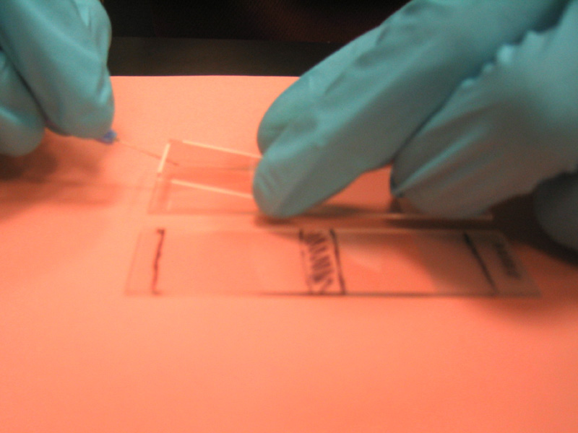
Fig. 2. First Lifter Slip in place on array next to mock slide.
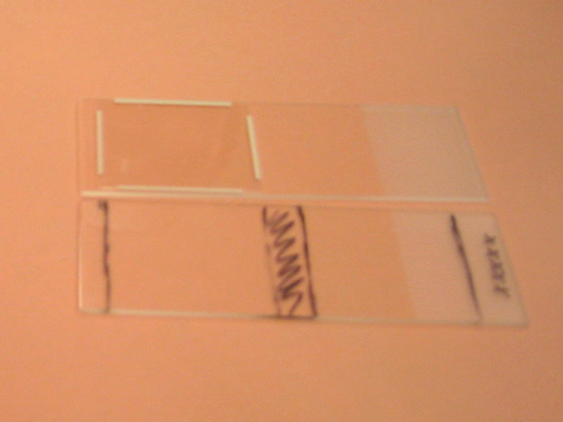
Fig. 3. Both Lifter Slips in place.
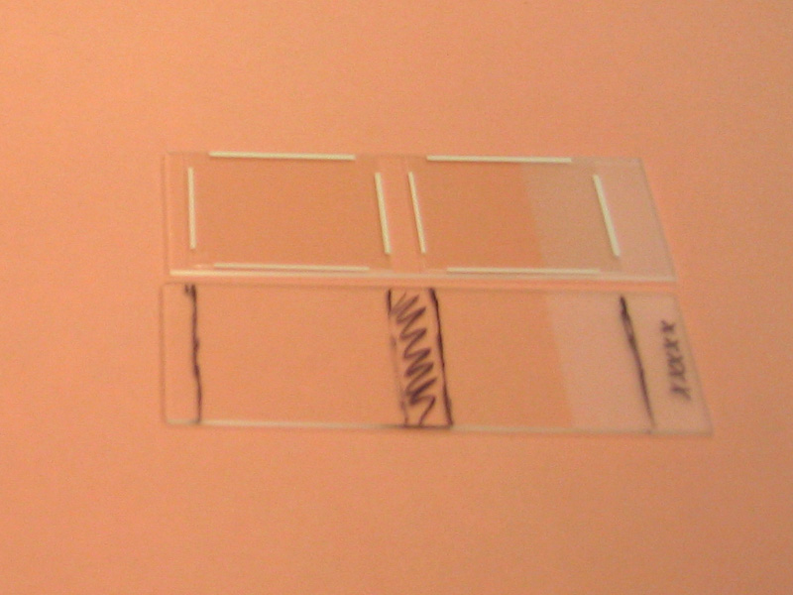

13. Pulse spin the cDNA hybridization solution from step 8. Pipet up 50ul – do not pipet up air bubbles. If this happens, expel the solution and start again. For lifter coverslips, place the pipet tip at the edge of one of the 4 corners. Pipet in a SLOW CONTINUOUS MOTION – watch the liquid, by capillary action, traverse across the space between the array and the coverlip. Do NOT pipet back “up” – you may suck up air that you will then pipet under the lifter slip. You may note a small bubble at an edge, but the edges are far enough from the grids that all oligos on the array should be exposed to solution. You will not require all 50ul – load until “full” (37-40ul for 24x30mm lifter slip).

Fig. 4. Pipetting liquid “under” one of the two Lifter Slips on microarray.
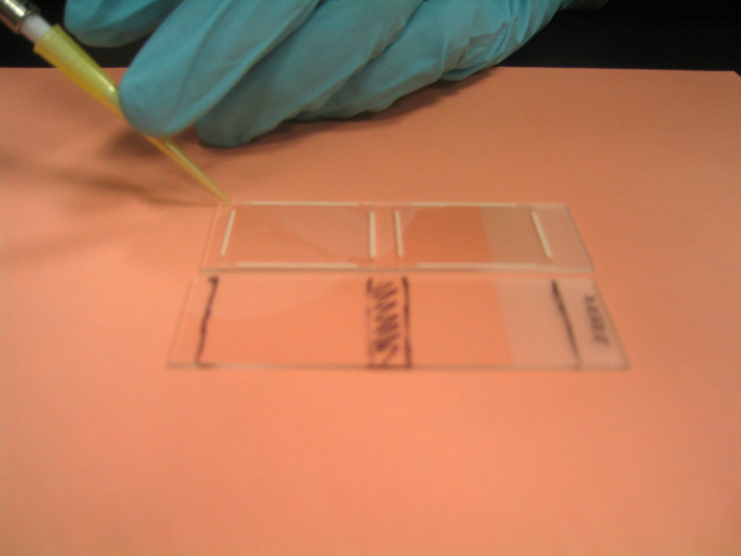

14. Get the 50ml conical from step 12 and place it down on the bench. Add a total of 50ul ddH₂O to the inside base of the tube. Do this by dividing the 50ul into 3 drops, and spacing them evenly down the base (near the cap, the middle, and the bottom). Do NOT jostle the tube so that the very tiny beads of water dissipate and water moves all around. The beaded water will help keep the hybridization “chamber” humidified, but it is important to keep the array from contact with the water. Place the array carefully into the conical and set in the Styrofoam base. Incubate at 50°C overnight.

Fig. 5. Conicals/hybridization chambers on Styrofoam base
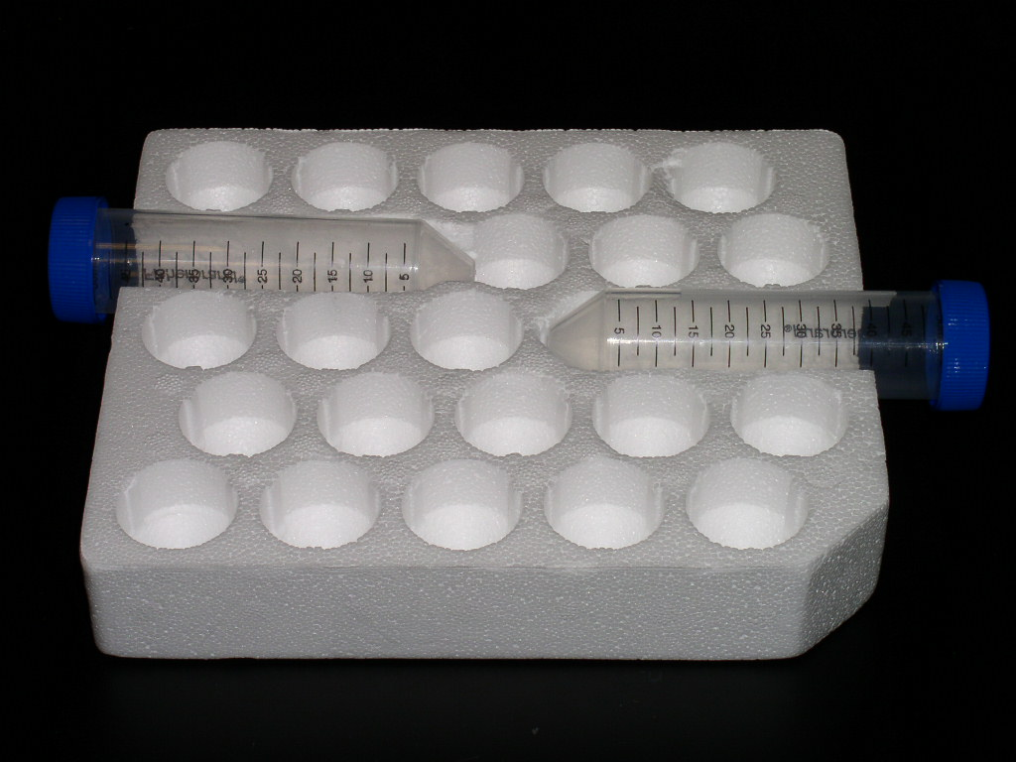

I. Post cDNA hybridization wash/Cy dye hybridization

Note that Genisphere sells kits with Cy or Alexa-fluor dyes. I have used Cy dyes successfully.

These remaining sections can be a bit tricky to schedule. Section I takes about 90 minutes, then there is a 4-5 hour incubation followed by about 60 minutes for Section J. The trick is where in the day to stick the 4-5 hour incubation. In the past, I have been fortunate to have class scheduled the same day as the lab. So, I use the class period in the morning to get through Section I (even though some people have to leave after 55 minutes for class that immediately follows) then the group reassembles late in the afternoon to finish up (Section J).

WEAR POWDER-FREE GLOVES WHEN HANDLING THE ARRAYS. POWDER/LINT ON YOUR ARRAY WILL AFFECT QUALITY OF RESULTS.

ALWAYS HANDLE ARRAYS AND COVERSLIPS/LIFTER SLIPS BY THE EDGES.

1. Per array, prewarm two 50ml conicals of 2xSSC, 0.2%SDS to 42°C.

2. Carefully remove the conical tube with the array from the 50°C incubator. Do not allow the water droplets to touch the array. Some moisture may have collected on the top of the tube; that is ok. Uncap the conical, remove the array, and lower the slide into a 50ml conical tube with 42°C 2xSSC, 0.2%SDS. Cap the tube and rock/gently agitate. Lifter slips should slide off almost immediately (within 30 seconds; regular cover slips can take 5-10 minutes or more to “detatch” from the array).

3. Transfer array to the second 50ml conical tube with 42°C 2xSSC, 0.2%SDS (leave coverslip behind in the first tube). Incubate at 42°C during 12-15 minute wash (you should gently rock conical a few times during incubation).

4. Transfer array to 50ml conical tube with room temperature 2xSSC. Place capped tube on rocker/agitator for 12-15 minutes.

5. Transfer array to 50ml conical tube with room temperature 0.2xSSC. Place capped tube on rocker/agitator for 12-15 minutes.

6. Transfer the array to an empty 50ml conical tube; IMMEDIATELY dry as in Section H step 10 but do not cap tube upon centrifuging (as directed by Genisphere’s instructions; here, spending time capping will actually allow for enough delay so that probability of streaking increases).

7. Place array in new 50ml conical tube; cap and prewarm to 50°C for at least 10 minutes.

AT THIS POINT, YOU WILL NEED TO WORK IN A DARKENED ROOM DUE TO THE USE OF THE CY3/CY5 DYES. IT DOES NOT NEED TO BE PITCH BLACK, BUT SHOULD BE QUITE DIM – JUST ENOUGH LIGHT (IDEALLY INDIRECT LIGHT FROM HALLWAY/WINDOW) TO SEE WHAT YOU ARE DOING.

8. During step 3 above, begin to prepare the 3DNA Array 900 Capture Reagent (kit vial 1 – note that there are two different vials numbered “1” – one each for Cy3 and Cy5 – prep both). It is necessary to break up aggregates that may have formed during freezing. To do so, thaw the tube in the dark (in a drawer, or surround tube with aluminum foil) for 20 minutes at room temperature. Vortex on high for 3 seconds, then pulse spin. Incubate tube at 50-55°C (I used 55°C) for 10 minutes. Vortex on high for 5 seconds, then pulse spin again. Genisphere suggests checking for aggregates by looking at the solution in the vial and looking for “air bubbles” or “flakes” at the side of the tube. This is your dye, so you do not want to expose it to light to look at the solution. We have had success simply by following the procedure as stated.

9. Thaw and resuspend the 2x hybridization buffer (kit vial 7) by heating to 70°C for 10 minutes (until resuspended). Vortex to mix and spin for a minute to collect buffer at bottom of tube.

10. Make a “stock” solution of 2x hybridization buffer and anti-fade reagent (kit vial 8); to a clean 1.5ml eppendorf tube, add 1ul of anti-fade reagent to 100ul of 2x hybridization buffer (kit vial 7). See step 11 for actual total volume you will need (you may need >100ul).

11. You need to determine the volume of 3DNA hybridization mix and make a solution based on that volume (see Section H step 7 for similar determination). For example, you can combine 2.5ul of Cy3 Array 900 Capture reagent (kit vial 1), 2.5ul of Cy5 Array 900 Capture reagent (kit other vial 1), 27.5ul 2x hybridization buffer/anti-fade reagent, and 22.5ul of nuclease free water (kit vial 10) for 55ul 3DNA hybridization solution. If adjusting volume to more or less than 55ul, do NOT adjust the volume of the capture reagents (always use 2.5ul of each). Simply use more/less 2x hybridization buffer/anti-fade reagent and nuclease free water. For our previous work, we made 55ul and used what would “fit” under the lifter slip (ca. 37ul) – see step 13.

12. Flick the tube (step 11) to mix the contents; pulse spin to collect contents. Incubate at 75°C for 10 minutes, then at 50°C until ready to add to the prewarmed array.

13. Pulse spin the prehybridization solution from step 12. Pipet up 55ul – do not pipet up air bubbles. If this happens, expel the solution and start again. For lifter coverslips, place the pipet tip at the edge of one of the 4 corners. Pipet in a SLOW CONTINUOUS MOTION – watch the liquid, by capillary action, traverse across the space between the array and the coverlip. Do NOT pipet back “up” – you may suck up air that you will then pipet under the lifter slip. You may note a small bubble at an edge, but the edges are far enough from the grids that all oligos on the array should be exposed to solution. You will not require all 55ul – load until “full” (37-40ul for 24x30mm lifter slip). Note that it may help to have a lightly-colored sheet of paper under the array to provide contrast since it will be dark in the room.

14. Get the 50ml conical from step 7 and place it down on the bench. Add a total of 50ul ddH₂O to the inside base of the tube. Do this by dividing the 50ul into 3 drops, and spacing them evenly down the base (near the cap, the middle, and the bottom). Do NOT jostle the tube so that the very tiny beads of water dissipate and water moves all around. The beaded water will help keep the hybridization chamber “humidified,” but it is important to keep the array from contact with the water. Place the array carefully into the conical and set in the Styrofoam base. Incubate at 50°C 4-5 hours. If your incubator has a window, place foil over the window to block light. WORK WITH YOUR ARRAY IN DARK CONDITIONS THROUGHOUT THE REST OF THE EXPERIMENT!!

J. Post Cy dye hybridization wash

Keep working in the dark (or as dark as possible). Continue to wear powder-free gloves.

IMPORTANT NOTE: There have been reports that Milli-Q water will interfere with the Cy5 (red) dye, resulting in loss of signal. Therefore, it is highly recommended to make the following solutions using Ambion’s nuclease free, non-DEPC treated, water! (1L, catalog number 9932).

1. Prewarm 50ml conical(s) of 2xSSC, 0.2%SDS (with or without 0.5mM DTT, see steps 2 and 3) to 65°C (based on Genisphere’s instructions, note different temp. than previous “initial wash” step in Section I).

2. Remove 50ml conical (hybridization chamber) from incubator carefully (remember the drops of water in the tube!), uncap, and carefully remove array and place it into 50ml conical with 65°C 2xSSC, 0.2%SDS. Cap the tube and rock/gently agitate. Lifter slips should slide off almost immediately (within 30 seconds; regular cover slips can take 5-10 minutes or more to “detatch” from the array).

3. Transfer array to a 50ml conical tube with 65°C 2xSSC, 0.2%SDS, 0.5mM DTT (DTT is included to help prevent fading of Cy5 signal – use FRESH DTT). Incubate at 65°C during 12-15 minute wash (you should gently rock conical a few times during incubation).

4. Transfer array to 50ml conical tube with room temperature 2xSSC, 0.5mM DTT. Place capped tube on rocker/agitator for 12-15 minutes.

5. Transfer array to 50ml conical tube with room temperature 0.2xSSC. Place capped tube on rocker/agitator for 12-15 minutes.

6. Transfer the array to an empty 50ml conical tube; immediately dry as in Section H step 10 but do not cap tube upon centrifuging. Carefully insert the dry array into a slide holder. Seal holder and package holder for overnight shipping and scanning. A FedEx envelope with some bubble wrap is sufficient protection when shipping arrays using a slide holder.

